Alexander King – r00852947
CSET 4850-901
Computer and Network Security
March 21st, 2021

Weekly Report #9

This week I learned about auding and I-RBAC. Auditing consists of logging, analysis, and reporting in an attempt to better secure devices. I-RBAC stands for “Isolation Enabled Role Based Access Control” model.

Auditng

We will often call Auditing “pen-testing” or penetration-testing. This is done to evaluate the security policies and how effective they are again us attacking them.

Logger – Will document and save information about our PC or network typically controlled by parameters. For example I could keep a log of everyone who signs in to some work account, or every device that connects to my network etc. These logs may or may not be human-readable. Event Viewer is one example of a Windows logging service. Another example would be users attempting to violate a security policy and access things they shouldn’t have access to.

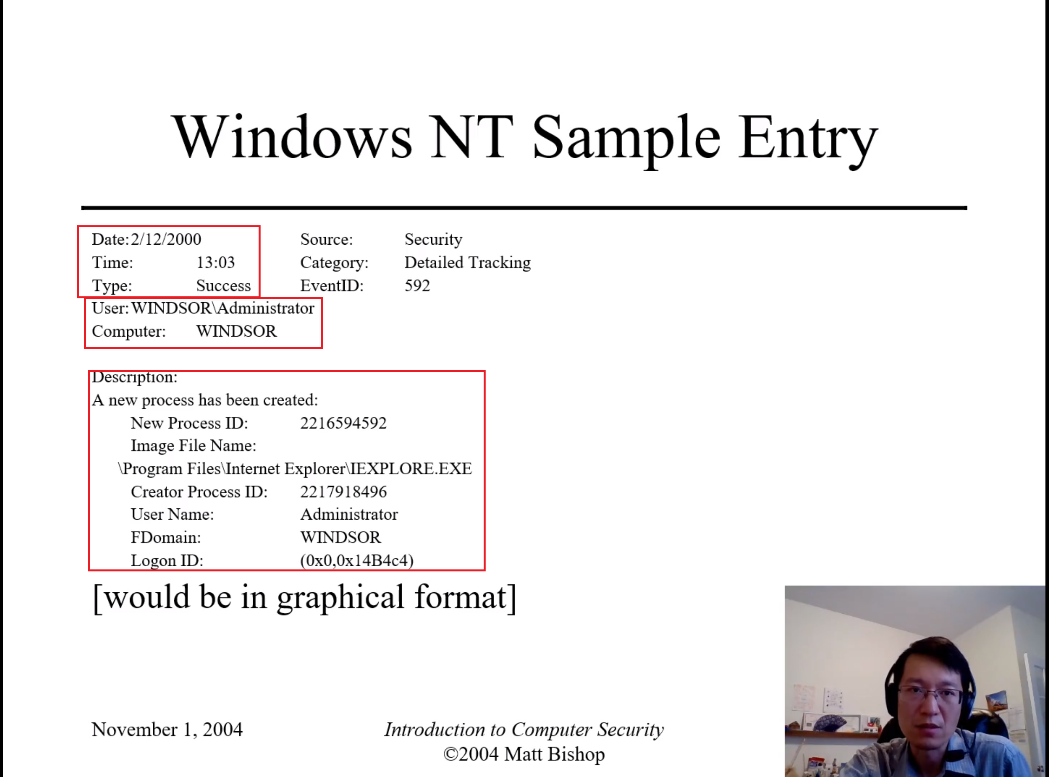
Looking at the sample Windows NT log you can see that on 2/12/2000 at 13:03 a user named Administrator on the device named WINDSOR sucessfully created a new process that appears to be Internet Explorer. This could be mundane in that they’re opening and using an outdated browser with their outdated operating system or it could possibly be a program that they’re trying to make appear as Internet Explorer but may not be.

Analyzer – Will look at the logged data for something. This could be behaviors or abnormalities. These may lead to changes in logging or could lead to a report of an event. We had an example of a telnet connection. I do not fully understand why anyone would be using telnet especially for something malicious as it is encrypted and I should be able to obtain a pretty good idea of what was going on. Also it opens an attack vector for a malicious actor to co-opt and otherwise legitimate telnet session.

Notifier – will report the results of analysis. We can set some triggers that we want to know about. The example we gave was 3 failed log-ins will lock the account in question and notify the relevant IT department.
An example of this is I know at the hospitals if you open the medical records of a psychiatric patient upon requesting access to these files it will ask the user to “break the glass”. This essentially means what you’re doing will be logged, someone will be notified that you’re accessing this highly protected patient information, and if you’re not their relevant doctor you will be asked why you accessed this. If you have a good reason and explanation everything will be fine and if you do not it is a firing offense that could result in immediate termination and possibly further HIPAA investigations that could jeopardize your ability to practice medicine in the future. This is a real-life example of a security policy in action where you know someone will be notified and will follow up on it.

Another example could be I want to check the logs of a recently terminated employee. I notice that an abnormally large amount of data was recently put onto an external storage device just prior to them leaving. I could then reasonably suspect this employee has stolen strategic data and could investigate further. This could also be used to deny former employees end-of-contract benefits (golden parachutes) etc.

I-RBAC

Isolation Enabled Role Based Access Control. I did the first half of this weekly report prior to watching this. I’m amused that they’re giving the exact same example I provided above. Where it will let a user “break the glass” to access something that maybe they need immediate emergency access to for a legitimate reason but also may not have a legitimate need to access. “breaking the glass” is a serious warning to the user that they will be given access but also that it will be logged, looked into, and they will be asked why it was done and they better have an excellent explanation or else it could cost them their job and ability to utilize their degree going forward. The punishments are unauthorized access of protected medical information can be very serious. In my opinion the system I am currently aware of is good because it will allow for emergency access when needed but also has serious repercussions for violations. If I get injured away from my normal home location whomever is caring for me can hopefully access my relevant medical data and do it quickly to be able to best care for me. Violators will have their standards of living and quality of life significantly impacted which seems to me to work good enough for the technology we have available.

Basic RBAC will have isolation incorporated. Operations by some roles will be isolated and then validated as discussed above. This is good for supporting untrusted / inexperienced roles.

We discussed “Safe Execution Environment” (SEE) as a way to test software execution in a safer designated environment prior to allowing it to execute somewhere we think it could possibly violate security policies where it matters. I seem to recall this was able to be attacked by just having it timeout. That was a couple of years ago that I became aware of that though and I do not know if a fix has been implemented for this without further research. I know this method has been proven exploitable in the past though and it seemed rather easy. When working as intended it will run the untrusted software, test for compatibility, check for configuration changes, and if needed study malicious code.

Virtual Machines offer two-way isolation. The host OS is hidden inside of a VM and reproduces the environment and results need to make their way from the VM to the host.

One-way isolation - the host OS is visible within the SEE but changes made are not visible to the host OS. The host OS and SEE environment will merge.

