Alexander J King

HW6

CPL

1) Create a program in C++ that includes two different enumeration types and has a number of operations using the enumeration types. Also create the same program using only integer variables. Compare the readability and predict the reliability differences between the two programs.

When I give a variable a double value in a for loop it converts it to an int value and warns me I could possibly have lost data. AFTER the for loop the incremented variable maintains the last value assigned by the loop unless I redefine it.

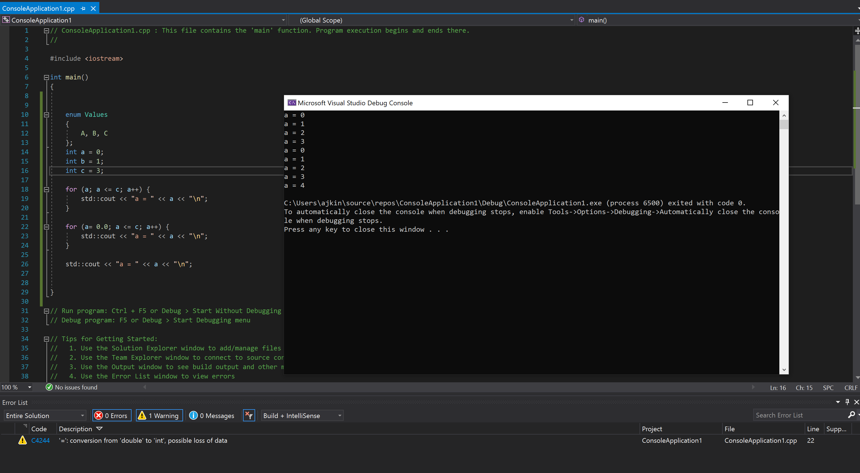

2) Write a program in C++ to determine the scope of a variable declared in a “for statement”. Specifically, the code must determine whether such a variable is visible after the body of the “for statement”. Explain if the variable was or was not visible and why.

The variable was visible and maintained the last incremented value because it is in scope.

See above picture.

3) What are the advantages and disadvantages of decimal data types?

Advantages: we can have more specific numbers.   
Disadvantages: They consume more system resources.

4) What are design issues for character string types?

They can ignore special characters like alt-168 ¿. Sometimes they will map to the position on a keyboard which could cause international keyboards to incorrectly display.

5) Define ordinal, enumeration, and subrange types.

An ordinal type is one in which the range of possible values can be easily associated with the set of positive integers • Examples of primitive ordinal types in Java – integer – char – boolean.

• All possible values, which are named constants, are provided in the definition • C# example enum days {mon, tue, wed, thu, fri, sat, sun}; • Design issues – Is an enumeration constant allowed to appear in more than one type definition, and if so, how is the type of an occurrence of that constant checked? – Are enumeration values coerced to integer? – Any other type coerced to an enumeration type?

• An ordered contiguous subsequence of an ordinal type – Example: 12..18 is a subrange of integer type Ada’s design type Days is (mon, tue, wed, thu, fri, sat, sun); subtype Weekdays is Days range mon..fri; subtype Index is Integer range 1..100; Day1: Days; Day2: Weekday; Day2 := Day1;

6) What are the advantages of user-defined enumeration types?

They add to the readability and reliability of programs.

7) What is the purpose of level numbers in COCOL records?

to show nested records.

8) What is the primary difference between a record and a tuple?

A tuple is a data type that is similar to a record, except that the elements are not named

9) What are two common problems with pointers?

• Dangling pointers (dangerous) – A pointer points to a heap-dynamic variable that has been deallocated • Lost heap-dynamic variable – An allocated heap-dynamic variable that is no longer accessible to the user program (often called garbage) • Pointer p1 is set to point to a newly created heapdynamic variable • Pointer p1 is later set to point to another newly created heap-dynamic variable • The process of losing heap-dynamic variables is called memory leakage

10) What is a C++ reference type, what is its common use, and why are they better than pointers for formal parameters?

**• C++ includes a special kind of pointer type called a reference type that is used primarily for formal parameters – Advantages of both pass-by-reference and pass-by-value**

Pointers can point at any variable regardless of when or where it was allocated.

11) What is a type error?

A type error is the application of an operator to an operand of an inappropriate type.  
Int + string.

12) What is a flow chart and why do we use them in programming?

A flowchart is a type of diagram that represents a workflow or process. We utilize them to both plan and explain to others our programs functionality.

13) What is pseudocode.

Is an informal high-level description of a computer program.