Alexander J King
Homework 4

Visual Basic Code
using System;
using System.Diagnostics;

namespace hw4
{
class Program
{
static void Main(string[] args)
{

Console.WriteLine("Hello World! (C# visual studio)"); // echo hello word
Console.WriteLine("Press any key to run homework 3 PowerShell Script"); // tell user to press any key
Console.ReadKey(); // read that they have pressed a key

// power shell program here
Process.Start(@"powershell.exe" , @"C:\Users\ajkin\Documents\school\helloworld.ps1");

System.Threading.Thread.Sleep(20000); // this is the worst bit of code. Pause this code for X sec while I do PS. (20 right now)
Console.WriteLine("Press any key to exit the program."); // tell the user to press any key to leave program
Console.ReadKey(); // read that the user has pressed a key
Console.Write("You pressed any key. 3 sec sleep then clear."); // inform them they pressed any key
System.Threading.Thread.Sleep(3000); // wait 3 sec
Console.Clear();
}
}
}

helloworld.ps1 Code

echo "hello world (PowerShell)"

Write-Host "Press any key to create new folder..."

[void][System.Console]::ReadKey($true)

New-Item -Path 'C:\Users\ajkin\Desktop\CSET4250' -ItemType Directory

Write-Host "Press any key to see all services..."
[void][System.Console]::ReadKey($true)

Get-Service

Write-Host "Press any key to start XboxGipSvc service..."
[void][System.Console]::ReadKey($true)
start-service XboxGipSvc
Get-Service XboxGipSvc

Write-Host "Press any key to stop XboxGipSvc service..."
[void][System.Console]::ReadKey($true)
stop-service XboxGipSvc
Get-Service XboxGipSvc

Screen shots of executing code step-by-step
1.C# Hello world and press any key to run PowerShell script.
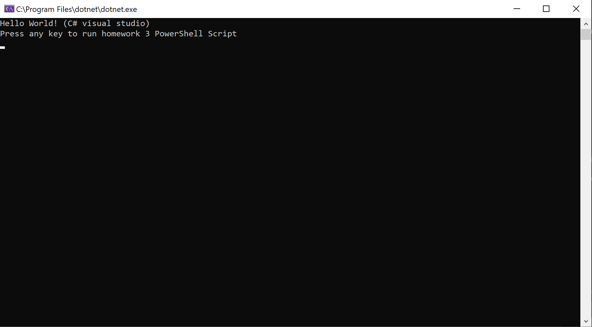
2.PowerShell Hello World
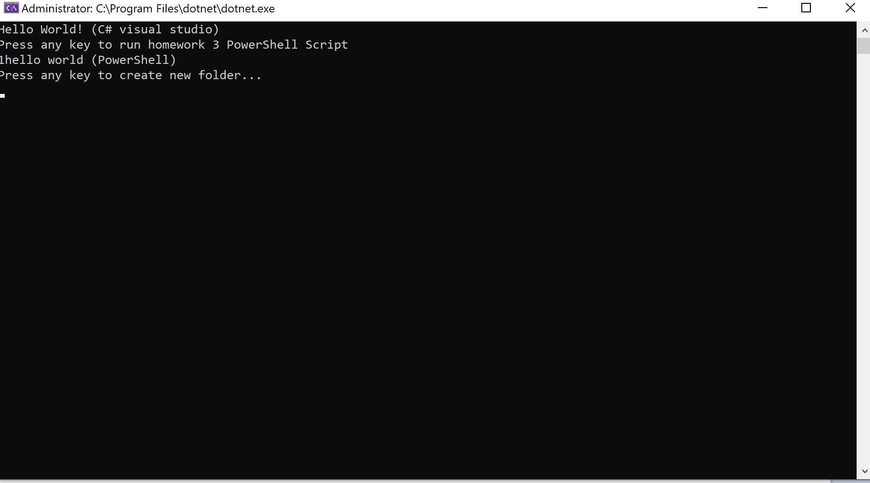
3.New Folder Created
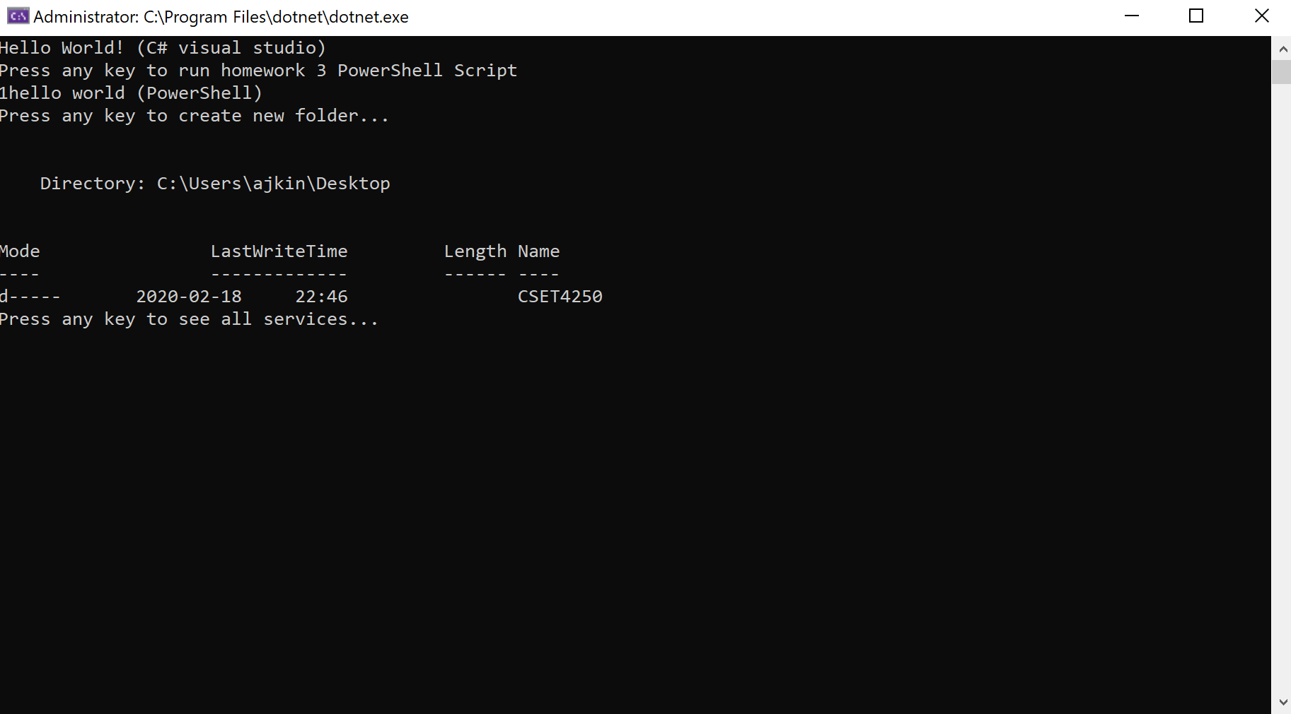

4. list all services (note XboxGipSvc stopped)
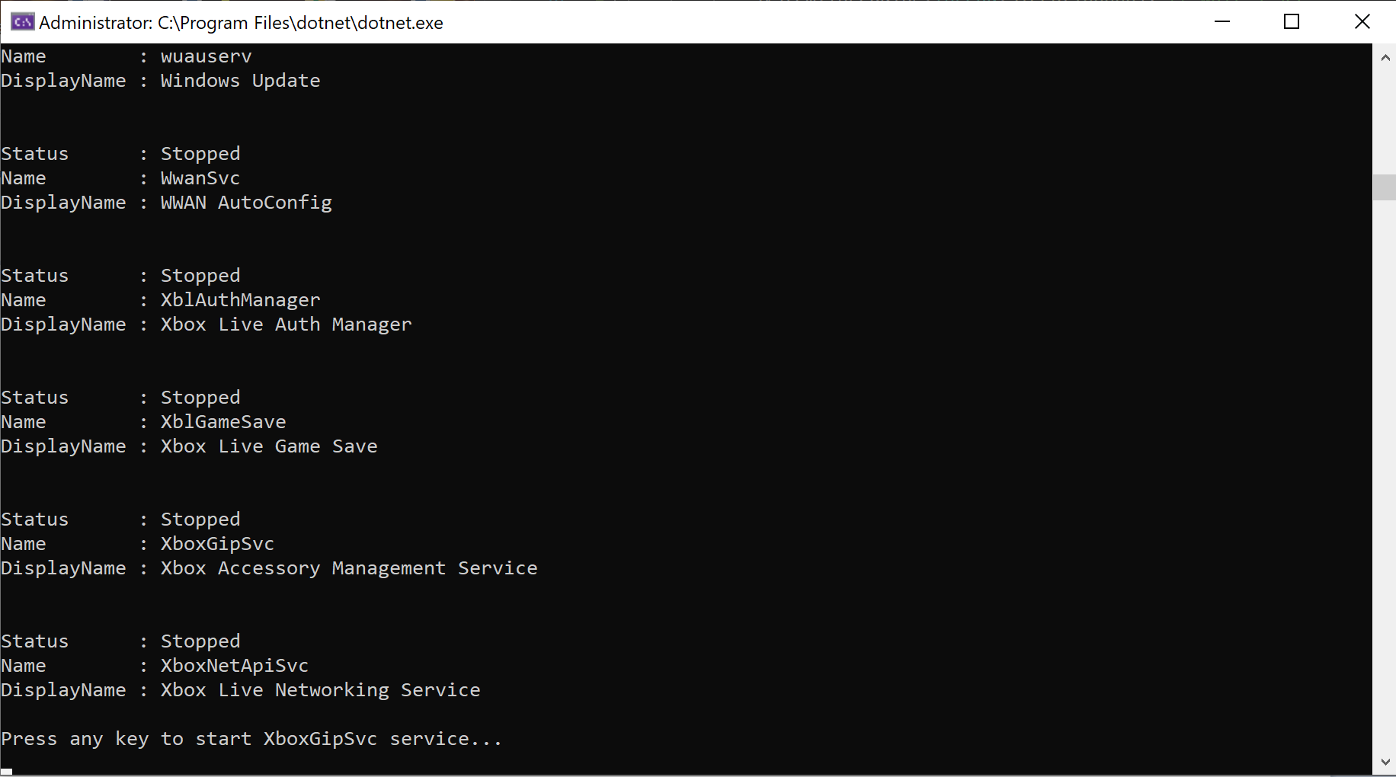
5.Note XboxGipSvc started and then after additional prompt stoped and displayed Get-Status to user.
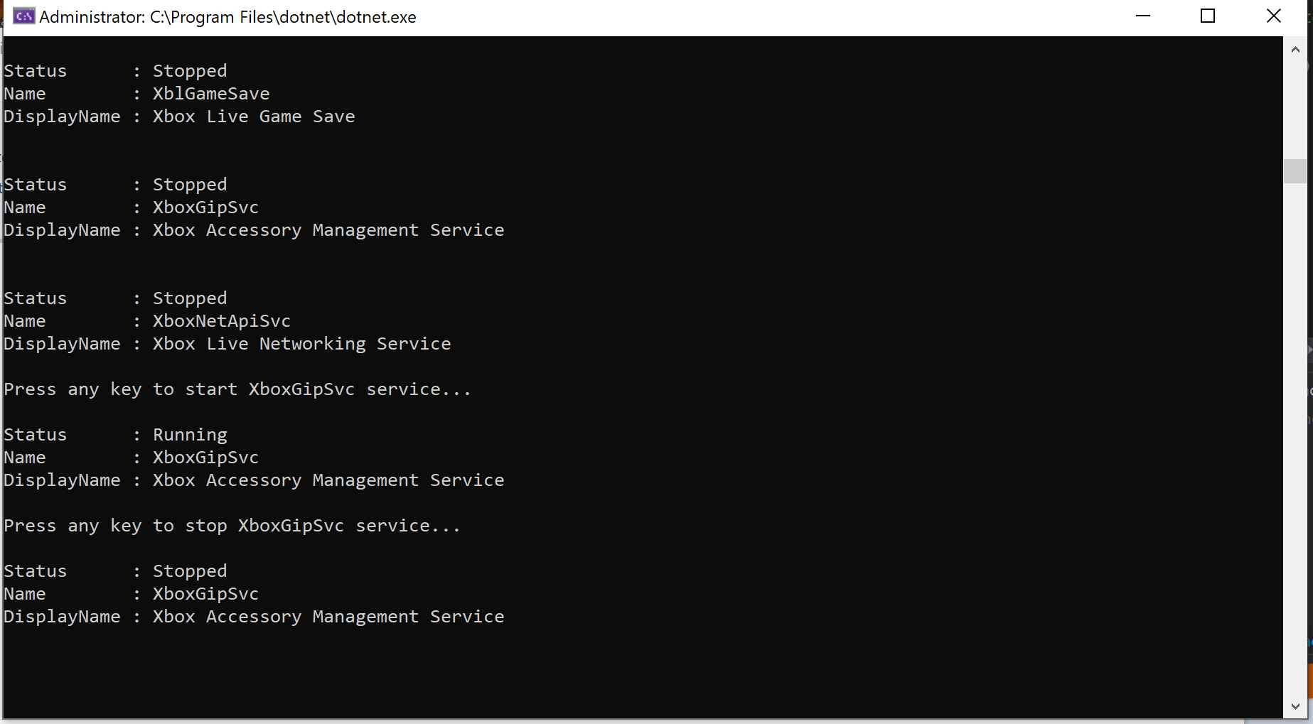

6. Press any key to exit
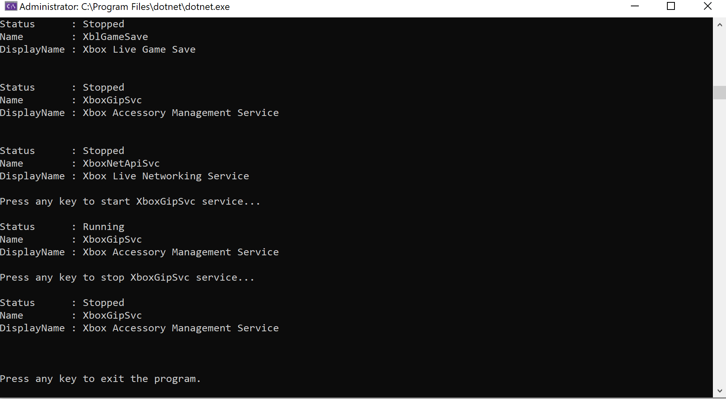
7. Pressed any key to exit. Pause 3 sec and clear.
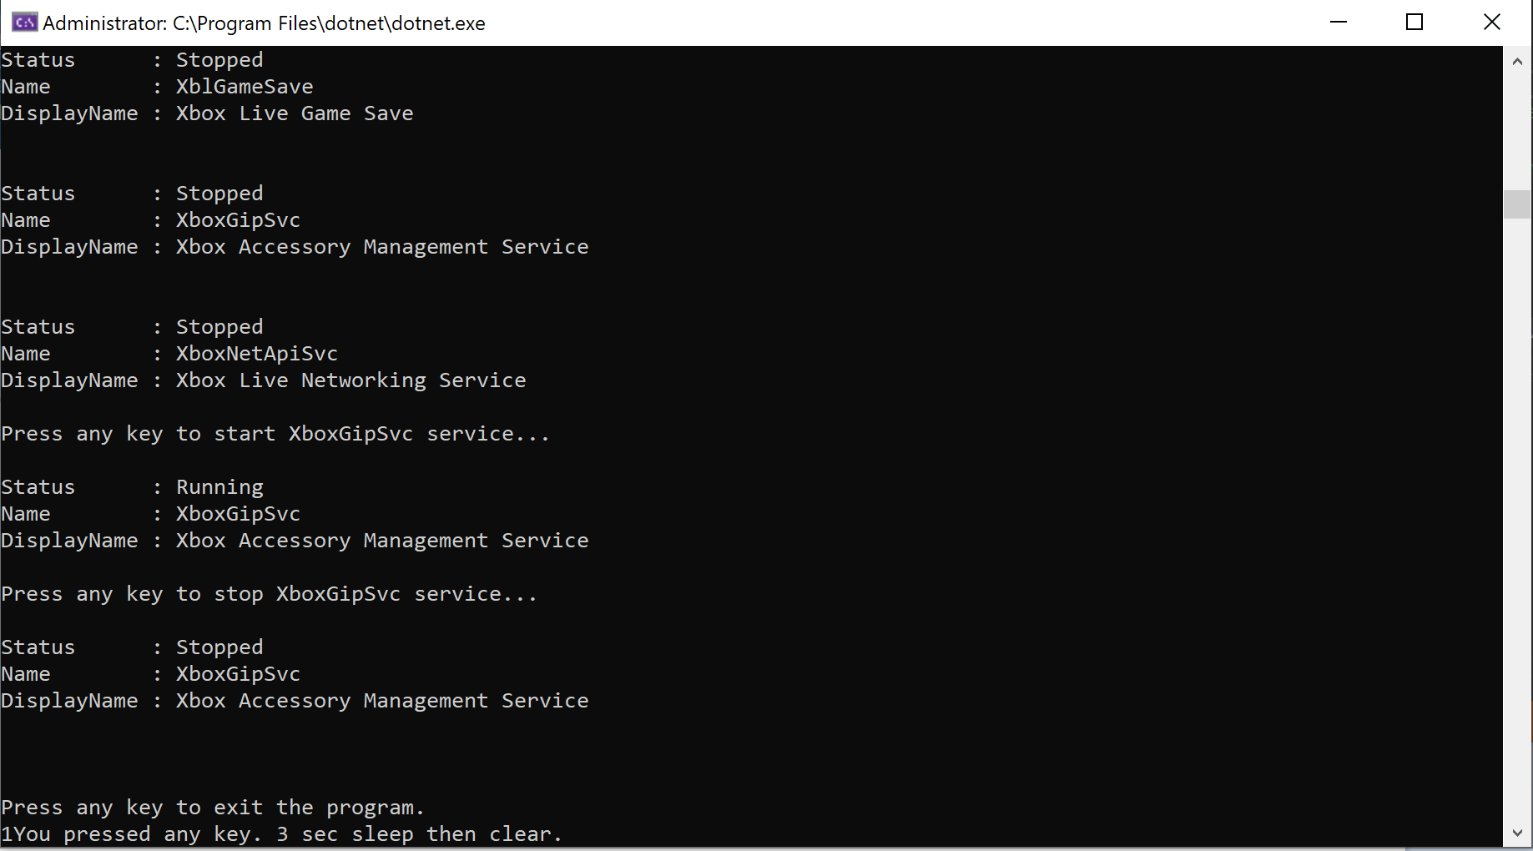

Thoughts/Improves
- I need to resolve a better way to wait for PowerShell to do whatever it is I want it to do. Currently I just told the C# program to sleep basically and gave myself enough time to successfully run the program. This needs fixed.
- I could check if the file exists before running. Currently if the file already exists it errors out. This was not implemented only because of lack of time. The assignment was not posted as ‘due’ on blackboard so when I did my homework it was neglected. I was given ~slightly above 24 hours to complete the task while having work and other classes. This was a best effort within the short time-frame I had. This feature did not appear specifically required so it was not included for time management.

