Alexander King
Database Driven Websites
PHP Lab

Hello World:
Note: The pictures are high enough resolution to easily scroll in and read as closely as one likes.

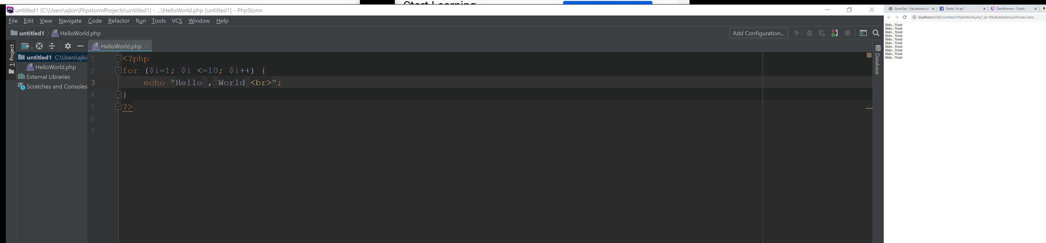
Hello World.
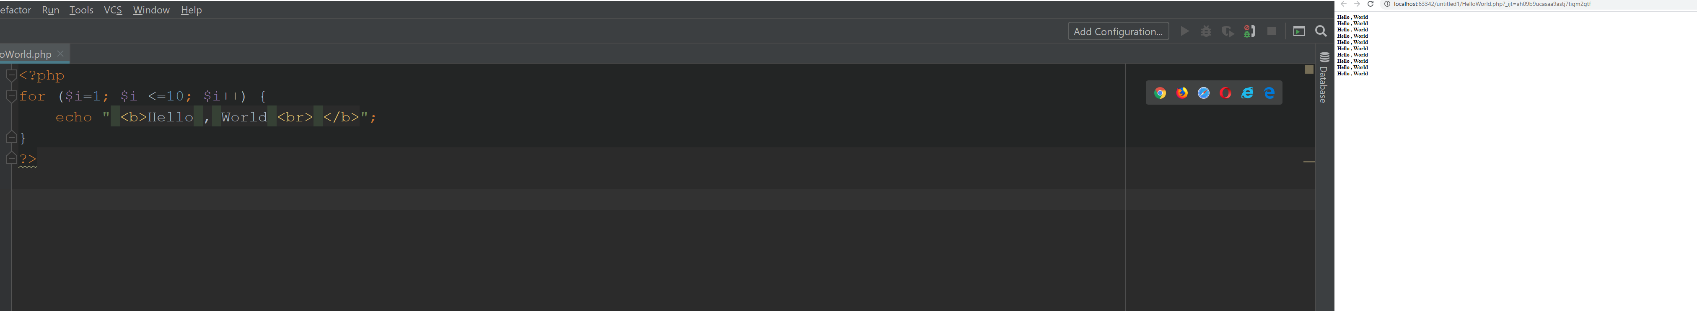
Bold Hello World.

Variables:

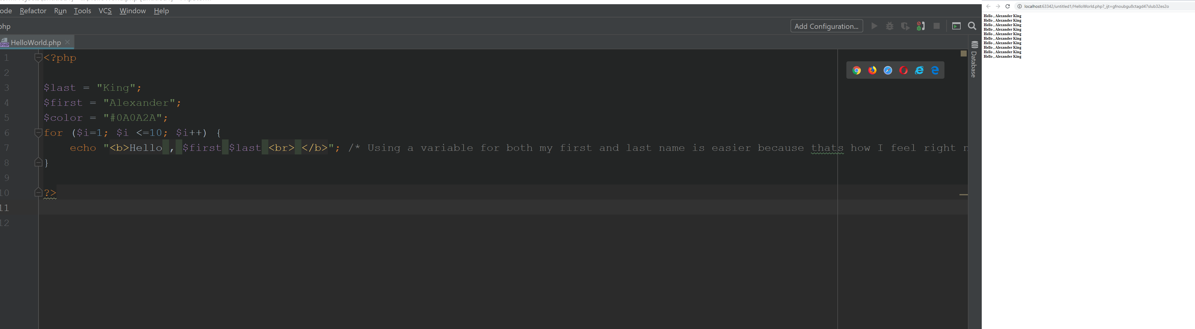
Set my first and last name to a variable because that felt easier than using one to me at the moment.

Making Decisions:

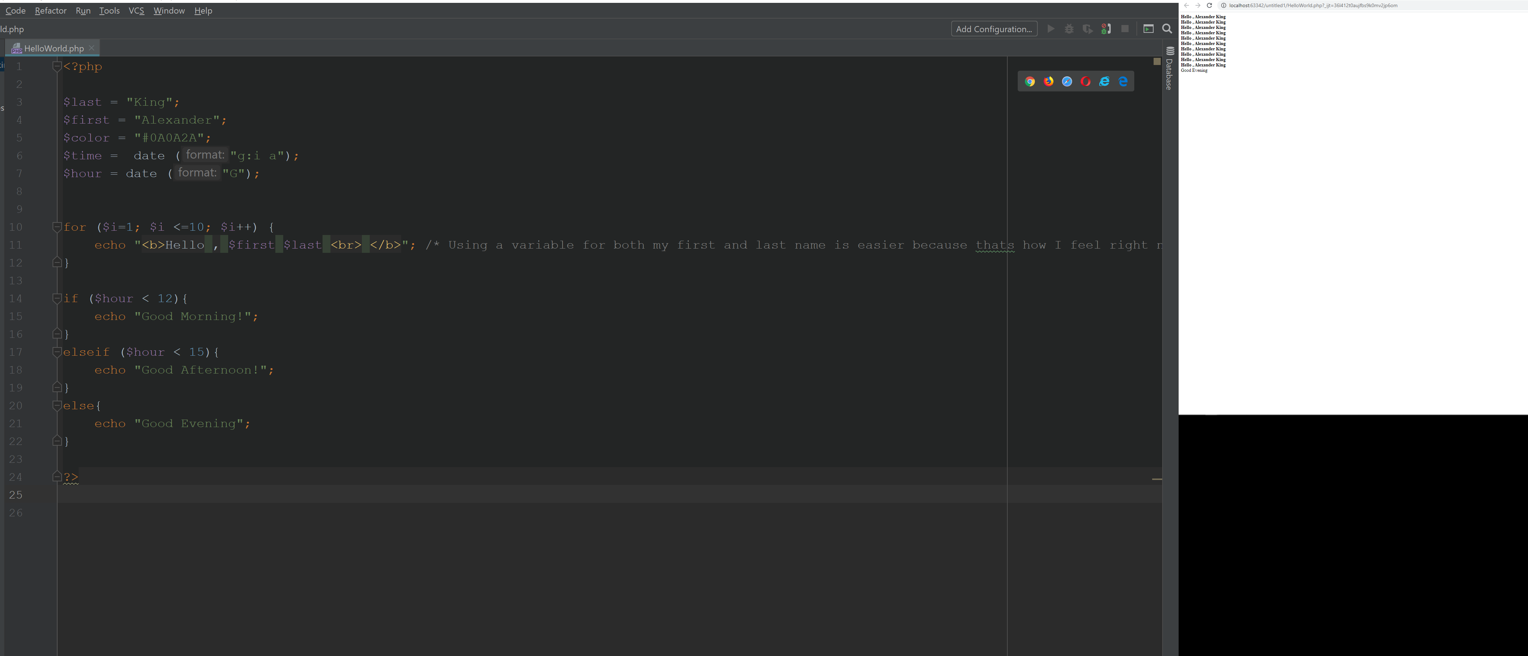
Program makes decision about what time it is for me and appropriately says good evening.

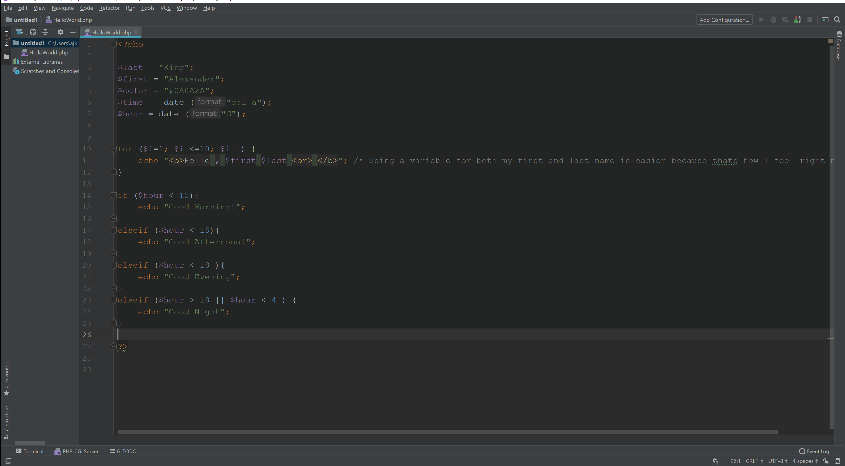
Added additional good night options and changed the times slightly.
Looping:

Done in part one.
Here is an additional screenshot for good measure.

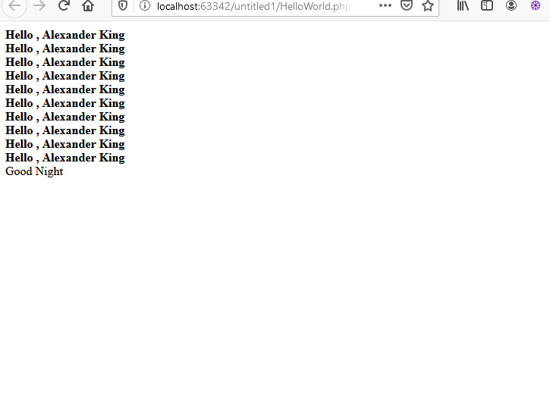

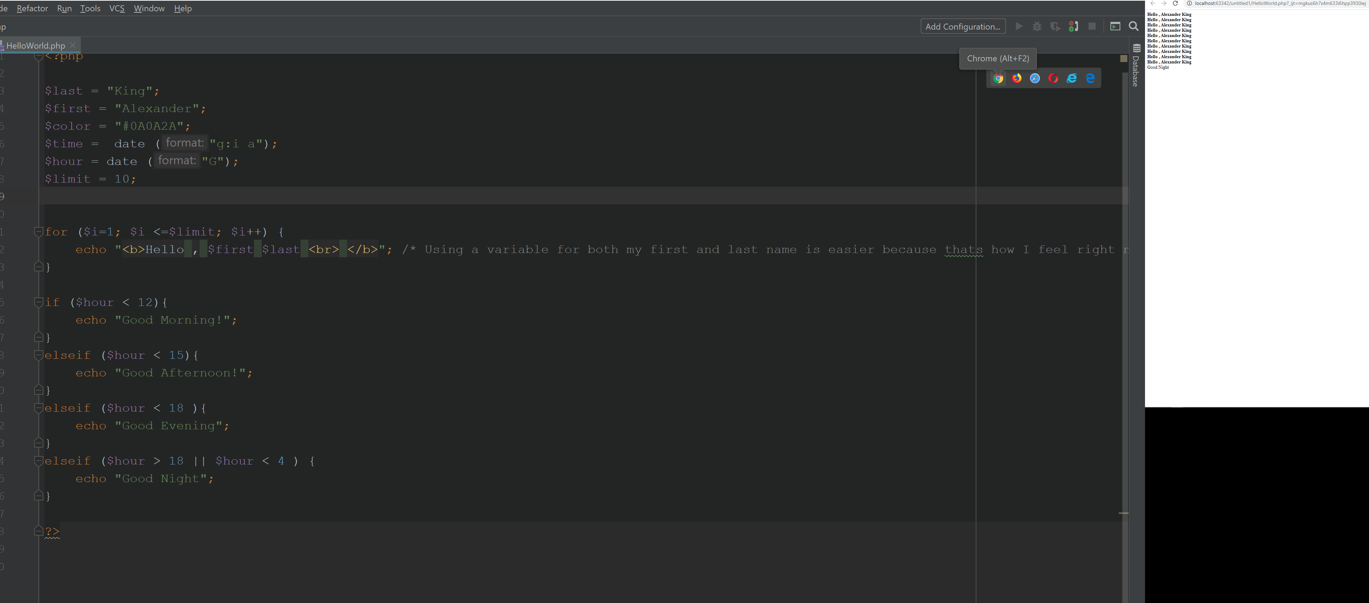
Changed from using for $i <= 10 to for $i<=$limit and tested custom limits.

Arrays:
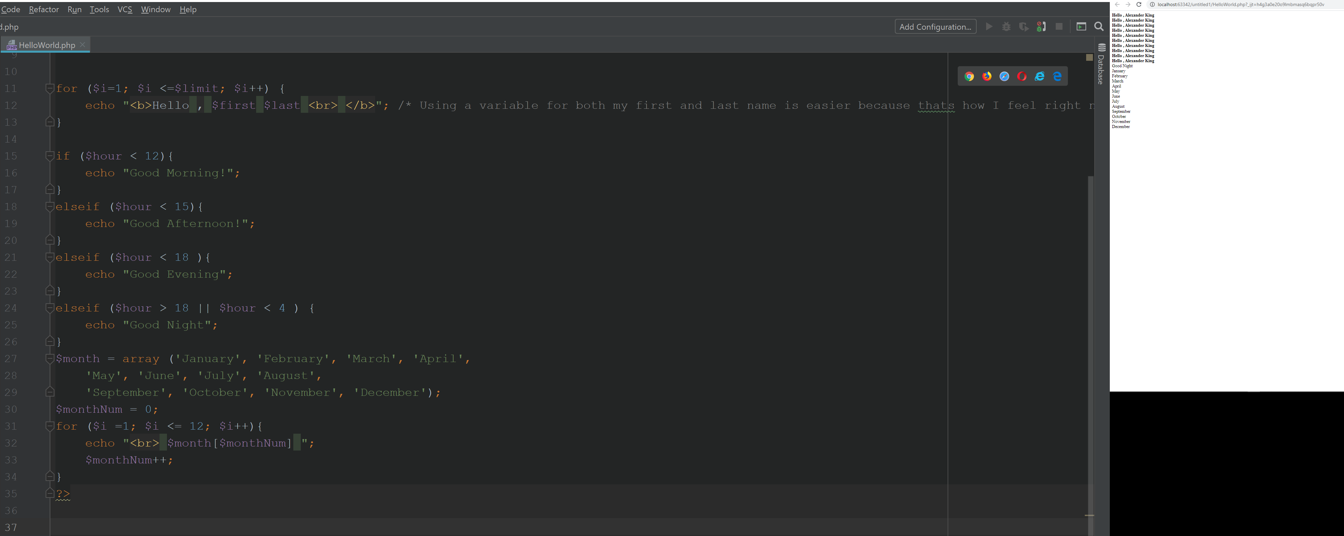
Name each month in a for loop in order Jan – Dec.

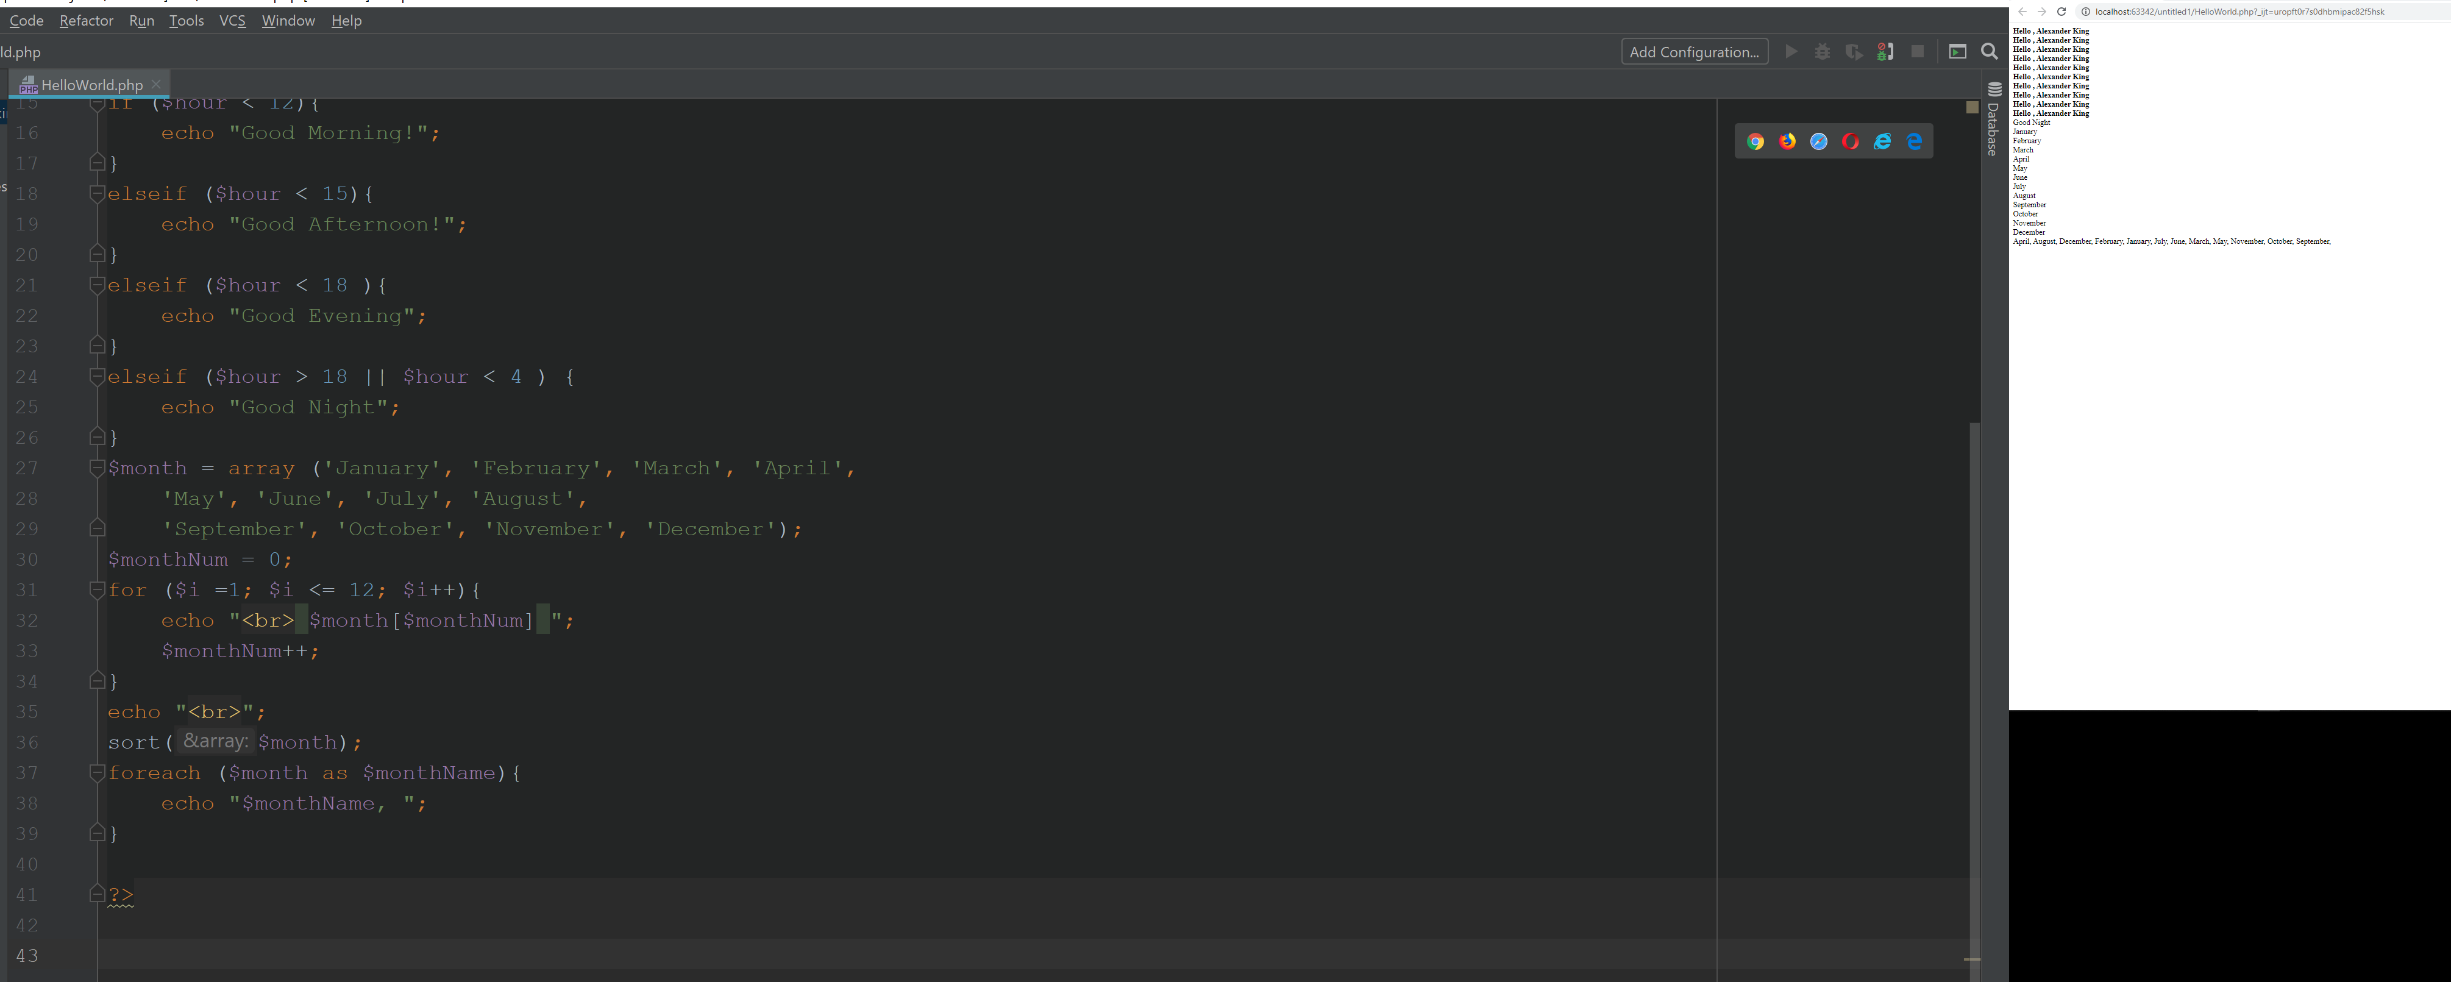
Name each month is alphabetical order. April-September using for each.

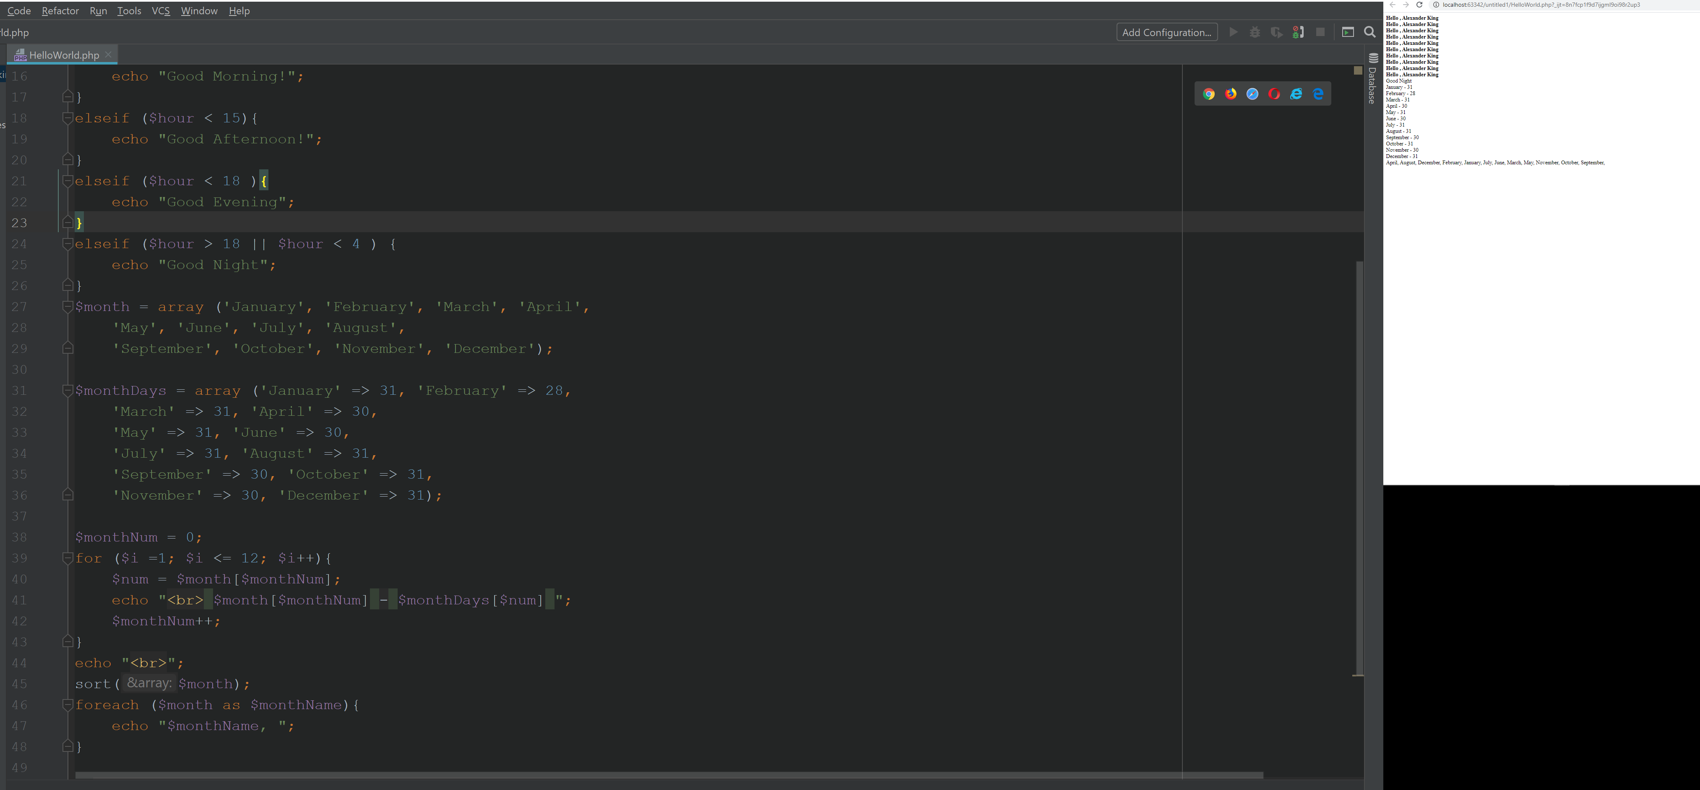
Include the number of days with each month.

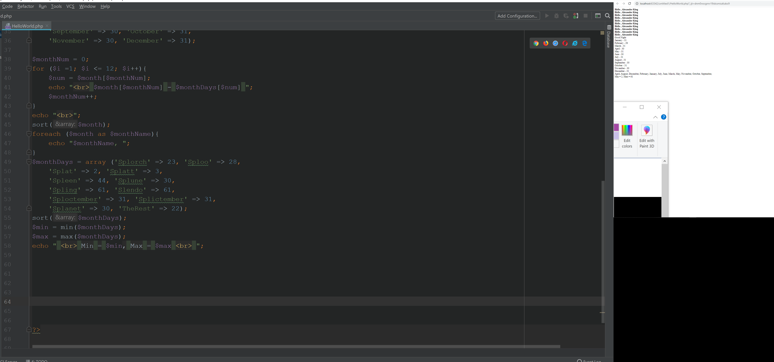
Using min() and max() fuctions to get the min and max values for the fictitious monthDays.
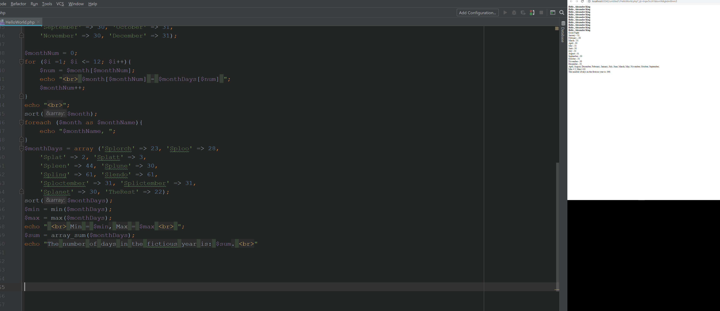
Using array_sum() to get the sum of the array and print back how many days in the fictitious year.

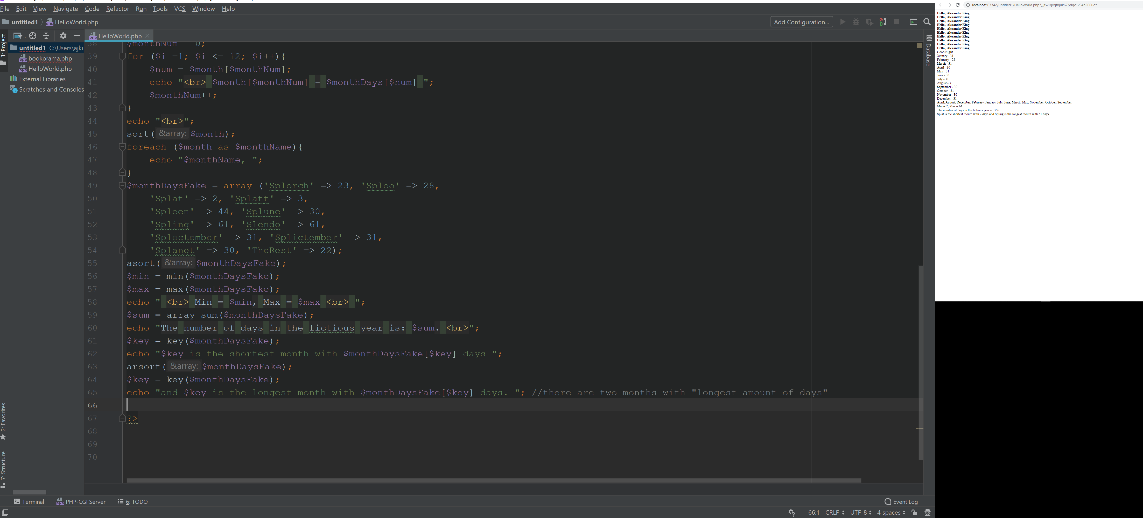
Print the longest month and days and the same for shortest. Getting the month name by setting a variable $key = key(monthDaysFake); after asorting and arsorting them. Then I display the number of days in that month by using the $monthDaysFake[$key] for the current sorting.

Sorting Associative Arrays
A. I expect the order to change to the months from least days to greatest. I also expect them to lose their key if I use sort instead of asort.

B. yeah that happened. <https://www.php.net/manual/en/array.sorting.php >

Part 3 WEB database access:

I’ve spent all day making my own database and attempting to connect to it without luck. I cannot find the mythical ‘your database’ mentioned in the homework. Looked high and low and came up empty. I did a ton of work because of this going from getting myself a Wamp setting it up as well as myadminphp and mysql workbench etc.

=/ o_0

Part 4

