Data Companion for Single Phase Transformers

Alexander J King
ENGT 3050:004
Transformers Lab
4.13.20
Procedure
Step
8 Yes
10
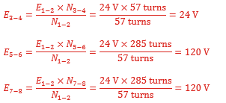
14
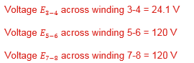
16
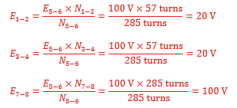
18
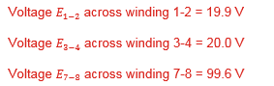
Yes they’re virtually equal. Yes the above manipulatons confirm the relationship between the turns ratio and the voltage ratio.
22.
Es= Ep * (Ns/Np)
120 = 24 * (Ns/Np)
120/24 = 5
5= (Np/Ns)
1:5 ratio

25
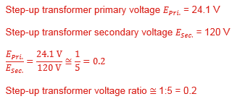
26.
Yes they’re virtually equal.

Yes it is considered a step-up transformer because it meets the definition: A transformer that increases the voltage from primary to secondary (more secondary winding turns than primary winding turns) is called a step-up transformer.
Voltage was increased by a factor of 5.

29
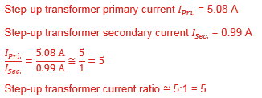
30. Yes. 5:1 is the inverse of 1:5.

31
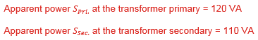
Yes they are close but not virtually identical.
34.
5:1 ratio

36
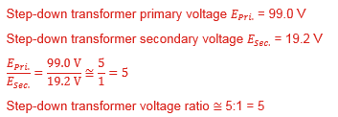
37. Yes they are virtually equal.
Yes you could conclude it is a step-down transformer because the ratio is going from 5 to 1. Greater to lesser.

41
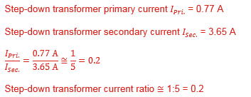
42.
Yes 5:1 in the inverse of 1:5.
43

Yes they’re close but not virtually equal.
44.
Yes they’re bi-directional because we covered stepping up (lesser to greater) and stepping down (greater to less) which fits the definition of bi-directional.

No a single power transformer cannot act alone as a step-up or step-down transformer because they need to have a difference in the wrapped coils in order to step up or down. Having one alone will not accomplish this task.

REVIEW QUESTIONS:
1.
A power transformer has 125 turns of wire in one of its windings, and 375 turns of wire in the other. What is the transformer turns ratio when it is used as a step-up transformer? What is the transformer turns ratio when it is used as a step-down transformer?
125:375 == 1:3 stepping up from 1 to 3.
375:125 == 3:1 stepping down from 3 to 1.

2. A step-up transformer connected to a resistive load has 300 turns of wire in the primary winding and 1000 turns of wire in the secondary winding. Determine the current Isec. flowing in the secondary winding of the transformer when a current Iprimary of 3 A flows in the primary winding.

300:1000
3:10
10:3
Ip = 3A
10/3 = 3.3333
3*3.3333 = 10A
10A = Isec.

3.
Is it possible for a single power transformer to operate at one time as a step-up transformer and at another time as a step-down transformer? Explain why.
If you change the location of the single-power input yes or if you change the specs of the secondary transformer yes.
The direction in which energy flows dictates if it is stepping up or stepping down.

4.
A step-down transformer has 480 turns of wire in the primary winding and 120 turns of wire in the secondary winding. Determine the voltage across the primary winding of the transformer when a voltage of 60 V is measuredacross the secondary winding of the transformer.

480:120
4:1
60*4 = 240v
Vp = 240v

5.
A voltage of 60 V is measured across the primary winding of a step-up transformer while a voltage of 300 V is measured across the secondary winding. Given that a current of 2.5 A flows in the primary winding of the transformer, calculate the current flowing in the secondary winding.

60:300
6:30
1:5
300v across Vs.
2.5a = Ip
2.5*5 = 12.5A
Is = 12.5A

