Alexander J King
Extra Credit 1
CSET 4750.001 Networking
November 7th, 2021

The University of Toledo College of Engineering 4750 Computer Networks and Data Communications Extra Credit (10 points) NOTE: You MUST answer all questions with a good faith effort in-order to receive any points.

1. Describe each of the good Network design goals as discussed in class.

Connectivity: Can you connect? For example I could set my N wireless AP to reject any non-N clients to prevent a bottleneck from a B/G device connecting. Or I could have a poorly assembled Ethernet cord that simply doesn’t connect.

Reliable performance: Is the connection reliable? If I expect X LAN transfer speeds am I achieving it?This could be influenced by things like how many devices are using a given wireless channel. If a channel is over populated I may not achieve the performance I expect. If I am losing ~25% of all packets that isn’t very reliable.

Management control and security: Control and security are things like using DNS to control where people on my network can or cannot go. I might block websites I do not want my users going to. Modern browsers will often issue a warning if you try this but you used to be able to redirect DNS requests to go anywhere you wanted. So I could have www.foxnews.com redirect to www.npr.org. Recently we discussed using the host file to accomplish this too.

Scalability: This describes your ability to grow. If you have a system that works for 10 users does it still work for 20,200,2000 etc? Consider what factors might be important for the scale of the operation you’re planning for like the network class and subnet you’re going to implement.

2. Explain each of the characteristics of an Ethernet network and how a switch interacts with those characteristics.

3. Explain the Sequence of events (in complete detail) that would occur if a host has packets destined for:
a) An address on the same local network in the “host” ARP table
Entry is in the arp table, the mac address is known and the frame is forwarded to the appropriate address.
b) An address on the same local network not included in the “host” ARP table
Broadcast message is sent out, if the device is actually on the network it will reply with it’s physical address and the frame will be forwarded to it, or the device is not on the network and the frame will be discarded.
c) An address not on the same network as the “host”
Broadcast message is sent out looking for the device, it is not located, frame is discarded.

4. Explain the Sequence of events (in complete detail) that would occur if a PC running Microsoft Windows attempts to Load “myut.utoledo.edu” Web Site using a Web Browser:
Assume the following:
IP address……………216.135.127.8/24
Default Gateway…… 216.135.127.1
DNS Server………….139.100.110.10
If the device has recently been to myut.utoledo.edu it will know it’s location and will not ask the DNS server, if it has not been to this url recently and thus is not in the host file it will make a request to the above DNS provider. If the DNS provider knows the IP address (location) of the URL it will send it to the user and the page will load. If it doesn’t know the location of this website you will get a 404 error. Authoritative answers are rare compared to just having accessed a site recently enough that you do not need to ask for one. The host file could also potentially block the URL by giving an answer of a loopback address. This could be bypassed by the browser though.

5. SSK Software Corp has offices in Toledo, Columbus and Pittsburg. Each office has 127 computers. The IT plan calls for connecting all offices using Routers. The Toledo site will also connect to the Internet. SSK Software Corp. has elected to use public IP address space on all computers at each of its sites.

Each location has 127 computers but actually needs 130 addresses to be functional min. I could justify more for scalability or I could justify using a less scale able option for cost savings.
130*3 =390 min addresses total.

a) Their ISP has restricted the IP ranges to the ones below. The ISP’s Network Administrator is on vacation – you have been asked to fill-in and select a range of addresses that will satisfy SSK Software Corp.’s needs with the least amount of wasted IP addresses. Propose a single range of addresses (using CIDR notation) for SSK Software Corp. and explain your answer.

201.137.136.0/24
201.138.135.0/24
225.113.8.0/24
225.113.9.0/24
192.168.0.0/16 private address
201.138.136.0/24
201.138.137.0/24
206.122.148.0/24
10.0.0.0/8 private address
201.138.138.0/24
201.135.138.0/24
201.136.137.0/25
201.138.139.0/24
__________________________________________________
Private address options removed → /25 only allows 128 addresses when we need 130. /24 is the next closest option providing 256 addresses so we will take 3 /24s. Also 225 is out of range / Class D.

201.138.135.0/24 - Toledo
201.138.136.0/24 - Columbus
201.138.137.0/24 - Pittsburgh

b) Propose subnets for each of SSK Software Corp.’s offices using CIDR notation
With the recommendation they do not need to subnet. Each string of addresses provices 256 addresses and they need 130 leaving an additional ~126 addresses per site.

6. Explain everything that can be determined from the following:
a. fe80::f0f6:1cff:fea1:53ed %4
ipv6 address, it is a link local address since it starts with fe80, mac address is f2:f6:1c:a1:53:ed, manufacturer is unknown.

b. 2002:ba64:28c4::ba64:28c4
ipv6 address, in ipv4 it would be 186.100.40.196, 2002 indicates a 6 to 4 tunnel (which is why we were able to get that ipv4 address).

7. Assume a host computer has the following configuration:
IP Address: 137.234.27.37
Subnet Mask: 255.255.0.0
Default Gateway: 137.234.27.1
a. What is the Class of this network? Has it been subnetted? How do you know?
It is a class B network known by the first octet of the IP address, the subnet is the classfull value for Class B networks which means it has not been subnetted. The default gateway address is following the normal convention but is otherwise irrelevant.

8. Joe obtained the following information from a workstation: C:\>ipconfig
Windows IP Configuration Ethernet adapter El90x1:
IP Address. . ……:169.254.40.5
Subnet Mask . . . . : 255.255.0.0
Default Gateway .:
Explain everything that can be determined about this host.
Ip address indicates it is a class B network with a classfull subnetmask meaning it has not been subnetted. There is no default gateway meaning it would only have LAN access and no WAN.

9. Explain the OSI model (and how it works), how/why it helps when making advancements in data communication. Compare the OSI model to the TCP/IP model and explain why they have different numbers of layers.

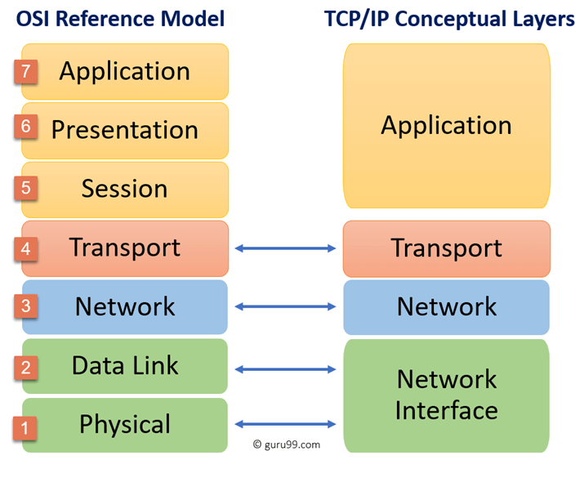Figure 1: https://www.guru99.com/difference-tcp-ip-vs-osi-model.html
We had a similar chart in our notes but instead of hunting for it I just searched for the same thing online, found this, properly linked to source address etc.
OSI model has 7 layers and the TCP/IP has 4. Layers 5,6,7 are all combined in the TCP/IP model.
OSI was created by the International Standard Organization (ISO) and the TCP model was created by Advanced Research project Agency Network (ARPANET). They have different header sizes (OSI min 5bytes vs TCP/IP min 20 bytes), TCP/IP predates the internet whereas OSI came after the internet.

10. The following information was obtained from a Unix computer:

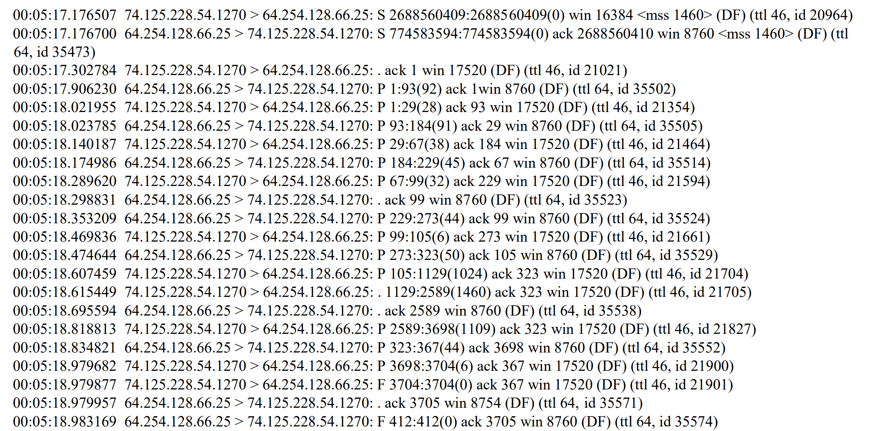

a. Describe what type of communication is occurring and how you know?
SMTP or commonly just called “email”. Because you can see that socket 25 is using and this is a well known port that I didn’t even have to look up and just know by heard (hopefully….. → looks up… yes it was SMTP!) 1270 is not a “well known port” but I looked this up and the answer makes sense. 1270 is TCP/UDP according to IANA. Between the 2 I would assume this is using TCP because I see ack packets.

b. What are the Domain Names for the two IP addresses communicating above?
