Alexander J King
The University of Toledo
College of Engineering

CSET4750 Computer Networks and Data Communications
Fall 2021 Final Exam Take Home - 60 points

You are not to communicate with other class members about this test until after its due date.
All answers must be your own work explained in your own words.
All answers must use techniques/tools learned in this CSET4750 course.

Academic dishonesty will not be tolerated. Any Test or assignment determined to be dishonest (Examples; Plagiarism,
Giving or receiving answers to an exam or assignment before it’s due date/time – see Policy Number 3364-71-04 for more
detail) may result in (a) Student receiving an F for the work in question. (b) Student Receiving an F for the course.

1. SSK Software Corporation has opened offices in Chicago, Napoleon, Nashville, and Toledo. The corporate headquarters are located in Toledo. Toledo will serve as the hub for the network, CISCO routers will be used at each location. The network has no Internet connection and the company has no plans to add one.
Workstation requirements at each of the locations are as follows: Location

Workstations
Planned Expansion
Chicago 23 +2 = 25

12
9
Napoleon22 +2 = 24

12
10
Nashville 18 +2 = 20

13
5
Toledo29 +2 = 31
25
4

a. Using CIDR notation, propose an IP network scheme to accommodate the office locations above.
Explain the decision process that was used to come up with your IP network scheme.
Your proposal must incorporate 2 options. Both options must account for the planned expansion.
i. Option (1) Must utilize the most efficient use of IP network/host using VLSM (4 Points)

Well to start with we’re not having an internet connection so I honestly find using a ton of private addresses to still be efficent but I am going to interpret this to mean you want the least number of IP addresses assigned to each location.

It said “workstations” so I assumed needed (current devices + planned expansion devices + 2 network infrastructure devices) = TotalDevices.

We will start with 192.168.0.0/24 and subnet it into 3 /27s and 1 /26. This will allow 30 addresses on each of the /27’s and 62 addresses on the /26.

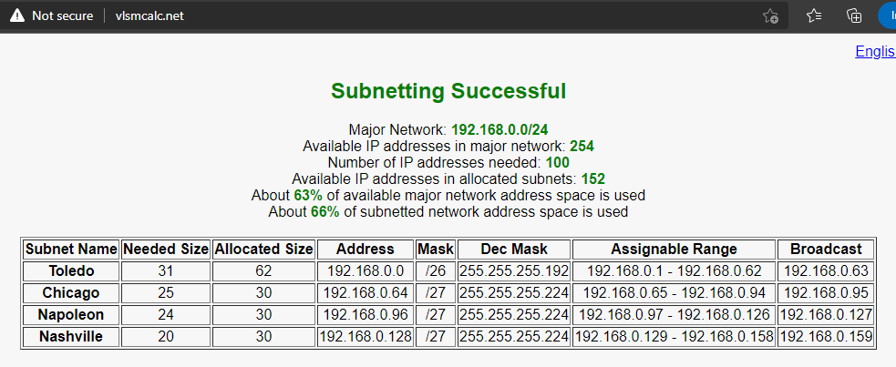
This will also allow us to add new locations if we desire as we’ve not used nearly all of the starndard /24.

ii. Option (2) Must utilize FLSM (option 2 is not required to efficiently use IP network/host).

Doing the same thing with fixed length we’re going to use all /26s as it was the largest size we needed and these need to be of a fixed length. 4 subnets and each get 64 addresses.
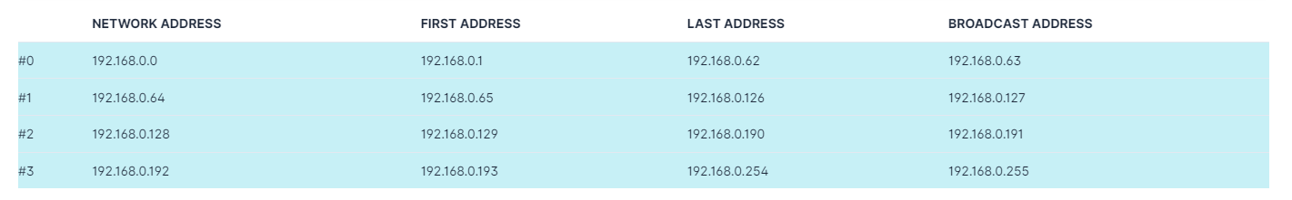

Provide pluses and minuses for each option. You should also specify the types of physical links that can be used to inter-connect the sites, with pluses and minuses for each type of physical connection. (4 points)
They both fit the number of devices we need and utilize only private addresses.
Variable length preserves about 40% of the address space we picked and allows us to grow but since it is variable length we will need to document where each network starts and stops because it isn’t consistent or intuitive. On the fixed length network the addresses are more inuitive because they’re all the same size but it utilizes the entire network with no leftover addresses.

b. Select one of your options from answer (1a) above to use in developing an IP network number scheme for each type of device on the network. The selected option must follow good network design goals. Apply your network IP number scheme by assigning IP addresses to types of devices used at each location. Diagram the entire network applying this scheme. (4 points)

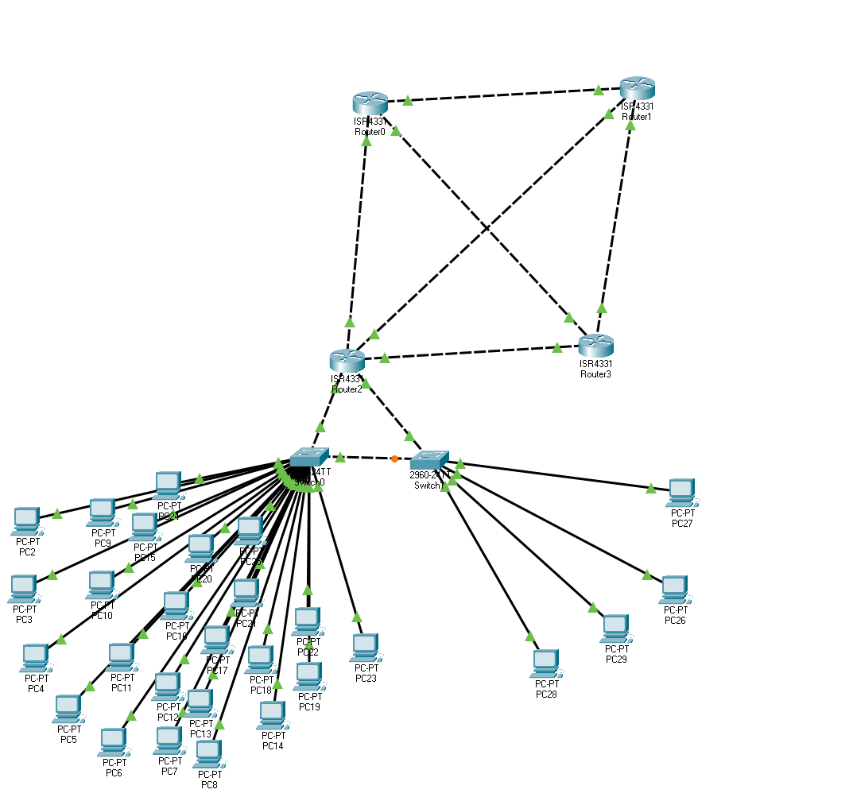
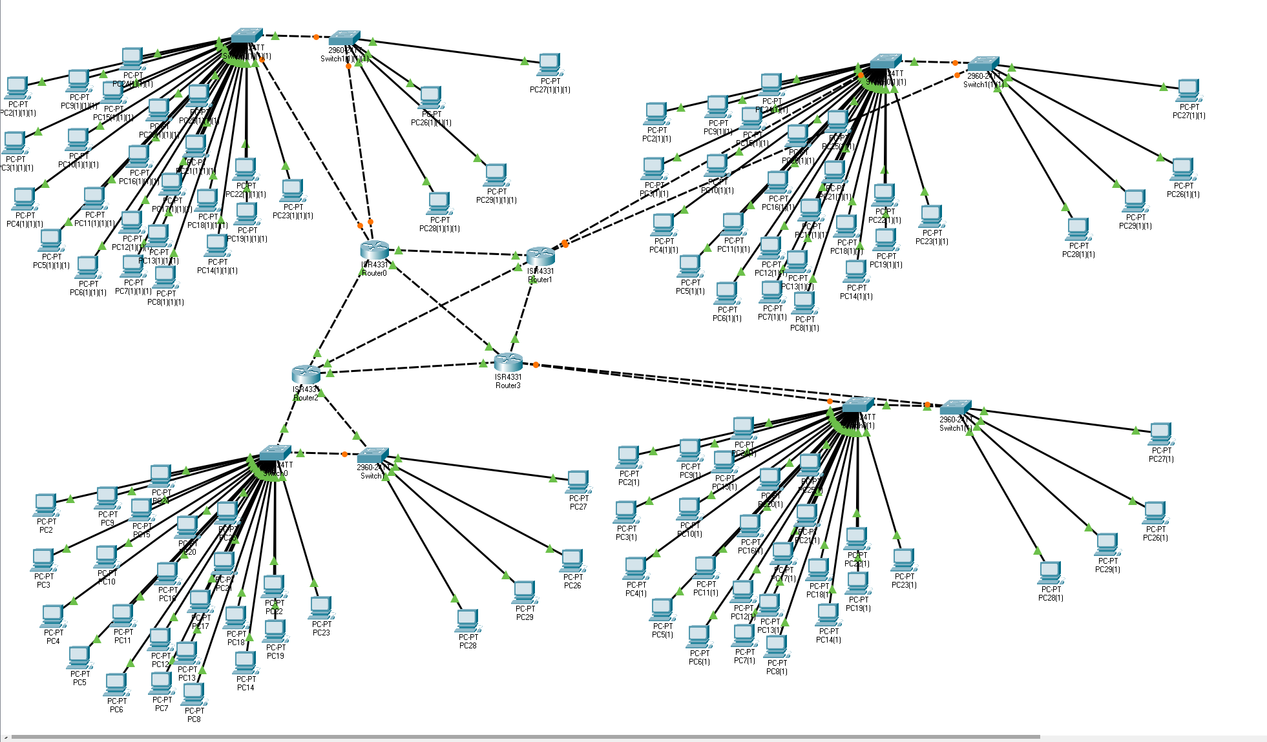

c. Assuming SSK Software elects to use static routing on each of the routers, what route entries would be required on each of the routers (Syntax is important).(3 points)

ip route <destination> <mask> <next hop> <metric-value (default 6)>
Enter this for each static route. The static routes would be to the other routers.
Each router has 3 other router connections so each router would have 3 of these commands. If we want out inside devides to be statically routed we would also set this up on the individual devices otherwise inside we could also use DHCP if we deem the local addresses being static to not be important. We could also decide it is best to have every single device have a static IP address inside the network as well.

d. Assume SSK Software wants to use dynamic routing; what entries would need to be configured in each of the routers to make this happen (give 2 sets of examples; each set should use a different type of dynamic routing). (3 points)

We could use RIP or OSPF.

If we elect to use OSPF we will use: <address-family> <ipv4> [optional unicast]

If we elect to use RIP we will use:
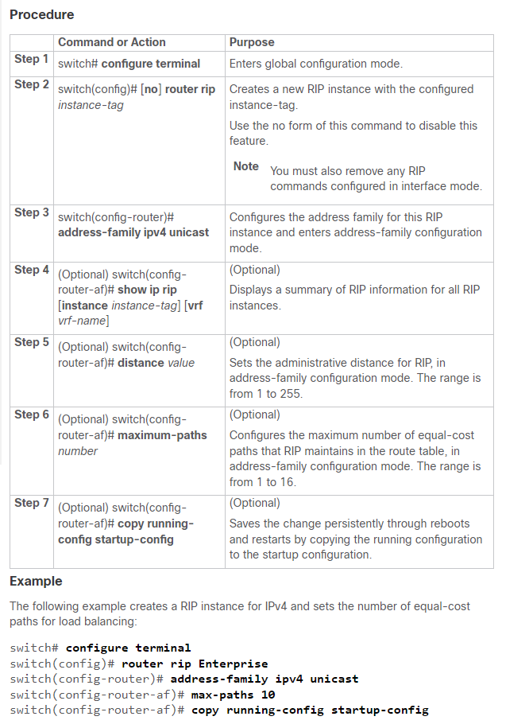Figure 1: https://www.cisco.com/c/en/us/td/docs/switches/datacenter/nexus7000/sw/unicast/config/cisco_nexus7000_unicast_routing_config_guide_8x/configuring_rip.html

e. Assume SSK Software wants to employ both static and dynamic routing (SSK software wants to employ all of your entries from ‘1c’ and ‘1d’ above). Is this possible? If so; what priority would be given to each type of route, in the event the router receives multiple types of routes to the same network? Explain your answer. (4 points)

Yes OSPF will allow this. Static routes will be assigned a cost value of 1 dynamic routes will be more costly in OSPF cost. Otherwise OSPF will calculate the path costs and determine which it thinks is best based on network statistics.

2) You have been hired as a Network Analyst for ABCorp. ABCorp has a single site located in Sylvania, Ohio, with 62 devices on an Ethernet network. Your job is to link ABCorp’s existing network to the Internet.

The internal IP network number scheme is 10.100.20.0/24 and it cannot be changed.

When ABCorp originally installed the network, IP address 10.100.20.1 was reserved for the “Internet router”
(The “Internet router” has not yet been purchased).

ABCorp would like to use their internal Windows Exchange Server as their inbound SMTP mail server. The IP address of the Exchange Server is 10.100.20.205.

ABCorp would also like to connect their internal WEB site to the internet via an IIS Server which has an IP
address of 10.100.20.210.

ABCorp is unsure of how to obtain an Internet connection and which items to purchase.
a. Discuss the various methods by which ABCorp might connect to the Internet (both physical and logical connections). Make a judgment about which physical and logical method(s) might be best for ABCORP and explain all Security measures you would recommend to ABCorp. Justify your answer.
(6 points)

We can set up reverse proxies for connections coming in, a proxy for any connections going out, utilize NATs for connecting to other locations etc. This will help with security because it is a ton easier to take a single NAT, proxy, or reverse proxy offline than it is to deal with every device individually. Additionally inside out network we can set it up not to use well-known ports and attempt to hide out topology as best we can. In this way people can communicate with our reverse proxy using well known ports and then the reverse proxy can utilize out own scheme for internal communications. The above mentioned devices will have static addresses so their location never changes and other devices can use DHCP because it doesn’t appear to matter what their address is or if it changes.

But because I have to impliment this in the next question and because I am limited on time.... instead of the above plan my plan is:
Create the given servers with static routes. Everything else on the network will connect via DHCP and OSPF will be utilized. This is the option because ABCorp wants it done NOW.

b. Based on the method and security measures selected above, identify the equipment (in complete detail) ABCorp would have to purchase in order to connect to the Internet (assume only CISCO network equipment). (5 points)

62 devices – we need atleast 3 switches to fit all of the devices.
1 router to connect to the internet.
A ton of ethernet cords. Min CAT5 / probably better.

c. Produce a working configuration file for ABCorp’s router. This configuration file must accomplish the needs of ABCorp. using the method(s) and equipment selected in (a) and (b) above.
(8 points)
This is an absolutly HUGE content question.... Like the scope of this question feels larger than the project and is worth 8 points. Further I cannot really reuse previous work for it since it has a different addressing scheme. To put it plainly I do not like this question as it feels unfairly too large for the number of points and being ~13% of one half of the final exam.

Feeling this question was asking for more than it is worth I changed my idea of the kind of network they should have due to time contraints and lack of decent funding.

Static IPs for the given servers and DHCP for every other device. DHCP set to exclude the static addresses.

Topology:
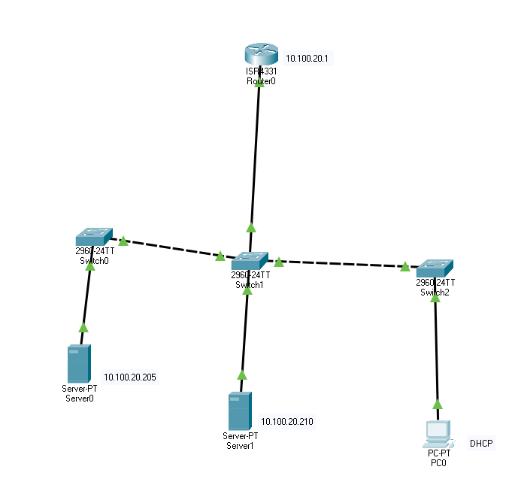

PC0 ipconfig /all (showing DHCP)

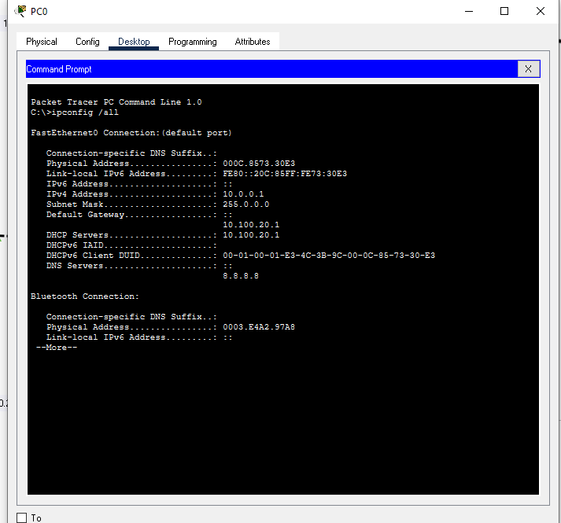

Pinging all devices:
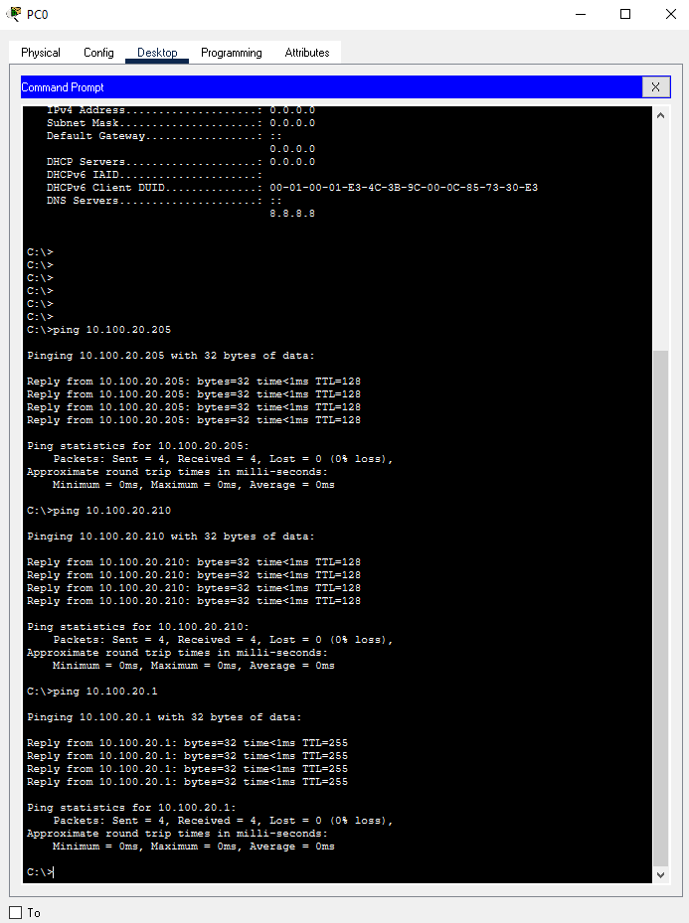
PC0 pinging all other devices:

Config:
Router#show running-config
Building configuration...

Current configuration : 1268 bytes
!
version 16.6.4
no service timestamps log datetime msec
no service timestamps debug datetime msec
no service password-encryption
!
hostname Router
!
!
!
!
ip dhcp excluded-address 10.100.20.205
ip dhcp excluded-address 10.100.20.210
!
ip dhcp pool Main
network 10.0.0.0 255.0.0.0
default-router 10.100.20.1
dns-server 8.8.8.8
!
!
!
no ip cef
no ipv6 cef
!
!
!
!
!
!
!
!
!
!
!
!
spanning-tree mode pvst
!
!
!
!
!
!
interface GigabitEthernet0/0/0
ip address 10.100.20.1 255.0.0.0
duplex auto
speed auto
!
interface GigabitEthernet0/0/1
no ip address
duplex auto
speed auto
!
interface GigabitEthernet0/0/2
no ip address
duplex auto
speed auto
!
interface GigabitEthernet0/1/0
switchport mode access
!
interface GigabitEthernet0/1/1
switchport mode access
!
interface GigabitEthernet0/1/2
switchport mode access
!
interface GigabitEthernet0/1/3
switchport mode access
!
interface GigabitEthernet0/2/0
switchport mode access
!
interface GigabitEthernet0/2/1
switchport mode access
!
interface GigabitEthernet0/2/2
switchport mode access
!
interface GigabitEthernet0/2/3
switchport mode access
!
interface Vlan1
no ip address
shutdown
!
ip classless
!
ip flow-export version 9
!
!
!
!
!
!
!
!
line con 0
!
line aux 0
!
line vty 0 4
login
!
!
!
end

d. SSK Software (from question 1 above) has entered into a long-term Software support contract with ABCorp. In order to completely and/or timely support the needs of ABCorp. SSK Software would like to inter-connect the two networks from its Toledo location via a CISCO router (connect SSK
Software’s network with ABCorp’s network)

Using the network layout, you selected for SSK Software in question 1(b) Using information and methods obtained from this CSET4750 class; i.
Propose a physical and logical plan to inter-connect the two networks without changing either company’s network numbering scheme. Include (in detail) any equipment either company would need to purchase to accomplish the plan. (4 points)

Each company needs a router, switches, and devices.
You can connect between the two using a NAT. You should be doing this anyways because one of these locations you do not have command and control over but this will also resolve addressing issues.

ii. ABCorp would like to limit SSK Software’s remote access onto its network. What entries would need to be configured in order to limit SSK Software’s remote access onto ABCorp’s network to just two PC’s at the same time, using only protocols TCP and/or RDP for remote support?
(4 points)

Use a /30 network to limit it to 4 addresses (2 devices) and the only allow TCP/RDP traffic.

Then use an access-list to only allow connections from specified addresses using specified protocols. Syntax from out slides below.

Syntax:
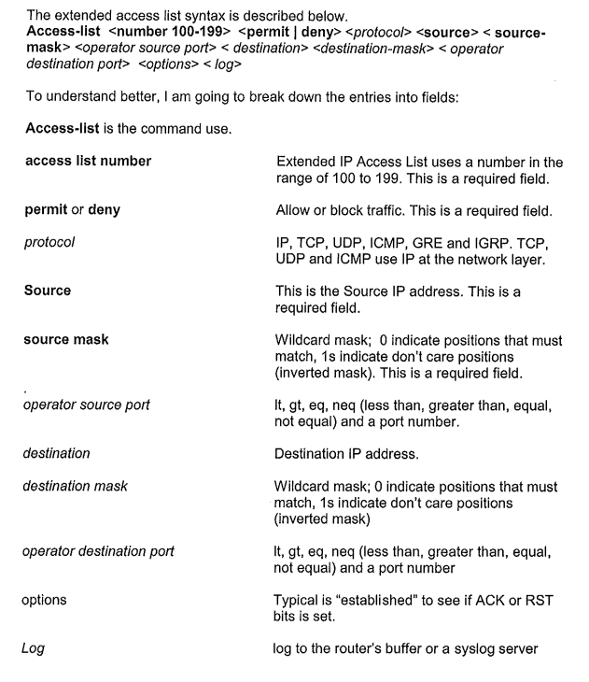

3) Paul administers a network with the addressing scheme: 192.168.0.0/24 Default Gateway of 192.168.0.1
You administer a network with the addressing scheme:
10.0.0.0/24 Default Gateway of 10.0.0.1

a) It is decided to connect the two networks in order to easily share information. On November 12, 2021
6:00am the two networks are successfully inter-connected via an Ethernet interface on a CISCO 2600
router

On November 18, 2021 at 10:20am you decide to apply windows updates to your MS SQL Server which has an IP address of 10.0.0.13/24 default gateway 10.0.0.1. Those updates require an immediate reboot and take 15 minutes to complete before booting back up.

****not in chronological order?***

On November 18, 2021 at 8:30am Paul attempts to ping the local IP address 192.168.0.16 from the host computer 192.168.0.100/24, Paul receives the following: C:\ping 192.168.0.16
Reply from 192.168.0.16: bytes=32 time=12ms TTL=64
Reply from 192.168.0.16: bytes=32 time=18ms TTL=64
Reply from 192.168.0.16: bytes=32 time=7ms TTL=64

On November 18, 2021 at 10:30am Paul again attempts to ping the local IP address 192.168.0.16 from the host computer 192.168.0.100/24, Paul now receives the following: C:\ping 192.168.0.16
Request Timed out.
Request timed out.
Request timed out.

Paul checks his network but make no changes.

On November 18, 2021 at 10:45am Paul attempts to ping 192.168.0.16 again – Paul now gets the following:

C:\ping 192.168.0.16
Reply from 192.168.0.16: bytes=32 time=12ms TTL=64
Reply from 192.168.0.16: bytes=32 time=18ms TTL=64
Reply from 192.168.0.16: bytes=32 time=7ms TTL=64

Assuming no changes were made to any equipment on the network and using only the information given.

Explain in detail what is occurring and why Paul now gets a reply. Who is the administrator of the CISCO
2600 router? (You or Paul) How do you know? (4 points)
Because the required infrastructure was down.... we said at 10:20 AM the system would be down for 15 min. He pinged while it was down... and then once again after it was up. I’m the admin... because I am running Windows updates for SQL while Paul just pings.

b) On November 20, 2021 1:00pm, Paul has no problem connecting to devices on your network (everything appears to be working perfectly). However, when Paul tries to ping those same devices on your network he gets “Request timed out”. (4 points)
i. Explain what is going on.
ii. Give your best estimate as to when the last configuration changes were made to the CISCO 2600
router. Explain your answer.

My network is blocking ICMP packets/frames. So yes he can connect to my devices just fine but no he can not ping them and get replies.
I may have decided to start blocking ICMP frames on or after On November 18, 2021 at 10:45am the last time Paul sucessfully pinged us and before Nov 20, 2021 1PM.

4) In working with computers it is very important to practice Ethical behavior. (3 points) a) In class we discussed ten rules to follow for good Computer Ethics. Explain each in your own words.

(not entirly my own words first from notes for reference)
1. Thou shalt not use a computer to harm other people.
2. Thou shalt not interfere with other people's computer work.
3. Thou shalt not snoop around in other people's computer files.
4. Thou shalt not use a computer to steal.
5. Thou shalt not use a computer to bear false witness.
6. Thou shalt not copy or use proprietary software for which you have not paid. LMAO 
♪♫ don’t copy that floppy♪♫ “YOU WOULDN’T DOWNLOAD A BABY!” (I would download a car)
7. Thou shalt not use other people's computer resources without authorization or proper compensation.
8. Thou shalt not appropriate other people's intellectual output. OH NO not the twitch source code.
9. Thou shalt think about the social consequences of the program you are writing or the system you are designing. Like the big brother dones capstone project.
10. Thou shalt always use a computer in ways that ensure consideration and respect for your fellow humans.

1. Don’t be malicious.
2. Don’t prevent functionality.
3. Don’t spy.
4. Don’t steal.
5. Don’t lie.
6. Don’t be a pirate (copying distinct from stealing)
7. Don’t botnet.
8. Don’t steal again.
9. Consider the possible negative uses of our creations. (Am I creating a dystopian big brother opression software? Do we like the NSA? Are they “keeping us safe” or persuing their own interests?)
10. Be excellent to eachother.

b) Who/what created the 10 rules for Computer Ethics?
CEI = Computer Ethics Institute.

c) What is ethical behavior? What are the requirements for an action to be determined as ethical behavior?
This question was also asked on the in-class portion of the exam. ☻
I said you need to act within the law and with intregirty.
Would I be okay with someone else doing a given action to me or my devices etc?
“Ethical behavior: Do the right thing even when nobody will know. Integrity.” From my notes.

