Alexander J King
CSET4750.001 – Homework 6
December 4th 2021
1) What is Dual Band WiFi?
2.4/5 Ghz wifi bands.
2.4 goes much further but 5Ghz has a higher bandwidth and more channels. For example I can see ~75 2.4 ghz networks from my apartment. Fitting 75 networks Into 3 non-overlapping channel options is not ideal so I tend to connect to my 5ghz network on an unpopulated channel. My dwelling is small enough this is an optimal solution.
2) What is a WiFi chanel?
It is the space in the band your wifi is operating on. Ideally you want to be on a wifi channel alone without any other networks present. 2.4 and 5ghz networks are easily the most common today. 6ghz exists but I’ve not got my hands on such hardware yet. 5ghz has significantly more channels than 2.4, while 2.4 has significantly superior range.
3) What is the difference between overlapping and non-overlapping WiFi channels?
Overlapping channels bleed into each other non-overlapping channels as their name suggests do not overlap.
This shows an example wifi network neighborhood. TELUS1087 would have the superior connection out of the networks pictured.
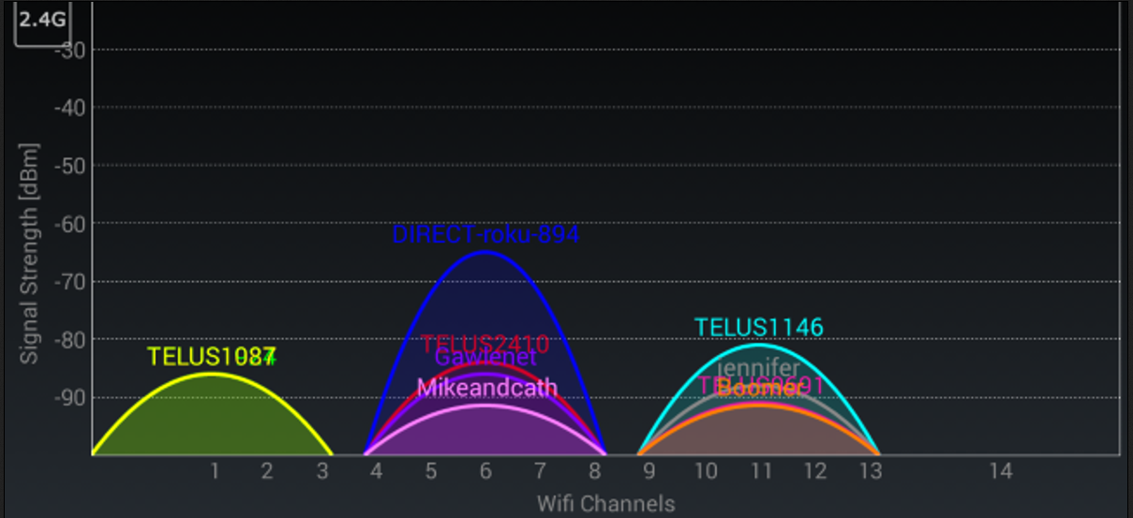Figure 1: Stock Picture from HowToGeek - Fair Use Demonstrative Educational
Another example would be if I had channel 8 set for my 2.4Ghz wifi I would be overlapping with a ton of networks and have the least optimal solution because of the overlap with so many other networks.

4) Does WiFi act more like a switch or a Hub?
Hub. I do not even have to be connected to your network to capture traffic on it with the most common configurations currently in use. This is why it is always a good idea to encrypt such traffic with current best-practices. Such as not using WEP, TKIP, or WPS.
5) What is the rebranding of WiFi?
Wifi 6 and wifi 6e…. instead of AX…. And whatever 6E should have been named. I’ve been getting ads for this recently and the marketing for it is kind of funny to me to be . I also noticed theyhonest were pushing wifi-6 instead of 6e which surprised me. They were marketed for home networks with no expectation of massive crowds.

