Alexander King
The University of Toledo College of Engineering
CSET4750 Computer Networks and Data Communications \
LAB 10: Network Design / Router Configuration Static Routing

All pictures are high resolution and should be easy to scroll in to better view.

Tasks to be accomplished:
1. Complete the set-up of each router, switch and 1 PC in the Toledo-Napoleon-Port Clinton scenario.

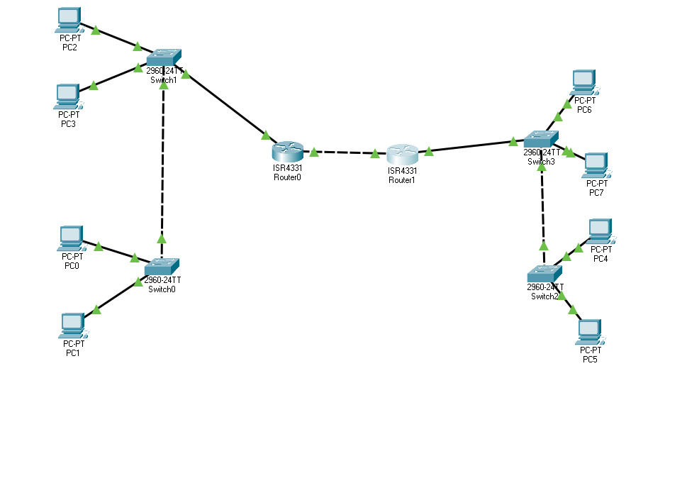

2. Ensure that you can successfully communicate (ping) between LANs. Show screen shots of each device successfully pining devices on the other subnets. (Ping from your PC, Switch, and Router to the Router, Switch, and PC at the other locations)

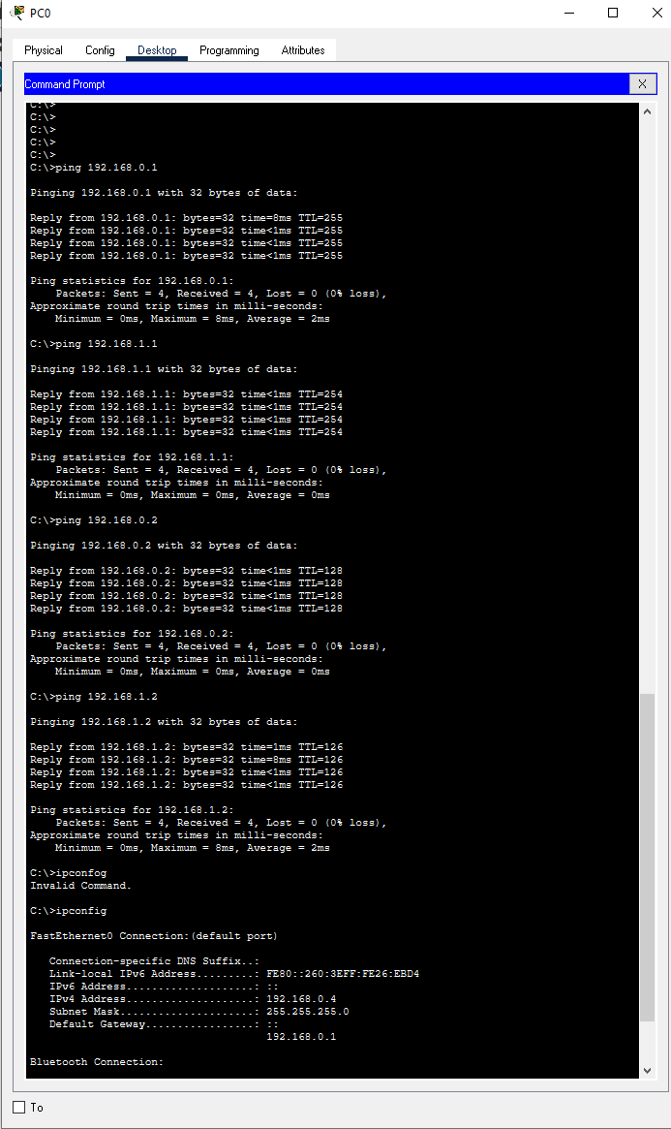

Pinging from PC0 to PC2, Router0, Router1, and PC6.
Checked both directions.

3. Capture the configuration files for each router and switch Save the configuration files to a folder “c:\CSET4750\”. You will need to refer to them later. ** Save the configuration files for both the Router and the Switch **

Done

4. What static route entries did you need to add to allow all devices on the inter-network to communicate? List the entries for each site.

Site0/Router0: Router(config)#ip route 192.168.1.0 255.255.255.0 10.1.1.2
Site1/Route1: Router(config)#ip route 192.168.0.0 255.255.255.0 10.1.1.1

