Alexander J King
11*6*21
Lab
ALL PICS HIGH RES CAN BE ZOOMED IN

CSET4750 Computer Networks and Data Communications LAB 13: Dynamic Routing OSPF Enabling OSPF on the Router Enabling OSPF on the router involves the following two steps in config mode:

1. Enabling an OSPF process using the router ospf command. The OSPF process-id is a numeric value local to the router. It does not have to match process-ids on other routers. It is possible to run multiple OSPF processes on the same router, but is not recommended as it creates multiple database instances that add extra overhead to the router.

2. Assigning areas to the interfaces using the network command. The network command is a way of assigning an interface to a certain area. The mask is used as a shortcut and it helps putting a list of interfaces in the same area with one line configuration line. The mask contains wild card bits where 0 is a match and 1 is a "do not care" bit, e.g. 0.0.255.255 indicates a match in the first two bytes of the network number. The area-id is the area number we want the interface to be in. The area-id can be an integer between 0 and 4294967295 or can take a form similar to an IP address A.B.C.D. Here's an example: RTA# interface Ethernet0 ip address 192.213.11.1 255.255.255.0 interface Ethernet1 ip address 192.213.12.2 255.255.255.0 interface Ethernet2 ip address 128.213.1.1 255.255.255.0 router ospf 100 network 192.213.0.0 0.0.255.255 area 0 network 128.213.1.1 0.0.0.0 area 23 The first network statement puts both E0 and E1 in the same area 0, and the second network statement puts E2 in area 23. Note the mask of 0.0.0.0, which indicates a full match on the IP address. This is an easy way to put an interface in a certain area if you are having problems figuring out a mask. Things to try: *** Make sure you have deleted all Static routes and removed RIP from the router ***

1) Enable OSPF with the entire network in area 0
done (in screenshots of confs)

2) Add an Ethernet connection between Port Clinton and Napoleon
Done, connected 3 “locations”

3) Make sure all devices at each site can communicate -
ping i Add cost to interfaces to force connection path
ii show ip route iii show ip ospf neighbor
iv show ip ospf interface v show ip ospf database
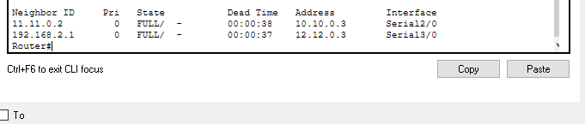
From router 0 Router: show ip ospf neighbor
Router1
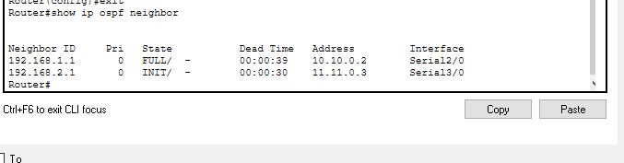

Router2
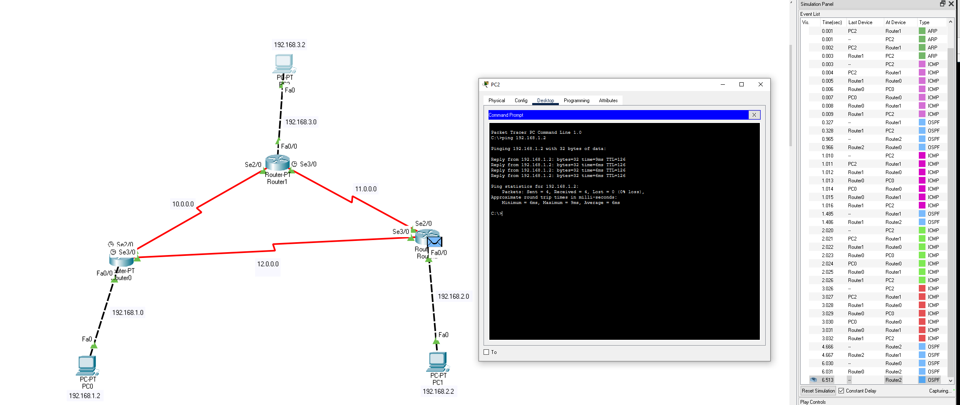
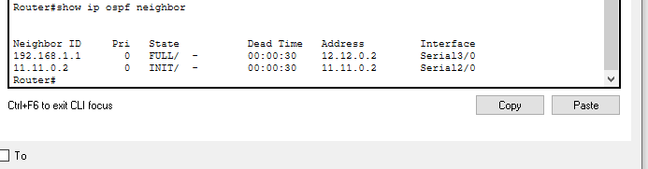

Handy slide I want to include:
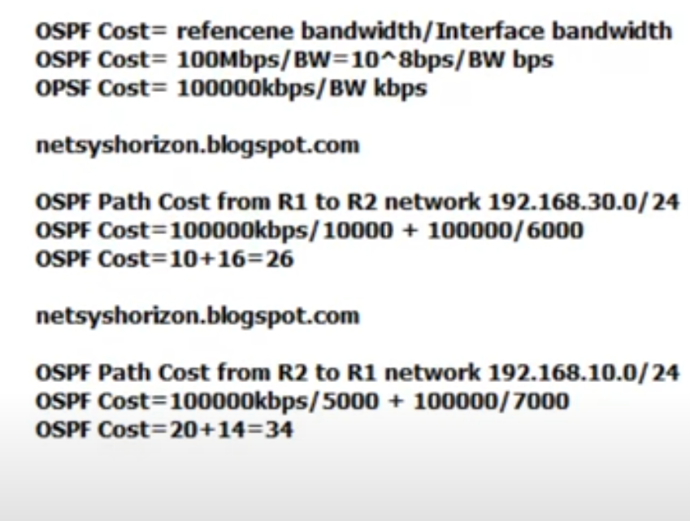Figure 1: https://www.youtube.com/watch?v=zgqaVkQe5Sw - Tariq Abosallout
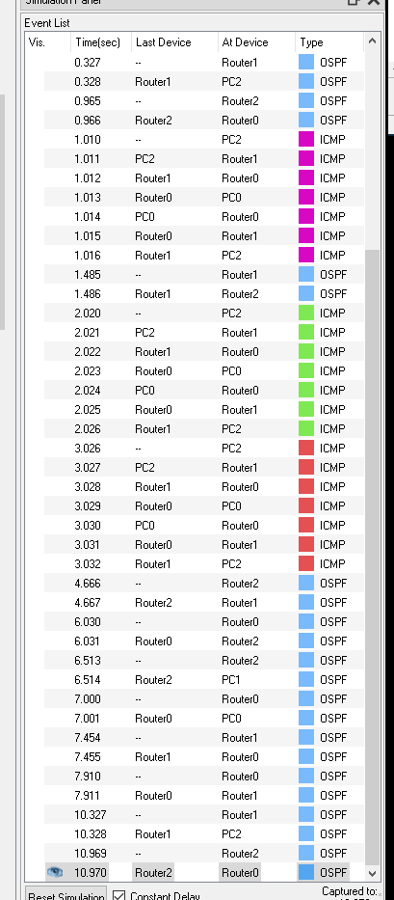
Above are the bandwidth values for each path router0 could take. Repeat for all routers and their paths if desired.

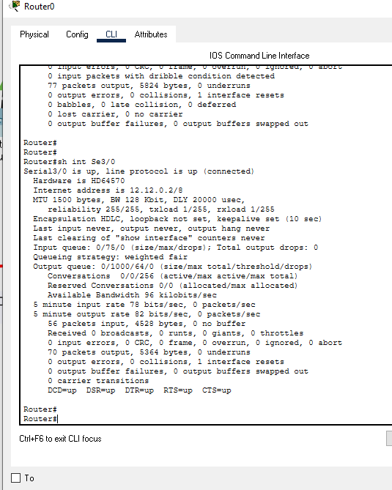
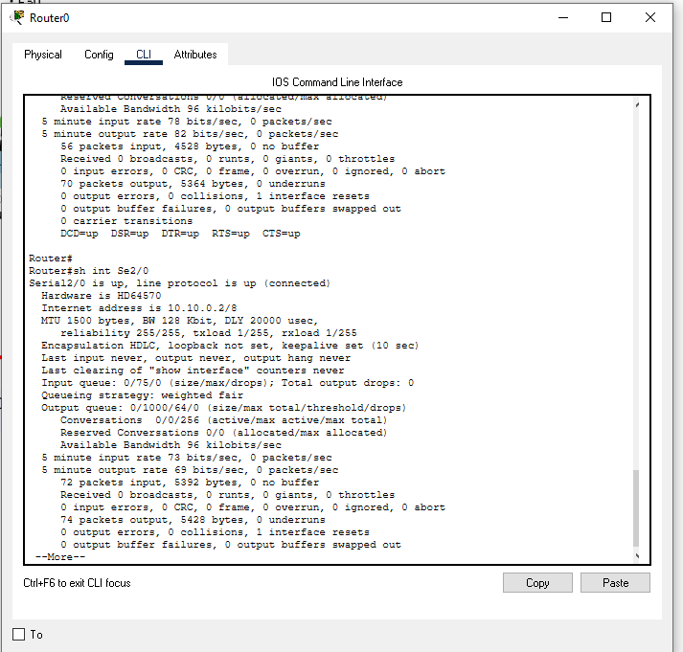

4) Change the ‘cost’ of the connection between Toledo and Port Clinton to force the route to use that path.
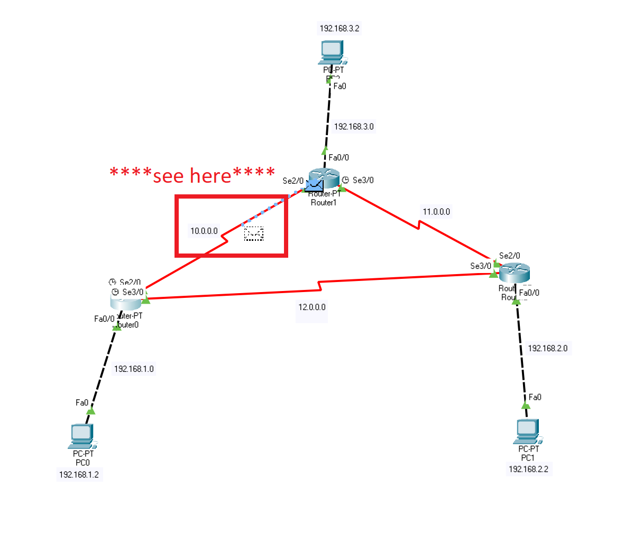
Router →
conf t
int Se/03
ip ospf cost 100
It now costs 100 to travel alone Se3/0

a) Trace the communication route to verify the route chosen
packet tracer animates the routes and also shows them in the simulation panel.

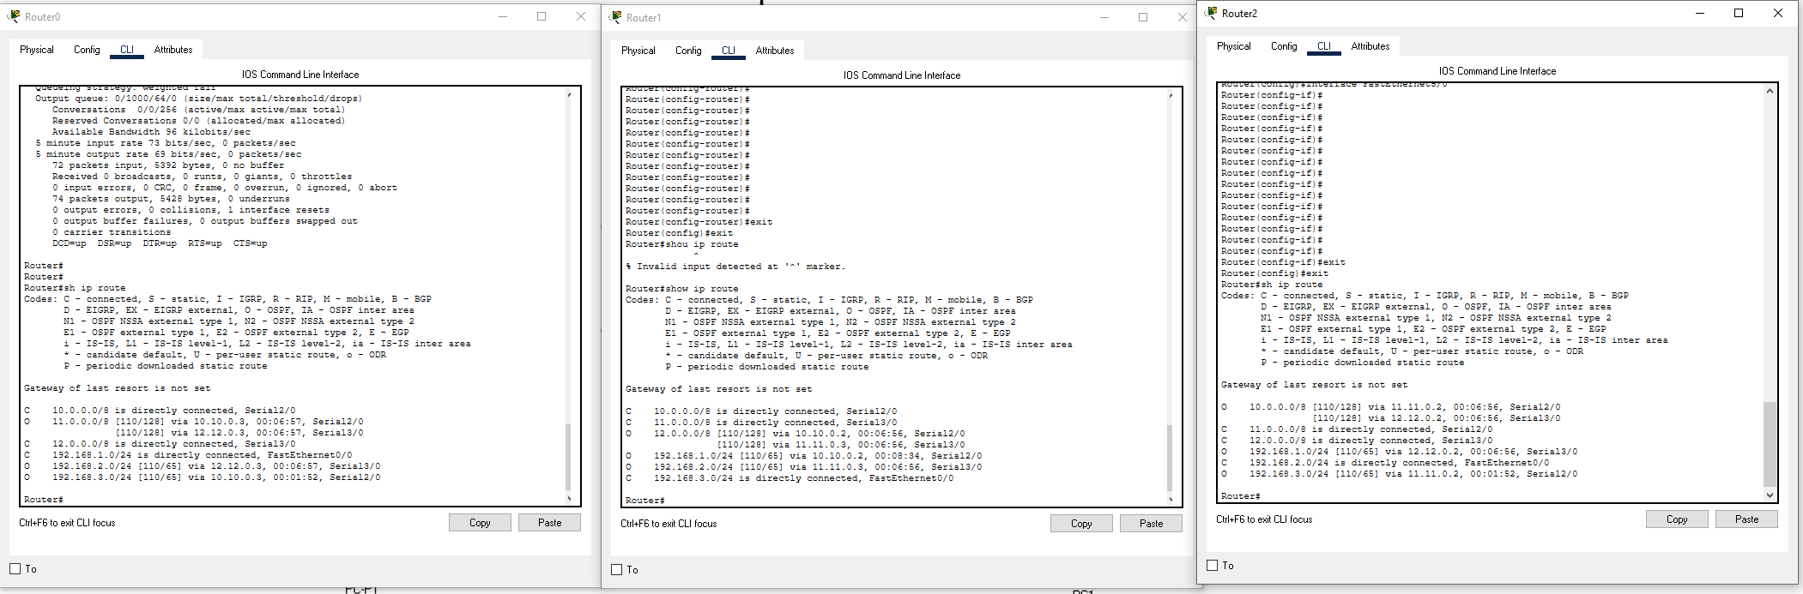

After above screenshot changed value to make it take a longer router with ospf value.
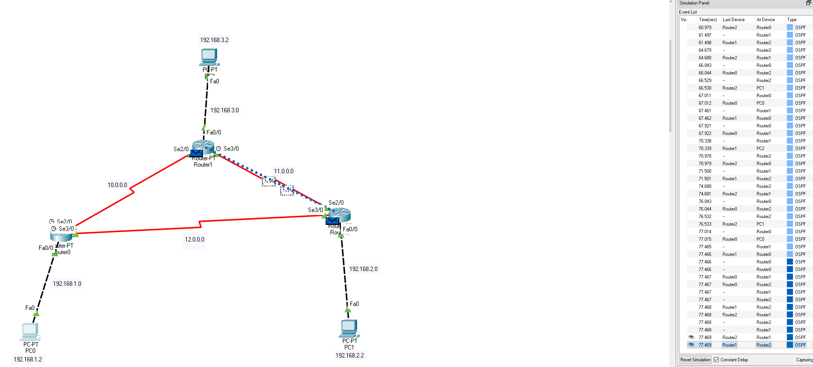

b) Disconnect the cable between Toledo and Port Clinton
I’ve not labeled location names so instead I am going to disconnect the now cheaper (but longer) route to force it to take the otherwise more expensive option.

c) Check communication and route to each device

More expensive option than above but now cheaper option is disconnected:
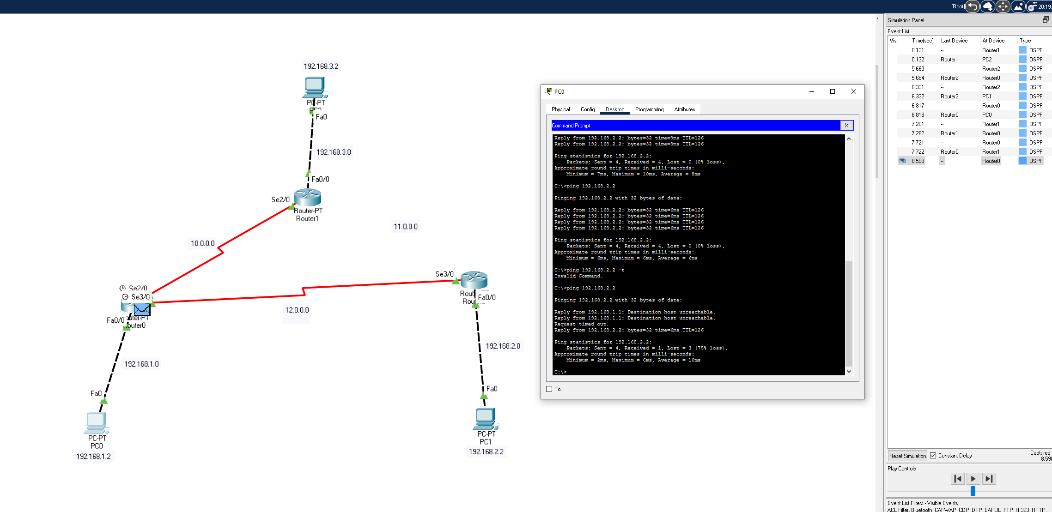

Packet first travels along the cheaper path and then realizes it cannot make its way. The first 2 claim destination host is unreachable, the third times out, and the fourth makes it to its destination along the functional desired path.

ping pc1 from pc2
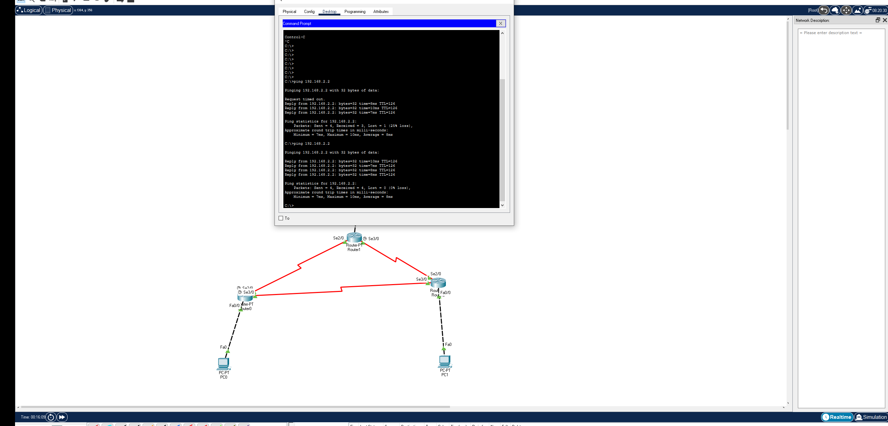

Questions:
1) What happened when the cable between Toledo and Port Clinton was pulled?
The route changes and goes to the “more expensive” but functional path after failing to make it on the more cost effective path.

2) What is area 0 used for?
It’s our OSPF area ID. We use it as a place to save our settings for a particular cluster of networks.

3) What is a wild card mask and when is it used
It’s the compliment of subnet mask.
255.255.255.0 subnet would be 0.0.0255 in wildacard. It indicates the scope of available IP addresses. It’s used on large networks to help reliability and stability of the network.

