Alexander J King
Lab14
CSET 4750.001 Lab 14

Topology
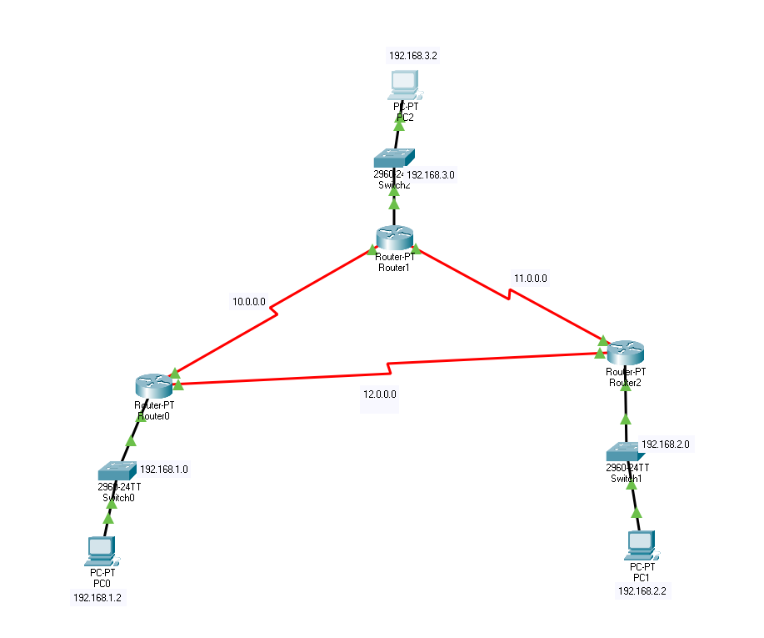

1.
Set up overload nat and insides/outsides for all routers.

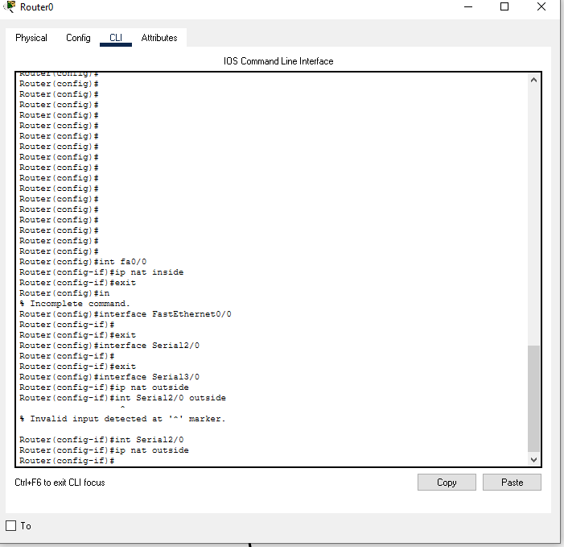
Do the same for other locations:

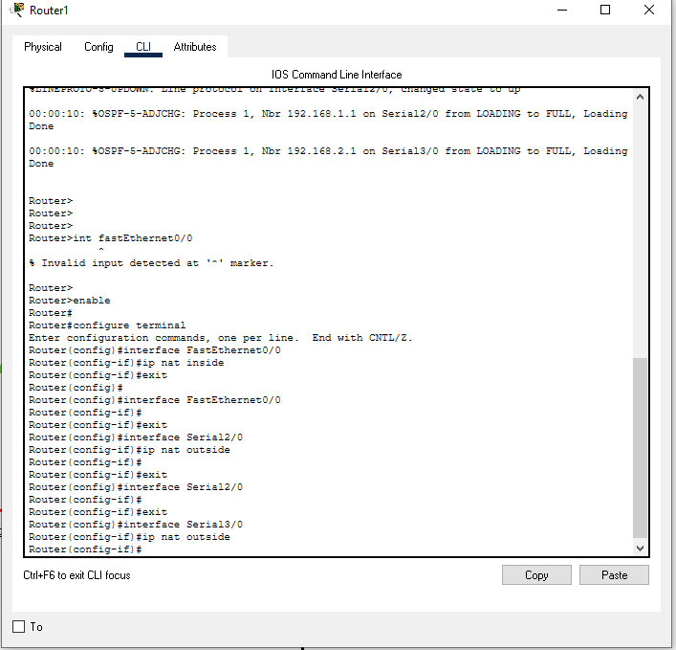

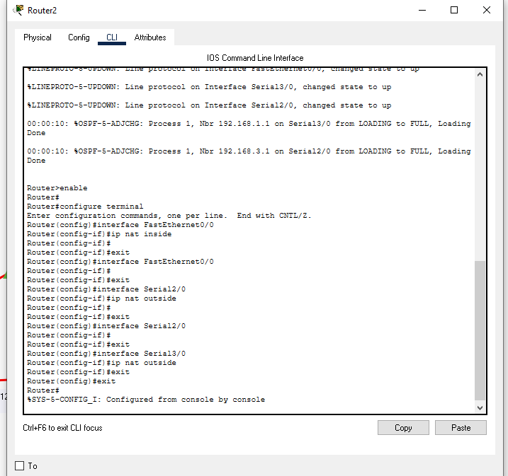

Do the same for other routers:

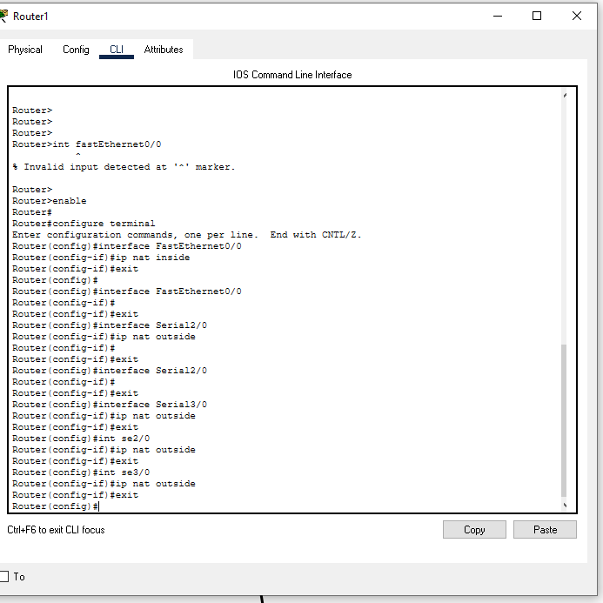

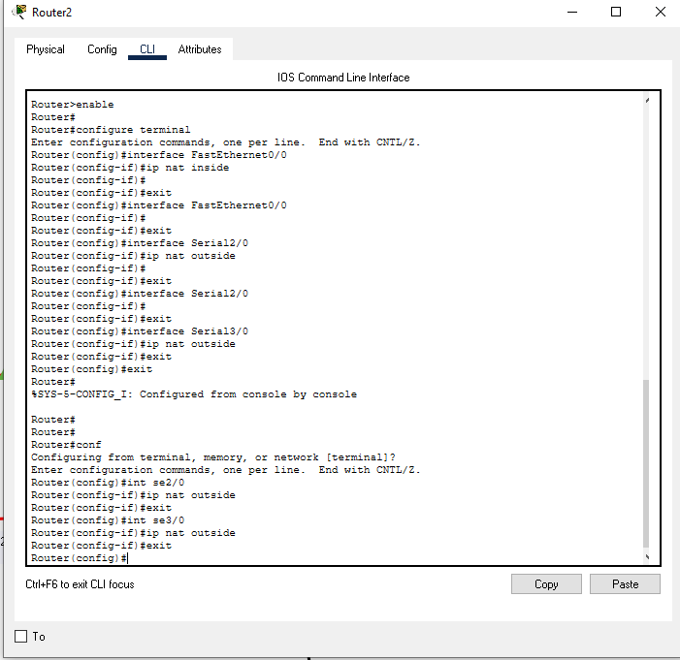

Use the NAT to ping outside of it.

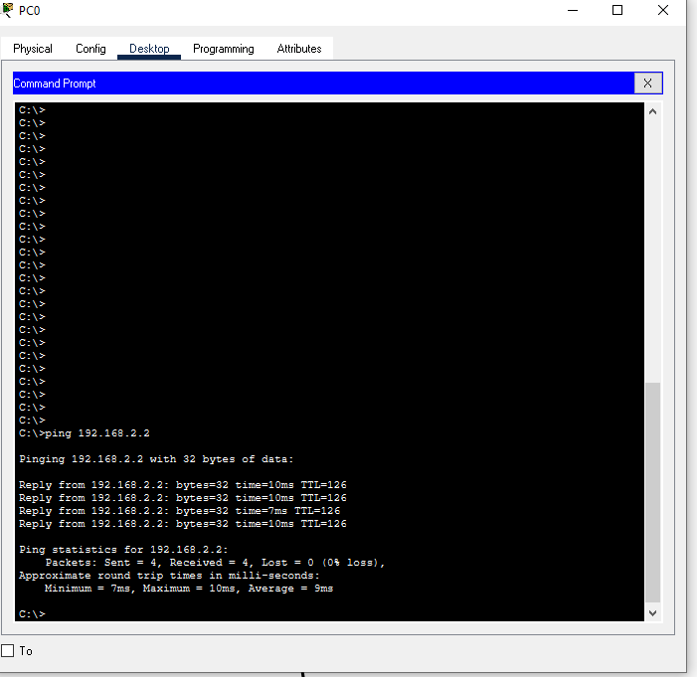

Repeat for all...

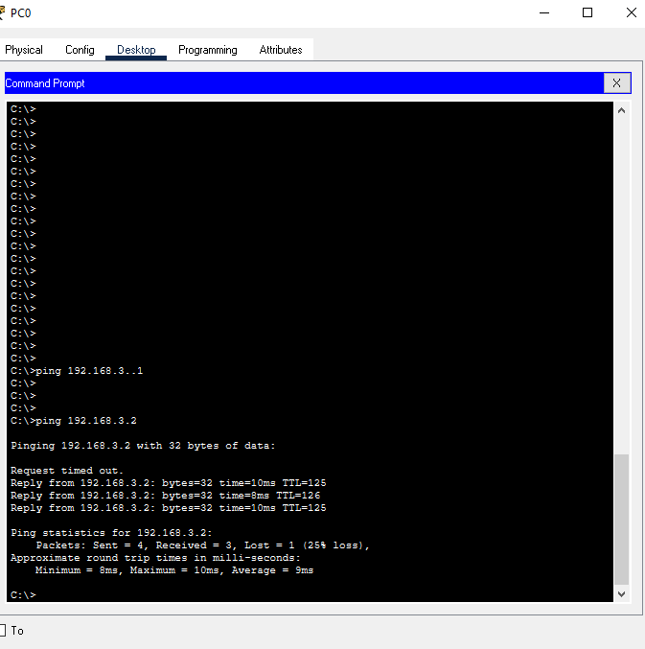
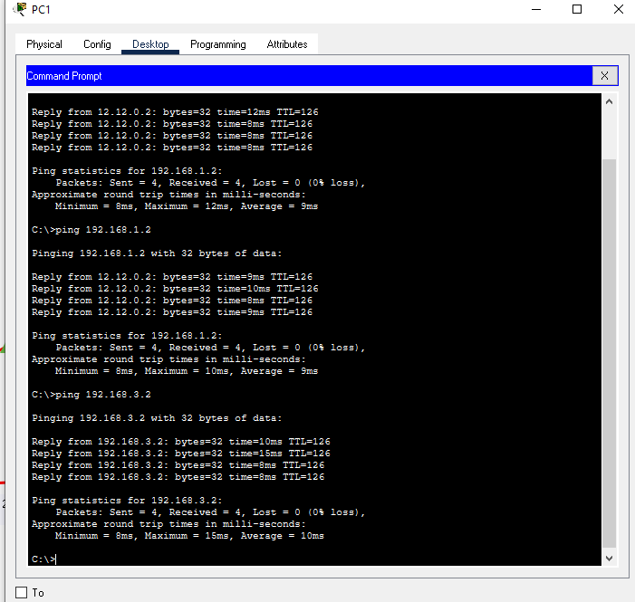

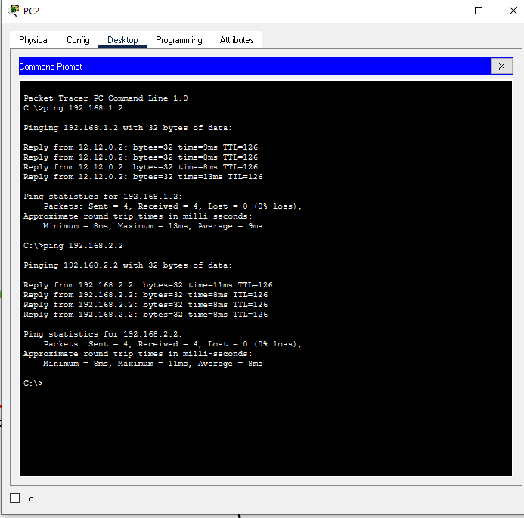

The changes required were creating and naming a new NAT and specifying the inside and outside interfaces.
2.
Change type of NAT from overload to static and utilize the same nat list NAT0. (NAT zero =/= NATO.)

a. Pinging outside the NAT your router replies to pings.

Move the inside address to the other 2 networks.

3.

Set a VLAN, set password for telnet,
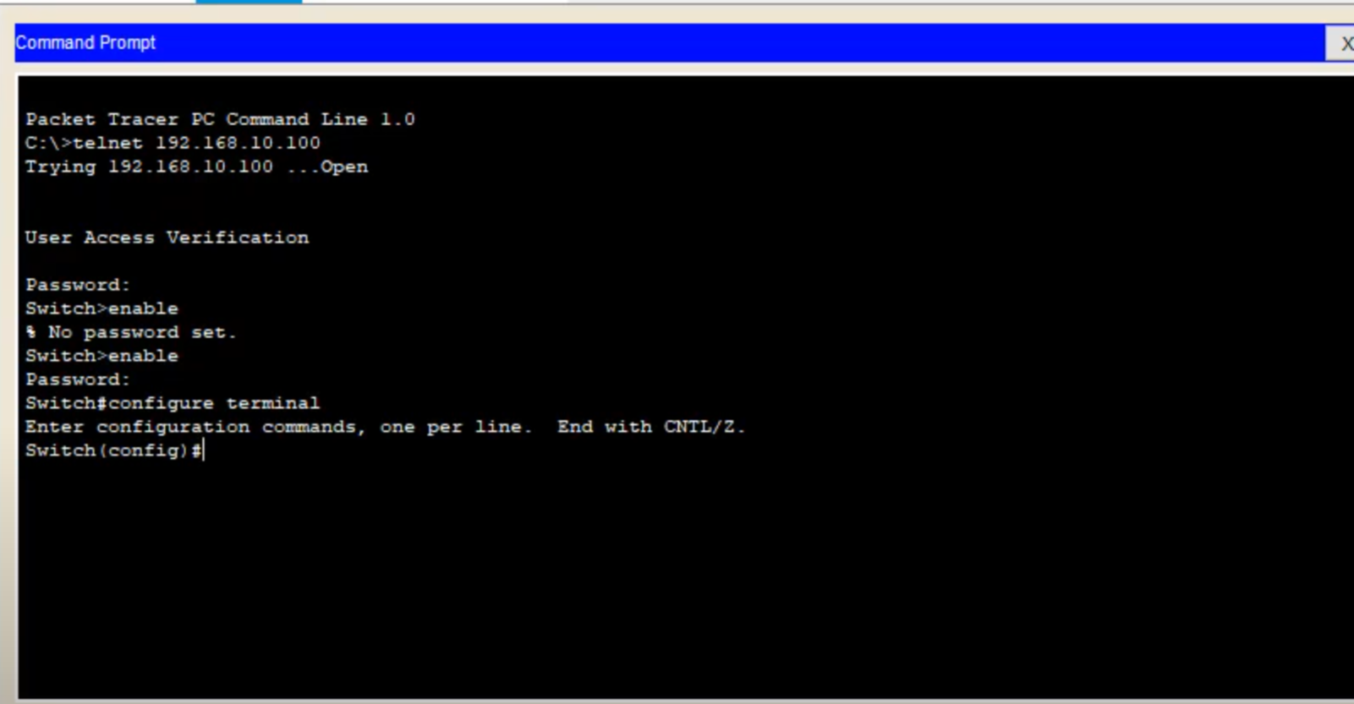
Open CMD on a device and telnet into the other devices on outside address. Ensure enable password.

