Alexander J King
CSET 4750.001
LAB 15
November 19th 2021

********ALL PICTURES ARE HIGH RESOLUTION AND CAN BE ZOOMED IN!*********

1.
Show access before implementing access control list. Shows 192.168.0.11 pinging 192.168.2.11.

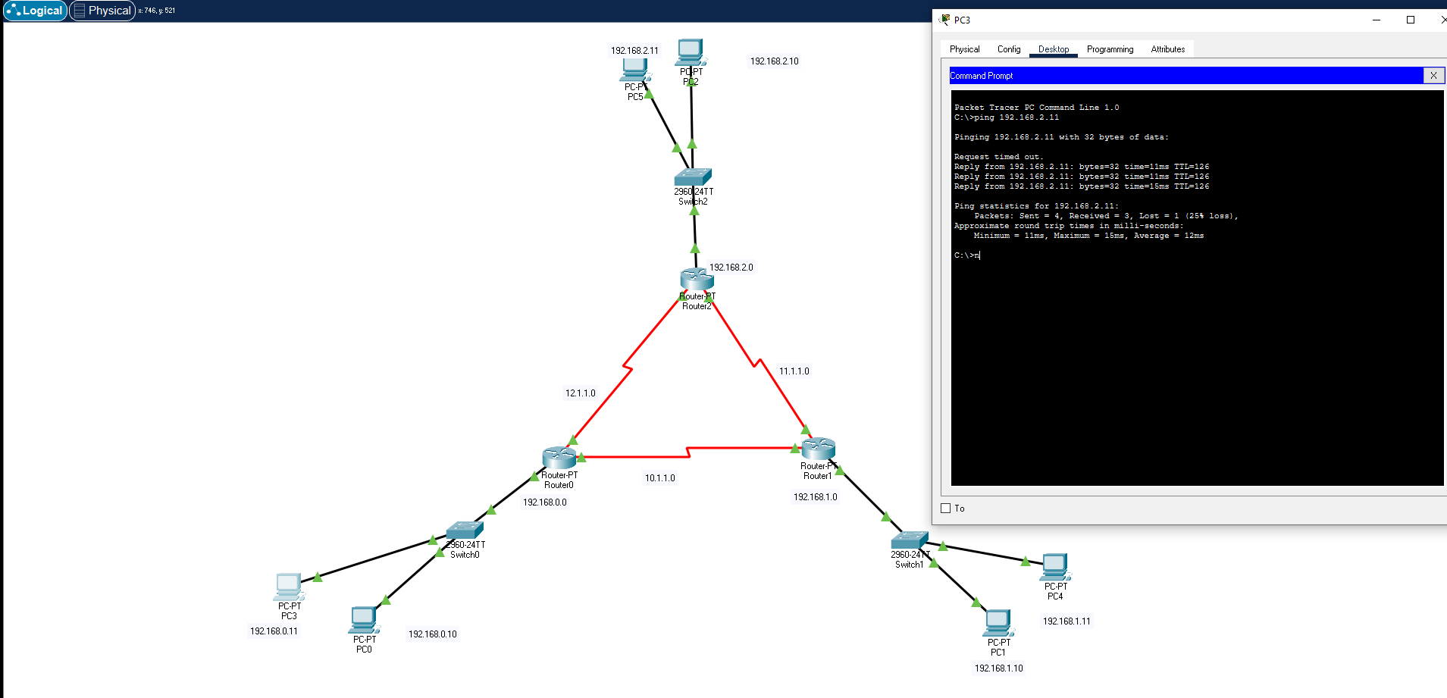

Block access to 192.168.0.11 to the outside but allow 192.168.0.10 access to the outside.
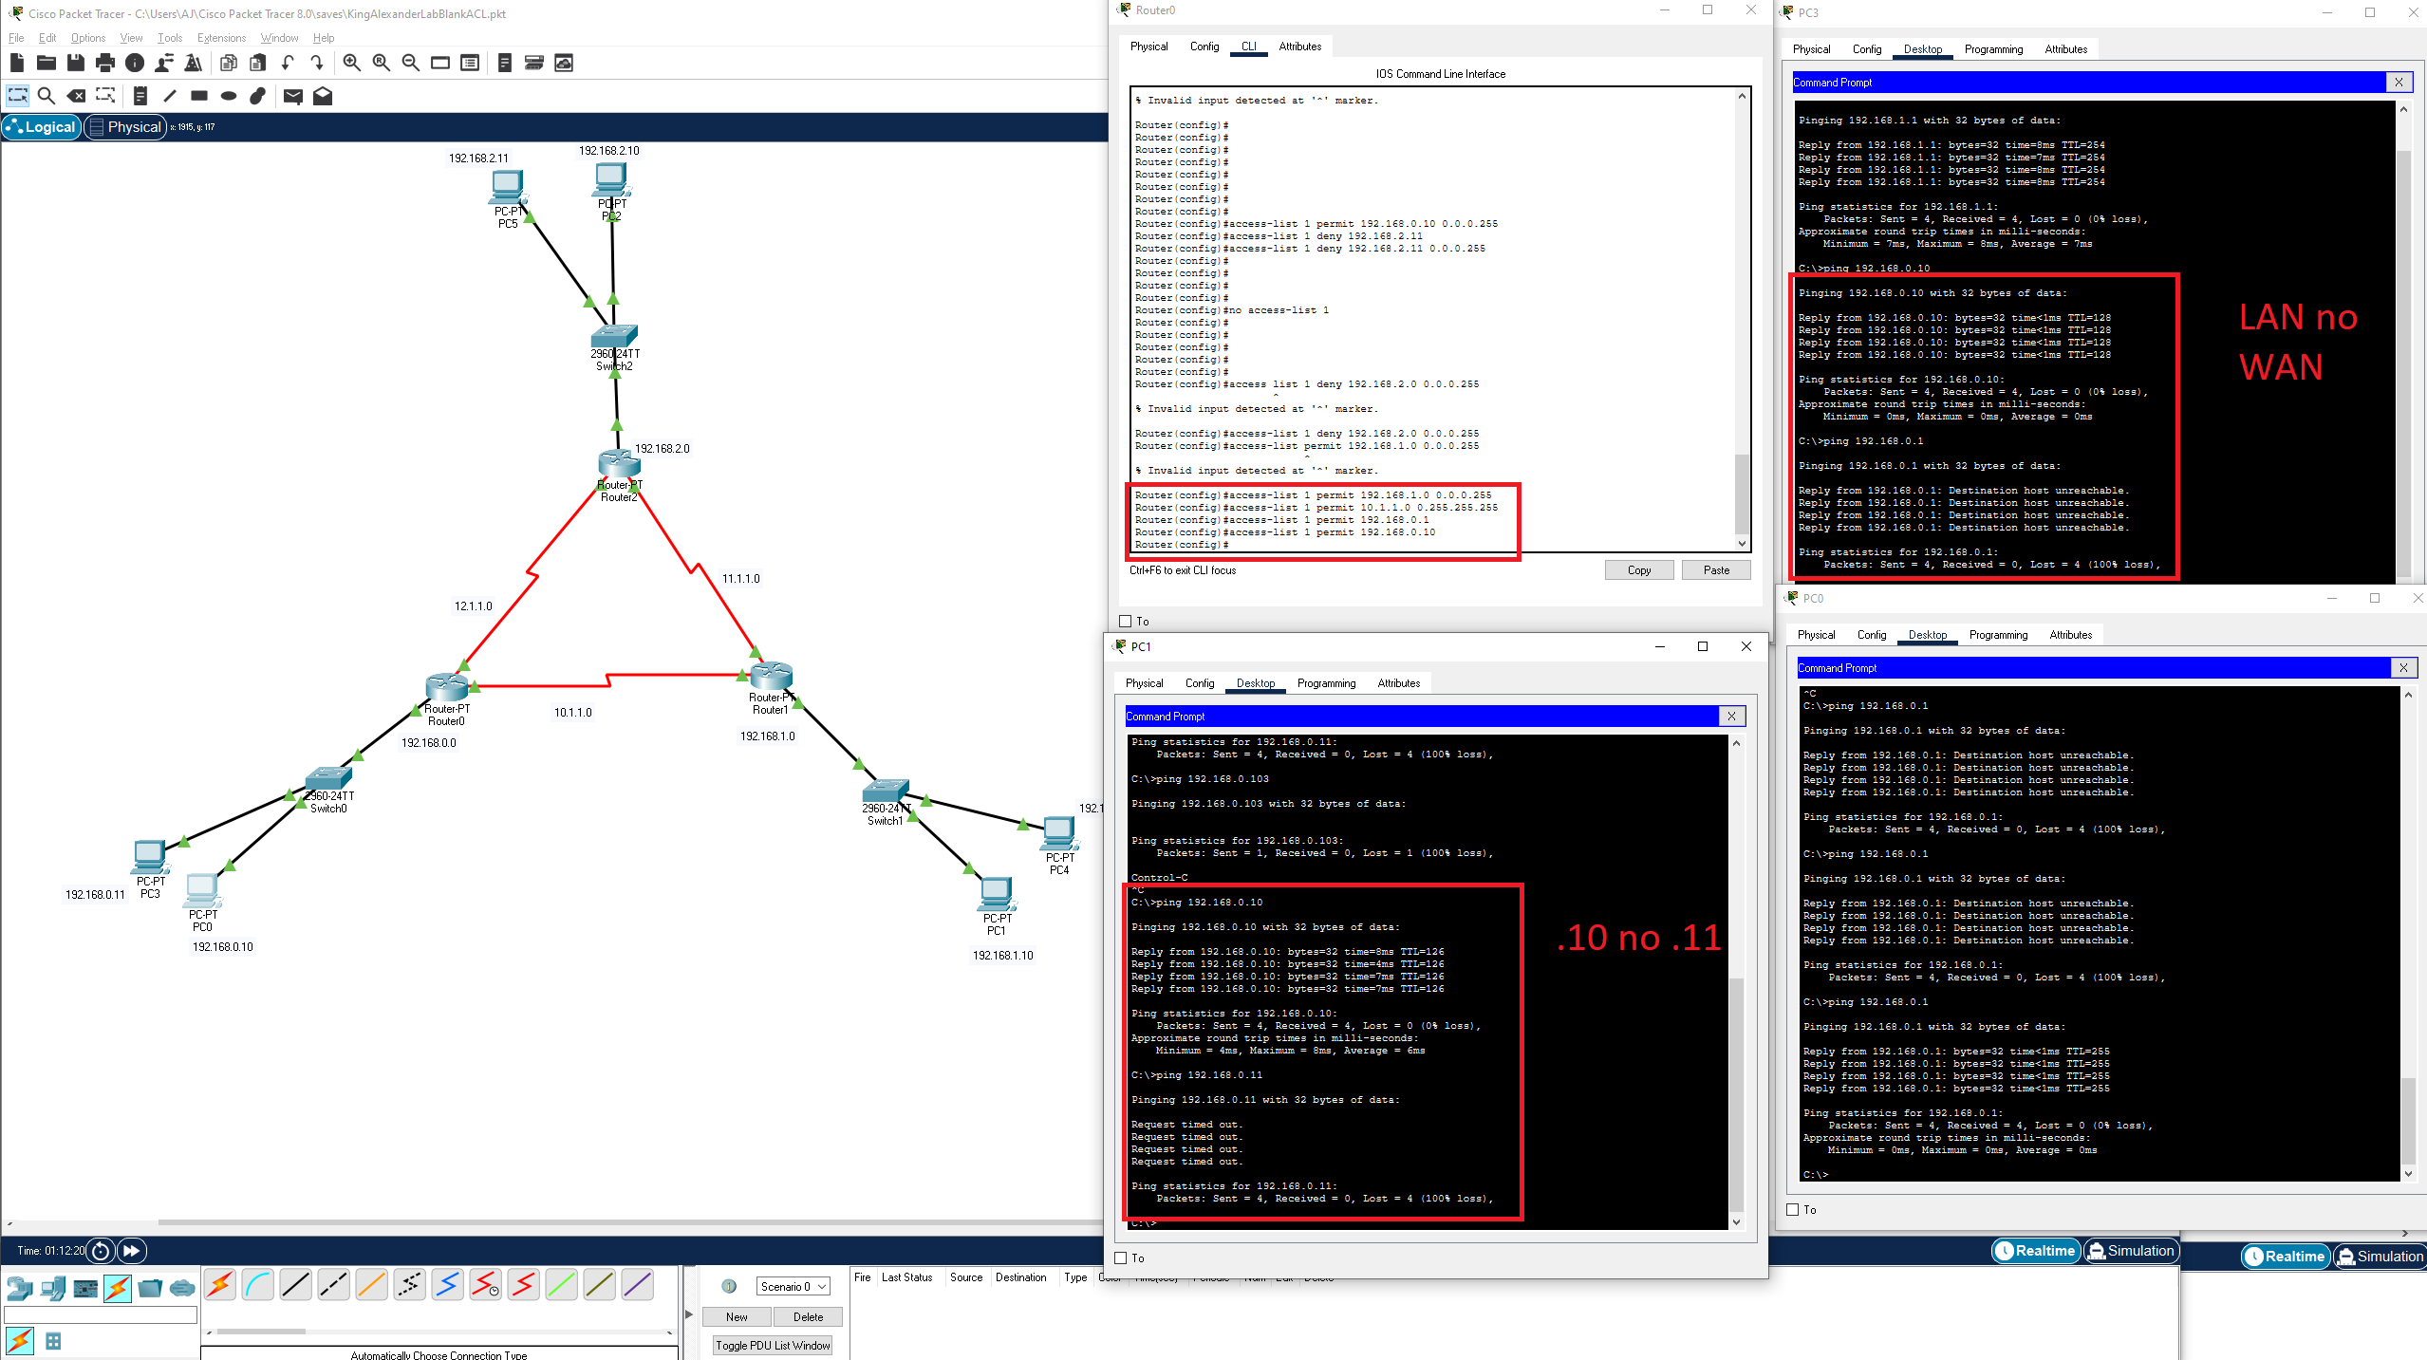
(“Block a website” with a rule) instead I blocked a specific device.

This shows 192.168.0.11 having LAN access only and no access across other networks and other networks being able to ping 192.168.0.10. Also shows configuration changes in Router0.

Part not shown: I set the interfaces for Se2/0 and Se3/0 as outside and Fa0/0 as inside.

Commands given:
Router(config)#access-list 1 deny 192.168.2.0 0.0.0.255
Router(config)#access-list 1 permit 192.168.1.0 0.0.0.255
Router(config)#access-list 1 permit 10.1.1.0 0.255.255.255
Router(config)#access-list 1 permit 192.168.0.1
Router(config)#access-list 1 permit 192.168.0.10
Router(config)#
Router#

2.
“echo requests” == pings? I assume yes.

access-list 100 deny icmp any any on router1 on the network 192.168.1.0.

BEFORE we apply the ACL: ping from PC 0 192.168.0.10 → 192.168.1.10
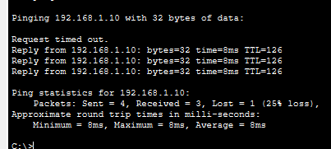

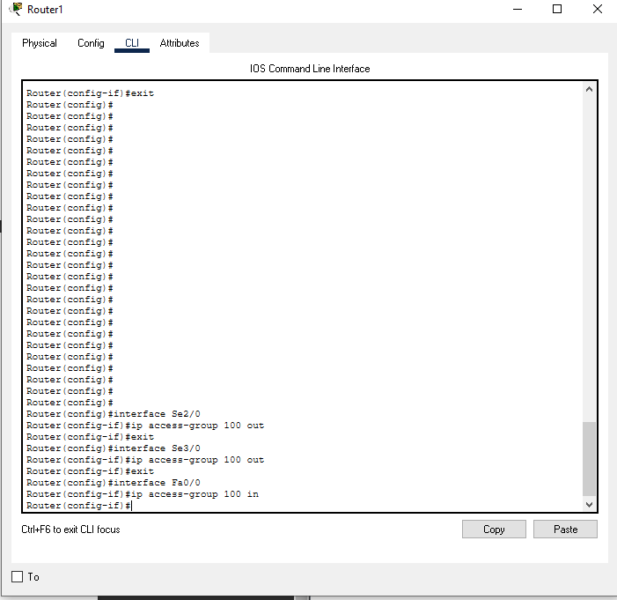
After we apply the list blocking ICMP any any:

We can now see PC0 (address 192.168.0.10) can ping other networks but not 192.168.1.10 inside of the 192.168.1.0 network.
