Alexander King
CSET 4750 .001
Lab 16 – DHCP
November 20th 2021

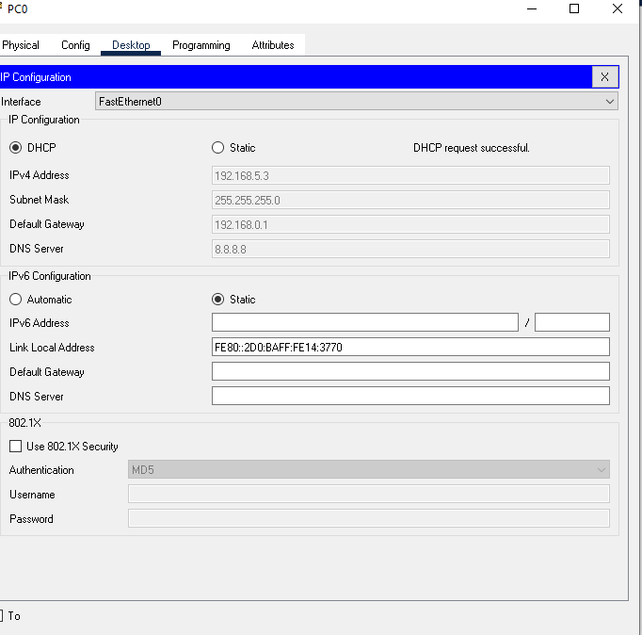
PC0 formerly 192.168.0.10 is now part of a DHCP vlan1 with a network addressing scheme of 192.168.5.0/24 Did the same for all end-user devices on the network.

Showing ipconfig /all of a device that connected with dhcp:
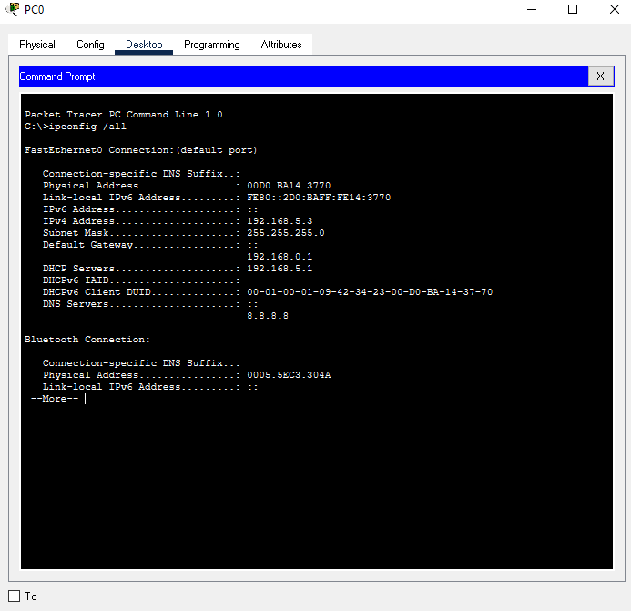

Show running config:
Router#show running-config
Building configuration...

Current configuration : 841 bytes
!
version 12.2
no service timestamps log datetime msec
no service timestamps debug datetime msec
no service password-encryption
!
hostname Router
!
!
!
!
!
!
!
!
ip cef
no ipv6 cef
!
!
!
!
!
!
!
!
!
!
!
!
!
!
!
!
!
!
interface FastEthernet0/0
ip address 192.168.0.1 255.255.255.0
duplex auto
speed auto
!
interface FastEthernet1/0
no ip address
duplex auto
speed auto
shutdown
!
interface Serial2/0
ip address 12.1.1.1 255.0.0.0
clock rate 2000000
!
interface Serial3/0
ip address 10.1.1.1 255.0.0.0
clock rate 2000000
!
interface FastEthernet4/0
no ip address
shutdown
!
interface FastEthernet5/0
no ip address
shutdown
!
ip classless
ip route 192.168.2.0 255.255.255.0 12.1.1.3
ip route 192.168.1.0 255.255.255.0 10.1.1.2
!
ip flow-export version 9
!
!
!
!
!
!
!
!
line con 0
!
line aux 0
!
line vty 0 4
login
!
!
!
end

