Alexander King
CSET 4750
Lab 9:

All pictures are high resolution and can be zoomed in if desired.

Things to do: Reset your CISCO Router back to factory defaults. Answer yes to the following: Would you like to enter the initial configuration dialog? [yes/no]: You will then enter the router configuration/setup menu.

1) Complete the setup menu following the Class IP addressing standards.
2) Review the Running Config Questions:

1) What is Rommon?
ROM monitor

2) What is global configuration mode?
Where we navigate to in the CLI to configure the Cisco device.

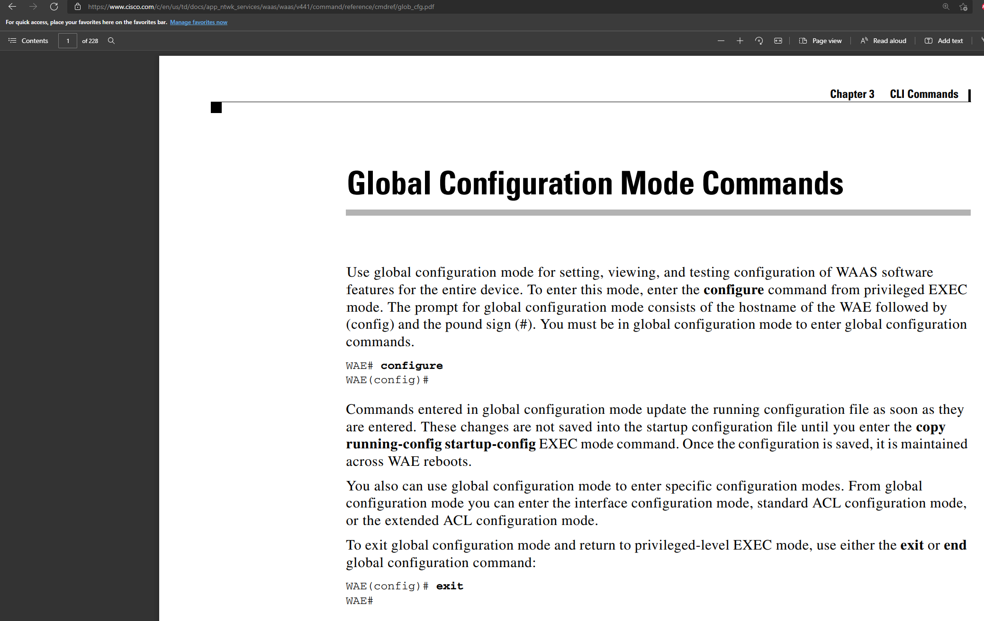

Router commands – explain the following commands:
3) ip-subnet-zero
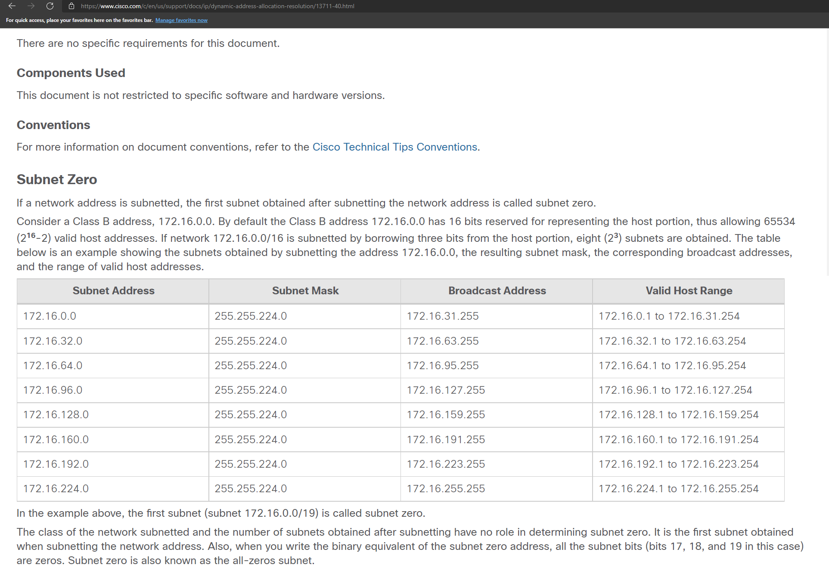
So if my default gateway is 192.168.0.1 with a subnet mask of 255.255.255.0 the subnet-zero would be 192.168.0.0/24.
4) ip-routing /no ip-routing
no preceding a command negates it.
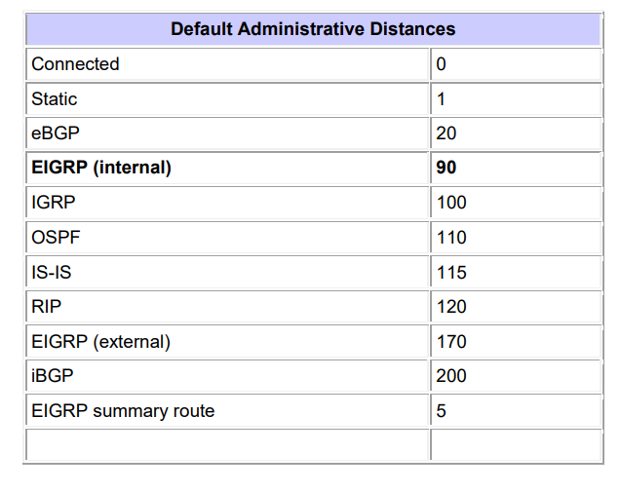

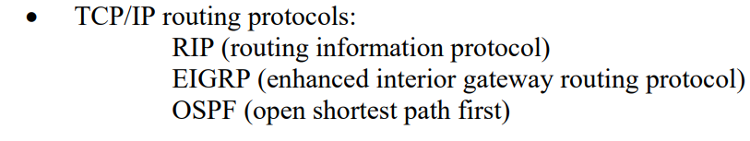
A routing command from lab 10 looked like:
Router(config)#ip route 192.168.1.0 255.255.255.0 10.1.1.2

5) ip-classless
Classless is when you are not classfull. This is the case when networks are not using their default CIDR.
Class A: /8 is class full
Class B: /16 is class full
Class C: /24 is class full.
Anything besides these default values would be classless.

6) line vty 0 4

vtw stands for r Virtual teletype

Telnet/SSH
0 4 allows for 5 simultaneous virtual connections

7) shutdown/no shutdown
Shutdown disables an interface. No preceding a command negates the command. So in this case would enable an interface.

