Alexander J King
CSET 4750.001
Final Project: IPV6 networking.

ALL PICTURES ARE HIGH RESOLUTION AND CAN BE ZOOMED IN!

Networking final project:
given network address:
King, Alexander J. 2001:cba0::/32
2001:cba0:0000:0000:0000:0000:0000:0000 / 32
subnetmask 48 bits.
We’re giving ourselves the ability to add more subnets than we think we will ever need while also allowing locations to have more users than we think we could ever need.

ACL – block unused addresses? Permit used addresses / deny unsued. Save text of inputs in multiple places. Currently short enough we can only allow eachother and deny everyone else and be able to rebuild out ACL in moments. Recall automatic deny all not permitted at end. Handy.
We will only need to utilize the first 3 subnets out of 65536 and less than 150/65536 at each location currently. This allows for more growth than any company could ever hope for.
Addressing scheme:
2001:cba0::/48 – router zero
2001:cba0:1::/48
2001:cba0:2::/48

2001:cba0:100::/48 etc for connects between routers

Google ipv6 dns : n

Commands

Router 1# configure terminal
Router 1(config)# ipv6 unicast-routing
Router 2# configure terminal
Router 2(config)# ipv6 unicast-routing

Router 1 (config)# interface FastEthernet0/0
Router 1 (config-if)# ipv6 enable
Router 1 (config-if)# no shutdown
Router 1 (config)# interface FastEthernet0/1
Router 1 (config-if)# ipv6 enable
Router 1 (config-if)# no shutdown

Router 1 (config)# interface FastEthernet0/0
Router 1(config-if)# ipv6 address 2001:AAAA:BBBB:CCCC::/64 eui-64
Router 1(config-if)# end

Range: 2001:cba0:0:0:0:0:0:0 - 2001:cba0:ffff:ffff:ffff:ffff:ffff:ffff

Packet Tracer:
pre routing.

Static:
allow all to communicate

Everyone pinging everyone:
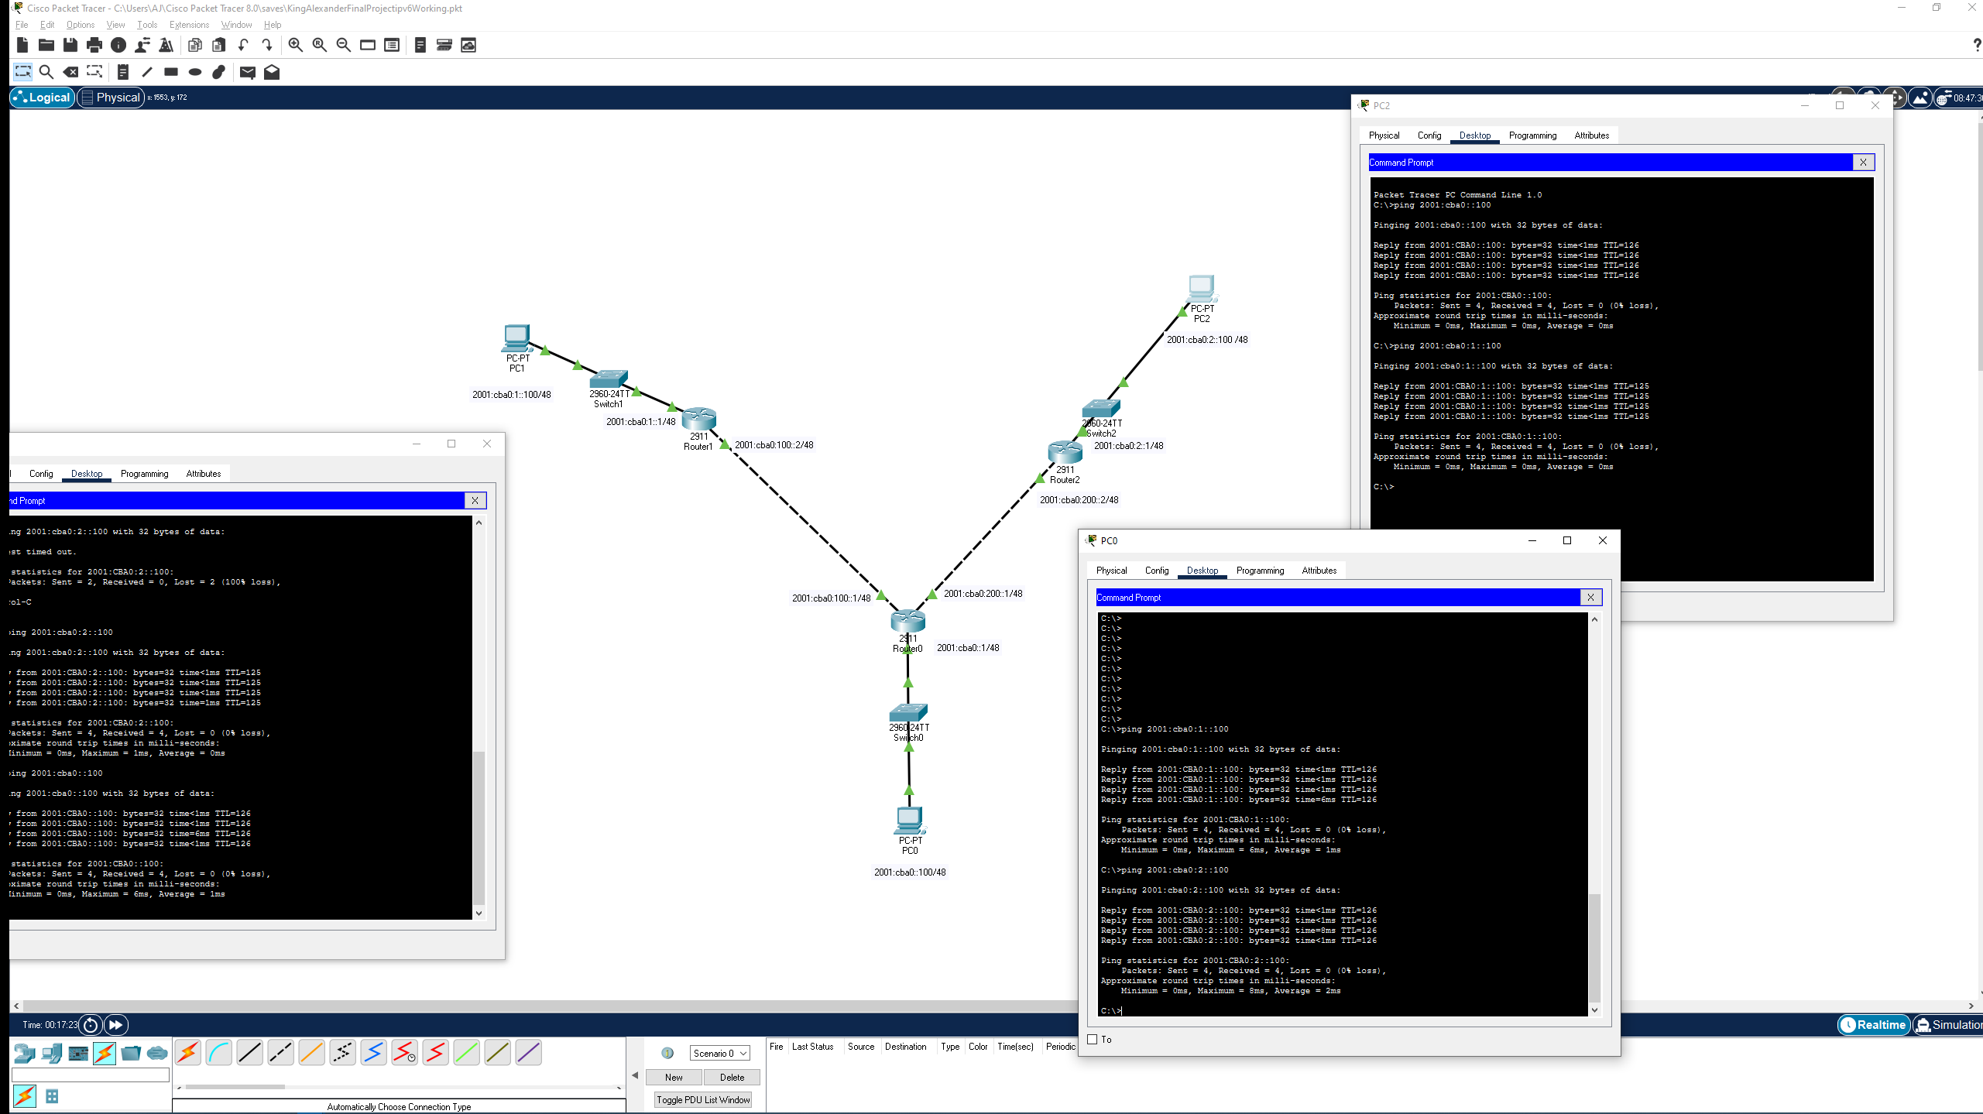

Startup/running-configs:
R0:
Router#show startup-config
Using 911 bytes
!
version 15.1
no service timestamps log datetime msec
no service timestamps debug datetime msec
no service password-encryption
!
hostname Router
!
!
!
!
!
!
!
!
ip cef
ipv6 unicast-routing
!
no ipv6 cef
!
!
!
!
license udi pid CISCO2911/K9 sn FTX15249Z49-
!
!
!
!
!
!
!
!
!
!
!
spanning-tree mode pvst
!
!
!
!
!
!
interface GigabitEthernet0/0
no ip address
duplex auto
speed auto
ipv6 address 2001:CBA0::1/48
ipv6 enable
!
interface GigabitEthernet0/1
no ip address
duplex auto
speed auto
ipv6 address 2001:CBA0:100::1/48
ipv6 enable
!
interface GigabitEthernet0/2
no ip address
duplex auto
speed auto
ipv6 address 2001:CBA0:200::1/48
ipv6 enable
!
interface Vlan1
no ip address
shutdown
!
ip classless
!
ip flow-export version 9
!
ipv6 route 2001:CBA0:1::/48 2001:CBA0:100::2
ipv6 route 2001:CBA0:2::/48 2001:CBA0:200::2
!
!
!
!
!
!
!
line con 0
!
line aux 0
!
line vty 0 4
login
!
!
!
end

R1:
Router#show startup-config
Using 864 bytes
!
version 15.1
no service timestamps log datetime msec
no service timestamps debug datetime msec
no service password-encryption
!
hostname Router
!
!
!
!
!
!
!
!
ip cef
ipv6 unicast-routing
!
no ipv6 cef
!
!
!
!
license udi pid CISCO2911/K9 sn FTX152477R5-
!
!
!
!
!
!
!
!
!
!
!
spanning-tree mode pvst
!
!
!
!
!
!
interface GigabitEthernet0/0
no ip address
duplex auto
speed auto
ipv6 address 2001:CBA0:100::2/48
ipv6 enable
!
interface GigabitEthernet0/1
no ip address
duplex auto
speed auto
ipv6 address 2001:CBA0:1::1/48
ipv6 enable
!
interface GigabitEthernet0/2
no ip address
duplex auto
speed auto
!
interface Vlan1
no ip address
shutdown
!
ip classless
!
ip flow-export version 9
!
ipv6 route 2001:CBA0::/48 2001:CBA0:100::1
ipv6 route 2001:CBA0:2::/48 2001:CBA0:100::1
!
!
!
!
!
!
!
line con 0
!
line aux 0
!
line vty 0 4
login
!
!
!
end

R2:

Router#show startup-config
Using 864 bytes
!
version 15.1
no service timestamps log datetime msec
no service timestamps debug datetime msec
no service password-encryption
!
hostname Router
!
!
!
!
!
!
!
!
ip cef
ipv6 unicast-routing
!
no ipv6 cef
!
!
!
!
license udi pid CISCO2911/K9 sn FTX1524E8X3-
!
!
!
!
!
!
!
!
!
!
!
spanning-tree mode pvst
!
!
!
!
!
!
interface GigabitEthernet0/0
no ip address
duplex auto
speed auto
ipv6 address 2001:CBA0:200::2/48
ipv6 enable
!
interface GigabitEthernet0/1
no ip address
duplex auto
speed auto
ipv6 address 2001:CBA0:2::1/48
ipv6 enable
!
interface GigabitEthernet0/2
no ip address
duplex auto
speed auto
!
interface Vlan1
no ip address
shutdown
!
ip classless
!
ip flow-export version 9
!
ipv6 route 2001:CBA0::/48 2001:CBA0:200::1
ipv6 route 2001:CBA0:1::/48 2001:CBA0:200::1
!
!
!
!
!
!
!
line con 0
!
line aux 0
!
line vty 0 4
login
!
!
!
end

RIP:
allow all to communicate
Every end device pinging every other end device.
P0: ping P1/P2
P1: ping P0/P2
P2: ping p0/p1

All using rip no static routes.

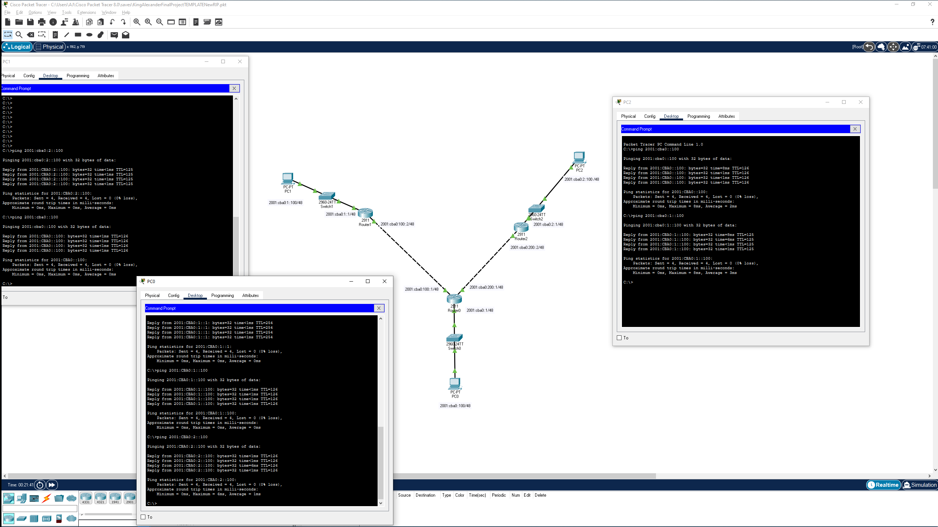
R0:
Router#show startup-config
Using 1088 bytes
!
version 15.1
no service timestamps log datetime msec
no service timestamps debug datetime msec
no service password-encryption
!
hostname Router
!
!
!
!
!
!
!
!
ip cef
ipv6 unicast-routing
!
no ipv6 cef
!
!
!
!
license udi pid CISCO2911/K9 sn FTX15249Z49-
!
!
!
!
!
!
!
!
!
!
!
spanning-tree mode pvst
!
!
!
!
!
!
interface GigabitEthernet0/0
no ip address
duplex auto
speed auto
ipv6 address 2001:CBA0::1/48
ipv6 rip king enable
ipv6 enable
!
interface GigabitEthernet0/1
no ip address
duplex auto
speed auto
ipv6 address 2001:CBA0:100::1/48
ipv6 rip king enable
ipv6 enable
!
interface GigabitEthernet0/2
no ip address
duplex auto
speed auto
ipv6 address 2001:CBA0:200::1/48
ipv6 rip king enable
ipv6 enable
!
interface Vlan1
no ip address
shutdown
!
router rip
!
ipv6 router rip 2001:cba0::
!
ipv6 router rip 2001:cba0:100::
!
ipv6 router rip 2001:cba0:200::
!
ipv6 router rip 2001:cba0:1::
!
ipv6 router rip 2001:cba0:2::
!
ipv6 router rip king
!
ip classless
!
ip flow-export version 9
!
!
!
!
!
!
!
!
line con 0
!
line aux 0
!
line vty 0 4
login
!
!
!
end

___________________________________________________________________________________
R1:

Router#show startup-config
Using 1030 bytes
!
version 15.1
no service timestamps log datetime msec
no service timestamps debug datetime msec
no service password-encryption
!
hostname Router
!
!
!
!
!
!
!
!
ip cef
ipv6 unicast-routing
!
no ipv6 cef
!
!
!
!
license udi pid CISCO2911/K9 sn FTX152477R5-
!
!
!
!
!
!
!
!
!
!
!
spanning-tree mode pvst
!
!
!
!
!
!
interface GigabitEthernet0/0
no ip address
duplex auto
speed auto
ipv6 address 2001:CBA0:100::2/48
ipv6 rip king enable
ipv6 enable
!
interface GigabitEthernet0/1
no ip address
duplex auto
speed auto
ipv6 address 2001:CBA0:1::1/48
ipv6 rip king enable
ipv6 enable
!
interface GigabitEthernet0/2
no ip address
duplex auto
speed auto
ipv6 rip king enable
!
interface Vlan1
no ip address
shutdown
!
ipv6 router rip 2001:cba0::
!
ipv6 router rip 2001:cba0:1::
!
ipv6 router rip 2001:cba0:2::
!
ipv6 router rip 2001:cba0:100::
!
ipv6 router rip 2001:cba0:200::
!
ipv6 router rip king
!
ip classless
!
ip flow-export version 9
!
!
!
!
!
!
!
!
line con 0
!
line aux 0
!
line vty 0 4
login
!
!
!
end

___________________________________________________________________________________

R2:

Router#show startup-config
Using 1030 bytes
!
version 15.1
no service timestamps log datetime msec
no service timestamps debug datetime msec
no service password-encryption
!
hostname Router
!
!
!
!
!
!
!
!
ip cef
ipv6 unicast-routing
!
no ipv6 cef
!
!
!
!
license udi pid CISCO2911/K9 sn FTX1524E8X3-
!
!
!
!
!
!
!
!
!
!
!
spanning-tree mode pvst
!
!
!
!
!
!
interface GigabitEthernet0/0
no ip address
duplex auto
speed auto
ipv6 address 2001:CBA0:200::2/48
ipv6 rip king enable
ipv6 enable
!
interface GigabitEthernet0/1
no ip address
duplex auto
speed auto
ipv6 address 2001:CBA0:2::1/48
ipv6 rip king enable
ipv6 enable
!
interface GigabitEthernet0/2
no ip address
duplex auto
speed auto
ipv6 rip king enable
!
interface Vlan1
no ip address
shutdown
!
ipv6 router rip 2001:cba0:2::
!
ipv6 router rip 2001:cba0:1::
!
ipv6 router rip 2001:cba0::
!
ipv6 router rip 2001:cba0:200::
!
ipv6 router rip 2001:cba0:100::
!
ipv6 router rip king
!
ip classless
!
ip flow-export version 9
!
!
!
!
!
!
!
!
line con 0
!
line aux 0
!
line vty 0 4
login
!
!
!
end

Dynamic OSPF:
allow all to communicate

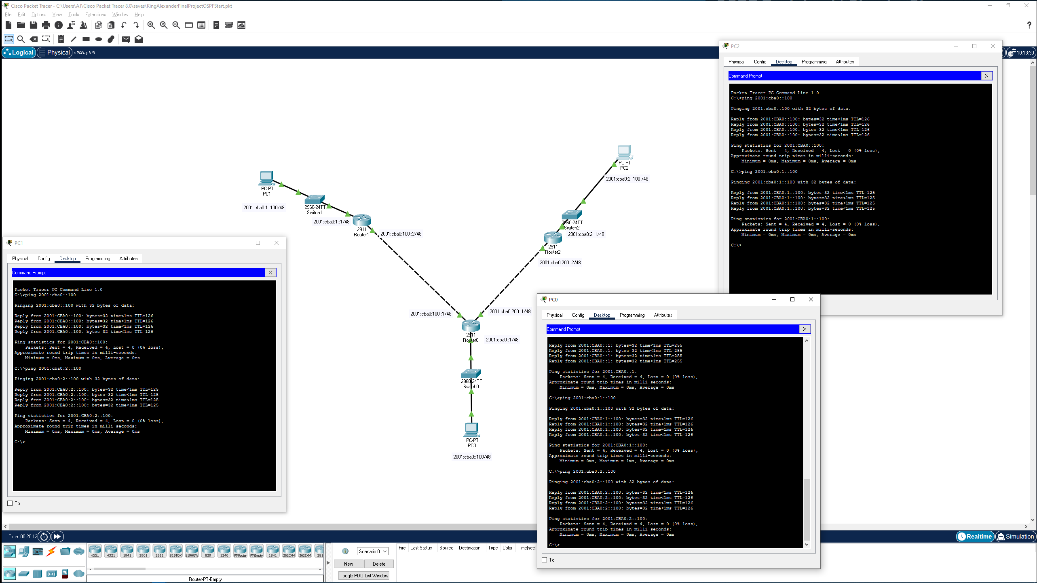
Every end device pinging every other end device.

R0:

Router#show startup-config
Using 1119 bytes
!
version 15.1
no service timestamps log datetime msec
no service timestamps debug datetime msec
no service password-encryption
!
hostname Router
!
!
!
!
!
!
!
!
ip cef
ipv6 unicast-routing
!
no ipv6 cef
!
!
!
!
license udi pid CISCO2911/K9 sn FTX15249Z49-
!
!
!
!
!
!
!
!
!
!
!
spanning-tree mode pvst
!
!
!
!
!
!
interface GigabitEthernet0/0
no ip address
duplex auto
speed auto
ipv6 address 2001:CBA0::1/48
ipv6 enable
ipv6 ospf 1 area 0
!
interface GigabitEthernet0/1
no ip address
duplex auto
speed auto
ipv6 address 2001:CBA0:100::1/48
ipv6 enable
ipv6 ospf 1 area 0
!
interface GigabitEthernet0/2
no ip address
duplex auto
speed auto
ipv6 address 2001:CBA0:200::1/48
ipv6 enable
ipv6 ospf 1 area 0
!
interface Vlan1
no ip address
shutdown
!
router rip
!
ipv6 router ospf 1
router-id 0.0.0.1
log-adjacency-changes
!
ipv6 router rip 2001:cba0::
!
ipv6 router rip 2001:cba0:100::
!
ipv6 router rip 2001:cba0:200::
!
ipv6 router rip 2001:cba0:1::
!
ipv6 router rip 2001:cba0:2::
!
ip classless
!
ip flow-export version 9
!
!
!
!
!
!
!
!
line con 0
!
line aux 0
!
line vty 0 4
login
!
!
!
end

R1:

Router#show startup-config
Using 1074 bytes
!
version 15.1
no service timestamps log datetime msec
no service timestamps debug datetime msec
no service password-encryption
!
hostname Router
!
!
!
!
!
!
!
!
ip cef
ipv6 unicast-routing
!
no ipv6 cef
!
!
!
!
license udi pid CISCO2911/K9 sn FTX152477R5-
!
!
!
!
!
!
!
!
!
!
!
spanning-tree mode pvst
!
!
!
!
!
!
interface GigabitEthernet0/0
no ip address
duplex auto
speed auto
ipv6 address 2001:CBA0:100::2/48
ipv6 enable
ipv6 ospf 1 area 0
!
interface GigabitEthernet0/1
no ip address
duplex auto
speed auto
ipv6 address 2001:CBA0:1::1/48
ipv6 enable
ipv6 ospf 1 area 0
!
interface GigabitEthernet0/2
no ip address
duplex auto
speed auto
ipv6 enable
ipv6 ospf 1 area 0
!
interface Vlan1
no ip address
shutdown
!
ipv6 router ospf 1
router-id 0.0.0.2
log-adjacency-changes
!
ipv6 router rip 2001:cba0::
!
ipv6 router rip 2001:cba0:1::
!
ipv6 router rip 2001:cba0:2::
!
ipv6 router rip 2001:cba0:100::
!
ipv6 router rip 2001:cba0:200::
!
ip classless
!
ip flow-export version 9
!
!
!
!
!
!
!
!
line con 0
!
line aux 0
!
line vty 0 4
login
!
!
!
end

R2:
Router#show startup-config
Using 1074 bytes
!
version 15.1
no service timestamps log datetime msec
no service timestamps debug datetime msec
no service password-encryption
!
hostname Router
!
!
!
!
!
!
!
!
ip cef
ipv6 unicast-routing
!
no ipv6 cef
!
!
!
!
license udi pid CISCO2911/K9 sn FTX1524E8X3-
!
!
!
!
!
!
!
!
!
!
!
spanning-tree mode pvst
!
!
!
!
!
!
interface GigabitEthernet0/0
no ip address
duplex auto
speed auto
ipv6 address 2001:CBA0:200::2/48
ipv6 enable
ipv6 ospf 1 area 0
!
interface GigabitEthernet0/1
no ip address
duplex auto
speed auto
ipv6 address 2001:CBA0:2::1/48
ipv6 enable
ipv6 ospf 1 area 0
!
interface GigabitEthernet0/2
no ip address
duplex auto
speed auto
ipv6 enable
ipv6 ospf 1 area 0
!
interface Vlan1
no ip address
shutdown
!
ipv6 router ospf 1
router-id 0.0.0.3
log-adjacency-changes
!
ipv6 router rip 2001:cba0:2::
!
ipv6 router rip 2001:cba0:1::
!
ipv6 router rip 2001:cba0::
!
ipv6 router rip 2001:cba0:200::
!
ipv6 router rip 2001:cba0:100::
!
ip classless
!
ip flow-export version 9
!
!
!
!
!
!
!
!
line con 0
!
line aux 0
!
line vty 0 4
login
!
!
!
end

ACL block Pings:

Reusing prior OSPF template so you will see this in the conf files be aware.

PRE-BLOCKING ICMP showing ping works

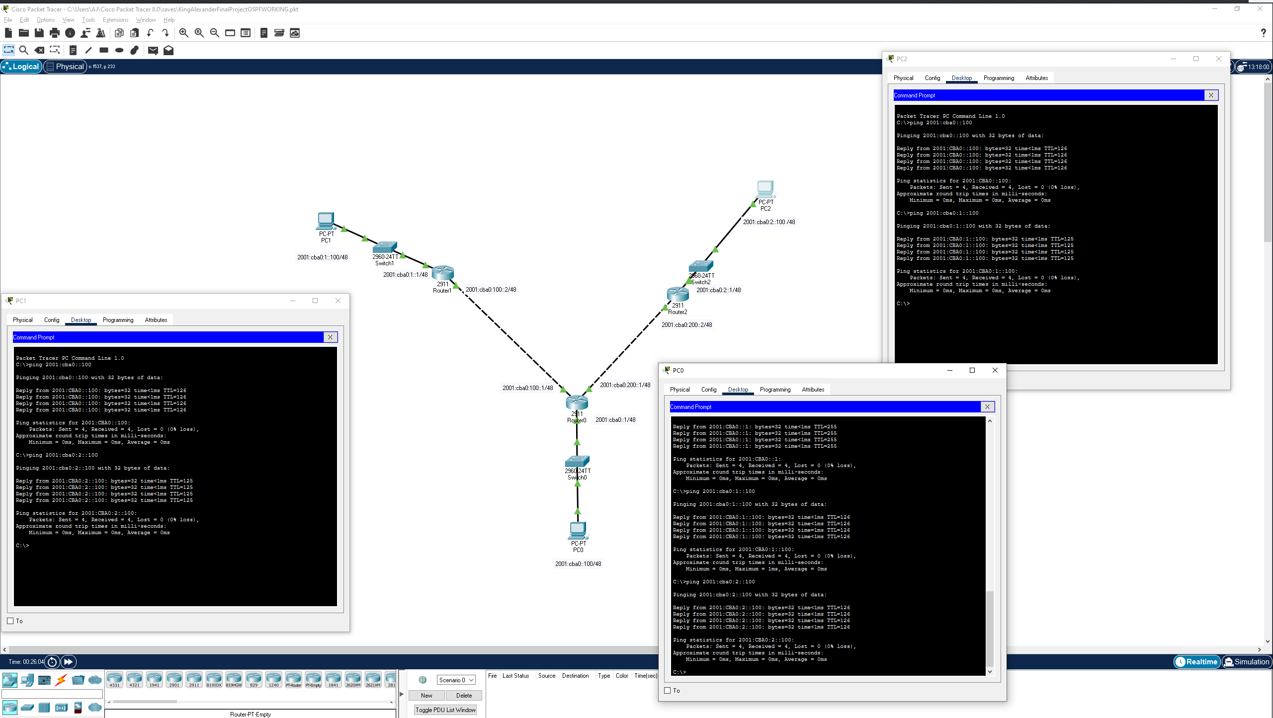

POST BLOCK ICMP ANY ANY
Run on all 3 routers (with OSPF settings routing):

ipv6 access-list ICMP
deny icmp any any
permit ipv6 any any
permit tcp any any
permit udp any any
(run on all 3)

int X/y/y
traffic-filter icmp <out/in>

This will block ONLY icmp frames/packets and allow tcp,udp,ipv6 to and from anywhere.

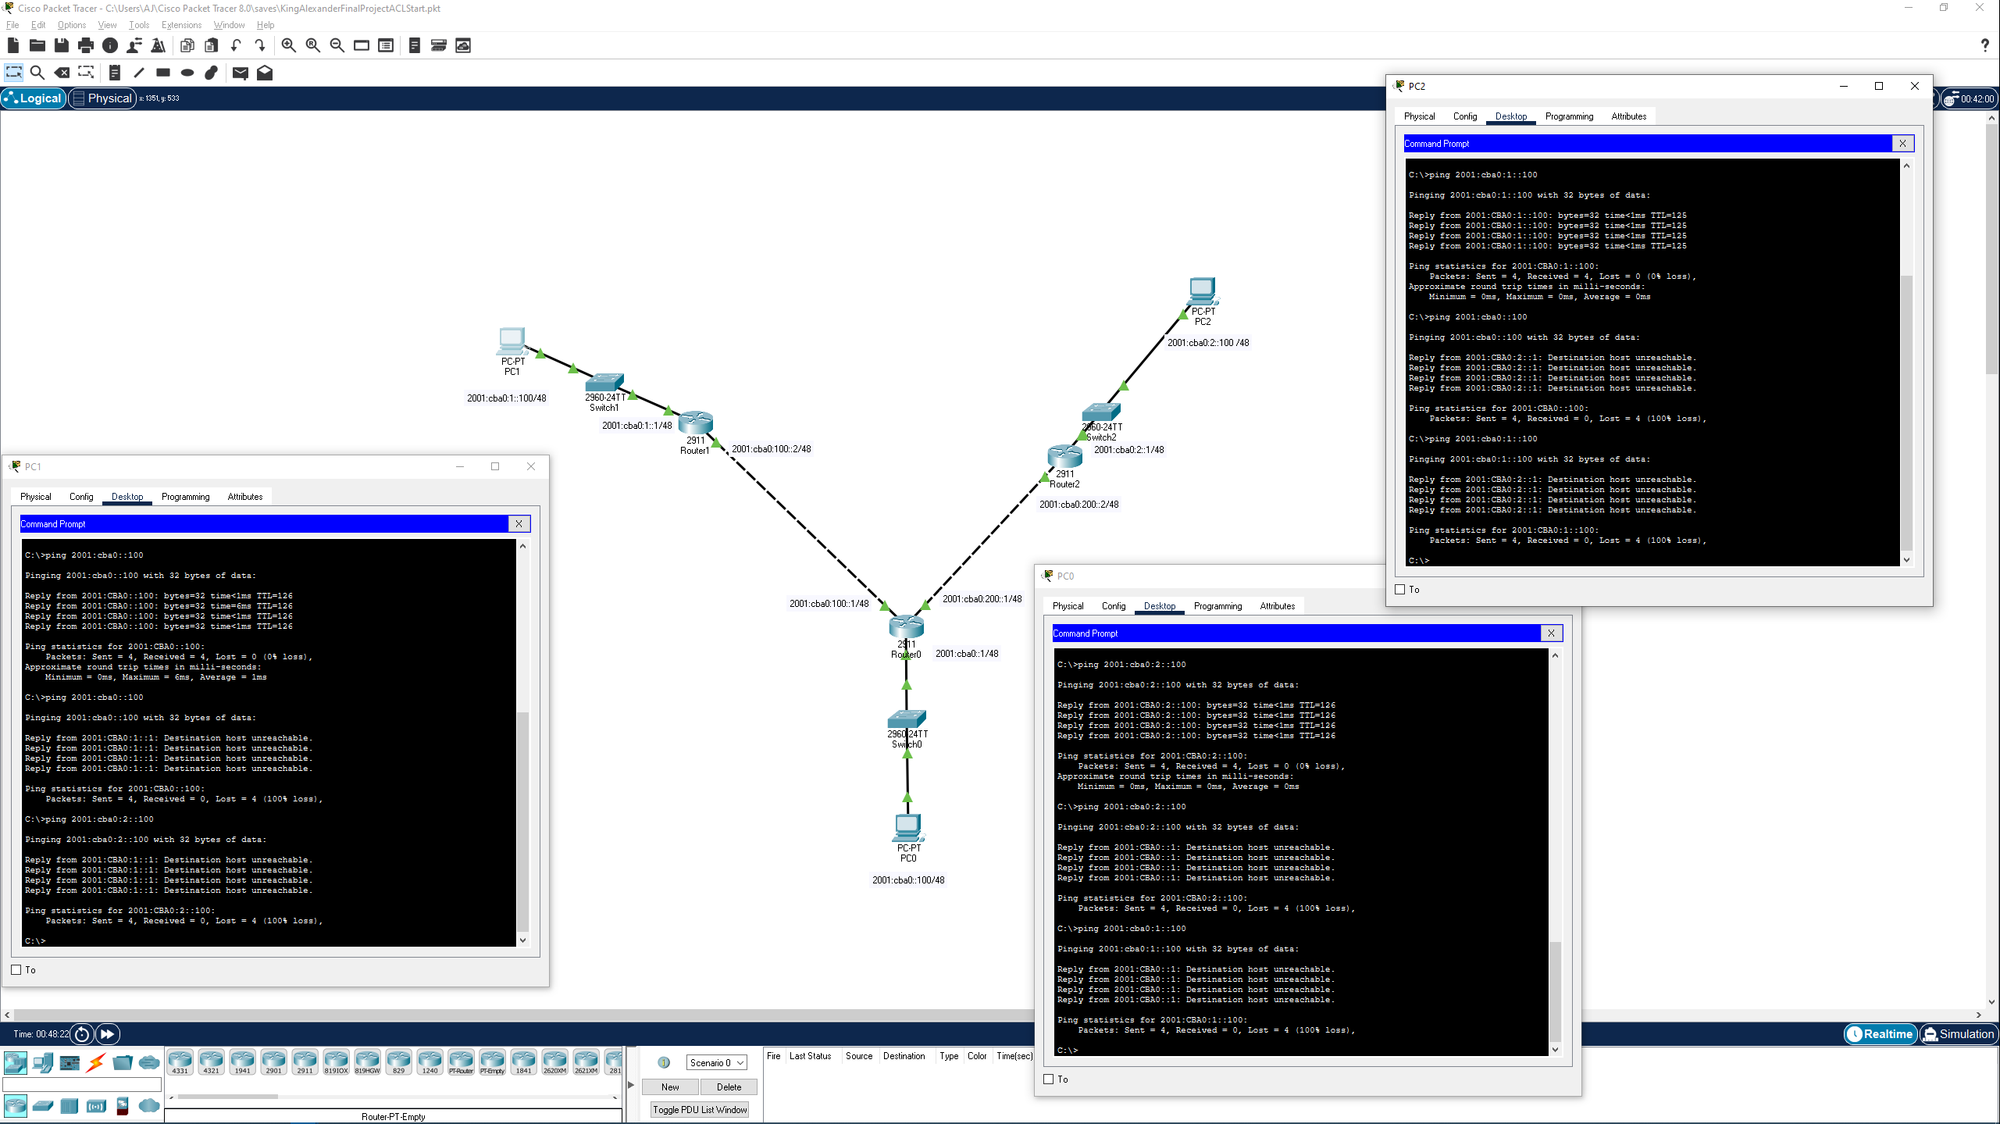
Showing expected failed pings:

R0:
Router#show startup-config
Using 1310 bytes
!
version 15.1
no service timestamps log datetime msec
no service timestamps debug datetime msec
no service password-encryption
!
hostname Router
!
!
!
!
!
!
!
!
ip cef
ipv6 unicast-routing
!
no ipv6 cef
!
!
!
!
license udi pid CISCO2911/K9 sn FTX15249Z49-
!
!
!
!
!
!
!
!
!
!
!
spanning-tree mode pvst
!
!
!
!
!
!
interface GigabitEthernet0/0
no ip address
ipv6 traffic-filter ICMP in
duplex auto
speed auto
ipv6 address 2001:CBA0::1/48
ipv6 enable
ipv6 ospf 1 area 0
!
interface GigabitEthernet0/1
no ip address
ipv6 traffic-filter ICMP out
duplex auto
speed auto
ipv6 address 2001:CBA0:100::1/48
ipv6 enable
ipv6 ospf 1 area 0
!
interface GigabitEthernet0/2
no ip address
ipv6 traffic-filter ICMP out
duplex auto
speed auto
ipv6 address 2001:CBA0:200::1/48
ipv6 enable
ipv6 ospf 1 area 0
!
interface Vlan1
no ip address
shutdown
!
router rip
!
ipv6 router ospf 1
router-id 0.0.0.1
log-adjacency-changes
!
ipv6 router rip 2001:cba0::
!
ipv6 router rip 2001:cba0:100::
!
ipv6 router rip 2001:cba0:200::
!
ipv6 router rip 2001:cba0:1::
!
ipv6 router rip 2001:cba0:2::
!
ip classless
!
ip flow-export version 9
!
!
ipv6 access-list ICMP
deny icmp any any
permit ipv6 any any
permit tcp any any
permit udp any any
!
!
!
!
!
!
line con 0
!
line aux 0
!
line vty 0 4
login
!
!
!
end

R1:
Router#show startup-config
Using 1235 bytes
!
version 15.1
no service timestamps log datetime msec
no service timestamps debug datetime msec
no service password-encryption
!
hostname Router
!
!
!
!
!
!
!
!
ip cef
ipv6 unicast-routing
!
no ipv6 cef
!
!
!
!
license udi pid CISCO2911/K9 sn FTX152477R5-
!
!
!
!
!
!
!
!
!
!
!
spanning-tree mode pvst
!
!
!
!
!
!
interface GigabitEthernet0/0
no ip address
ipv6 traffic-filter ICMP out
duplex auto
speed auto
ipv6 address 2001:CBA0:100::2/48
ipv6 enable
ipv6 ospf 1 area 0
!
interface GigabitEthernet0/1
no ip address
ipv6 traffic-filter ICMP in
duplex auto
speed auto
ipv6 address 2001:CBA0:1::1/48
ipv6 enable
ipv6 ospf 1 area 0
!
interface GigabitEthernet0/2
no ip address
duplex auto
speed auto
ipv6 enable
ipv6 ospf 1 area 0
!
interface Vlan1
no ip address
shutdown
!
ipv6 router ospf 1
router-id 0.0.0.2
log-adjacency-changes
!
ipv6 router rip 2001:cba0::
!
ipv6 router rip 2001:cba0:1::
!
ipv6 router rip 2001:cba0:2::
!
ipv6 router rip 2001:cba0:100::
!
ipv6 router rip 2001:cba0:200::
!
ip classless
!
ip flow-export version 9
!
!
ipv6 access-list ICMP
deny icmp any any
permit ipv6 any any
permit tcp any any
permit udp any any
!
!
!
!
!
!
line con 0
!
line aux 0
!
line vty 0 4
login
!
!
!
end

R2:

Router#show startup-config
Using 1235 bytes
!
version 15.1
no service timestamps log datetime msec
no service timestamps debug datetime msec
no service password-encryption
!
hostname Router
!
!
!
!
!
!
!
!
ip cef
ipv6 unicast-routing
!
no ipv6 cef
!
!
!
!
license udi pid CISCO2911/K9 sn FTX1524E8X3-
!
!
!
!
!
!
!
!
!
!
!
spanning-tree mode pvst
!
!
!
!
!
!
interface GigabitEthernet0/0
no ip address
ipv6 traffic-filter ICMP out
duplex auto
speed auto
ipv6 address 2001:CBA0:200::2/48
ipv6 enable
ipv6 ospf 1 area 0
!
interface GigabitEthernet0/1
no ip address
ipv6 traffic-filter ICMP in
duplex auto
speed auto
ipv6 address 2001:CBA0:2::1/48
ipv6 enable
ipv6 ospf 1 area 0
!
interface GigabitEthernet0/2
no ip address
duplex auto
speed auto
ipv6 enable
ipv6 ospf 1 area 0
!
interface Vlan1
no ip address
shutdown
!
ipv6 router ospf 1
router-id 0.0.0.3
log-adjacency-changes
!
ipv6 router rip 2001:cba0:2::
!
ipv6 router rip 2001:cba0:1::
!
ipv6 router rip 2001:cba0::
!
ipv6 router rip 2001:cba0:200::
!
ipv6 router rip 2001:cba0:100::
!
ip classless
!
ip flow-export version 9
!
!
ipv6 access-list ICMP
deny icmp any any
permit tcp any any
permit udp any any
permit ipv6 any any
!
!
!
!
!
!
line con 0
!
line aux 0
!
line vty 0 4
login
!
!
!
end

