The University of Toledo College of Engineering
CSET4750 Computer Networks and Data Communications
LAB 1: Understanding Basic Utilities
• Device Manager a) Network Adaptors b) Com / LPT ports c) All Hardware connected to the PC
• Control Panel – Network and Sharing - Change Adapter settings a) Obtain automatically – Dynamically assign from a DHCP server b) Static Entries
• IP Stack a) IP address b) Subnet Mask c) Default Gateway d) DNS – Domain Name Service (IP Resolution)
• Command prompt Utilities:
a) Ping - Short for Packet InterNet Groper, ping is a utility used to determine whether a specific IP address is accessible. It works by sending an echo ICMP packet to the specified address and waiting for a reply.
b) Tracert - The tracert command is used to visually see a network packet being sent and received and the amount of hops required for that packet to get to its destination.
c) IPCONFIG /all /release /renew /flushdns /registerdns ipconfig is a command line utility available on all versions of Microsoft Windows starting with Windows NT. This utility allows you to get the IP address information of a Windows computer. The University of Toledo College of Engineering CSET4750 Computer Networks and Data Communications
LAB 1: Understanding Basic Utilities
1) Identify by name the Network Adaptor(s) in your PC.
This was said to be a “trick” question as you did not specify logical or physical.
You said my ipconfig / all was functionally correct.

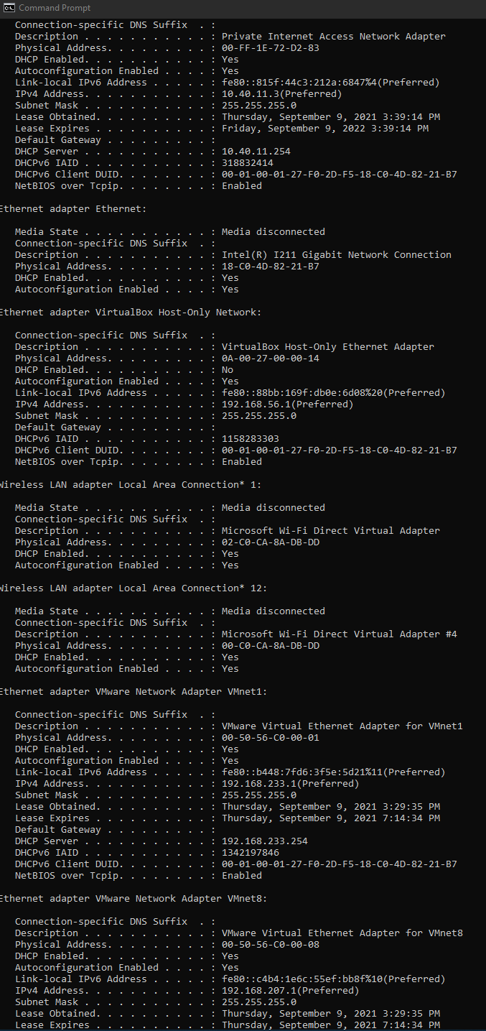

2) What is the IP Stack of the PC you are on? Is it obtained dynamically or static? How do you know?
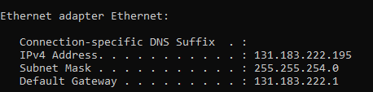
It's static in the lab. I know because I looked in View Hardware and Connection Properties.
I also could have opened the network adapter properties and looked under ipv4 if we were able.
(note portions of this lab were done in our lab room and some at home. Lab was static home is dynamic)
DNS is 8.8.8.8 and 8.8.4.4 (Google)
3) Identify any Com port(s) on the PC you are on.
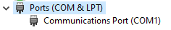
4) Determine if the following are accessible: If so how many hops are between your PC and each device? What are the IP addresses for each device?
a) Your PC’s default gateway.
Yes it is accessible. Zero hops (getting to default gateway doesn’t count. )
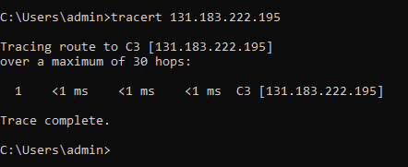
b) eng.utoledo.edu
Yes. 6 hops.
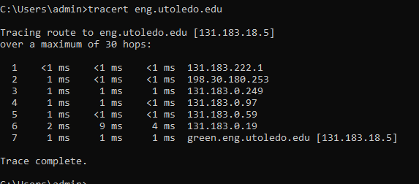
c) et791.ni.utoledo.edu
It claims unreachable but provided an IP address. Unknown not enough information.
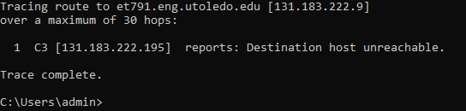
d) www.myut.utoledo.edu
Unreachable (it is not www =P~)
It cannot be found in DNS.
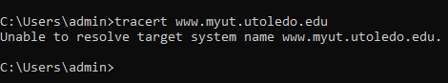
e) AMAZON.com
It hit the max of “30” (including the default gateway and timeouts) and did not end up getting Amazon.
I had a total of 30-13 = 17 hops. It is available … based on opening it in a browser. It is unknown in CMD.
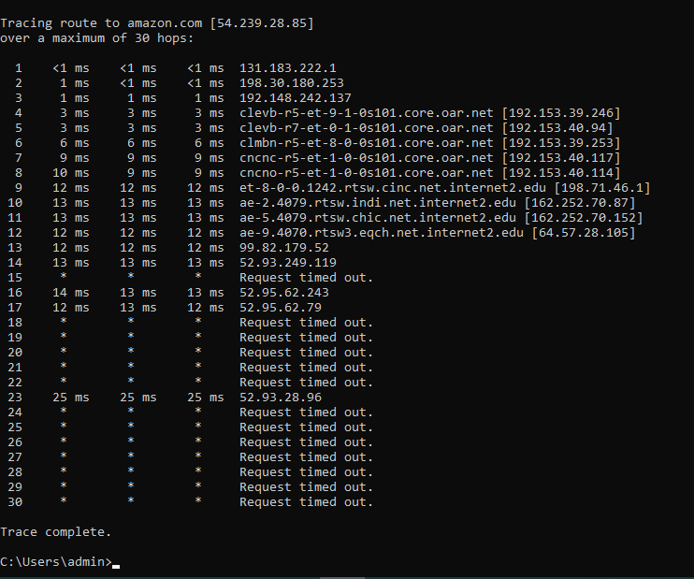
f) Microsoft.com *** F) and G) were unintentionally incomplete on my first turn in… I thought I did these. It was a mistake not laziness. I’m doing them now***
Unknown. Maxed out at 30 “hops” including timeouts and the default gateway. I count 13 hops exuding these. It gave us an IP and can confirm in a browser it is accessible.
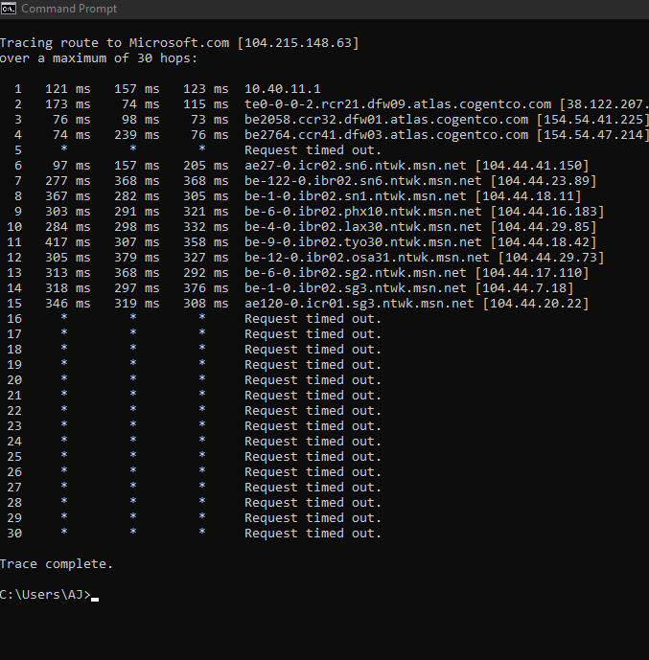
g) FOXNEWS.com
7 hops and it is available.
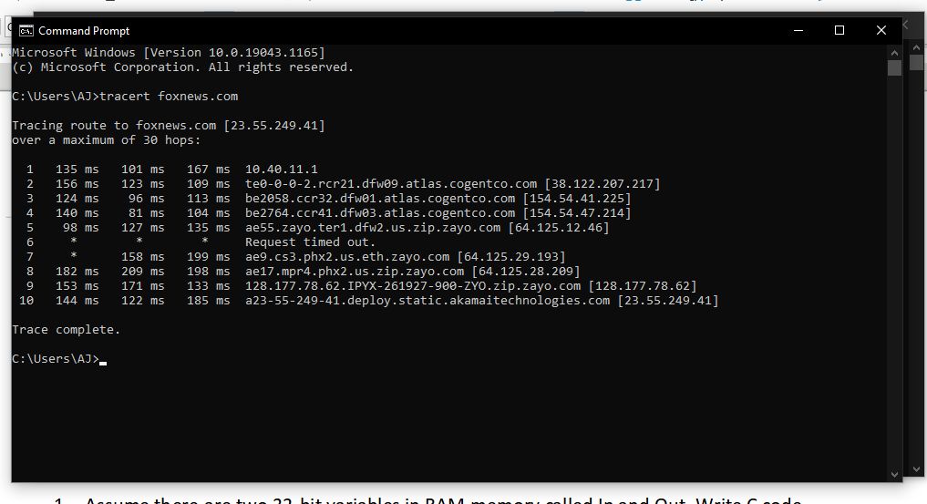
5) Explain how you would force your PC to renew the lease for its IP stack.
By releasing it and renewing it.
a) Renew the lease on your PC
Open CMD and
Ipconfig / release
ipconfig /renew
We need to release it because if it is not past t1 (50% of lease time) it will not actually renew if you only use the ipconfig /renew
i) How can you tell if the IP stack was renewed?
by typing ipconfig /all
STOCK PHOTO
