The University of Toledo
College of Engineering
CSET4750 Computer Networks and Data Communications
LAB 3: CISCO Enterprise switch Configuration

1) To bypass a password on a Cisco Enterprise switch Read below and answer the question (you do not have to actually perform the task)

a) Assuming you are connected to the console port of the Cisco switch – using ‘Putty’ Once you are connected and see something on the terminal window when you press enter, unplug the power cable on the switch. Next, hold down the mode button on the front, and connect the power cable. Release the mode button after the 1x port LED goes out. On a 2940 or 2950 switch release the mode button after the stat light goes out. On a 2955, press the break key (ctrl-break on Windows) when you see the message that the switch will auto boot.

b) At the switch: prompt, type flash_init and press enter.

c) Now type load_helper and press enter.

d) Now type dir flash:

e) rename flash:config.text flash:config.backup

f) Next, boot the switch using the boot command. NOTE: Once the system is booted, you will be asked if you want to enter the initial configuration dialog. Say no and press enter. Then go into Enable Mode.

g) rename flash:config.backup flash:config.text

h) copy startup-config running-config NOTE: After each command, you will be prompted to confirm the name of the destination file. Do this by pressing ‘enter’ each time.

i) Go into global configuration mode by typing config terminal. Next type no enable secret. Now you can reset your enable password to whatever password you want. Question: Why does this work (Why can you change the password)?

The University of Toledo College of Engineering CSET4750 Computer Networks and Data Communications LAB 3: CISCO Enterprise switch Configuration

2) Perform each of the following using the Console commands: (Take screen shots of each task and place them in a PDF file - The PDF file is to be turned in)

a) Show Running Configuration from one of the switches
enable → input password → show ? To see commands → show running-config.

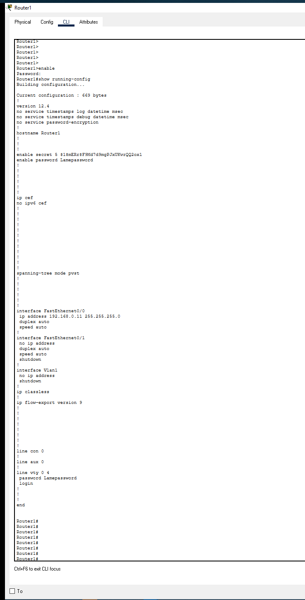

b) Change speed of at least one port on the switch

Start:
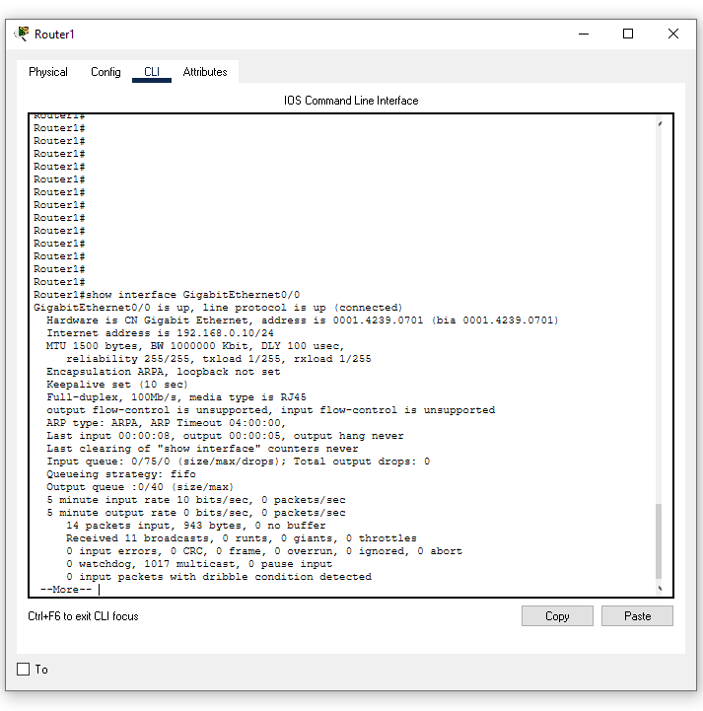
End:
-change speed to auto…. Note this could actually make the speed stay in the same place but the setting HAS been changed.

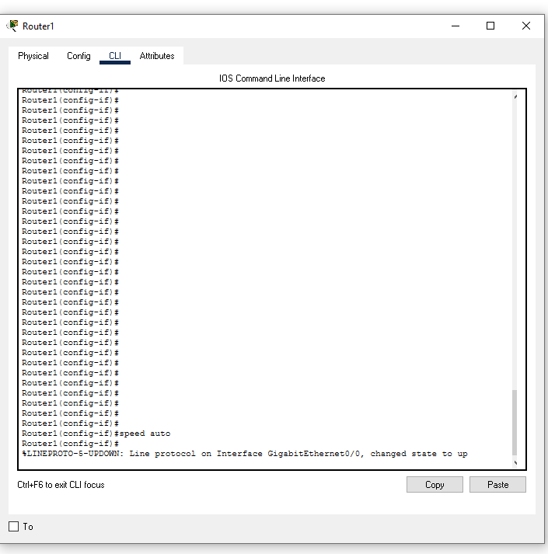
- showing speed again. It did stay at 100, it did not like 1000 with my cable choice I used ? To show the options and it listed 10/100/1000/auto. Changed from what I presume was 100 → auto.

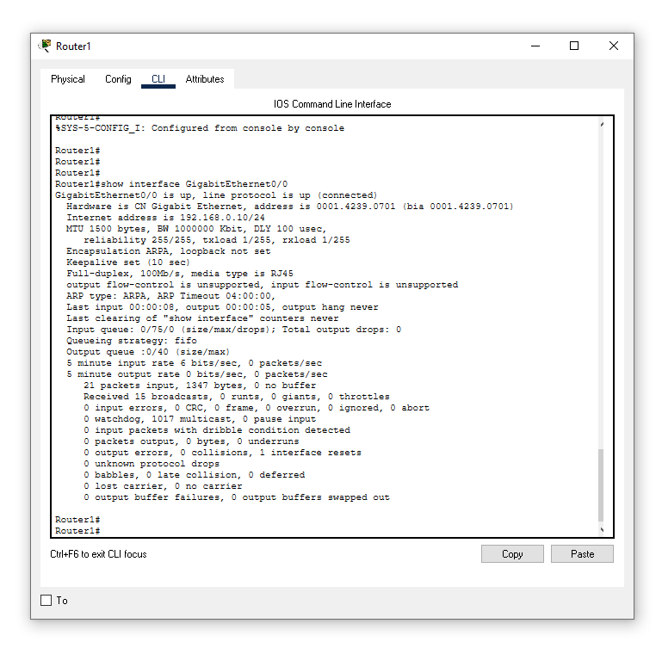

c) Change the duplex on at least one port on the switch

Changed to half duplex:

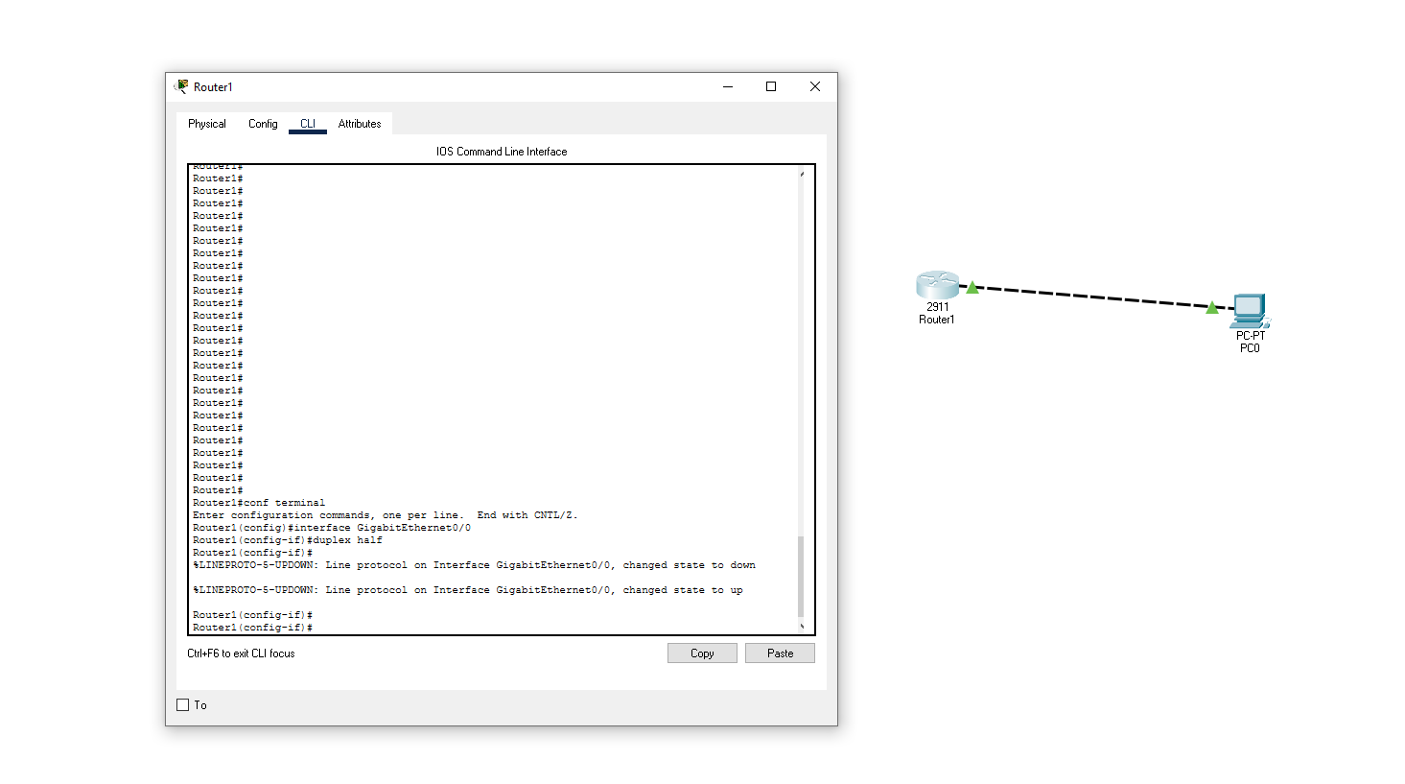

d) Show last saved (written) Configuration
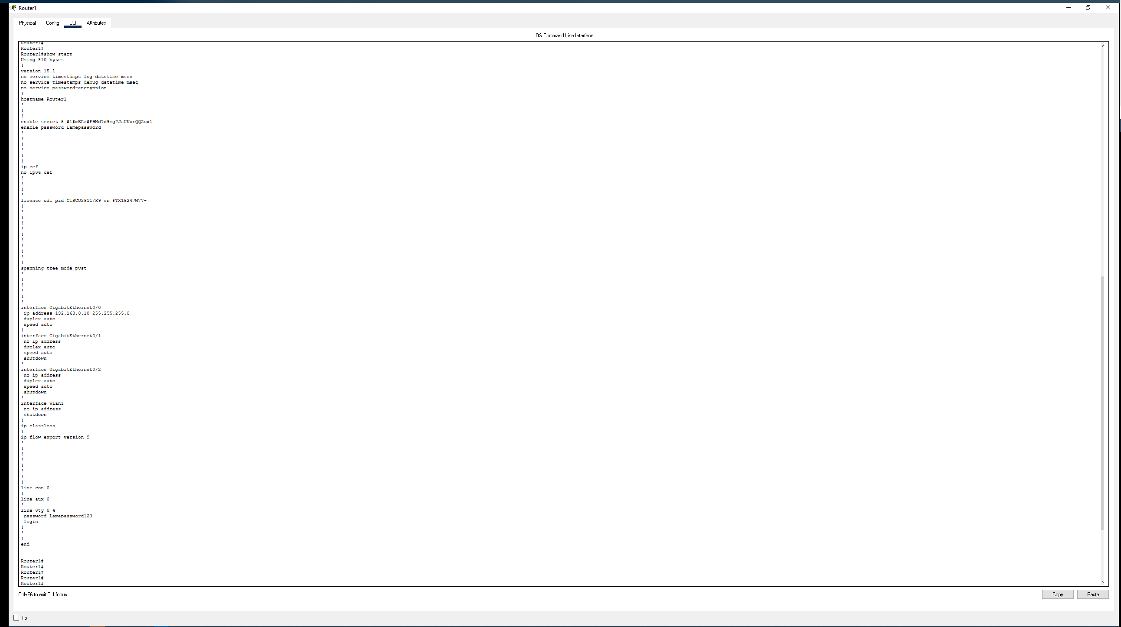

e) Show CDP Neighbors

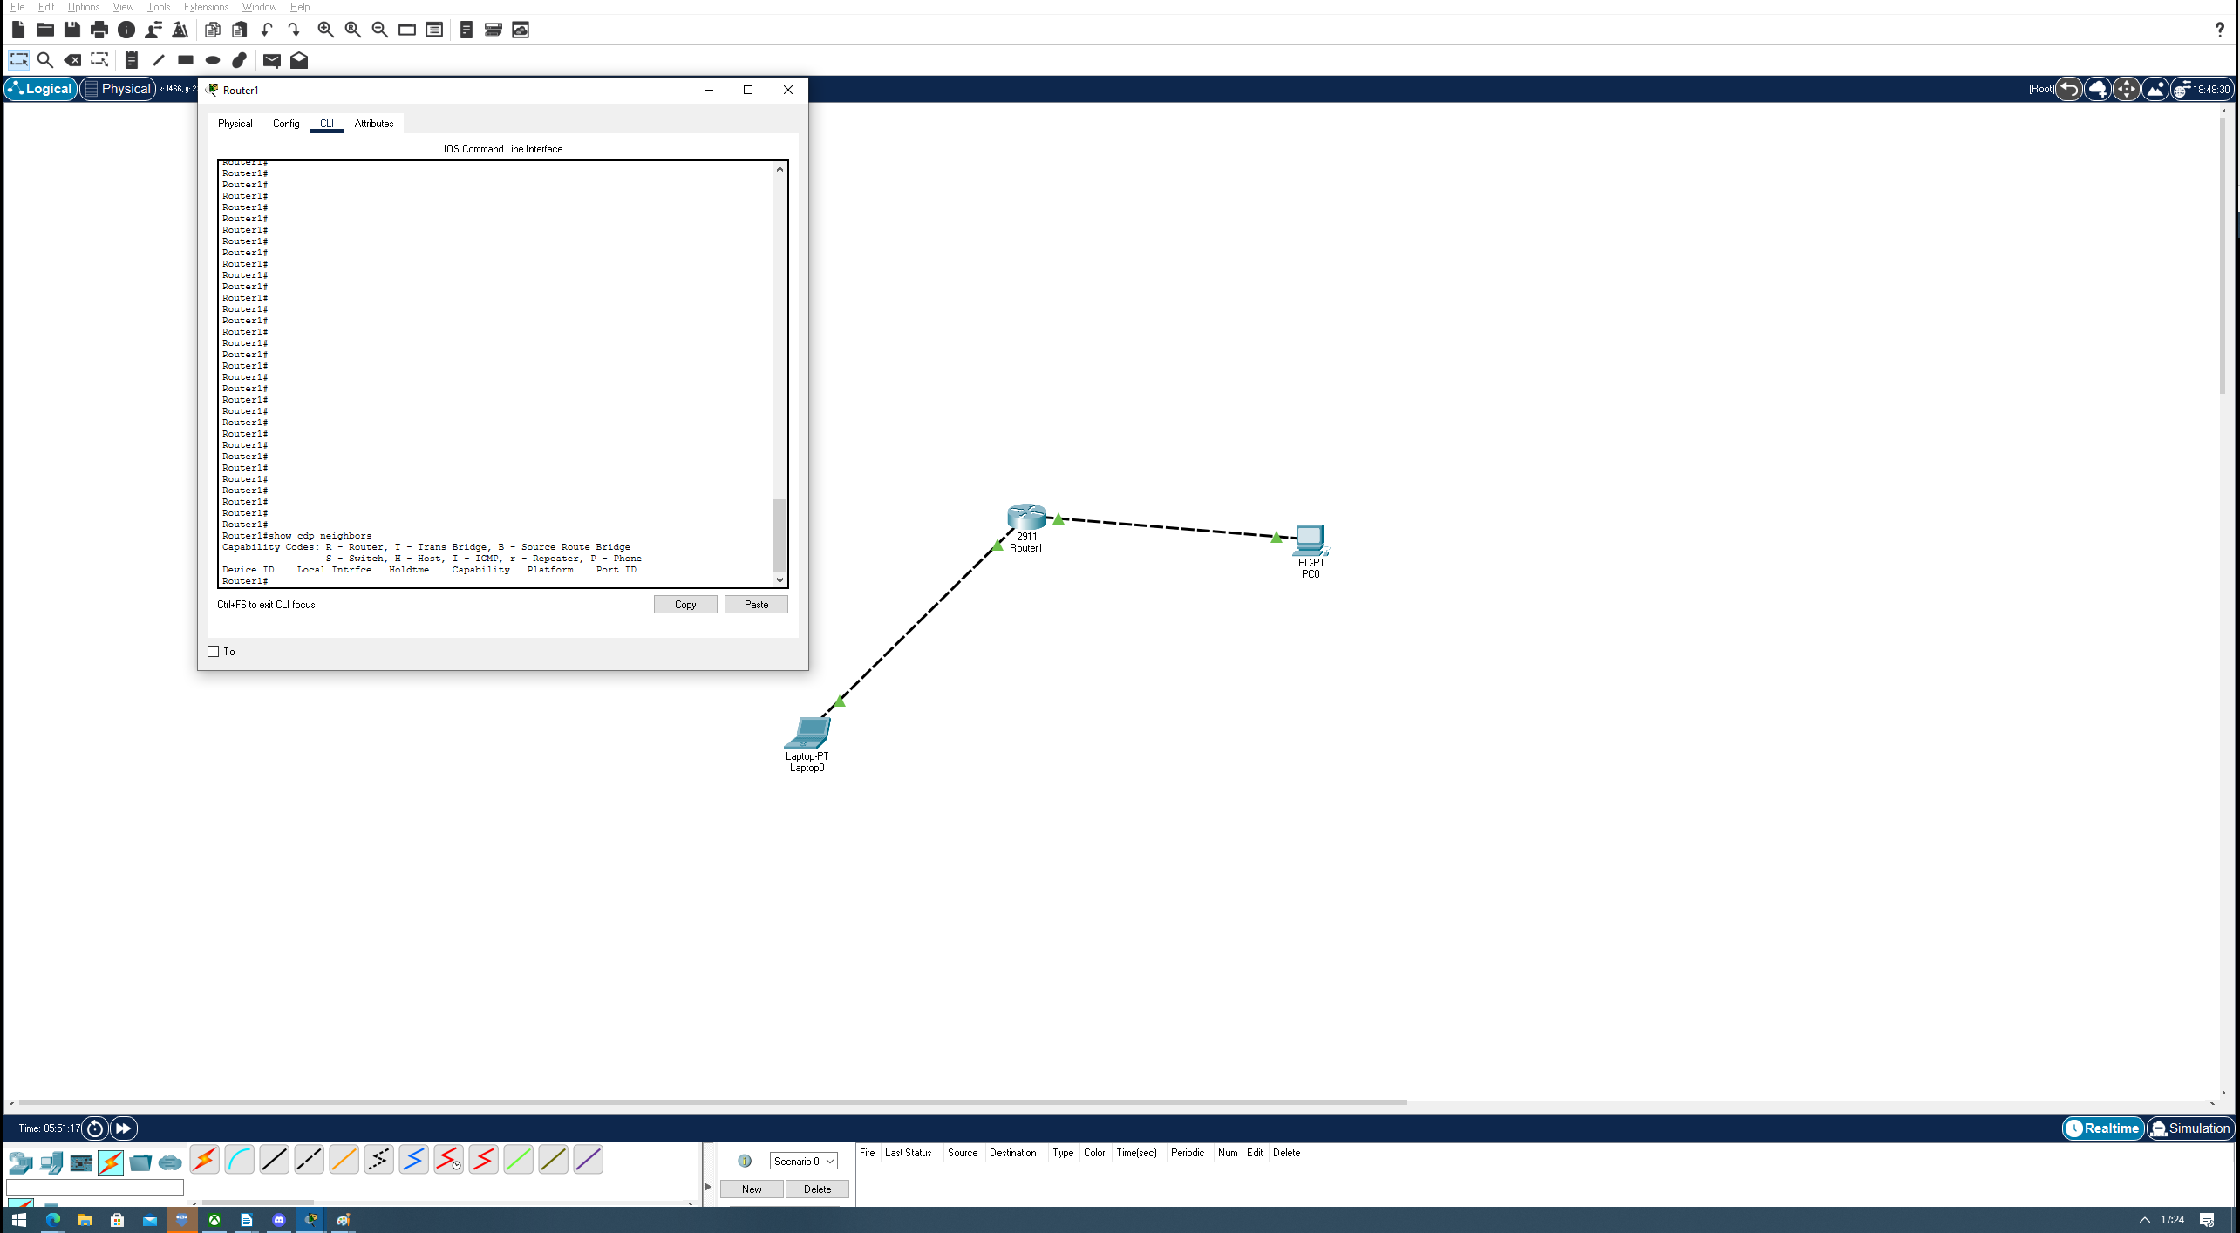
Doesn’t appear to show anything using switch CLI.

f) Show “?” See what other options are available
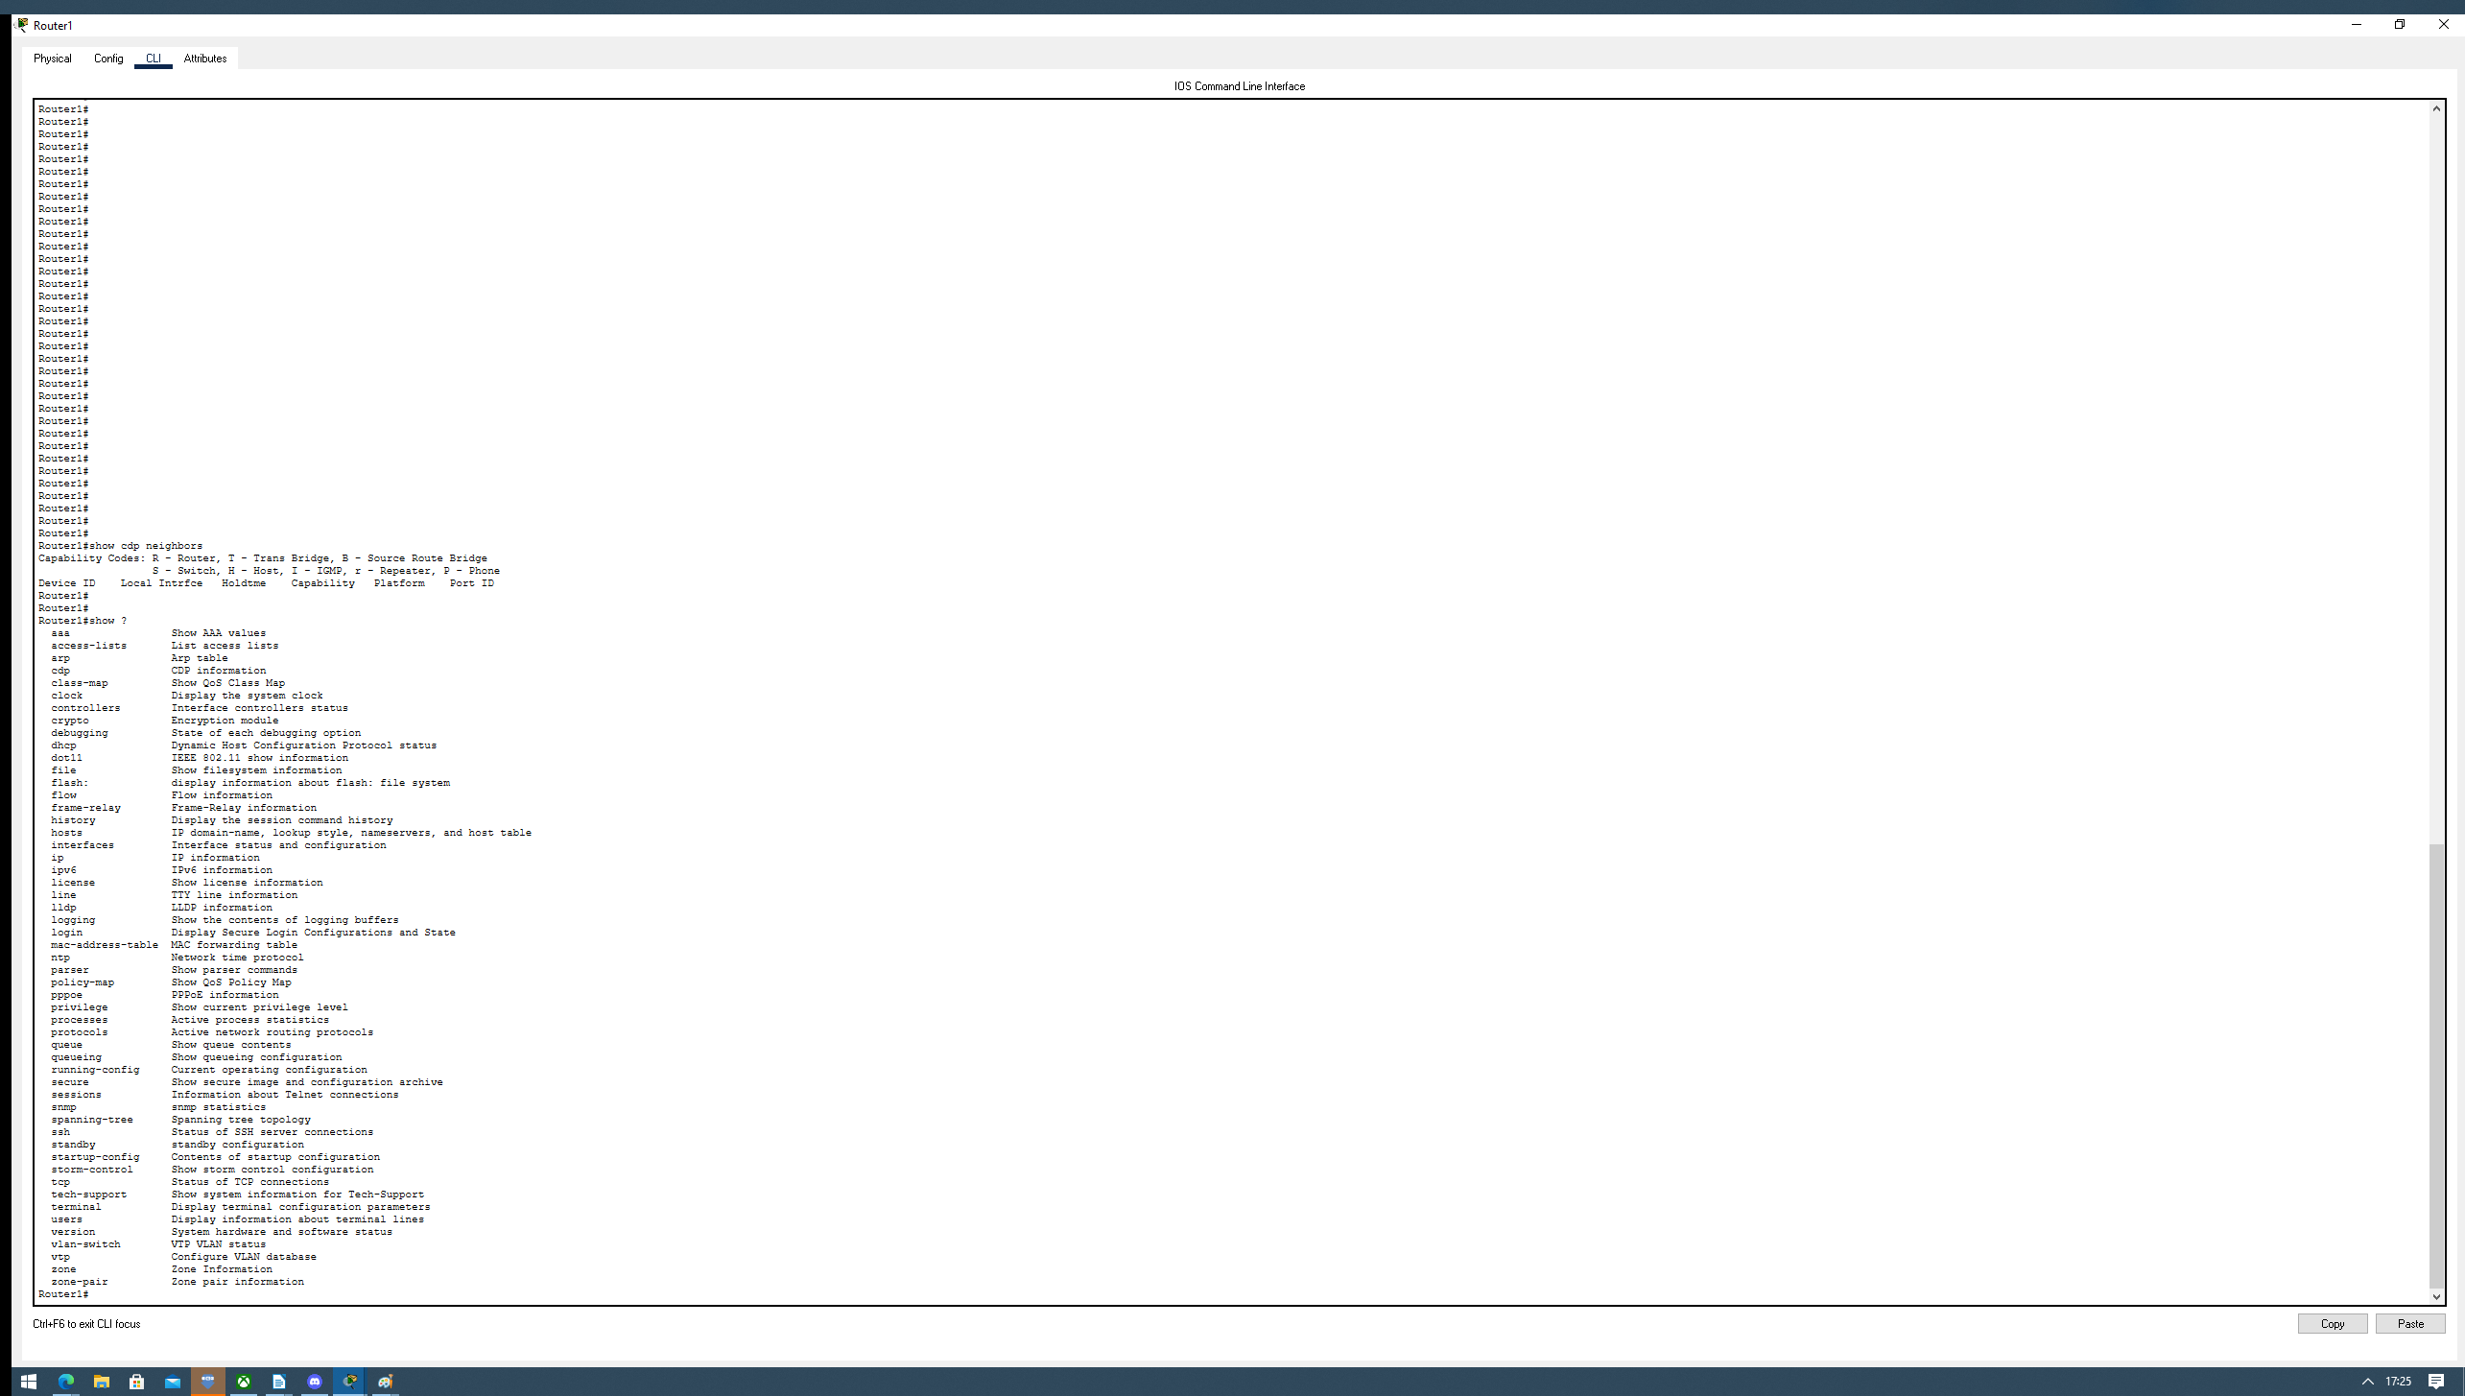

g) Connect the Switch to the second Switch

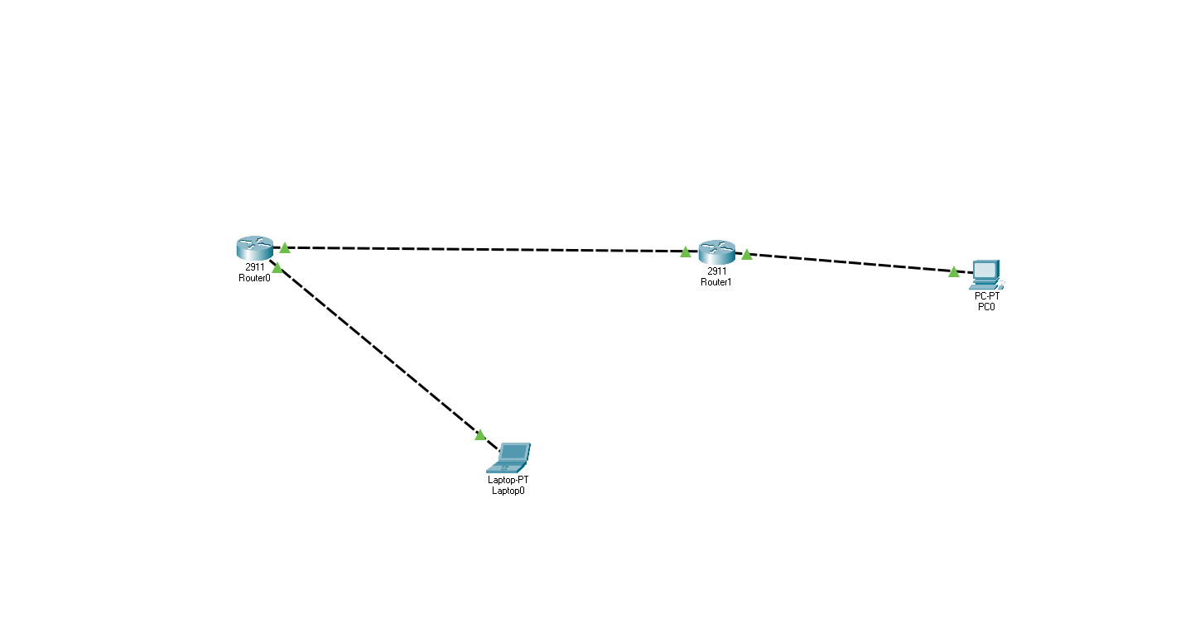

h) Show CDP Neighbors again – look for differences
There is now a result being the new Router0 switch.

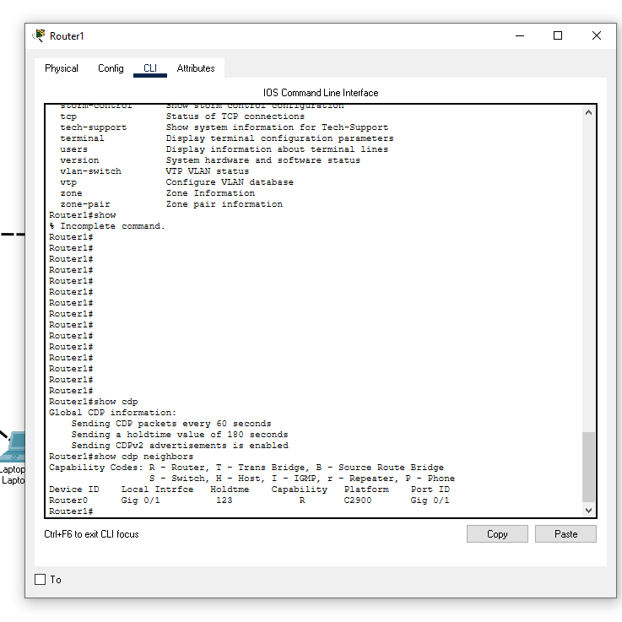

i) Turn Spanning tree on – with fast to port Explain what spanning tree is and how fast to port interacts with it
I cannot get this to function. Need to ask question / correct.

Portfast helps prevent loops in a network and is supported only on nontrunking AP.

Via Cisco website note for myself : “Caution You can use PortFast to connect a single end station or a switch port to a switch port. If you enable PortFast on a port that is connected to another Layer 2 device, such as a switch, you might create network loops.”

j) Down at least one port on the switch
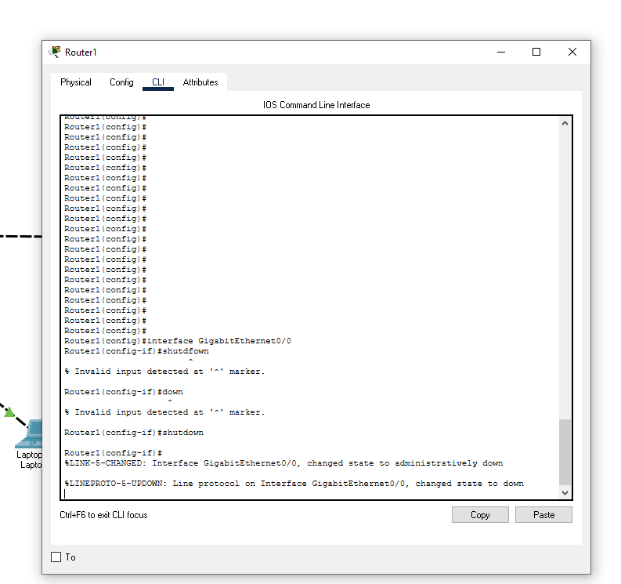

k) Bring the port back on-line
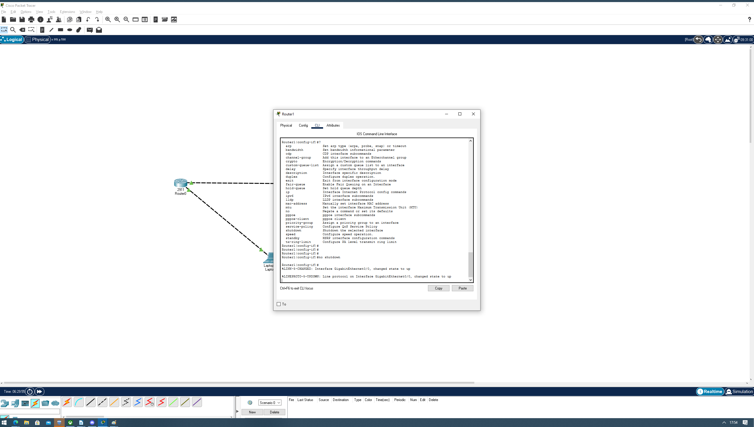

l) Configure the a IP address for the switch Modes: Enable Config T
? huh? Do what?
This?

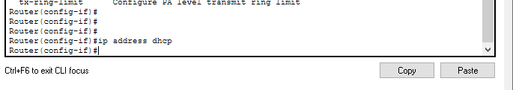
En→ conf t → interface GigabitEthernet0/0 → ip address dhcp

