Alexander J King
The University of Toledo College of Engineering
CSET4750 Computer Networks and Data Communications
LAB 4
9.20.21

all screenshots are high res / able to be zoomed in.

Determination of MAC Addresses/DHCP/Packet Capture Two hosts on a local area network can only communicate if they know each other’s physical network address.
* Determining the MAC address of devices from Windows O/S (XP and newer). Start/Run/cmd/ipconfig or ipconfig /all
* Determining the MAC address on a Unix machine: You can determine the MAC address using the interface configuration command: ifconfig # man ifconfig # ifconfig –a At boot, the NIC is initialized by the O/s. You can see the messages involved in system start-up by typing the command: dmesg. You can control output by piping the results to: more. Within the more command, you can search for strings by typing: /search_string # dmesg | more
* Determining the MAC address of other host on the network: One method of determining which hosts are on the LAN is by examining the ARP table. Additionally, the ARP table can be manipulated to add new entries or deleted stale entries: man arp -or- arp /h # arp –a display arp table # arp –d

* delete arp table #ping host ip to add host ip to arp table (example ping 131.183.222.84) #arp –a The University of Toledo College of Engineering CSET4750 Computer Networks and Data Communications LAB 4: Determination of MAC Addresses/DHCP/Packet Capture Page 2

1) Supply the IP Address, MAC Address and NIC Manufacturer for each of the following:
a) Your workstation
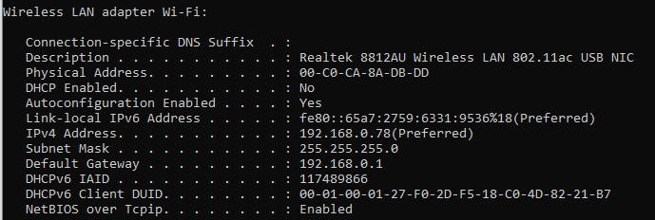

b) Your lab partner’s workstation
My linux VM with a bridged network is how it is actually normally gets WAN (eth0) It doesn’t have WAN right now because my second NIC isn’t wanting to work there is LAN between the VM and my machine though. Also I’m going to use the same Afla wireless card from ‘my workstation’ above because I want to use airodump to find my AP mac (wlan0).

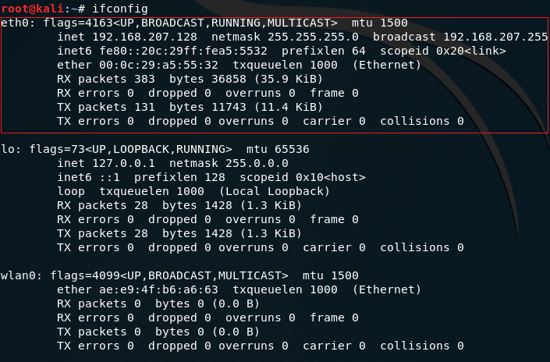

c) The default gateway for your LAN
via aerodump-ng
via AP dashboard
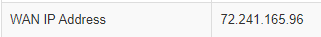

d) et791.ni.utoledo.edu
Can only get IP.
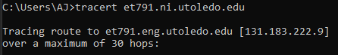

e) foxnews.com
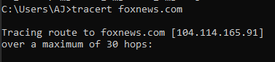

f) eng.utoledo.edu
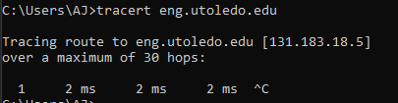

2) What is the broadcast IP for the network your workstation is on?
192.168.0.255

a) What happens if you ping the network broadcast IP?
Windows doesn’t let you to prevent basically DDOSing the entire internet.
Linux will let you but it did not end up pinging the entire internet. I believe it just stayed local.

b) What happens if you ping the LAN broadcast IP?
They all time out but everyone on the network replies to the broadcast and populates my ARP table.

3) Windows DHCP Observation: Disconnect the Ethernet cable connecting the classroom switch to another switch (if you are doing the Lab remotely – use packet tracer). Then force the computer to attempt to renew the lease for its IP stack.

a) Explain what happened.
It cannot find a DHCP server. It will fail multiple times and then utilize Aaxxx to keep retrying every 5 min.

b) Reconnect the Ethernet cable to the classroom switch and then force the computer to attempt to renew the lease for its IP stack. Explain what happened
It reconnects when the server once again becomes available.

The University of Toledo College of Engineering
CSET4750 Computer Networks and Data Communications
LAB 4: Determination of MAC Addresses/DHCP/Packet Capture

Page 3 GUI Implementations and All-in-One’s Wireshark is a network protocol analyzer that combines all of the elements the OSI layers into a single analyzer. The GUI, advanced capture features, and ease of use make it a popular choice for network administrators seeking an all-in-one package. http://www.wireshark.org
1) Start wireshark
2) Ping another PC in the classroom
3) Open the Web Page http://www.cnn.com
4) Set a filter to only show icmp
5) Do step ‘2’ and ’3’ again

Questions:
1) What type of data are you seeing when using TCPDUMP or Wireshark?
Once we filter for icmp traffic that is all I’m going to see. These are pings.

2) What is promiscuous mode?
Promiscuous mode allows us to keep packets that the system would normally otherwise throw out because they’re not intended for us.
With the correct NIC you could also packet inject.

3) What is Pcap/WinPcap?
Driver needed for promiscuous mode. “packet capture / Windows Packet Capture”.

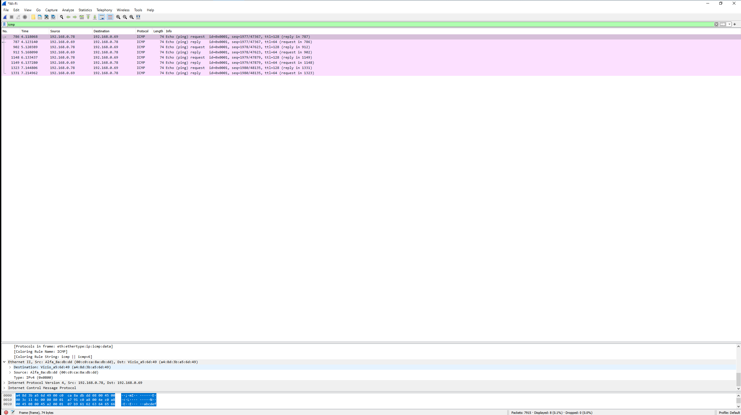
Output for pinging my TV on the same network. I did a default ping so I sent 4 requests and got 4 replies.
Unfiltered output is a ton of TCP just like it should be…. But I am noticing something that might make me tweak some settings I am getting the occasional malformed packet. Not good.

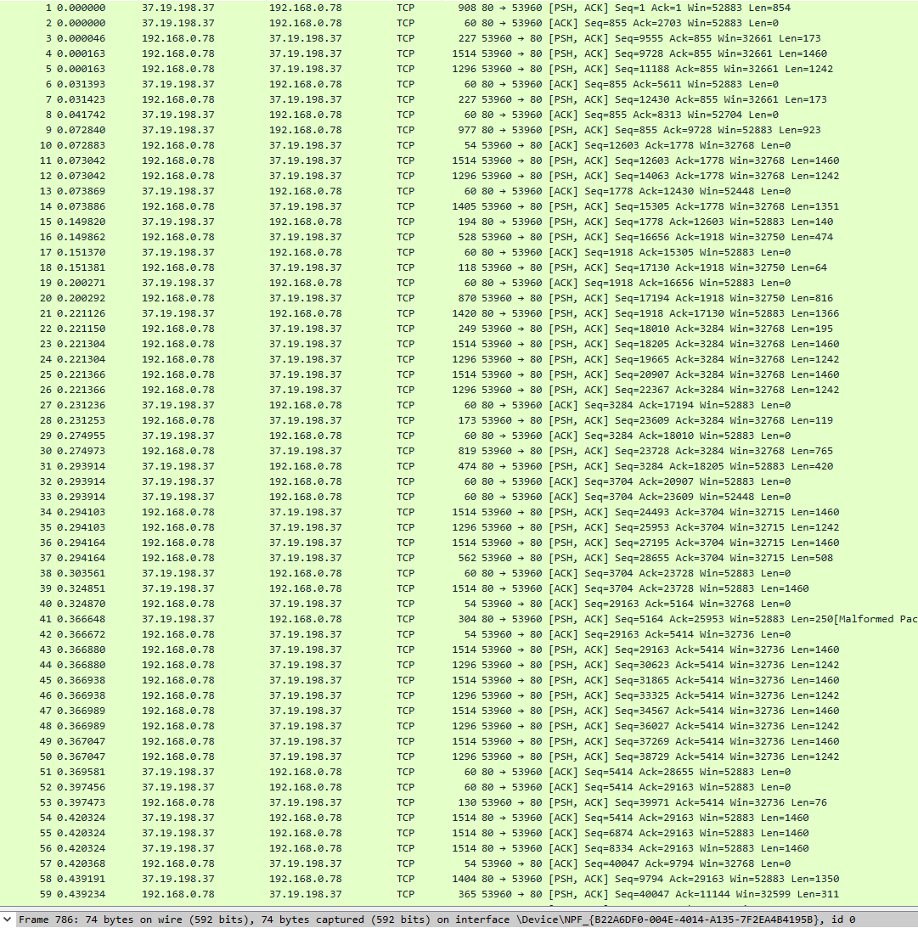

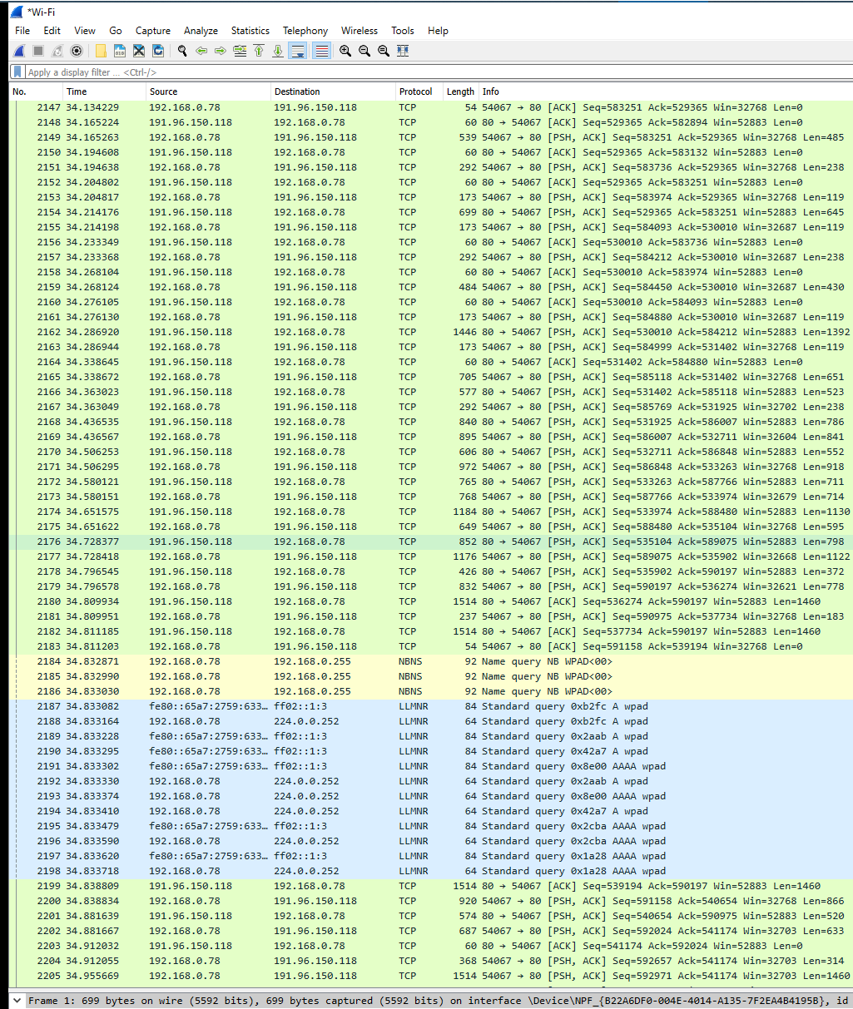
Checking my settings and I think I found the one that was off → no more malformed packets and all is well in the LAN.
“NBNS serves much the same purpose as DNS does: translate human-readable names to IP addresses (e.g. www.wireshark.org to 65.208.228.223)”. - https://wiki.wireshark.org/NetBIOS/NBNS
Link-Local Multicast Name Resolution (LLMNR)
♪♫ I control my flow better than TCP, I rep the west coast like Easy-E, you best not front if you can’t pass the GRE cuz there’s so much drama in the PhD.♪♫ - Monzy

