Alexander J King
The University of Toledo College of Engineering
CSET4750 Computer Networks and Data Communications
LAB 5: DHCP Messages/Supernetting/subnetting

1) Monitoring DHCP messages
a) Start Wireshark – configure to monitor only UDP packets
b) Type ipconfig /all – ipconfig /release – ipconfig /renew
c) Locate the DHCP Messages in the WireShark Log for each command

Question: Using only the DHCP messages, what is the IP address of the DHCP server? How do you know?

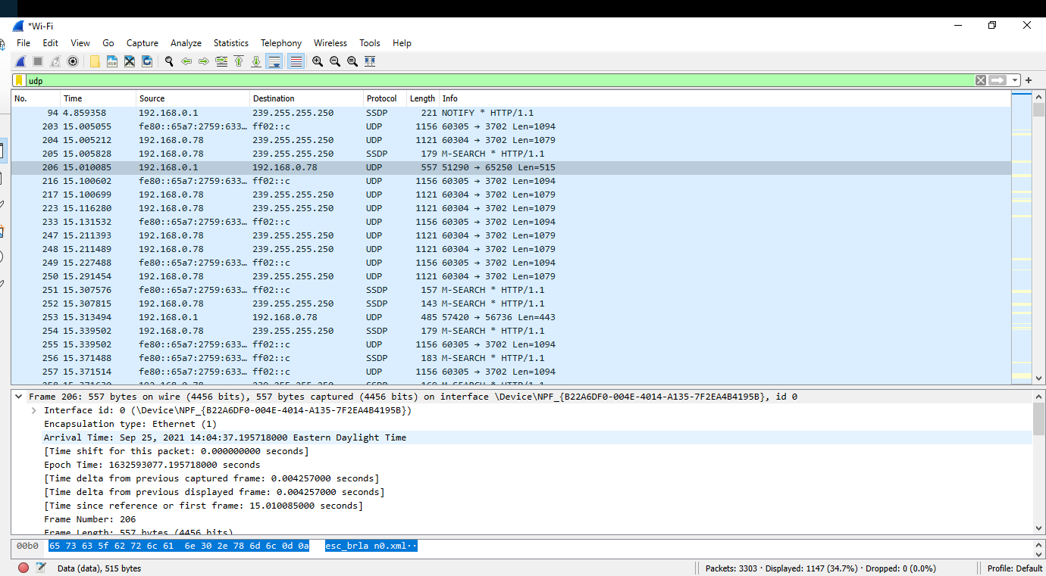
(high resolution able to be zoomed in)

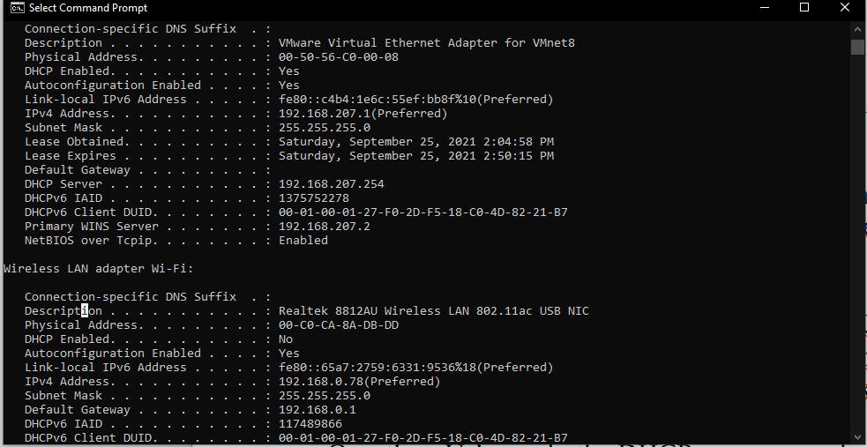
I know because ipconfig / all shows the dhcp server address. Seen here as 192.168.207.254

2) Using the addresses below, make a Supernet with the most usable host.
225.113.8.0/24
225.113.9.0/24
192.168.0.0/16
220.127.136.0/24
220.128.135.0/24
220.128.136.0/24
220.128.137.0/24
206.122.148.0/24
10.0.0.0/8
220.125.138.0/24
220.126.137.0/25

a) What is the CIDR notation for the Supernet?
192.0.0.0/8

b) What is the range of addresses for the Supernet?
192.0.0.1-192.255.255.254

The University of Toledo College of Engineering CSET4750 Computer Networks and Data Communications

LAB 5: DHCP Messages/Supernetting/subnetting Page 2

3) Identify the networks if you subnet 125.10.30.0/24 into:
a) Two /25 networks
125.10.30.1-125.10.30.126
125.10.30.129-125.10.30.254

b) Four /26 networks
125.10.30.1-125.10.30.62
125.10.30.65-125.10.30.126
120.10.30.129-125.10.30.190
125.10.30.193-125.10.30.254

c) How many networks would you have if you used fixed length /30 networks? List the first four sub-networks

64 networks
125.10.30.1-125.10.30.2
125.10.30.5-125.10.30.6
125.10.30.9-125.10.30.10
125.10.30.13-125.10.30.14

3) Identify the networks if you subnet 222.0.1.0/24 into:
One /25 and One /26 and One /27 and One /28 and One /29 and One /30

222.0.1.0
222.0.1.128
222.0.1.192
222.0.1.224
222.0.1.240
222.0.1.248

The University of Toledo College of Engineering CSET4750 Computer Networks and Data Communications LAB 5:
DHCP Messages/Supernetting/subnetting Page 3

4) Identify the network ranges for the following addresses:
a) 215.206.129.130/16
215.206.0.1-215.206.255.254

b) 215.206.129.130/15
215.206.0.1-215.207.255.254

5) Are the following addresses “local” (on the same network)?
193.230.131.132/29
193.230.131.92/29

No.

If not - What would you have to do to make them “local”?

Use a normal /24 instead of /29.

