Alexander J King
The University of Toledo College of Engineering
CSET4750 Computer Networks and Data Communications
LAB 5: DHCP Messages/Supernetting/subnetting

1) Monitoring DHCP messages
a) Start Wireshark – configure to monitor only UDP packets
b) Type ipconfig /all – ipconfig /release – ipconfig /renew
c) Locate the DHCP Messages in the WireShark Log for each command

Question: Using only the DHCP messages, what is the IP address of the DHCP server? How do you know?

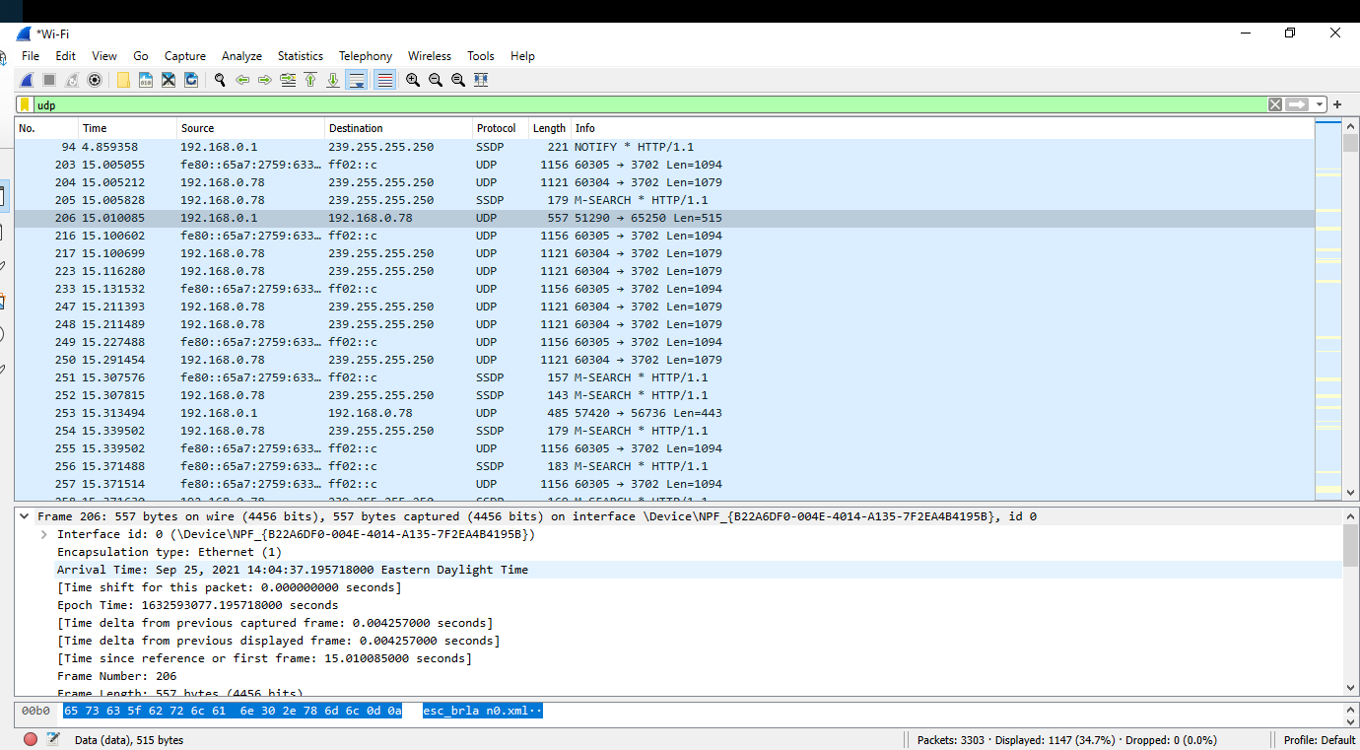
(high resolution able to be zoomed in)

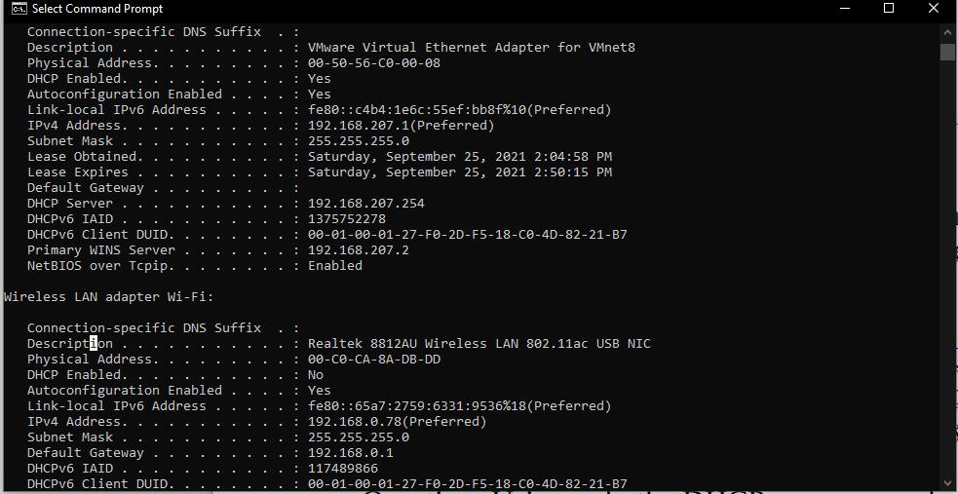
I know because ipconfig / all shows the dhcp server address. Seen here as 192.168.207.254.
Note this is for VMWARE that thinks it has an Ethernet connection. My actual Ethernet cable is damaged needed re-crimped. Someone ripped the RJ45 out of its socket.

2) Using the addresses below, make a Supernet with the most usable host.
220.128.136.0/24

a) What is the CIDR notation for the Supernet?
220.128.136.0/23

b) What is the range of addresses for the Supernet?
220.128.136.0 - 220.128.137.255

The University of Toledo College of Engineering CSET4750 Computer Networks and Data Communications

LAB 5: DHCP Messages/Supernetting/subnetting Page 2

3) Identify the networks if you subnet 125.10.30.0/24 into:
a) Two /25 networks
125.10.30.0-125.10.30.127
125.10.30.128-125.10.30.255

b) Four /26 networks
125.10.30.0 - 125.10.30.63
125.10.30.64 -125.10.30.127
120.10.30.128-125.10.30.191
125.10.30.192-125.10.30.255

c) How many networks would you have if you used fixed length /30 networks? List the first four sub-networks

64 networks
125.10.30.0 - 125.10.30.3
125.10.30.4-125.10.30.7
125.10.30.8-125.10.30.11
125.10.30.12-125.10.30.15

3) Identify the networks if you subnet 222.0.1.0/24 into:
One /25 and One /26 and One /27 and One /28 and One /29 and One /30

222.0.1.0 - 222.0.1.127
222.0.1.128 - 220.0.1.191
222.0.1.192 - 222.0.1.223
222.0.1.224 – 220.0.1.239
222.0.1.240 – 222.0.1.247
222.0.1.248 – 222.0.1.255

The University of Toledo College of Engineering CSET4750 Computer Networks and Data Communications LAB 5:
DHCP Messages/Supernetting/subnetting Page 3

4) Identify the network ranges for the following addresses:
a) 215.206.129.130/16
215.206.0.0 - 215.206.255.255

b) 215.206.129.130/15
215.206.0.0 - 215.207.255.255

5) Are the following addresses “local” (on the same network)?
193.230.131.132/29
193.230.131.92/29

No.

If not - What would you have to do to make them “local”?

Use a normal /24 instead of /29.

