Windows Firewall has been standard since Windows XP. In Windows XP SP2, it was enabled by default, and it has steadily improved over the years.
A firewall is designed to protect a computer or network by controlling inbound and outbound traffic. Most firewalls operate with an implicit deny philosophy. In other words, all traffic is blocked (implicit deny) unless there is a rule that explicitly allows the traffic.
Windows Firewall on Windows 7 also uses an implicit deny philosophy. The only traffic that is allowed is the following:
- Traffic that is explicitly allowed by an exception or a rule. Both inbound and outbound rules can be configured.
- Return traffic that has been requested. For example, if a user requests a web page from a website, the web page is allowed as return traffic.
Windows Firewall works as both a packet-filtering firewall and a stateful firewall.

Packet-filtering firewall
A packet-filtering firewall can filter traffic based on IP addresses, ports, and some protocols. The firewall examines packets individually. Packets can be allowed or blocked based only on what is in each packet. A packet-filtering firewall can't evaluate packets based on the entire communication.

Stateful firewall
A stateful firewall can monitor the state of a connection. In other words, instead of examining each packet individually, it evaluates the packets in the conversation. This allows a stateful firewall to detect and block many attacks.
As a stateful firewall, it can inspect and filter all IPv4 and IPv6 traffic.

1) Run “netstat –an” from the command prompt on your computer.

a. Consider the following output. How is the output you see the same or different?

Active Connections
Proto Local Address Foreign Address State
TCP 0.0.0.0:135 0.0.0.0:0 LISTENING
TCP 0.0.0.0:445 0.0.0.0:0 LISTENING
TCP 0.0.0.0:1025 0.0.0.0:0 LISTENING
TCP 0.0.0.0:1051 0.0.0.0:0 LISTENING
TCP 0.0.0.0:1067 0.0.0.0:0 LISTENING
TCP 0.0.0.0:1083 0.0.0.0:0 LISTENING
TCP 0.0.0.0:2201 0.0.0.0:0 LISTENING
TCP 0.0.0.0:2207 0.0.0.0:0 LISTENING
TCP 0.0.0.0:2679 0.0.0.0:0 LISTENING
TCP 0.0.0.0:3703 0.0.0.0:0 LISTENING TCP 0.0.0.0:5000 0.0.0.0:0 LISTENING TCP
127.0.0.1:2206 0.0.0.0:0 LISTENING TCP
127.0.0.1:2206 127.0.0.1:2207 ESTABLISHED
TCP 127.0.0.1:2207 127.0.0.1:2206 ESTABLISHED
TCP 127.0.0.1:5180 0.0.0.0:0 LISTENING TCP 192.168.0.103:139 0.0.0.0:0 LISTENING
TCP 192.168.0.103:1083 128.153.4.131:22 ESTABLISHED
TCP 192.168.0.103:2201 128.153.3.131:143 ESTABLISHED
TCP 192.168.0.103:12669 0.0.0.0:0 LISTENING
TCP [::]:135 [::]:0 LISTENING 0
TCP [::]:1025 [::]:0 LISTENING 0
UDP 0.0.0.0:445 *:*
UDP 0.0.0.0:500 *:* UDP 0.0.0.0:1027 *:*
UDP 0.0.0.0:1063 *:*
UDP 0.0.0.0:1086 *:*
UDP 0.0.0.0:4211 *:*
UDP 127.0.0.1:123 *:*
UDP 127.0.0.1:1052 *:*
UDP 127.0.0.1:1084 *:*
UDP 127.0.0.1:1085 *:*
UDP 127.0.0.1:1104 *:*
UDP 127.0.0.1:1900 *:*
UDP 192.168.0.103:123 *:*
UDP 192.168.0.103:137 *:*
UDP 192.168.0.103:138 *:*
UDP 192.168.0.103:1900 *:*
UDP 192.168.0.103:10581 *:*
UDP 192.168.0.103:21210 *:*

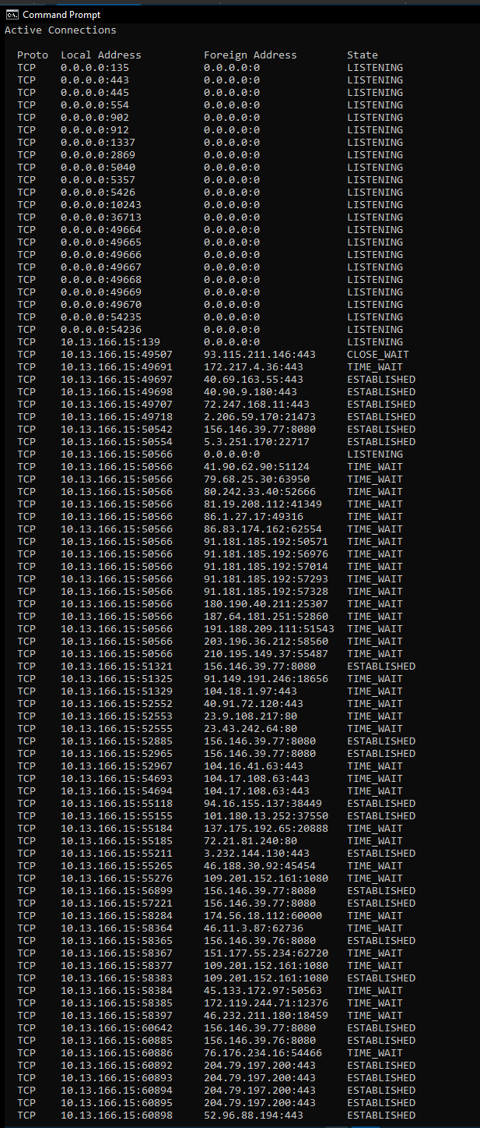

Notice that each line has the following columns:
Proto, Local Address, Foreign Address and State

Let’s examine each one.

The name of the first column, Proto, stands for protocol and is either TCP or UDP. TCP and UDP are two types of network protocols in the Internet.

Notice that the TCP lines all end with either ESTABLISHED or LISTENING for a state.

ESTABLISHED connections are those that are actively being used to transfer data. The LISTENING connections are not currently being used to transfer data but they represent server software that is ready to accept and respond to requests should they arrive.

The foreign and local address portions of each line are composed of two portions separated by a colon -- an IP address and a port number. The IP address indicates the numerical address of the computer on which the network software is running. The port number indicates the “mailbox” number on that particular computer for that particular service or network conversation.

You can investigate each type of server running on your machine.
For example, consider the first line:
TCP 0.0.0.0:135 0.0.0.0:0 LISTENING.

It says that a service is listening on TCP port 135.
- What type of service typically runs on TCP port 135?
Location Service

- What are some computer viruses that have exploited flaws in this service?
Null session access vs Windows NT ~2002

- Do a complete investigation of each service running on your computer. List the services.
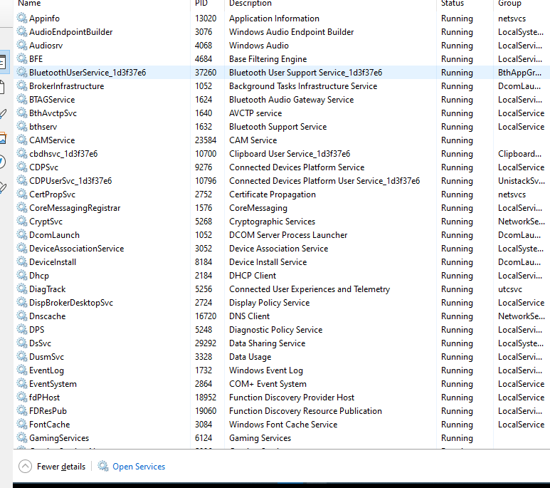

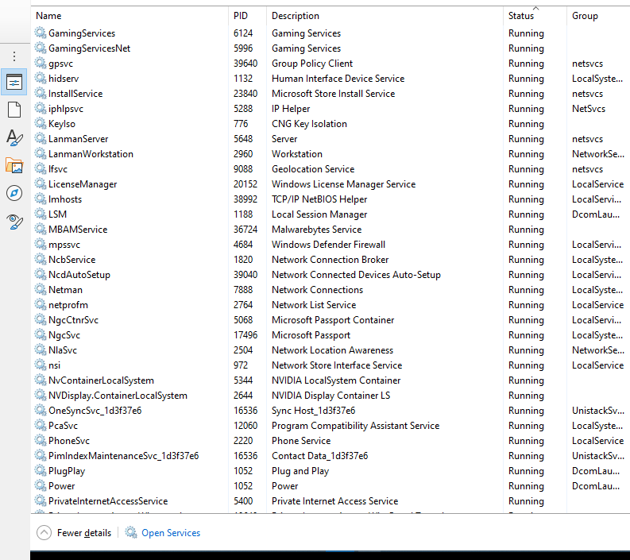

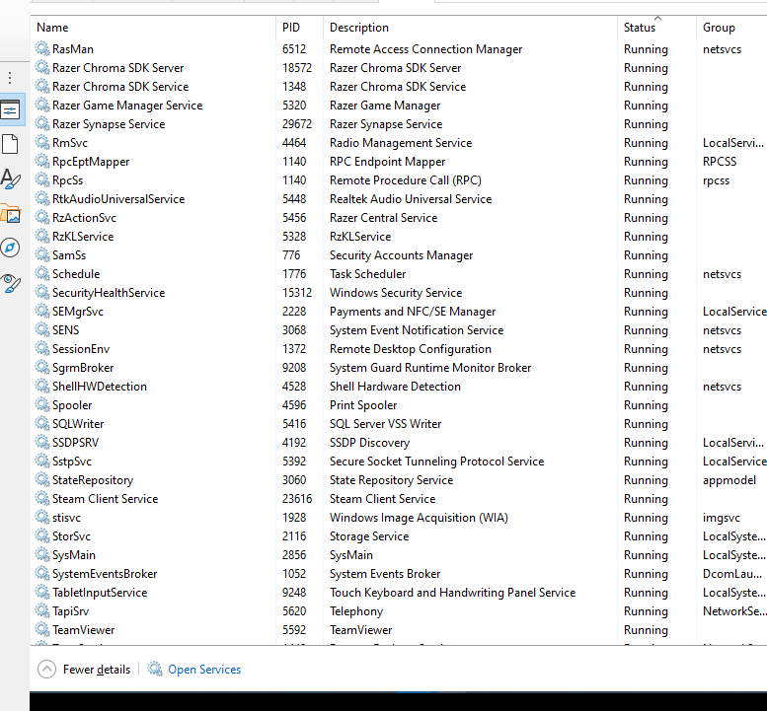
- A group called the Internet Assigned Numbers Authority decides what services run on what ports.

What is the term used to describe the ports assigned by the Internet Assigned Numbers Authority?
Registered Ports.

2) Start Wireshark
- Connect to “myut.utoledo.edu” Look for 3-way Handshake
What is the Port # used to make the Connection with “myut.utoledo.edu”?
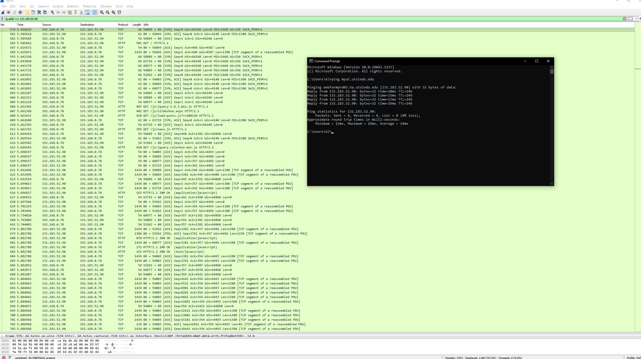
Find IP address with a ping and sort to only see communications with that IP within Wireshark.

My port was 56049 the destination (myut.utoledo.edu) is using port 80

What is the Socket used to make the above connection?
131.183.52.90:80
ip + port = socket.

- Log into “myut.utoledo.edu”
Explain what happened to the Port # and why.
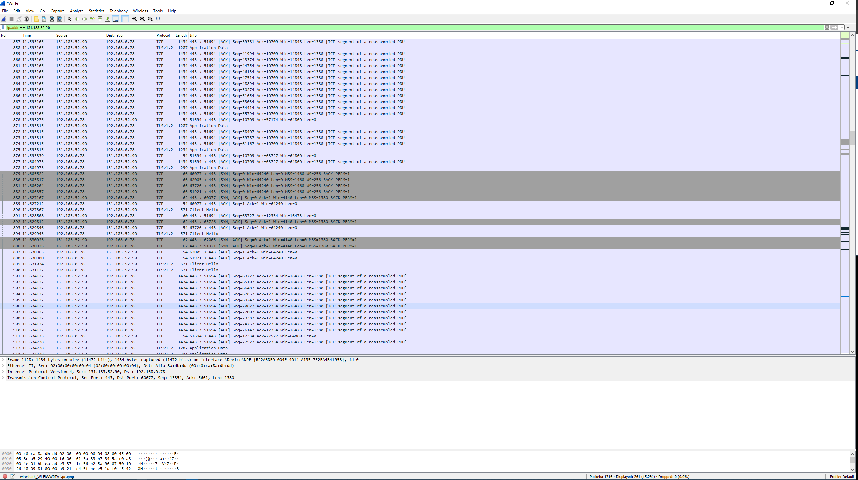
Switched to port 430 UDP/TCP. We’re using TCP. It changed I suspect because we switched from non-ssl to using SSL for a secure log-in.

Setup a Hub with 2 PC’s and a frame grabber – Wireshark (snooper)

Exercise:
Assume you want to monitor activity on a “target” machine, but you do not have access to the target. In our testbed, we have the following network structure:

192.168.1.250 host A
192.168.1.200 host B (“target”) 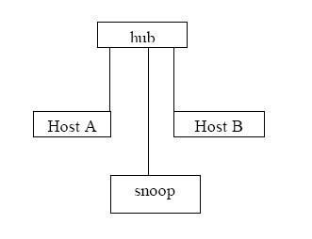

The “snoop” can monitor data between host A and host B using a Frame capture program filtered to the Host IP

Things to Try:
NOTE: Try these with Host B plugged into a Hub – document what happens
Then plug Host A, Host B, and the sniffer into a switch and try them again – document what happens

- Host A: Ping Host B
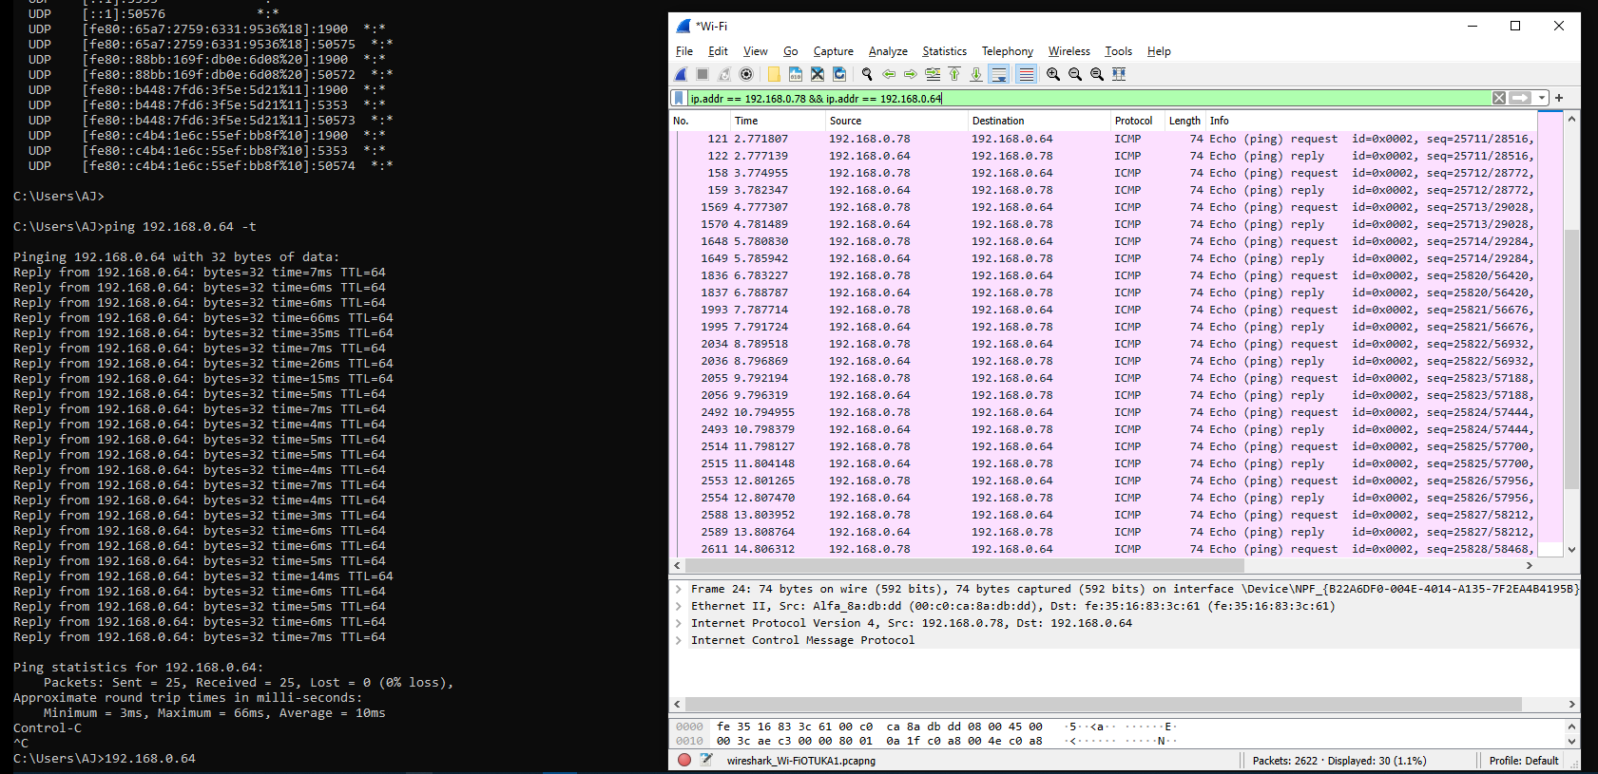

- Host B: Ping Host A
same as above (in reverse).

- Host B: Ping the Broadcast IP
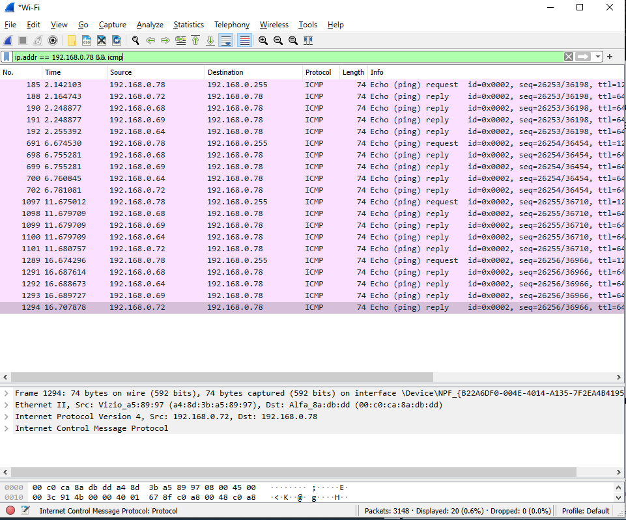

Host B: Continually Ping Host A
Same as above pings except you run ping <host A address> -t to keep it going until stopped.

Questions for Exercise:

- In the test bed above, what are the requirements necessary to monitor a target machine?
Be connected to the same hub.

- Is it be possible to monitor the target machine when the hub is replaced by a switch? Why or why not?
No. Not unless I port mirror on the switch to gain access to the packets I want to monitor.

- Would it be possible to monitor the target machine if Host A were located on another LAN or WAN?
No.

- What are the advantages and disadvantages of using programs of this type?
The advantage is being able to audit the network with a powerful freeware tool. This can help us secure out networks.
The disadvantage is similar…. Attackers could also monitor the network with a powerful freeware tool for malicious purposes.

- Assuming you wanted to control the unauthorized capture of data on your LAN, what measures might be implemented?
I could encrypt everything as I would normally do anyways. So the data could be captured but it will not really be readable or helpful.

I could also use a switch instead of a hub.

- What if the “server segment” were protected, could the server still be compromised by the use of such a program
I’m not sure I understand what is being asked. Feels like missing context.
If a segment is properly protected I shouldn’t really be able to get too much useful information. Could still get socket and try to attack that. Maybe nmap the address.

4) Using the PDF named “Configure Port Mirrors on Cisco Switches” on Blackboard.
Configure a port on your Enterprise Switch to Monitor
Configure a port on your Enterprise Switch to Receive the Mirrored data
On the PC connected to the Receiving port start Wireshark
Thing to try on the Monitored port
Ping another Host on the same LAN

Have another Host on the same LAN ping it
Ping the Broadcast IP
Telnet eng.utoledo.edu 80
Go to www.myut.utoledo.edu

- What are the differences between snooping on a device using port mirror and using a tool like Wireshark?
Not much. They will both grab and save packets not intended for them. But when you’re using a switch to accomplish this you MUST mirror the port you want to monitor.

- What are the advantages of using port mirror over a tool like Wireshark?
I personally prefer wireshark.
The advantage would be not being on a hub though. It makes it easier for the good guys to see the data going across the network and harder for the bad guys.

