The University of Toledo College of Engineering
CSET4750 Computer Networks and Data Communications
LAB 7: DNS/IPv6
1) The "Hosts" file in Windows and other operating systems is used to associate host names with
IP addresses. The computers use the numbers to actually find the sites, but we have words
like www.yahoo.com so humans do not need to remember the long strings of numbers when
they want to visit a site. HOSTS file location: Windows - %systemroot%\system32\drivers\etc\ Unix/Apple - /etc/hosts A series of steps are used when searching for IP addresses that go with host names. The first
step, is the hosts file on your local computer. If the IP address (for the requested host/site) is
found in your Hosts file, the computer will stop looking and go to that site, but if it is not it will
look in the local DNS cache, if the IP address is found the computer will stop looking and go to
the site. If the IP address is not found in either the Hosts file or the DNS cache then the
computer will ask a DNS computer (domain name server) for the information. Since the search ends once a match is found, that provides us with a mechanism to block sites
we have no interest in. You may block sites that serve advertisements, sites that serve
objectionable content, or any other site that you choose to block.
We can put names and addresses into the Hosts file so your computer does not have to ask a
DNS server to translate the domain name into an IP number. This speeds up access to the host
site you want to see because your computer no longer has to query other systems on the
Internet for the address translation. When you type in a web address like www.yahoo.com,
the host name portion of the web address is translated into an IP address before the site is
accessed. If you put Yahoo!'s host and IP settings into your Hosts file, it would load a little
quicker because your computer doesn't have to ask another to translate where to look for
Yahoo! Computers have a host address of their own - it is known as the "localhost" (or loopback)
address, with an IP address of 127.0.0.1 which it uses to refer to itself. If you associate another
computer's host name with your localhost IP address, you have effectively blocked that host
since all attempts to access it will lead back to you. That is how we will block sites using the
Hosts file. We will tell our computer that the IP address of the site we want to block is our own
address. That way, our computer will not ever leave and go looking for the site we are
blocking - which keeps that site from appearing because the computer thinks it has found the
site and displayed it already.
The University of Toledo College of Engineering
CSET4750 Computer Networks and Data Communications
LAB 7: DNS/IPv6
Page 2

a) What are the IP addresses of “myut.utoledo.edu” and “www.foxnews.com”
[131.183.52.90 – my UT
23.201.73.219] – FauxNews
b) Using the local HOSTS file, make the “www.foxnews.com” Domain Name point to the
IP address for “myut.utoledo.edu”. What happens when you try to go
“www.foxnews.com” and the “myut.utoledo.edu” Domains? Explain what happened
and why.
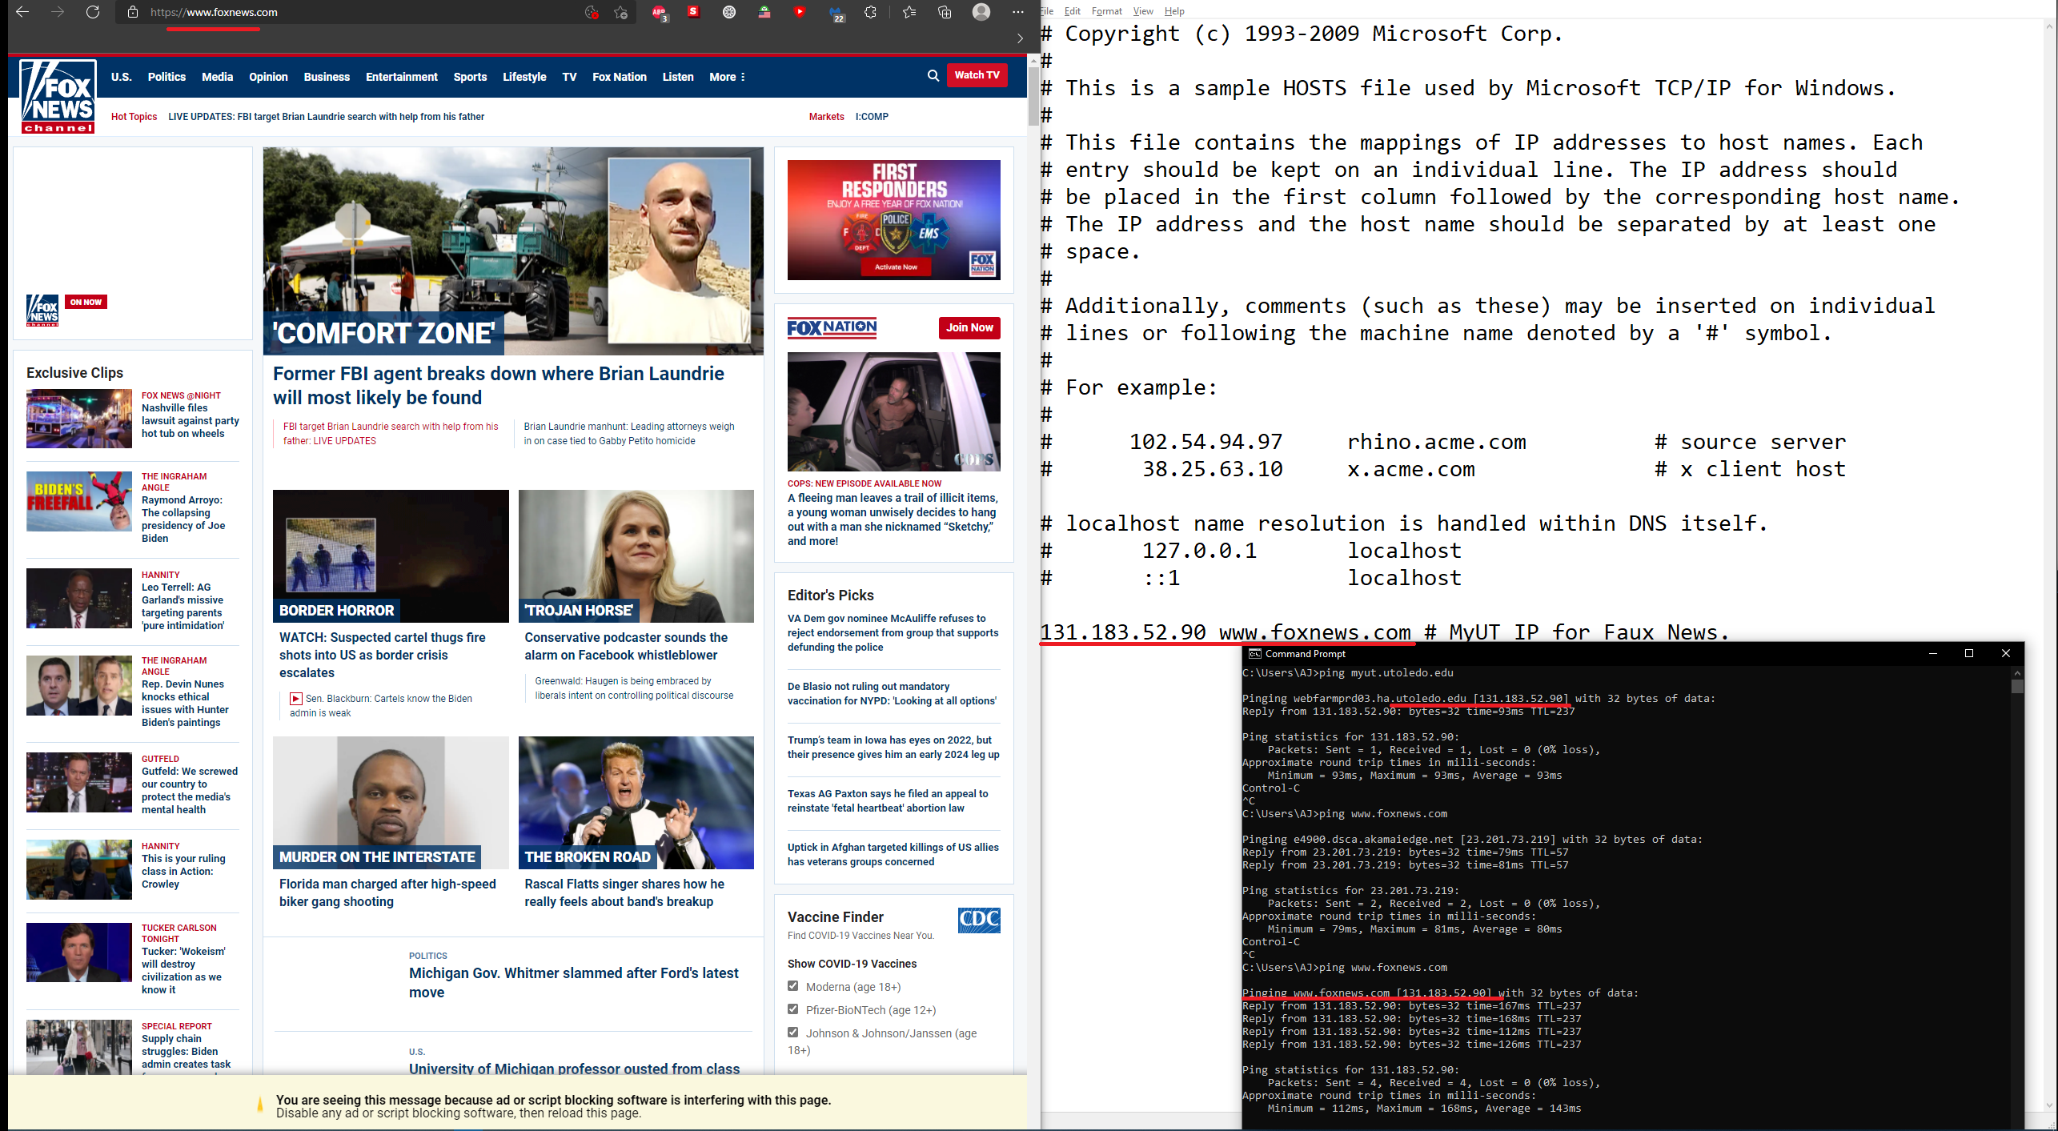

Pinged both myut and FauxNews got their IP addreses and then pointed Fox towards MyUT IP address in the local host and the browsers still went to the correct Faux news. You can however see when I tried to then ping www.foxnews.com it pinged the Myut address.
In short: It worked in CMD and not in a browser.

c) Using the local HOSTS file block both the “www.foxnews.com” and the
“myut.utoledo.edu” domains. Explain how you blocked the sites and what happened when you attempt to access the sites.

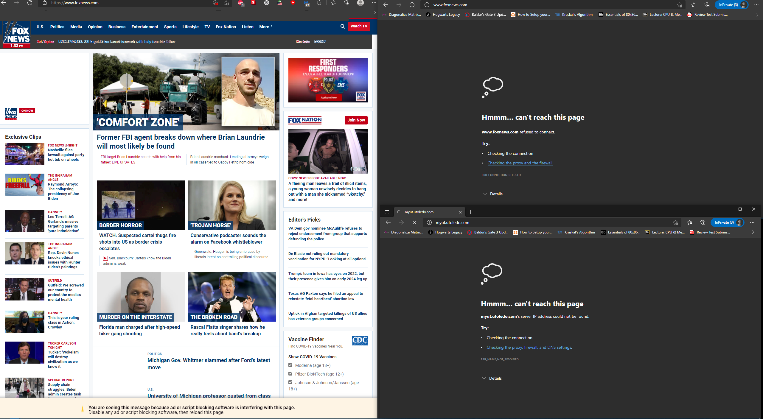
Blocked only in incognito…. Does my browser proxy bypass the host file?
Normal left, in-private right.
Right hand side is the expected result.

d) Erase your entries in the HOSTS file and save the file. What happens when you try to go to “www.foxnews.com” and the “myut.utoledo.edu” domains? Explain the
difference between what you see now and what happened in “c)” above

Now the sites work! ♪♫ Oh happpy days (Oh happy days) when MyUT loads!♪♫
The University of Toledo College of Engineering
CSET4750 Computer Networks and Data Communications
LAB 7: DNS/IPv6
Page 3 2)The ipconfig/displaydns command provides you with a means to view the contents of the DNS
client resolver cache, which includes entries preloaded from the local Hosts file, as well as any
recently obtained resource records for name queries resolved by the system. This information
is used by the DNS Client service to quickly resolve frequently queried names before it queries
its configured DNS servers. When the ipconfig /displaydns command is used to display current resolver cache contents,
the resultant output generally includes the local host and loopback IP address (127.0.0.1)
mappings. This is because these mappings typically exist in the default (unmodified) contents
of the local Hosts file. After you can add host mapping entries to the local Hosts file and save the file, these entries
are added to the displayed output of this command. The resolver cache can also support negative caching of unresolved or non-valid DNS names.
These entries are added by the DNS Client service when it receives a negative answer from a
DNS server for a queried name. The negative result is cached for a short period of time so that
it is not again queried, which could cause query performance problems. During DNS troubleshooting, you can flush and reset the cache to discard negative entries
from the cache and any other dynamically added entries that were not preloaded. Use the ipconfig /flushdns command to flush and rest the cache

a) Flush the DNS cache on the local computer
b) run ipconfig /displaydns
c) go to www.foxnews.com and myut.utoledo.edu
d) run ipconfig /displaydns and explain why the difference between what you see now and what you saw in “b)” above

After flushing dns it will be empty. After visiting these sites again and getting an authoritative answer for their DNS location it will repopulate my /displaydns and appear in the results.

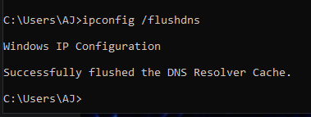

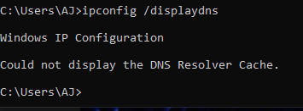

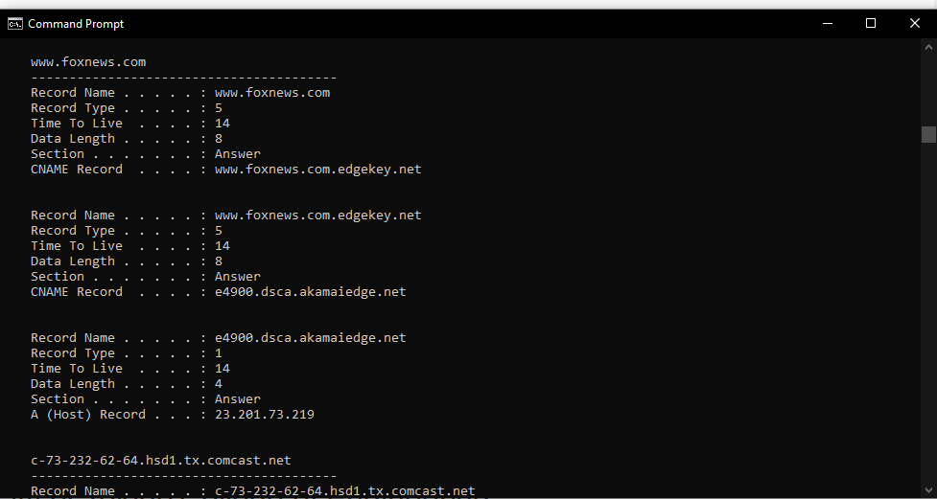
Getting this error “could not display the DNS Resolver Cache. Even after navigating to the sites.
Expected result would be to repopulate with the a non-authoritative entry to be used.
***remembers to turn off VPN*** and now I can see www.foxnews.com in my ipconfig /dnsdisplay

The University of Toledo College of Engineering
CSET4750 Computer Networks and Data Communications
LAB 7: DNS/IPv6
Page 4
3) Wireshark
a) run ipconfig /flushdns
b) start wireshark
c) filter on DNS
d) Load “my.ut.utoledo.edu”
e) Find the DNS messages What is the IP of the DNS Server?

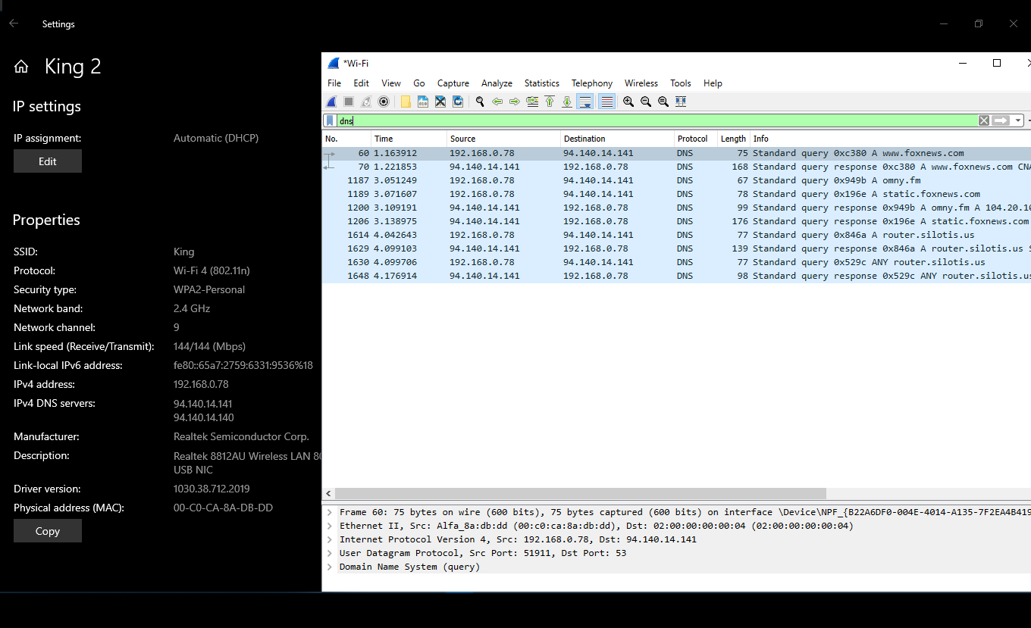
Top result in Wireshark is the dns query. Confirmed this is the expected address looking in my network properties (it is the expected address).

4) Do NSLOOKUP on: my.ut.utoledo.edu
utoledo.edu What information do you find? Explain.
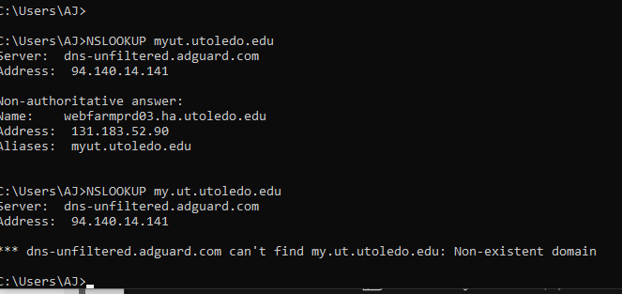
Homework typed URL wrong so I did both. my.ut.utoledo.edu && myut.utoledo.edu
Typing it correctly shows my DNS server and the ip address of myut.utoledo.com. Typing it incorrectly (as the homework suggested) produces only my DNS server IP.

5) Do a reverse lookup for your answers to 4 above. What information do you find? Explain.
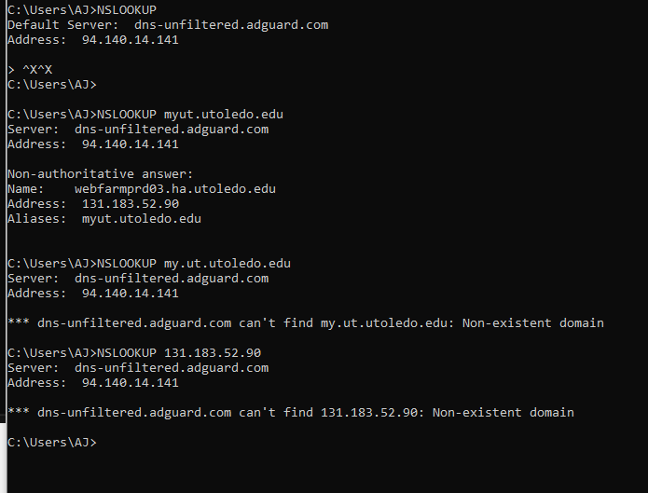

I did a nslookup for 131.183.52.90… I think this is what the question wanted?

The University of Toledo College of Engineering
CSET4750 Computer Networks and Data Communications
LAB 7: DNS/IPv6

Page 5
6) Environment variables are some of the most useful tools available to command shell script writers. By default, all Windows systems include a host of environment variables that can provide important information about the system and the current user.

To list all your system's environment variables, you can type “set”.

a) Run ipconfig /all – is your compter running Ipv6? How many Ipv6 addresses are on your computer?
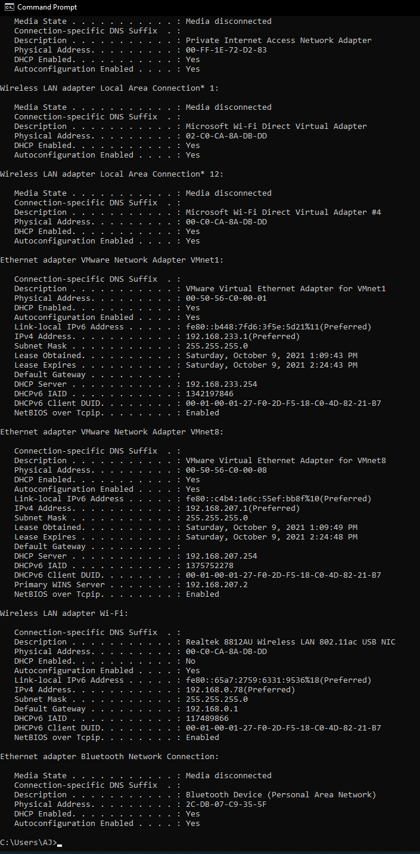

I see local link IPV6 addresses so I assume yes it is running IPV6.

b) Using the “SET” command, what is the COMPUTERNAME of your computer?
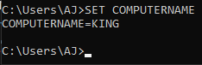

c) Ping the COMPUTERNAME – What address replies to the ping? Is it an Ipv4 or Ipv6 address?

IPV6
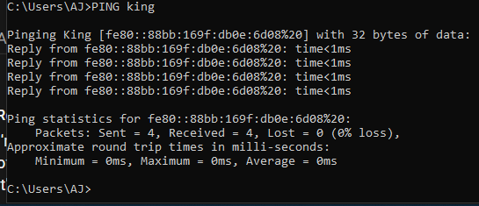

d) Ping the COMPUTERNAME of your LAB partner’s computer – forcing a reply from Ipv4 then force a reply from Ipv6 – How would you do this?

IPV4 use at the end of the command -4
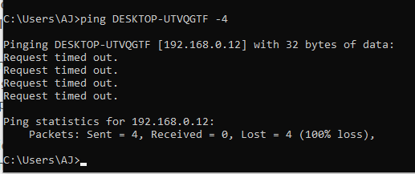

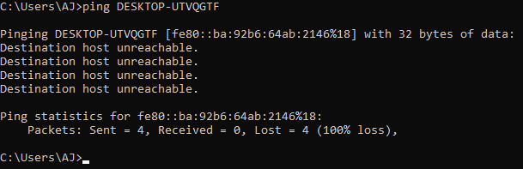
IPV6 - default

Looks like her device doesn’t reply to pings. Looking at the IPV4 address it came up with looks right though.

e) In the Network Connection Properties i. Remove Ipv6 ii. Run ipconfig /all iii. What is the difference between what you see now and what you saw in ‘a)’ above?
No longer lists some of the ipv6 addresses. Still see some IPV6 dns addresses.

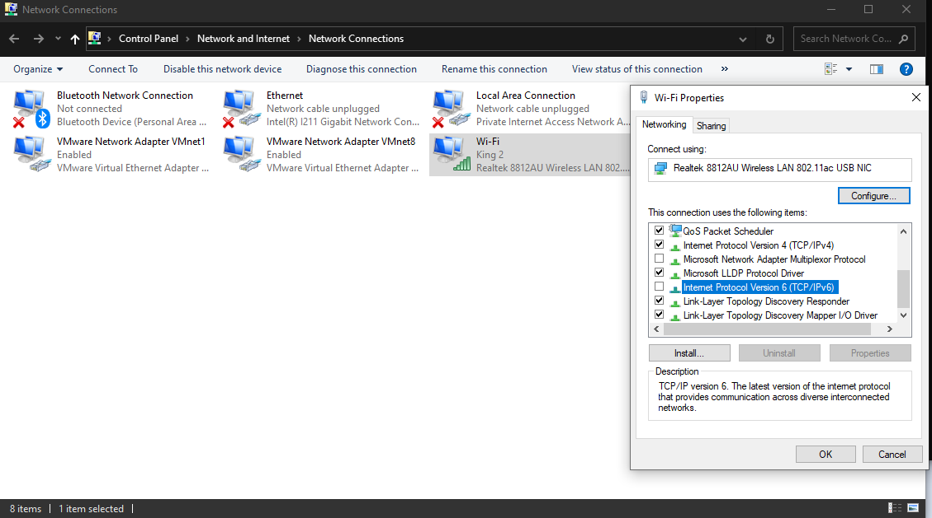

Still works.

The University of Toledo College of Engineering
CSET4750 Computer Networks and Data Communications
LAB 7: DNS/IPv6
Page 6
f) Ping the COMPUTERNAME of your computer (forcing Ipv6) – what address is used now?
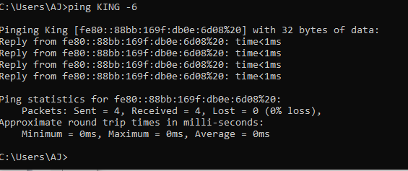

g) In the Network Connection Properties – Allow Ipv6 again
-done
h) Make a guess – Does your computer fully support Ipv6?
Yes.

7) From your browser run http://test-ipv6.com – Does your computer fully support Ipv6?

No. With the VPN off only DNS was using IPV6. With it on nothing used IPV6.
I was very very wrong lol.

8) Look at the Ipv6 address for the 6to4 Tunnel adapter (use ipconfig /all)
a. From left to right (after the 2002:)you will see 8 Hexadecimal characters
b. Convert those Hexadecimal characters to decimal
c. What is important about those values?

-doesn’t exist on my device. Will try this next time we meet in class. Maybe not on the test day Monday.
I can conver between dec,binary,and hex though pretty easily. One of my other classes has us doing this regularly.
So as an example lets say 01 in hex is also 01 in binary is also 01 in decimal….
A is 10 and so on.

9) Monitoring IPv6s
a) Start Wireshark – configure to monitor IPv6 packets
b) Locate the IPv6 Packets in the WireShark Log
c) What are the Source and Destination Addresses?

-none my device doesn't do IPV6 besides DNS. But even when it has the ability to do ipv6 dns it didn’t by default as seen above in wireshark dns packet capture.

IPv6 - 6to4 address to use in LAB 7 Question 8
2002:88ab:8925 ::88ab:8925

88ab 8925 → 2292943141
I don’t see anything particularly special here.

a) What are the 13 Root Servers that serve DNS?

a.root-servers.net | 198.41.0.4, 2001:503:ba3e::2:30 | Verisign, Inc.
b.root-servers.net | 199.9.14.201, 2001:500:200::b | University of Southern California,  Information Sciences Institute
c.root-servers.net | 192.33.4.12, 2001:500:2::c | Cogent Communications
d.root-servers.net | 199.7.91.13, 2001:500:2d::d | University of Maryland
e.root-servers.net | 192.203.230.10, 2001:500:a8::e | NASA (Ames Research Center)
f.root-servers.net | 192.5.5.241, 2001:500:2f::f | Internet Systems Consortium, Inc.
g.root-servers.net | 192.112.36.4, 2001:500:12::d0d | US Department of Defense (NIC)
h.root-servers.net | 198.97.190.53, 2001:500:1::53 | US Army (Research Lab)
i.root-servers.net | 192.36.148.17, 2001:7fe::53 | Netnod
j.root-servers.net | 192.58.128.30, 2001:503:c27::2:30 | Verisign, Inc.
k.root-servers.net | 193.0.14.129, 2001:7fd::1 | RIPE NCC
l.root-servers.net | 199.7.83.42, 2001:500:9f::42 | ICANN
m.root-servers.net | 202.12.27.33, 2001:dc3::35 | WIDE Project

b) How many actual servers make up the network of 13 Root Servers?

“Hundreds” in “many countries”.
c) What is the authority that maintains the 13 Root Servers?

IANA
d) What is a Top Level Domain?

.edu, .com, .net, .io, .ag, .bz etc etc etc.
These are TLDs. Different countries have authority over different TLDs. .com has some rules that .ru doesn’t. Or at-least the enforcement is quite different.
e) What order do we read Domain Names?
Right to left starting with the TLD.

