Embedded Systems Design

EET 3350 READING HOMEWORK 3 ON CH6/8
INSTRUCTIONS: Show all your work. Feel free to work out the homework by hand and take a picture.
Read ch6 and 8 and explain in your own words how to initialize GPIO and interface I/O. [ 5 pt]
Read the TM4C123 datasheet http://www.ti.com/lit/ds/spms376e/spms376e.pdf

There are 6 physical GPIO blocks: A,B,C,D,E,F. We reference them with their address that we find by using our reference sheet.
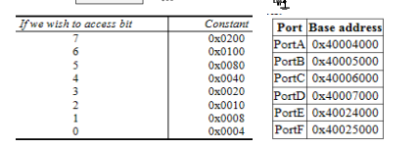

So Port F bit 0 would be 0x40025000 + 0x0004 = 0x40025004.

DIR states if it is in an input (0) or output (1)
PU 0 (pullup resistors)
AFSEL 0 (alternate function selection)
AMSEL 0
DEN 1 (enable 1=yes 0=no)
PCTL 0

Summarize pp46-49: Microcontroller overview and features. Summarize pp649-689: General purpose inputs/outputs (GPIOS). What is the format to input data into the PCTL register? How is this different from other GPIO registers? [5 pt]

pg 46-49 is an overview of our micro-controller features, a diagram of our microcontroller, and some brief information about our processor core.

649-689 covers GPIOs. It givens an in-depth explanation of alternate functions, digital, and analog. Covers register map, setting data, direction, interrupt sense, pull up/down select, and GPIO locks, and port control.

I/O –
Parallel – multiple data streams at the same time
Serial – 1 data stream
Analog - high/low
Time

ports can have input pins,

EET 3350 HOMEWORK 3 ON CH6/8
INSTRUCTIONS: Show all your work.
[ 1pt each]

- How many bits wide is Port B? How many bits wide is Port F?
B:4 bits per pin, 8 pins, 8*4 = 32 Bits
F: 4 bits per pin, 5 pins, 5*4 = 20 Bits
- What are the steps required to initialize a parallel port? Which steps are optional?
Set read port, set write port, write direction. If direction is 0 input is on and if it 1 output is on.
Main tutorial video for this from Ebook page < https://www.youtube.com/watch?v=du1c7LVPDFA> (for myself later if I need to review.)

pin 4/0 are INPUT switches, 3/2/1 are OUTPUT leds.

portf (5 pins) 4,3,2,1,0
0x40025400 DIR 0|1|1|1|0 ………...0= input 1= output

0x4002551c DEN 1|1|1|1|1 ………. enabled all.
void PortF_Init(void) { volatile unsigned long delay;
SYSCTL_TCGC2_R |= 0x00000020; //F Clock
delay = SYSCTL_RCGC2_R; // delay to allow initialization of clock. OPTIONAL but a good idea
GPIO_PORTF_LOCK_R = 0x4C4F434B // unlock PortF PF0
GPIO_PORTF_CR_R = 0x1F; // allow changes to PF4-0
GPIO_PORTF_AMSEL_R = 0x00; // disable analog, not used here OPTIONAL THIS IS DEFAULT
GPIO_PORTF_PCTL_R =0x00; // GPIO clear bit PCTL OPTIONAL THIS IS DEFAULT
GPIO_PORTF_DIR_R = 0x0E; //PF4, PF0 inputs and PF3,PF2,PF1 are outputs. 0000 1110 → 0,14 → 0x0E
GPIO_PORTF_AFSEL_R = 0x00; //not using alternative functions OPTIONAL THIS IS DEFAULT
GPIO_PORTF_PUR_R = 0x11; // enable pullup resistors on PF4 and PF0. 0001 0001 → 0x11
GPIO_PORTF_DEN_R = 0X1F; // enable digital pins PF4-0. 0001 1111 → 0x1F
}

- Using C language, specify a #define that allows us to access bits 2 and 5 of Port A.
Use this #define to make both bits 2 and 5 of Port A high.

#define PA2 (*(volatile unit_t *) 0x40004010))
#define PA5 (*(volatile unit32_t *) 0x40004080))

Use the tables below to answer the following questions.
- If you were to use UART5 at pins PE4 and PE5, how would you program the GPIO registers?
|0|0|1|1| |0|0|0|0|
(PORTS E4/E5)
into hex is 0x30 to enable both.
Rx is receive and tx is transmit…. So…. We need to ensure tx is set to output
|0|0|0|1| |0|0|0|0| = 0x10

GPIO_PORTE_CR_R = 0x30; // allow changes to PE4/PE5
GPIO_PORTE_AMSEL_R = 0x00; // disable analog, not used here OPTIONAL THIS IS DEFAULT
GPIO_PORTE_PCTL_R =0x00; // GPIO clear bit PCTL OPTIONAL THIS IS DEFAULT
GPIO_PORTE_DIR_R = 0x10; // DIRECTION PE4 set to input, everything else zeroed for output.
GPIO_PORTE_AFSEL_R = 0x00; //not using alternative functions OPTIONAL THIS IS DEFAULT
GPIO_PORTE_PUR_R = 0x00 // not used
GPIO_PORTE_DEN_R = 0x30; // enable digital pins on PE4/PE5 0011 0000 = 0x30. Unused disabled.

5. To make a pin a digital output, what value do you load into corresponding bits the following registers? Assume it does not need an internal pullup. Write the corresponding Hex value for each register.

DIR 1
PU 0
AFSEL 0
AMSEL 0
DEN 1
PCTL 0

6. How would you program the GPIO registers to make PF5 and PF2 input, and make PF3 PF1 and PF0 outputs?
There is no PF5… it is pf0-4 for a total of 5 pins… above has a 5 and a zero…. So this is not a thing is the correct answer. Will do below assuming PF5 is actually PF4. Still feel calling this malformed should be technically correct, the best kind of correct.

0|1|0|1|1 → 0xB
GPIO_PORTF_DIR_R = 0x0B; // sets PF4 AND PF2 to inputs (zeros), and PF3,PF1,PF0 to outputs (1).
// ignores non-existent PF5 and assumes PF4 in its place.

- Interface a switch to Port A bit 5 using positive logic and sketch it.
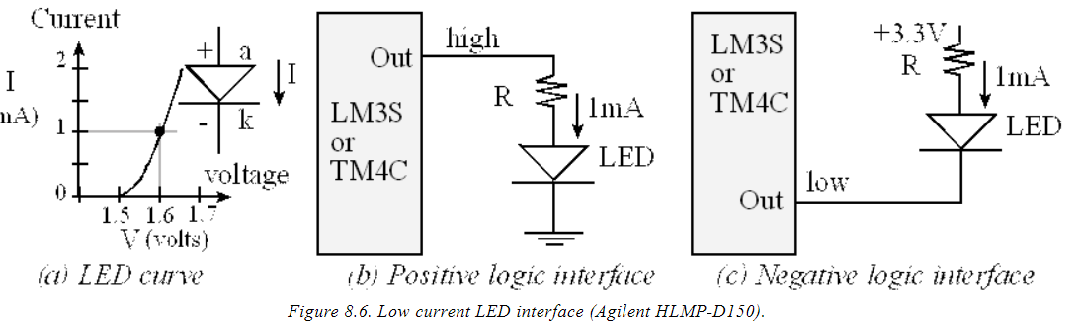Figure 8.6: Via Book shows positive and negative logic interface.
PortA 0x40004000 + pin5 = 0x40004080

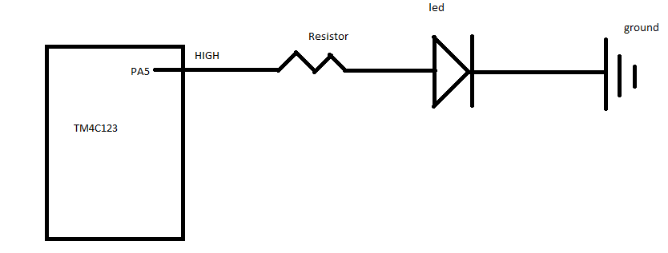

- Interface a switch to Port A bit 6 using negative logic and sketch it.
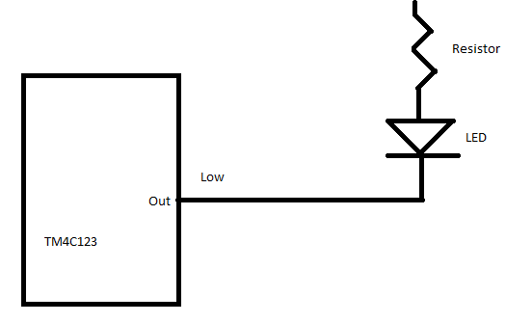

- Interface an LED to Port A bit 7 using positive logic and sketch it.
The LED parameters are 1.5V 20mA. Assume the output low voltage of a 7406 V_{OL} is 0.5V. What is the size of the resistor? Show the table for the GPIO registers and the hex values that will be needed for programming.

Asking for positive logic but provided ‘low voltage’ parameter. Assumed Vhigh = 3.2V
Vs = 3.2 V
Vled = 1.5v
Iled = 20 mA
Resistor = 85 ohms
GPIO port: portA = 0x40004000, bit 7 = 0x0200. 0X40004000+ 0x0200 = 0x40004200
GPIO port DIR = 1 for output to LED.
GPIO DEN = 1 to enable
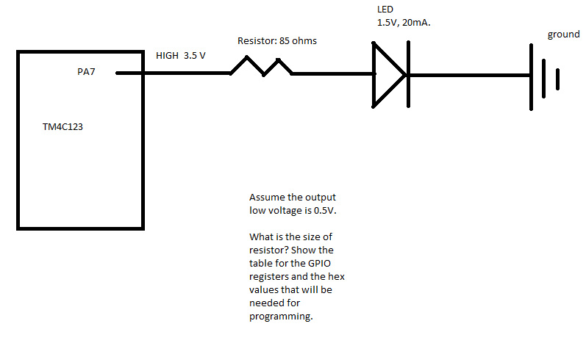

- Interface an LED to Port A bit 4 using positive logic and sketch it. The LED parameters are 1.4V 2mA. Assume the microcontroller output voltage V_{OH} is 3.2V. What is the size of the resistor?
