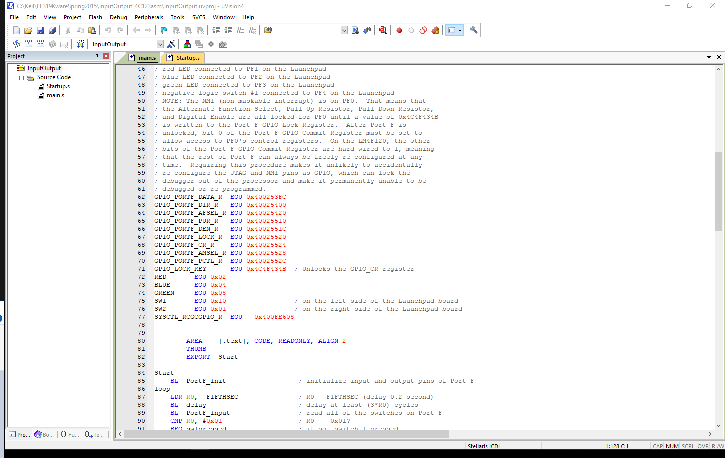
Deliverable: Get a screenshot of the Build Mode Window showing your project name.
I do not know of a “project name”
Our team name is Parking lot boys.

Deliverable: Get screenshot of the Debug Mode windows showing the project name.
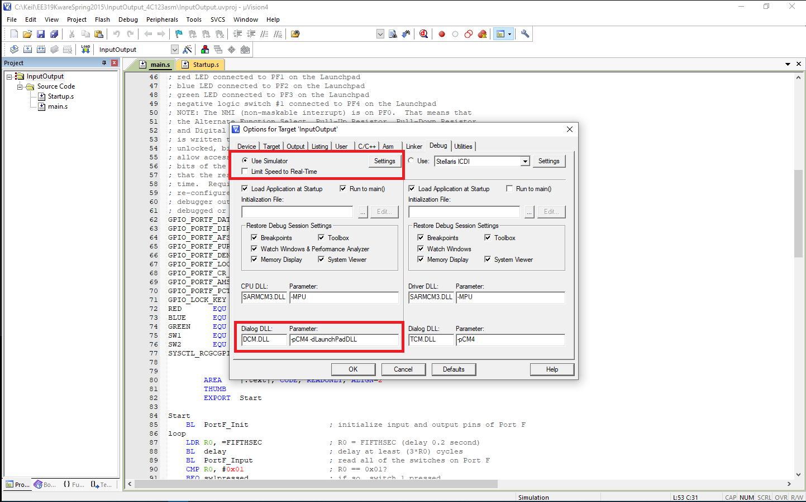

Question: What is this assembly program doing?

