Electrical Engineering Technology
Lab Report Cover/Grade Sheet

Name: Alexander J King Date: 9.30.21
Partners: Tim Roberts (I think).
Course Number: 001
Lab Number/Title: 1 / turn on the red LED.

Grading Element | Maximum Points | Your Points
Objective | 10%
Procedure | 10%
Data & Results | 20%
Discussion | 20%
Conclusion | 20%
Spelling & Grammar | 10%
Check out sheet | 10%
Further investigation bonus | 10%
Late report penalty | -20%x days
Total | 100%

Comments: _____________________________________________________________________
______________________________________________________________________________
______________________________________________________________________________

Instructor: Sandrine Mubenga, PE, PhD________
1: Objective
This lab experiment is an opportunity for you to discover how the material you are learning in class can be applied in a real-world, practical application. In your own words, write an explanation of the theory behind the experiment as they relate to the current chapter and course objectives.

Ensure connectivity of chip with PC and Keil software. Test code was run and expected results achieved. Main objective was to debug given code and become familiar with IDE environment. Practice using both the simulator and physical chip. Learn basic GPIO usage.

2: Procedure
In your own words, write an explanation of the procedure behind the experiment. Include as much visual aid as possible such as wiring diagram, screenshots and pictures. The procedure must be detailed enough so that someone else can reproduce the lab.

Connect device to computer. Set up IDE for use with simulator. Set clock to 16mhz and select using the simulator. After any changes to the code prior to running it needs to be rebuilt.

Add given code to the IDE statup.s and InputOutput.c. Read and understand provided code. Test different inputs and outputs. No switches, switch 1, switch 2, switches 1 and 2. Tested in simulator and then switched to physical device by downloading the content to the device and resetting it. Confirmed appropriate outputs on device.

3. Data &Results
Show how results were verified. If any data was collected, list here. Add any visual information that can enhance the quality of your report.

All pictures are high resolution and can be zoomed in.
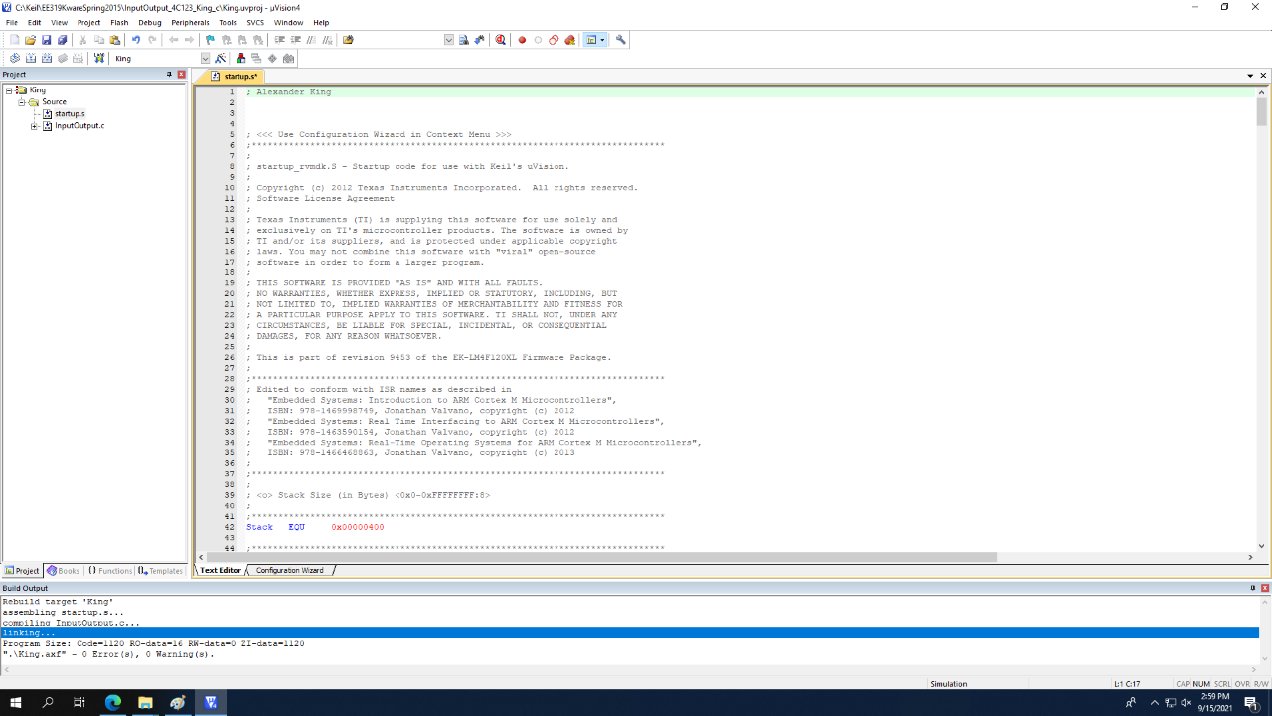
Requested deliverable showing my name commented in the program.

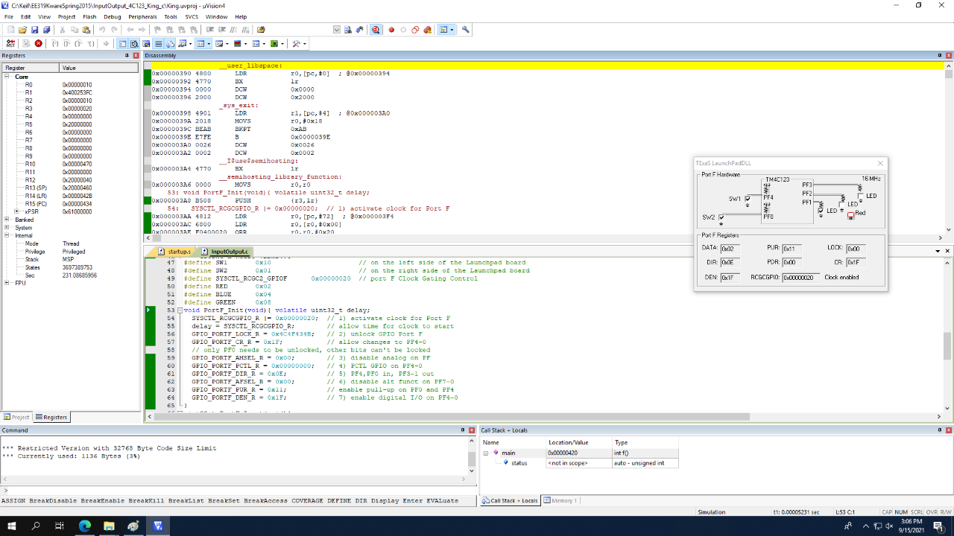
Deliverable showing output with LED lighting up.

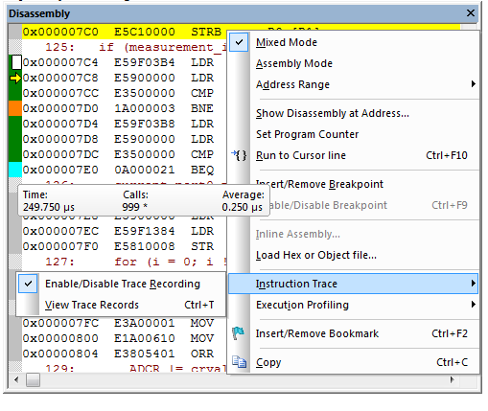

Deliverable: Disassembly page. Acquiring a screenshot of this during lab was forgotten but the step was otherwise done. The picture above is from the instructions. These are not the droids you’re looking for.

Outputs:
SW1 | SW2 | LED color (Assembly) | LED color .c file
0 | 0 | 0 | 0
0 | 1 | Red | Red
1 | 0 | Blue | Blue
1 | 1 | Green | Green

Question: What happens when you run the code?
The execution will stop at every breakpoint. Running step-over will proceed 1 line at a time.

Question: What is the C program doing?
Turning on the LEDs corresponding to the above chart. It checks what switches if any are pressed and provides the corresponding output LED.
Question: what is the assembly program doing?
The same thing as the C program but in assembly. Input/Output table is above. Compares given inputs in any and provides programmed outputs in the form of lighting up LEDs.

Question: Will this software ever turn on all three LED colors?
No. There exists no defined function in the given program to turn on all 3 LEDs simultaneously. It is however possible to make your own function that lights all 3 LEDs simultaneously.

Compare the assembly code from the disassembly window to the assembly code from step 2.
Question: Are they different? If yes, explain how. In your own words analyze each line of the code and explain how the C program is executed in assembly code.

Yes they are different. The assembly code would be written like MOV AB,1 moving the value 1 into register AB. The disassembly code shows memory addresses instead. Slightly less readable than normal assembly. The C program is converted to machine language by the device and executed. Assembly is already a low level language C is generally not considered a low level language.

Question: What is the 1st line that is
1) fully executed code,
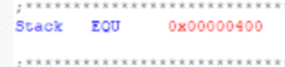
Stack EQU 0x00000400
Sets the stack size in bytes.

Question: How are the programs from steps II and III different? How are they the same? Which one is easier to understand and why.

C is easier to understand because it is a high level language and is considered to be more human readable than Assembly. They otherwise accomplish the same goal. The obvious difference is language used and readability.

4. Discussion
You and your partners have had the opportunity to work through, by trial and error, each step of the lab experiment. Include an explanation of the errors made and what was done to fix them. Discuss the results of your lab and show how the objectives were met.

Errors made include trying to give a binary input value instead of pin values. So for example I wanted to set pf3 and thought I was supposed to enter it like 0011 for a binary three. This was corrected and I realized I needed to only have a one for pf3 like 1000. Otherwise no issues were encountered.

5. Conclusion
Summarize the results or your lab and show how the objectives were met. State at least 4 specific outcomes that you were able to achieve during the experiment.

Able to connect TM4C123 chip to computer and interface it with Keil.

Proper outputs achieved for given inputs on both the simulator and physical device for both C and assembly.

Properly set up simulator to match the TM4C123 in order to get an accurate simulation.

Learned the basics of how to use Kiel IDE for program debugging.

Acquired additional practice converting from binary → hex.

- You will need to print out 1 copy of this cover sheet off of Blackboard for every lab report.
- You will need to print out a checkout sheet off of Blackboard prior to the lab and have it signed by the TA or Instructor.
- Screen shots of graphic displays may be included as well as pictures and samples of programs if applicable.
- Every student is required to fill out their lab report and hand in a hardcopy by the due date. You can and should work on the experiment with your partners to make sure all your data are matching each other’s but you will still be graded on your own lab report and the personal write-up that YOU give.
- Proper nouns must be avoided throughout the report.
- UT has resources available to assist students improve their writing skills. If you use the writing center, please have them notify me.

