Alexander J King
R00852947
November 4th, 2021

EET3350‐ Embedded Systems Design
Lab 3

EET3350 Lab3: LED Interface‐ Panic Button

Purpose

The purpose of this lab is to learn how to make the TM4C123 microcontroller interact with real external components. You will learn how to interface an external output (LED) to the real board Launchpad . You will also learn how to write the program in C to activate the external i/o.

When power is on, a Blue LED is on the Launchpad. Upon pressing SW1, the LED on the Launchpad toggles between blue and green. The external LED through PA2 also blinks.

This system could be used as a panic button that sends a remote signal to a central location or the police station. Students have to interface the LED to the Launchpad and write the program in C. Students are introduced to interfacing external i/o.

System Requirements

You are implementing a security system that consists of a panic button in a room with a remote light in the police station. Use the Launchpad to implement the panic button in the room and use an external breadboard to implement the remote signal at the police station. SW1 is the panic button located inside the room. When SW1 is not pressed, the blue LED is on and steady, and the remote RED LED is off. In case of an emergency, when the user presses SW1, the LED blinks green and blue as long as the panic button is pressed. The red LED at the police also blinks as long as SW1 is pressed.

Chapter 8 of the e‐book shows an LED interface that implements positive logic. In this lab you will connect the LED to PA2 in positive logic. You will attach this LED to your protoboard (the white piece with all the holes), and interface them to your TM4C123.

Overall functionality of this system is similar to the previous lab except that 1) you will have to remove the PUR initialization because pull up is no longer needed. 2) add a connection to PA2 for the LED , 3) you should increase the delay so it flashes about 8 Hz.

- Make PF4 an input.

- Make PA2, PF2 and PF3 outputs.

- The system starts with the Launchpad blue LED ON (make PF2=1) and the remote RED LED OFF (PA2=0).

- Wait about 62 ms

- If the switch is pressed (PF4 is 0), then blink the Launchpad LED green and blue as long as the switch is pressed and blink the remote RED LED (PA2=1). Else turn the Blue Launchpad LED on.

- Steps 3 and 4 are repeated over and over
Dr. Mubenga

EET3350‐ Embedded Systems Design
Procedure

- Write the pseudocode.

While (1){
LEDon = blue; // turn on blueLED while the device is powered on.
ExternalLED = on; // turn on external led
If (sw1 ==1){
waitTime; // wait desginated amount of time
LEDon = blue; // could probably skip this one as it is already blue from being on… could just change it to green.
ExternalLED =off; // will make external LED blink. Turns off here will turn back on after delay at top of while loop.
LEDon = green;
waitTime; // wait for a designated amount of time.
} // end if
} // end while main.

- Develop the flowchart. Show a couple of refinements.

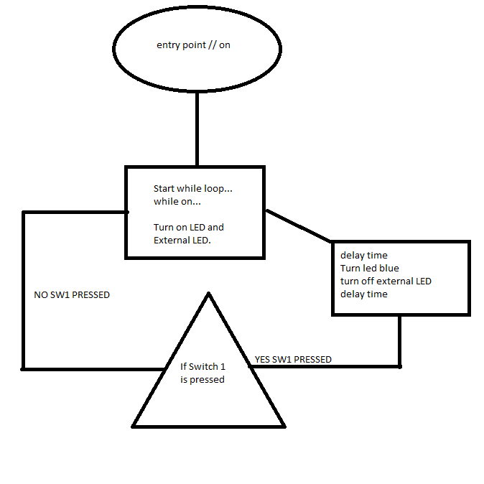

- Interface the LED using your sketch from the Pre‐lab.
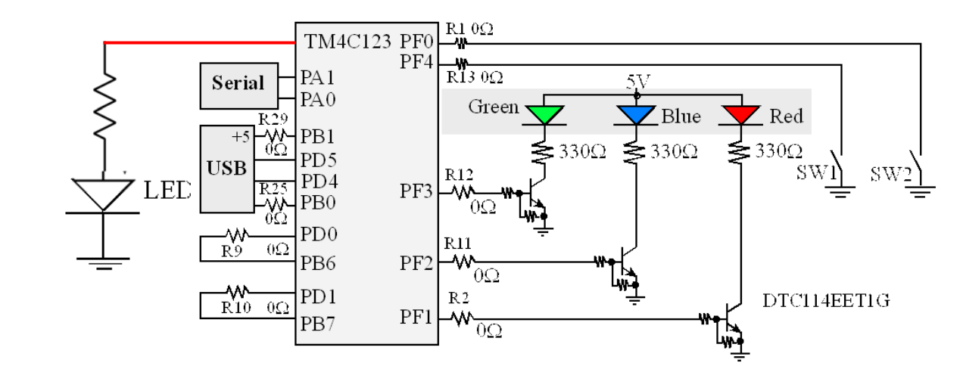

IF ←

R

- F

Engineers must be able to read datasheets during the design, implementation and debugging phases of their projects. During the design phase, datasheets allow us to evaluate alternatives, selecting devices that balance cost, package size, power, and performance.

The LED is a green 3mm tinted diffused lamp. Using the attached LED datasheet, find the value of the forward voltage VF.

What is the forward current IF when the LED operates at the desired voltage VF? Size the resistor according to e‐book chapter 8.
V = 5v given in diagram
R = 330 ohm given in diagram
V = IR, V/R=I
I = 5/330
I = 0.01515 (repeating) amps.

Build the circuit above.

- Modify your code from the previous Lab to add the external red LED.
I was excused/sick for the prior lab. Can’t really do this… Via class policy I was told not to do or submit late work and that the grade of my final exam will be assigned.

- Go to the debug mode and test your code in the simulator mode. Observe the GPIO registers.

- Connect your prototype (Launchpad + protoboard) to the computer USB and turn on the Launchpad.
- Then, load the code to the Launchpad and test the prototype. To load the code, go to Target Options‐>Debug Tab‐> click the button on the right side of the window, and select Stellaris ICD from the drop down menu, then click ok. From the main Build mode window, build and load the code to your Launchpad. Click the Reset button on the Launchboard to complete programming.

Deliverables

- Grading sheet and check off sheet. You can print it yourself from Blackboard.
Was not physically in class to do this… Doing this at home with Kiel.

- Circuit diagram, can be hand drawn

- Pseudocode
While (1){
LEDon = blue; // turn on blueLED while the device is powered on.
ExternalLED = on; // turn on external led
If (sw1 ==1){
- waitTime; // wait desginated amount of time
LEDon = blue; // could probably skip this one as it is already blue from being on… could just change it to green.
ExternalLED =off; // will make external LED blink. Turns off here will turn back on after delay at top of while loop.
LEDon = green;
waitTime; // wait for a designated amount of time.
} // end if
} // end while main.

- Flowchart
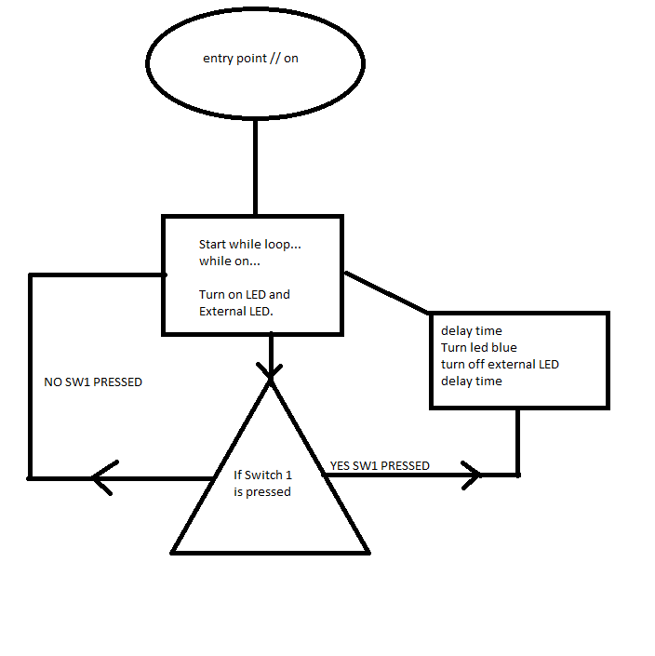

- Circuit diagram, can be neatly hand drawn
This was asked for in #1 and provided with the lab? Relevant bits are PF4 for SW1, Green LED, Blue LED, and PA2 for the external LED.

- Picture of Launchpad with SW1 pressed.
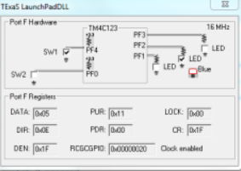
Expected result. Instead my clock in failing to enable… (could also be green when pressed, it will switch on a delay)

- Picture of Launchpad with SW1 not pressed. (always blue when SW1 not pressed and on

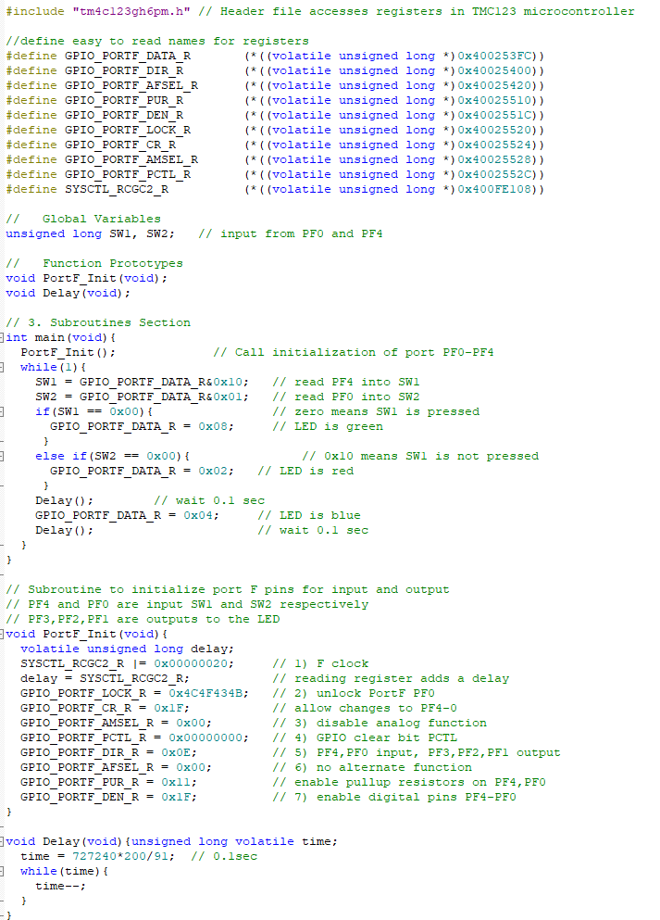
- C code of your final program
****lacking last weeks lab to take code from, as instructions dictate, due to an excused absence I got code from GitHub to try and accomplish***
If that isn’t worth points give me none. Do NOT name me cheater or plagiarizer.
https://github.com/sphanlung/TivaC/blob/master/LedBlink.c

Precautions to avoid damaging your system
Dr. Mubenga

EET3350‐ Embedded Systems Design
- Do not attach or remove wires on the protoboard when power is on. Always shut power off when making hardware changes to the system.

- Touch a grounded object before handling CMOS electronics. Try not to touch any exposed wires.

- Do not plug or unplug the modules into the LaunchPad while the system is powered.

- Do not use the TM4C123 with any external power sources, other than the USB cable. In particular, avoid connecting signals to the TM4C123 that are not within the 0 to +5V range. In particular, voltages less than 0V or greater than +5V will damage the microcontroller.

- Do not use PC3, PC2, PC1, PC0. These are needed for the debugger.

- You can’t use PA1 PA0 PD4 and PD5. These are connected to the serial port and USB.

- See the textbook. If you use both PD0 and PB6, remove R9 from your board. If you use both PD1 and PB7, remove R10 from your board.
Dr. Mubenga

EET3350‐ Embedded Systems Design

Dr. Mubenga

EET3350‐ Embedded Systems Design
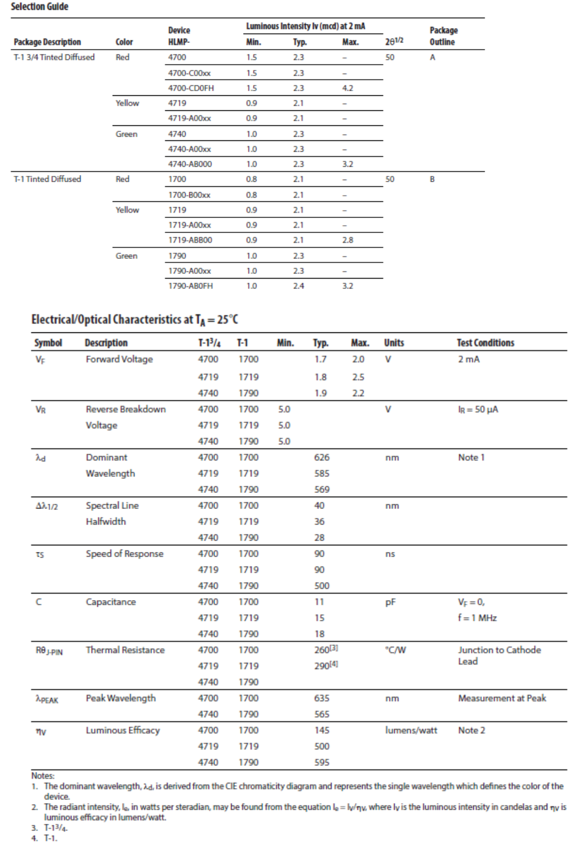
Dr. Mubenga

EET3350‐ Embedded Systems Design
