Formatting rather broke when I downloaded the document. These do not look the same.

Alexander J King
R00852947
1/1/21
A:
1) What is the name of the software we used for PCB design?
DipTrace
2) What is the name of the software we used for PCB fabrication?
ProtoMat S
3) a) in the figure [above] fill in the name of the main parts of the PCB
1.pad
2. Silkscreen
3. Soldermask
4. trace
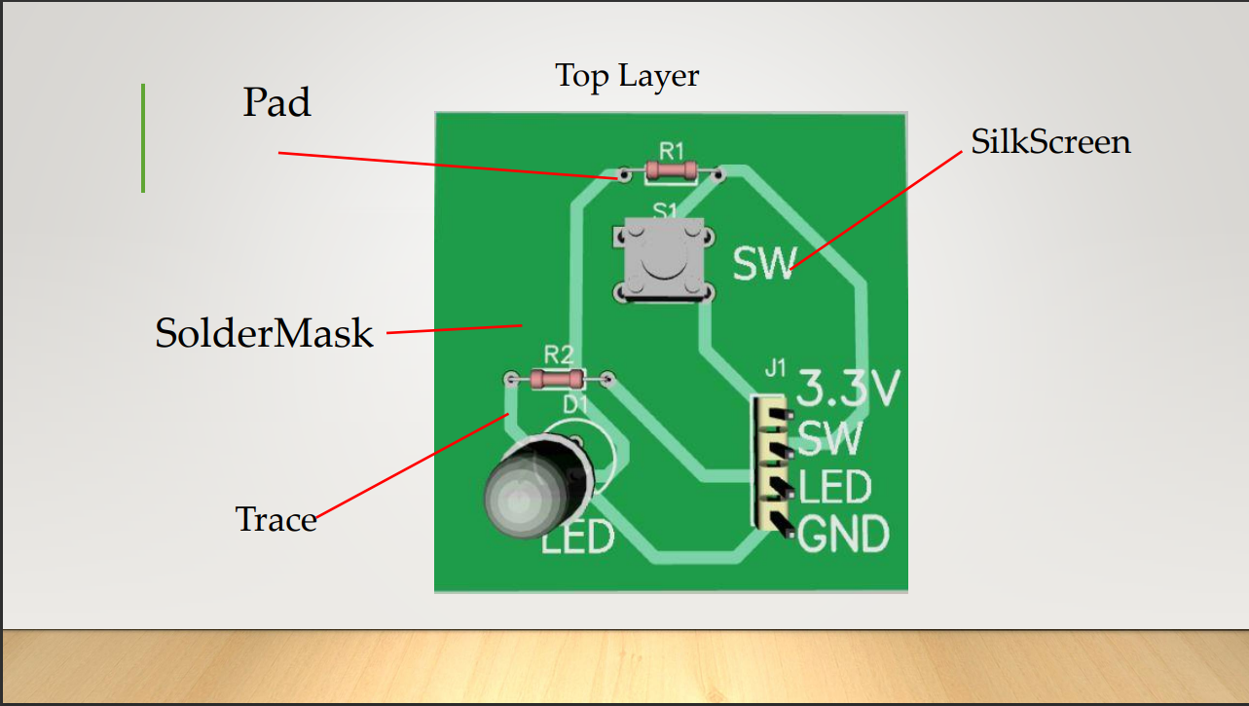

b) Give the detailed definition of each term in question 3 (a)
1. Pad is where things like resistors or switches connect to the board.
2.This includes pattern shapes, texts and all other shapes placed in the top silk layer
3. Top Mask : This is a solder mask layer. It is generated automatically, based on pads, custom pad settings defined in the Export Gerber dialog box
4. Trace is where the electrical connections are. It’s like a wire built into the board.

