AJ King
R00852947
Install build-essential package.

Do this by running sudo apt-get install build-essential -y in the terminal to install with all of the default options.
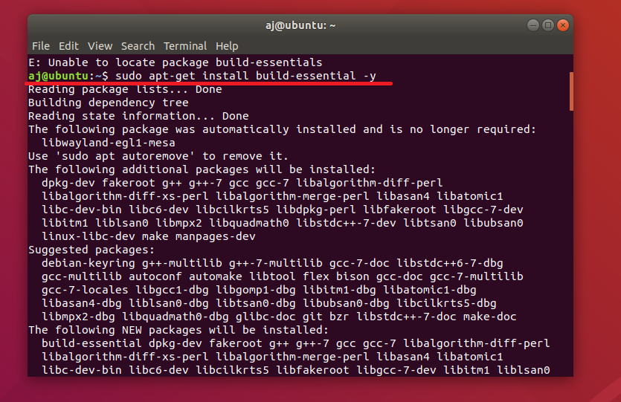

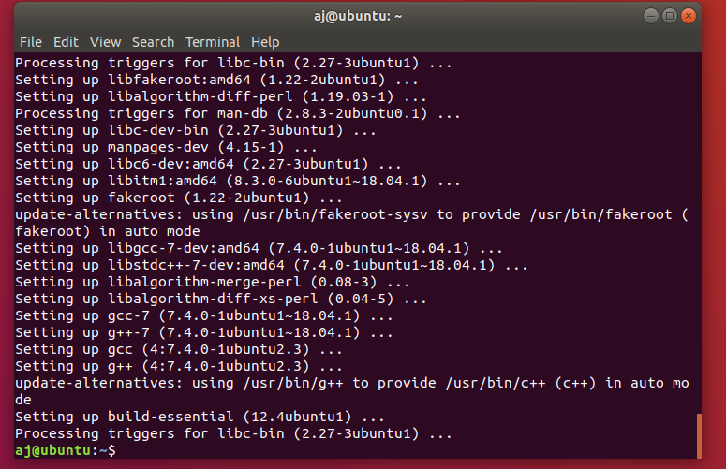
After it has been successfully installed you will be presented with the following:

The only difference between the steps I took and what was presented in the power point was that there was a type-o in the directions. Sudo apt-get install build-essentials. The needed removed. I decided to get fancy and use a -y because I did not plan on doing anything besides the default options.

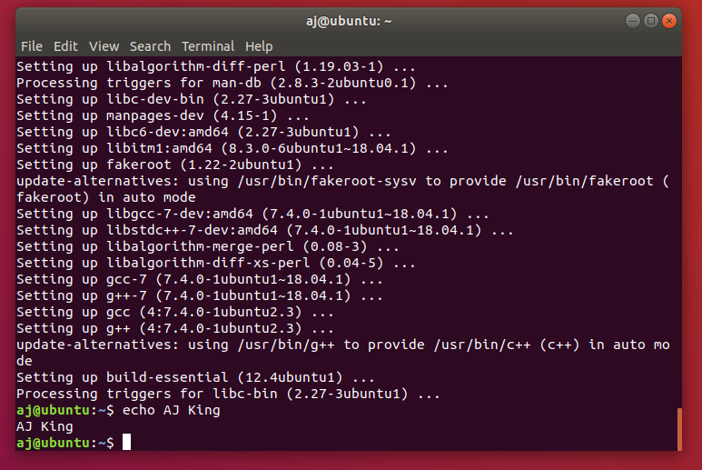
As an afterthought I’m noticing it is requesting that I also write C code to have it print my name. Using the code ‘echo AJ King’ prints my name. (would this have worked without installing the above? I feel like it would but I’ve already installed it so I cannot be sure at the moment.)
See here:

