Alexander J King
R00852947
DHCP lab
2.24.20

SCREENSHOTS

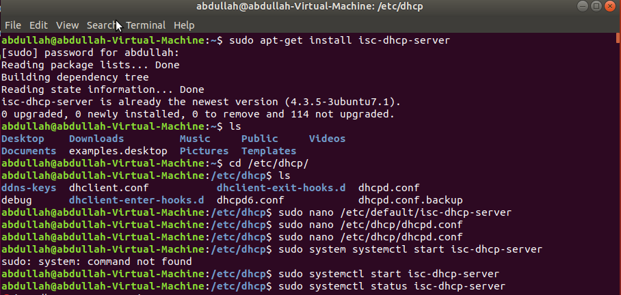
Ensure package we want to use is installed and CD into ‘/etc/dhcp/ and open the config file. We set the options below.
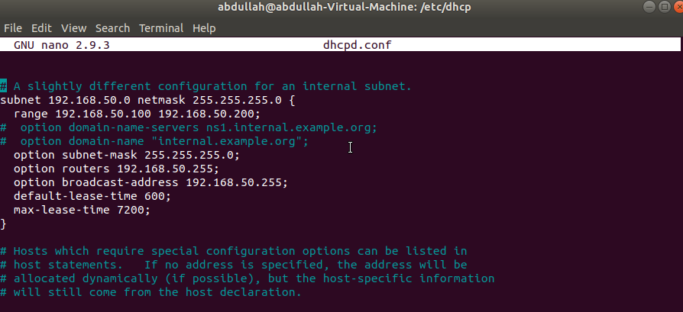

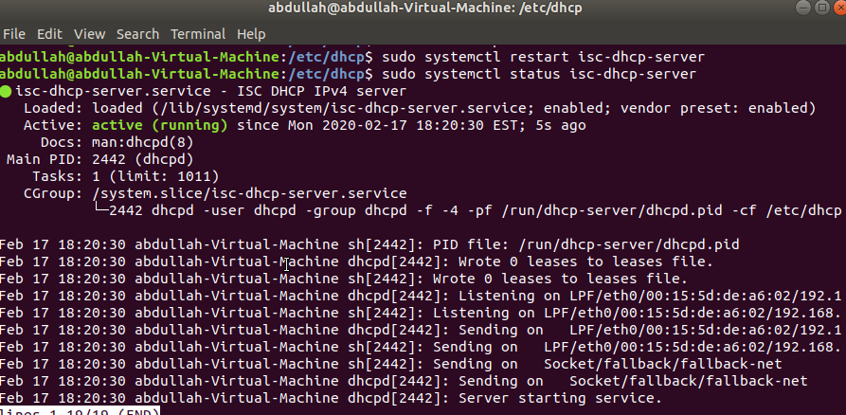
Start the server running sudo systemctl start isc-dhcp-server and ensure it is running using sudo systemctl status isc-dhcp-server

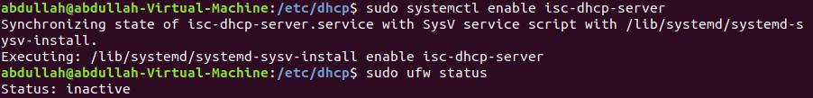
Ensure the firewall isn’t going to block us. Status inactive so optional steps in lab notes were not needed.

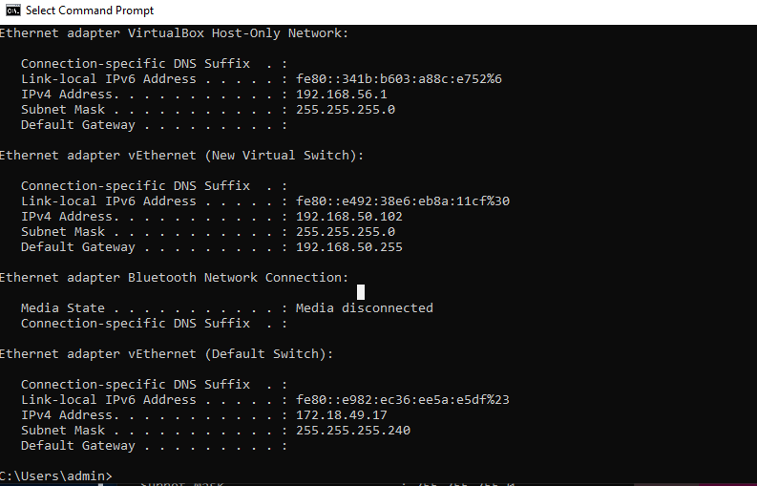
On our client machine connected to the dhcp server. Ensure connection by opening command prompt and running ‘ipconfig’.

** MY prelab notes / proceedure**
Shared with many in the class after my group finished to help them succeed.
These notes are created by me Alexander King.

These are the basic steps and guide I created for the group and subsequently much of the class. The steps below should be readable to anyone in the field. It includes set-up of the dhcp server, client connection testing, and optional firewall rule to allow udp traffic to and from the NIC.

SOURCE: < https://www.youtube.com/watch?v=j3wsYskgdAs >

sudo apt-get install isc-dhcp-server
sudo nano /etc/default/isc-dhcp-server -> change INFACESv4="<NIC name>"
ctrl-o write ctrl-x exit
cd /etc/dhcp/
sudo nano /etc/dhcp/dhcpd.conf -> comment out dns server because we don't have one configured. uncomment authoritative. uncomment subnet group. Set the subnet group options to match NIC.
Comment out option domain-name-servers in subnet.
Subnetmask .... nic?
option router .255
option broadcast-address match above.

sudo system systemctl start isc-dhcp-server

sudo system systemctl status isc-dhcp-server (Let it be active)
if service not running mistaken config file or not set NIC.

sudo system systemctl enable isc-dhcp-server

iff firewall -> sudo ufw status (to see if firewall)
sudo ufw allow in on <NICname> from any port 68 to any port 67 proto udp

________________________CLIENT SIDE______________________________

sudo nano /etc/network/interfaces -> ensure auto <NIC name> && iface <NIC name> inet dhcp
sudo systemctl restart netowkring
ip a (to check if connected)

________________________________Windows___________________
open ipv4 settings of NIC and ensure obtain Ip address automatically.
open cmd -> ipconfig

__________back to server side _____________________
(in /etc/dhcp) dhcp-lease-list (this will list connected clients.

to set static ip on a client
Copy the mac address of the client you want to edit from lease list (or could airodump-ng?)
sudo nano /etc/dhcp/dhcpd.conf - > uncomment host passacaglia, under hardware ethernet place the mac address. Delete whatever is below it within the brackets. add 'fixed-address <whatever static ip you want them to have>' save it ctrl-o ctrl-x
sudo systemctl restart isc-dhcp-server
sudo systemctl status isc-dhcp-server

___________________________________________________________________________________

