Alexander King
UnixAdmin
FTP server
4.20.20

sudo apt-get install vsftpd
I picked this FPT server because it is popular, easy to use, free, and functional.
< https://en.wikipedia.org/wiki/Vsftpd >

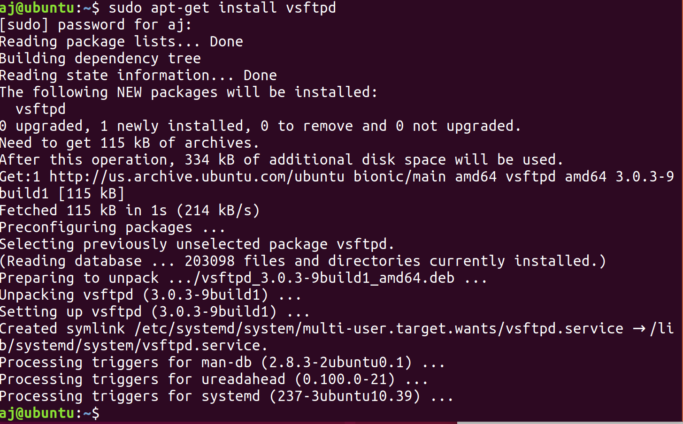

Create a user:
sudo adduser ftpuser

add a firewall rule sudo ufw ftp allow

navigate to ftp://YourServerIP
It will prompt you for a log in we’re going to use the ftpuser user I just created.

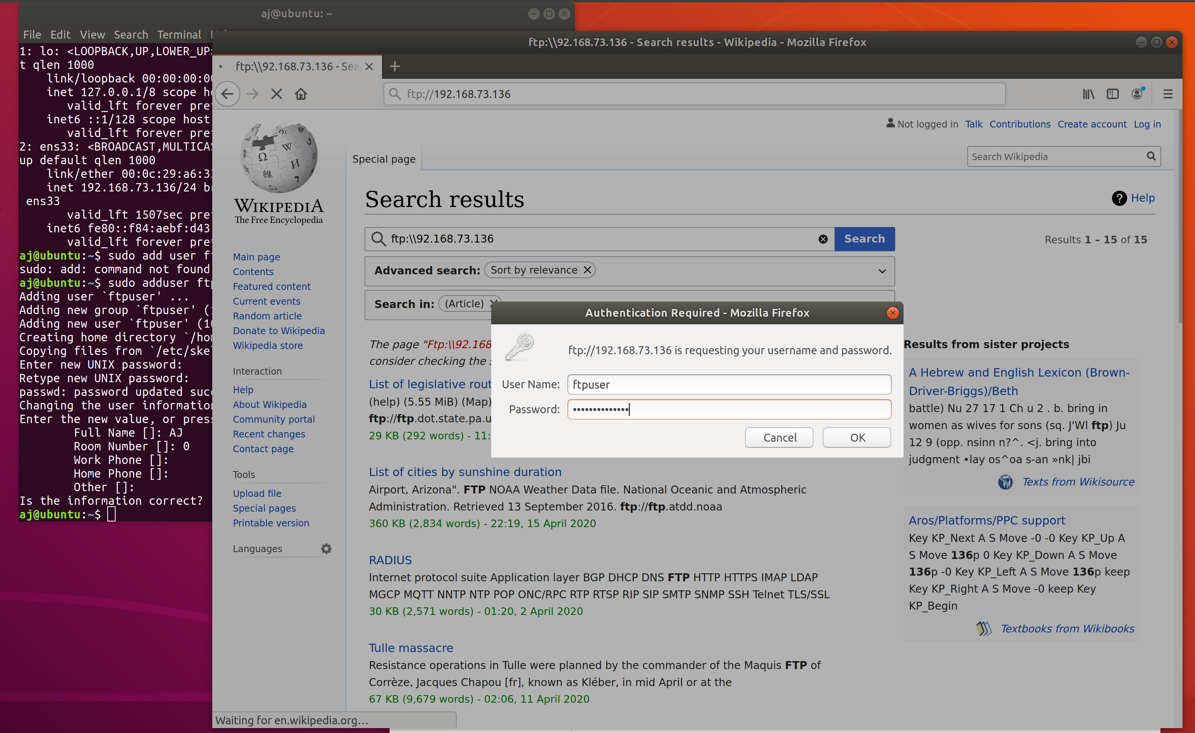

Cd into the new users home.

cd ho/home/ftpuser/

ls to see what there is.

Create a new director named share and create a new file called example file. This is how we can add files to the ftp server. We can make new files/folders or move existing ones.



Edit the users who are allowed to ftp.

cd /etc/
sudo nano ftpusers

add aj and ftpuser

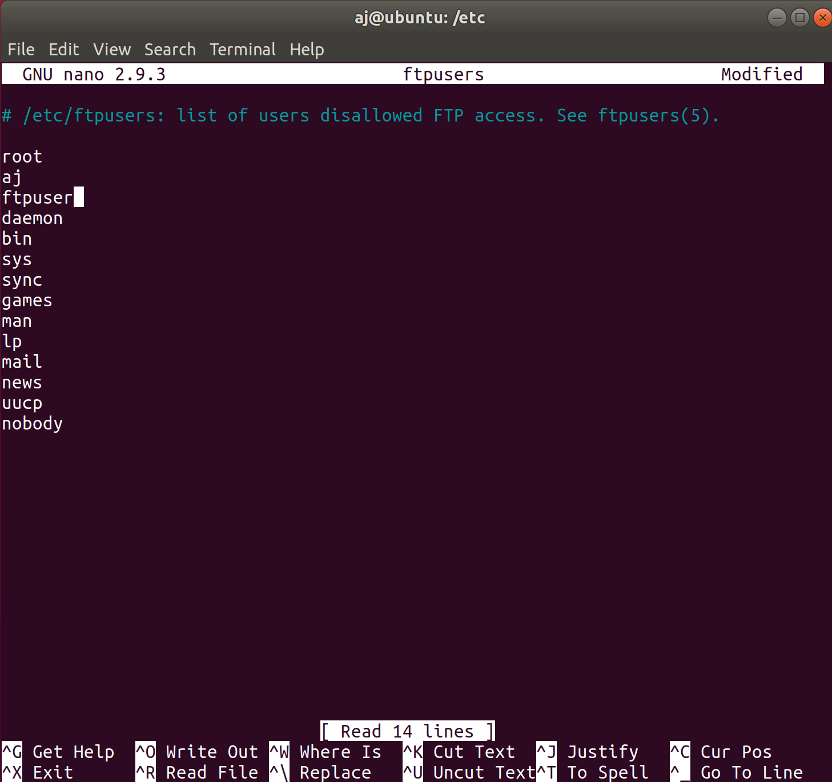
Now restart vsdtpd by running: sudo systemctl restart vsftpd

Trying to log in with us on the disallowed list produces nothing. We’re prompted for our log in credentials and when they’re input nothing updates.

So now we take ourselves back off that list and log back in.

We can download the example file by clicking on it.

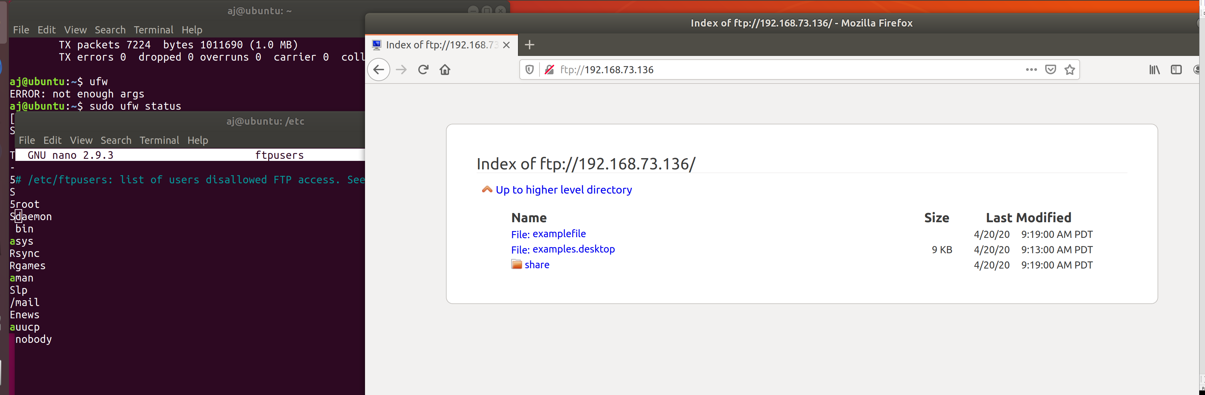

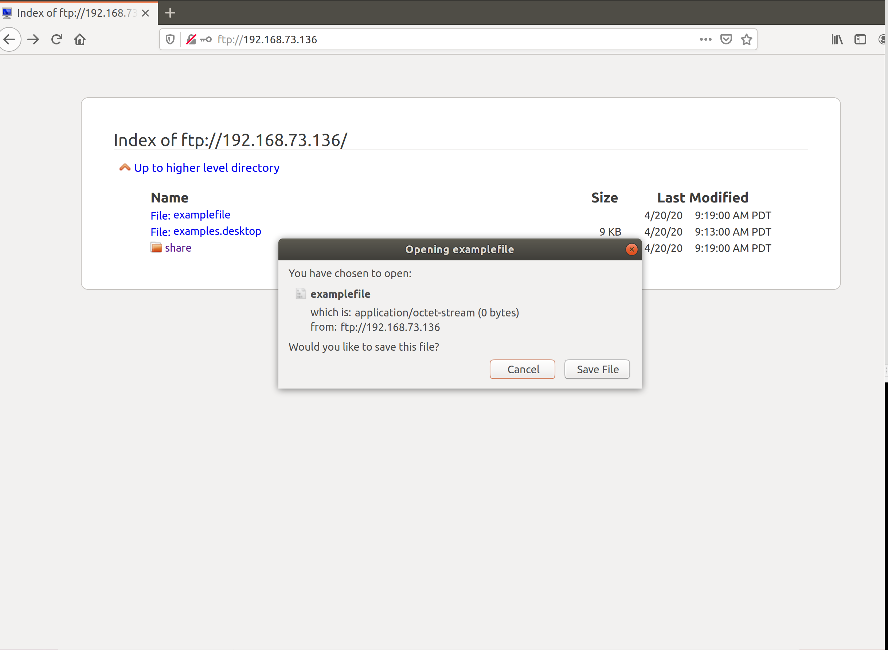
As an after thought the same thing on a window client machine:

If you want to allow “anonymous” login open up cd /etc/ sudo nano ftpusers and remove ‘nobody’. Ctrl-o to save and now you can access it without credentials.

We like security so after this we’re going to add nobody back into the banned list.

