Alexander King
Unix Admin
fsck lab
4.6.20

Start by creating a snapshot and then checking my partitions by running: sudo fdisk -l
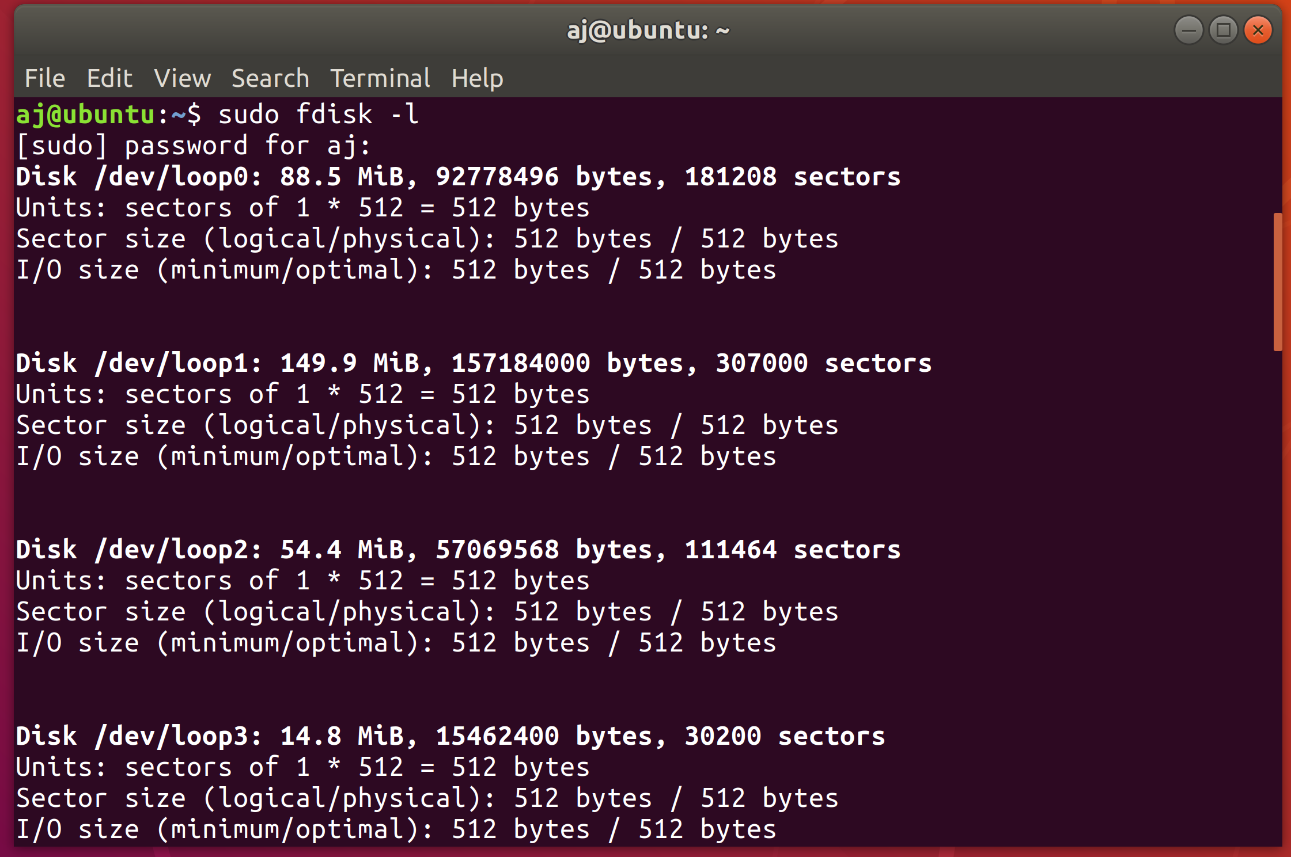
/dev/sda1

Unmount the main file system. I had to use -l ‘because it was busy’.
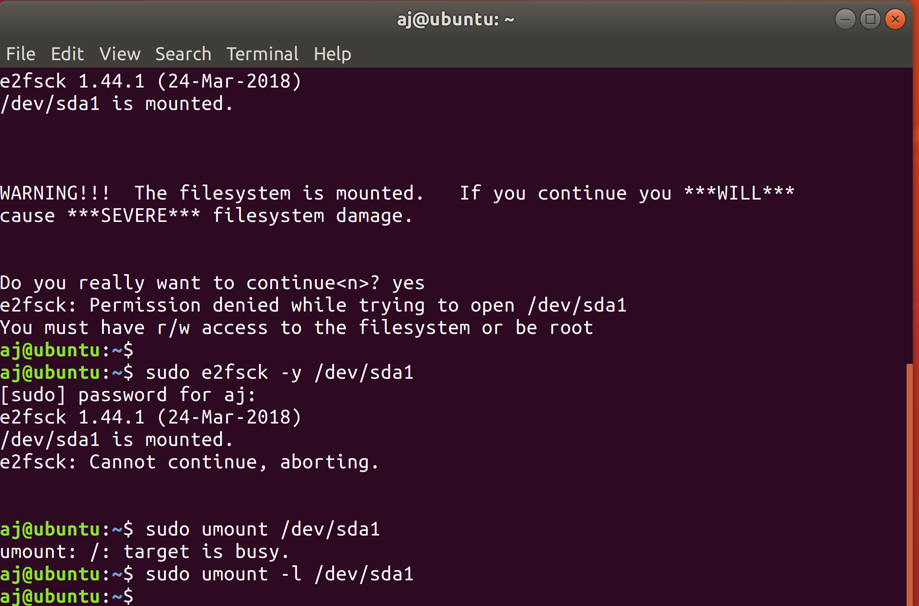

After unmounting I can no longer sudo or sudo su. So we’re going to ask it to run on boot.
sudo nano -w /etc/default/grub

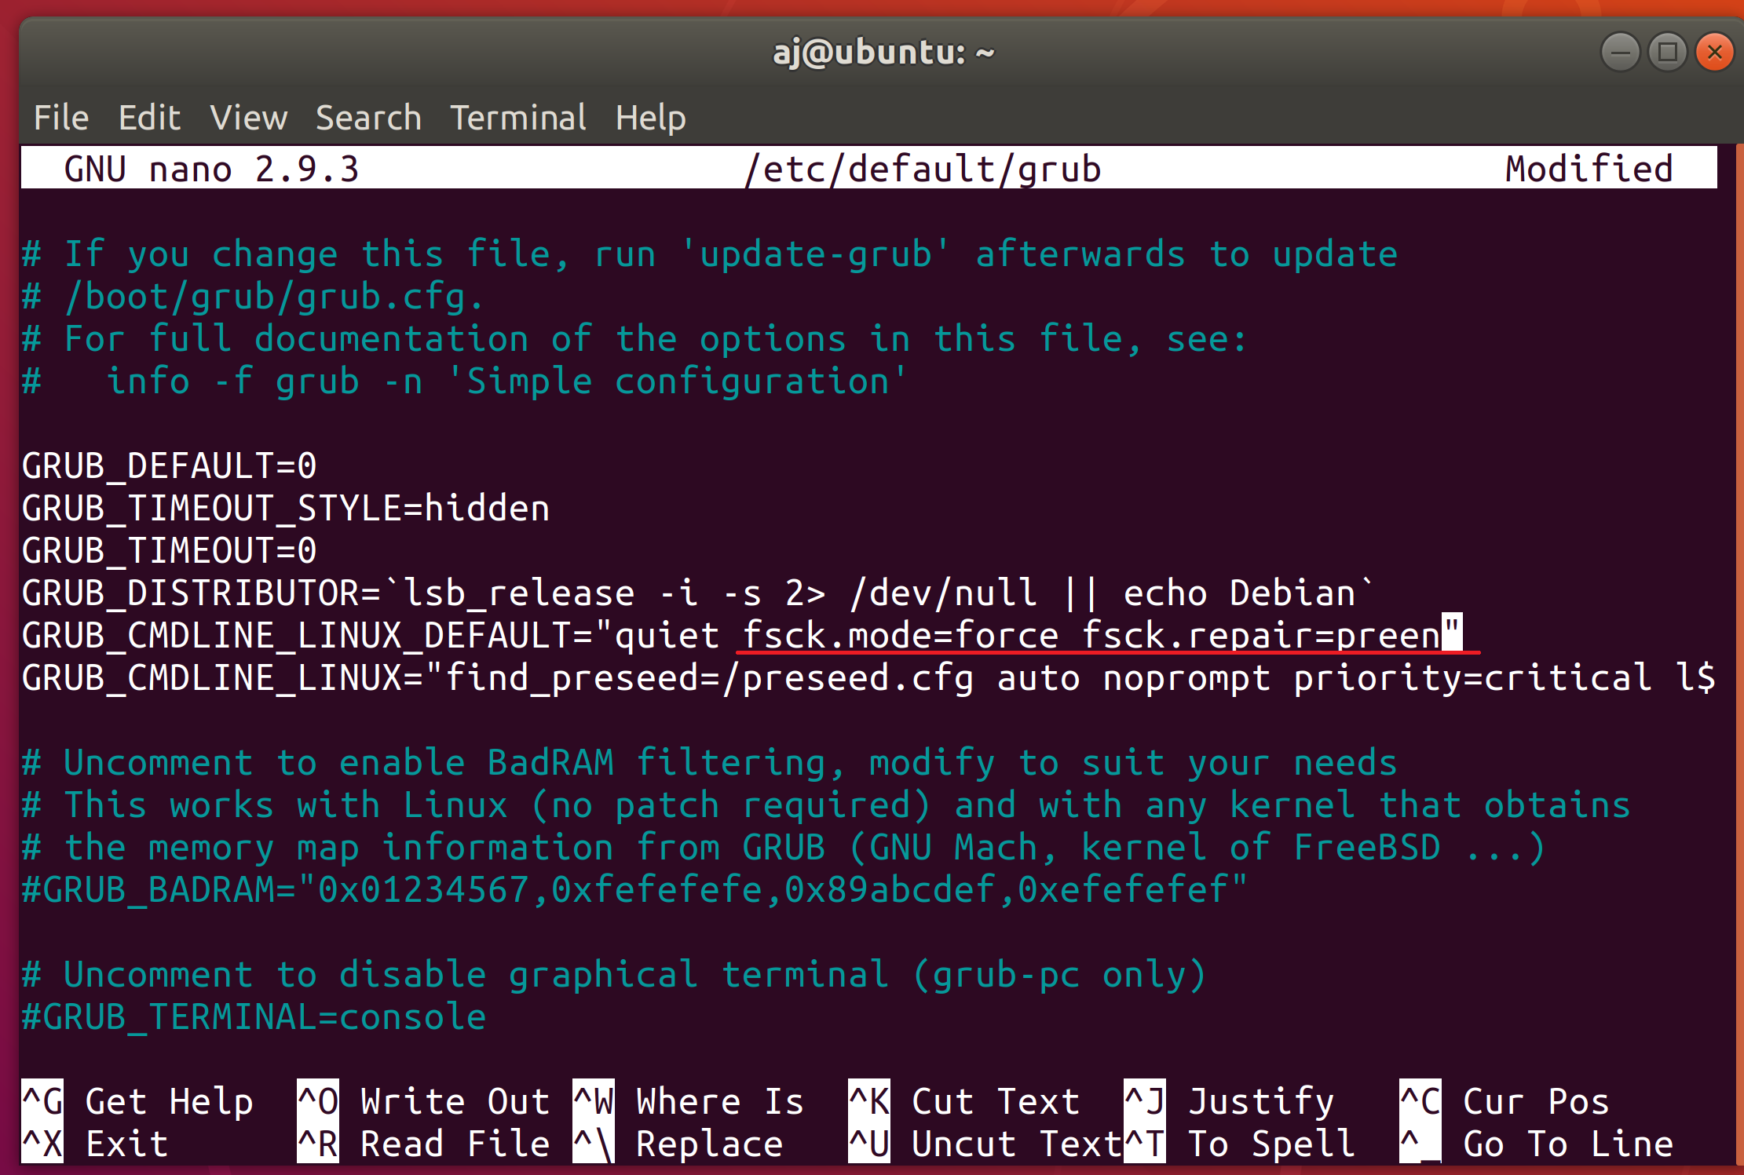

sudo update-grub
sudo shutdown -r now
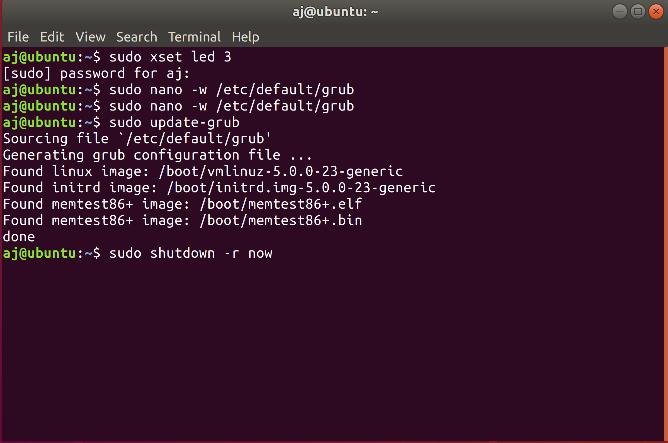

Now it persistently runs on boot. If I want to change this I can go back and edit my grub file above back to how it was previously by removing the underlined portion.
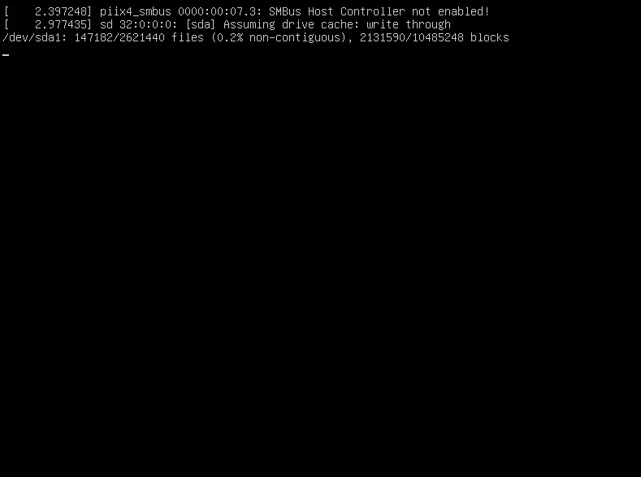

So for mounting and opening an iso example I copied over my ubuntu .iso from my windows machine. Right click it → open with archive manager → .iso appears mounted on desktop → right click open the .iso.

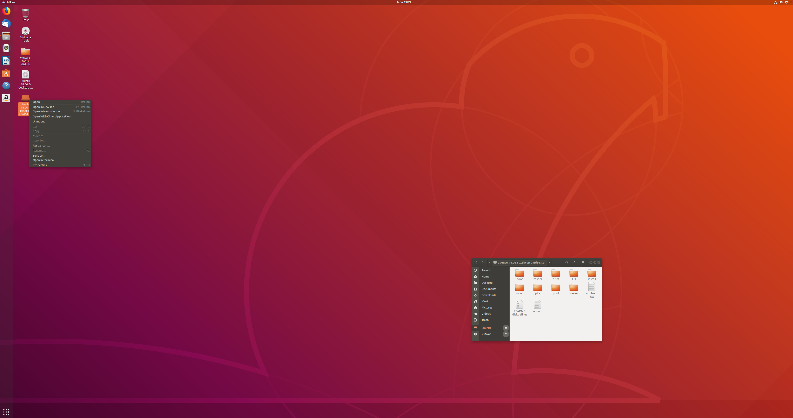
(high resolution feel free to zoom in if you like?)

To unmount right click the mounted instance and click unmount. I could fdisk this again but I have already removed the .iso from my machine. We used fdisk in step one to see our partitions doing it again would be redundant.

