Alexander J King
Unix AdminSudo apt install php -y
Install php with default settings.
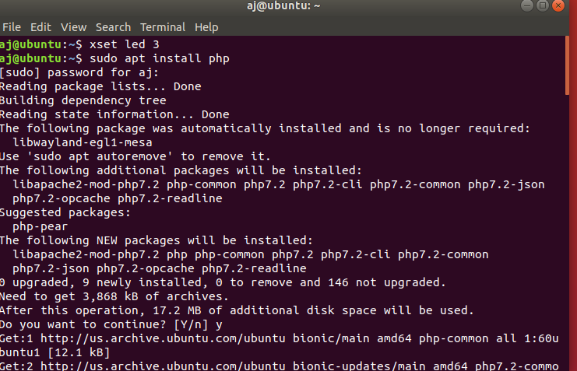

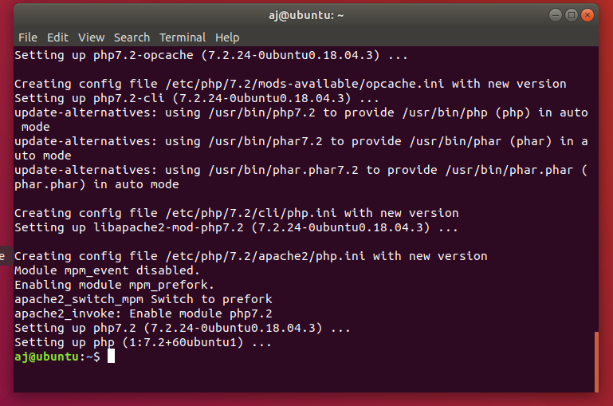
When it finishes successful you will see this:

Create and move the file to the desired directory:
Check php version.
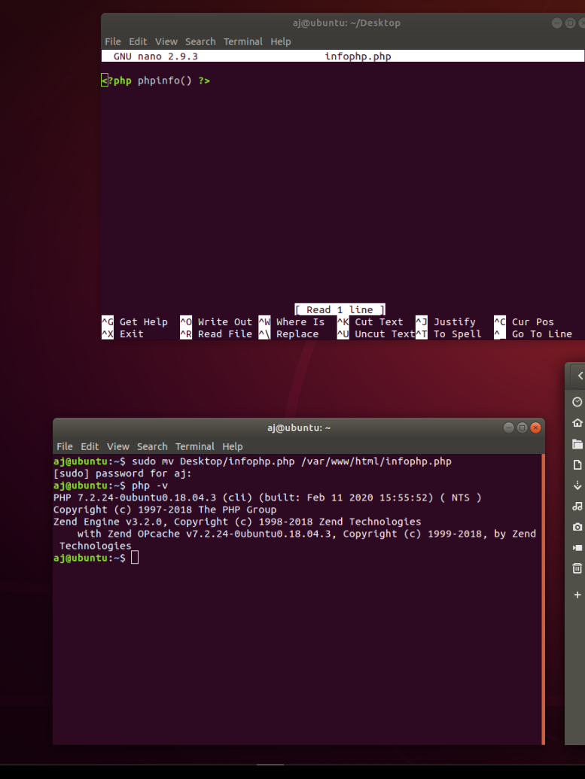

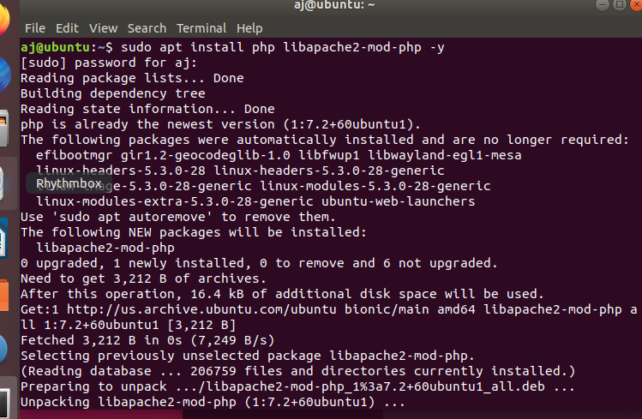
Install php libapache2-mod-php with default settings:

It will not display in html for me. I tried several work arounds and am unsure why this might be.

