Alexander King
Unix Admin
Cron Lab
3.30.20

-Write a script that will write the current disk usage into a log file.
-Schedule this to run every minute of every day
-Show your cron file settings for this.
-Be creative: develop with a simple, useful and unique automation script
-Schedule this to run every every day
-Show your cron file settings for this.
Document your code and explain what your automation script does on Blackboard
Remember to complete BOTH the disk usage and your own automation script. Don't forget to include your code.

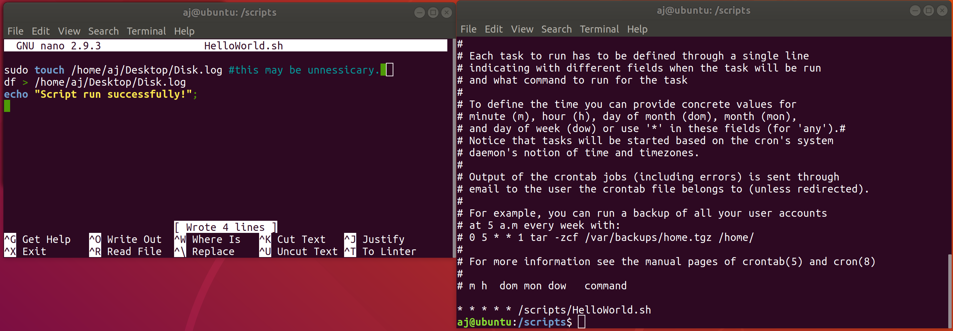
Make a script file and directory.
Sudo mkdir /scripts
cd /scripts
sudo touch HelloWorld.sh
Edit the the new HelloWorld.sh file. (I ran some helloWorld like tests first)
Add to HelloWorld.sh:
sudo touch /home /aj /Desktop /Disk.log
df > /home /aj /Desktop /Disk.log
echo “script run successfully!”;

the run successfully message was for manual testing before cron job.

Open crontab by running: crontab -e.
If it is your first time running this it may ask you for a default text editot. I used nano.
Usage is as shown in comments above my line I added. * for wildcard (all) every second of every day of every month of every year etc. After the stars we add our command which is going to run my script so we enter the script address: /scripts/HelloWorld.sh

We now navigate to our desktop where the log file is set to save and delete it. We then wait a few moments for the new iteration to appear which proves the scheduled task and script are both functional. Open it and ensure everything looks as it should.

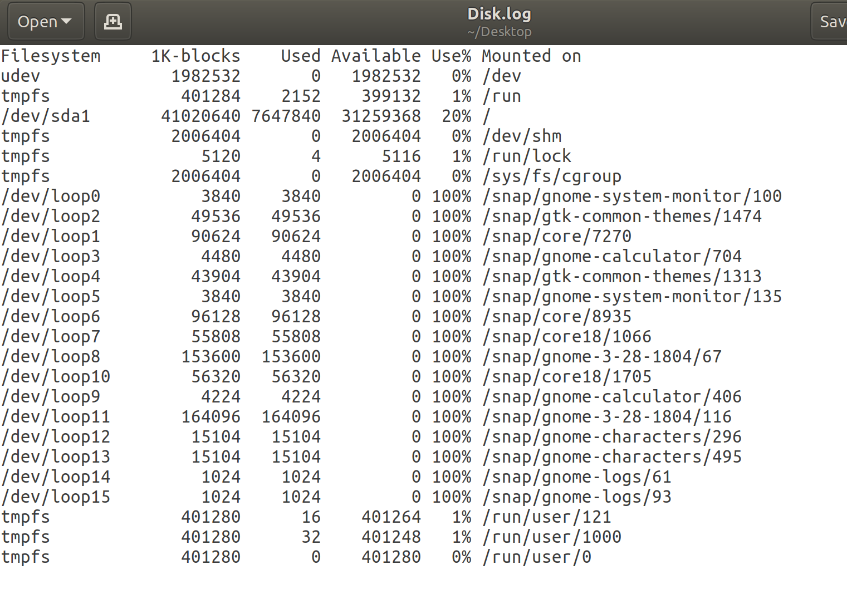
Non-required portion…. I removed the cronjob because I don’t want to write this file every second of every day. Opened the file by running :crontab -e and simply commented out as to preserve work but not the automated process.

CODE:
Cron job:
* * * * * /scripts/HelloWorld.sh

HelloWorld.sh:
sudo touch /home/aj/Desktop/Disk.log #this may be unnessicary.
df > /home/aj/Desktop/Disk.log
echo "Script run successfully!";

