Alexander King
Unix Admin
PHP Lab

GOALS
Install MySQL Server on your Ubuntu installation
- Password: cset
Install MySQL WorkbenchIn
MySQL Workbench
- Create a database called CSET
- Create a table called Students with fields Name and Address
-Create a user CSET, password csetGrant that user all permissions to the CSET database

Document your experience on Blackboard. Please include enough detail that would allow the average user to duplicate your work.

Hint for connection issues: https://linuxconfig.org/install-and-configure-mysql-workbench-on-ubuntu-linux

sudo apt-get update etc as usual to start.
Sudo apt-get install mysql-server to install my sql server.
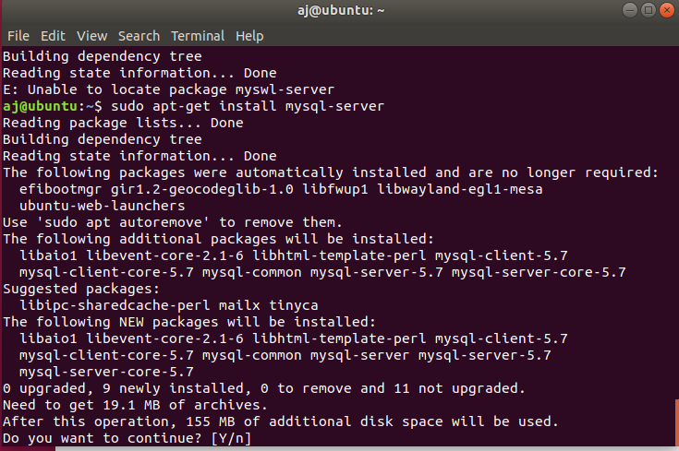

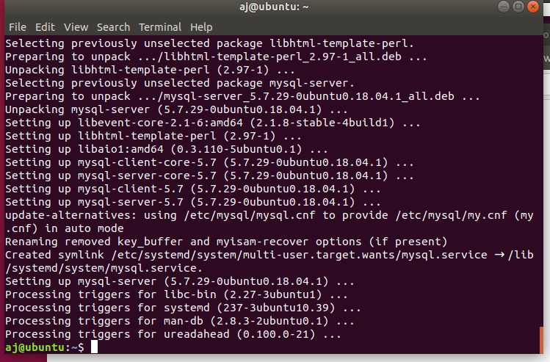

Install mysql workbench:
sudo apt-get install mysql-workbench
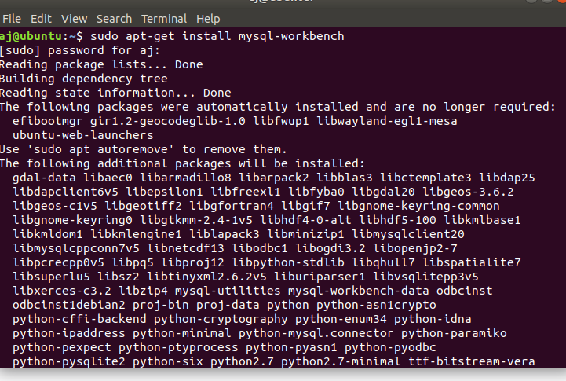

In Ubuntu hit the Windows button and type mysql and open the work bench that appears.
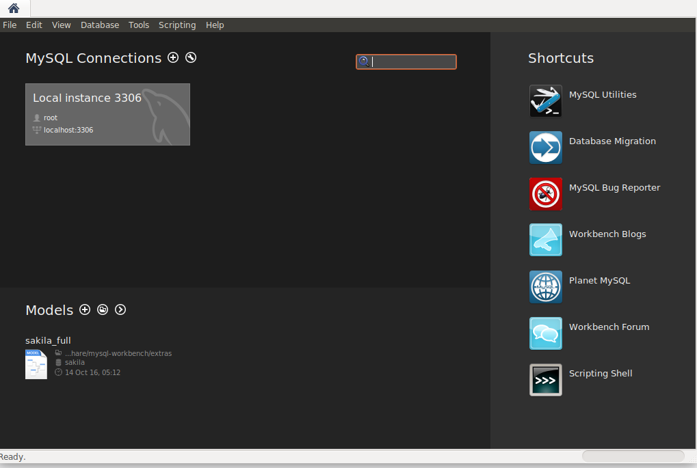

Open mysql by running: sudo mysql -u root -p
-u user
-p require password so it will not show up in command history.
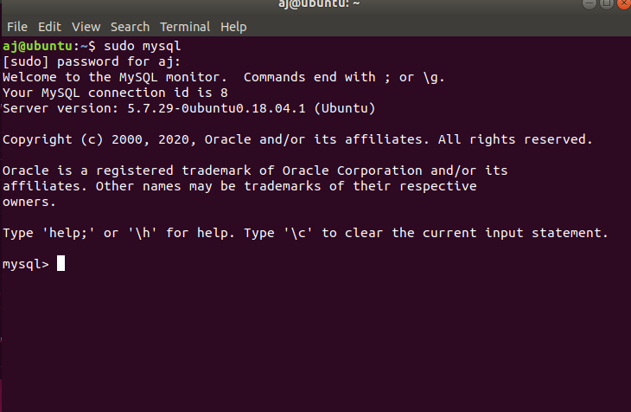

Make and show the databases by running CREATE DATABASE CSET; and SHOW DATABSES;
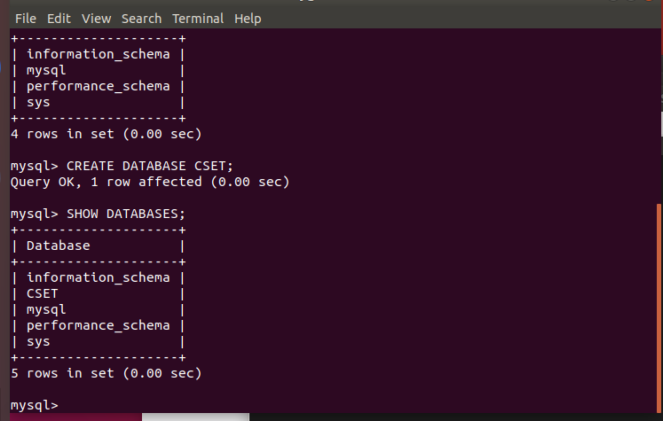

Enter the database by using USE CSET;
Create table and fields within the database.
- Create a table called Students with fields Name and Address: VARCHAR(50) is a string capped at 50 NOT NULL means you must include the field.
Run DESCRIBE Students; to have it display the newly created fields in CSET.
CREATE TABLE Students(Name VARCHAR(50) NOT NULL, Address VARCHAR (50) NOT NULL);

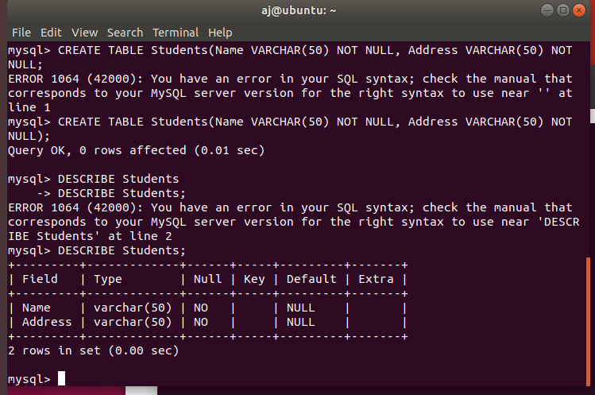

CREATE USER ‘CSET@localhost’ IDENITFIED WITH sha256_password BY ‘cset’ PASSWORD EXPIRE INTERVAL 180 DAY;
Creates a user named CSET at the localhost using a sha 256 password set to ‘cset’ that is set to expire every 180 days.
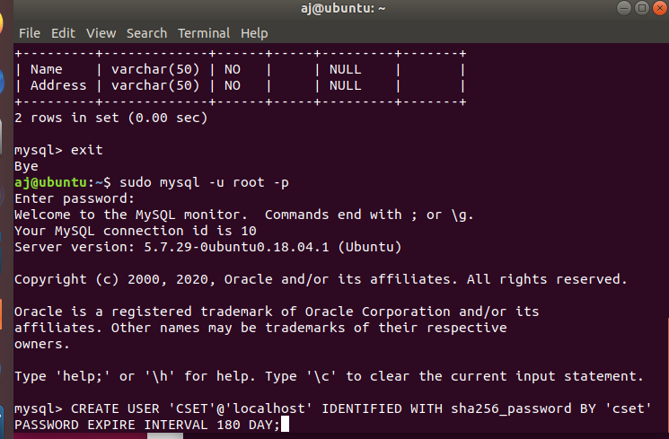

Grant user ‘CSET’@’localhost’ all permissions within database CSET.* and refresh privileges by:

GRANT ALL ON CSET.* TO ‘CSET’@’localhost’;
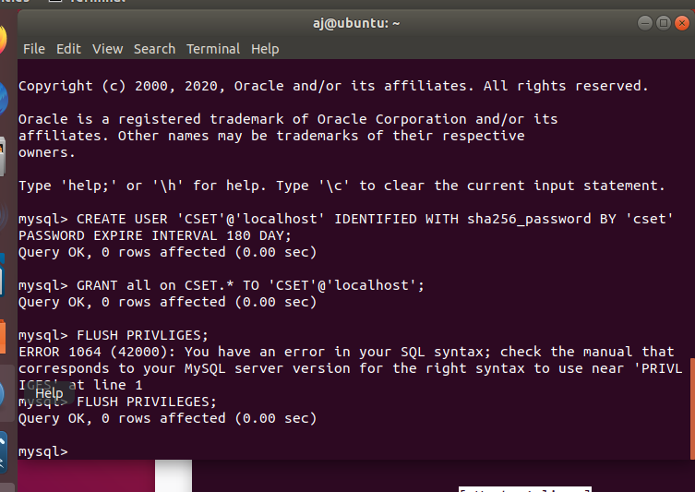
FLUSH PRIVILEGES;
EXIT;

sudo mysql -u CSET -p
Log in as user CSET and require password.

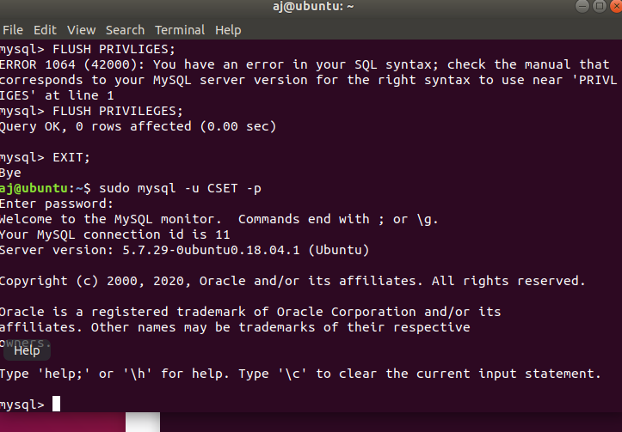

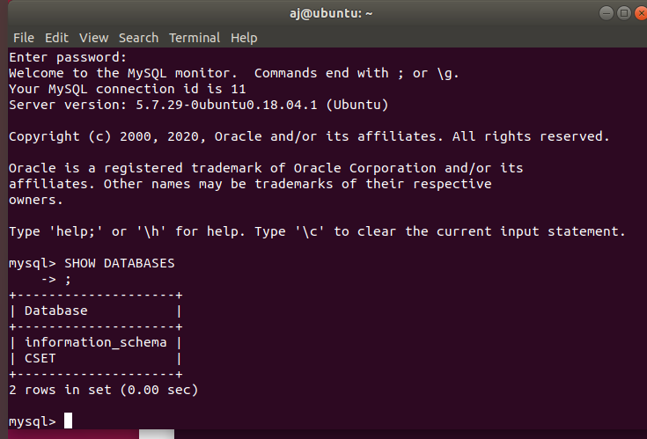
SHOW DATABASES; to see available databases for this user:

