Alexander J King
Unix Admin
Processes
4.1.20

First you need to acquire gnome-system monitor by running: sudo apt install gnome-system-monitor
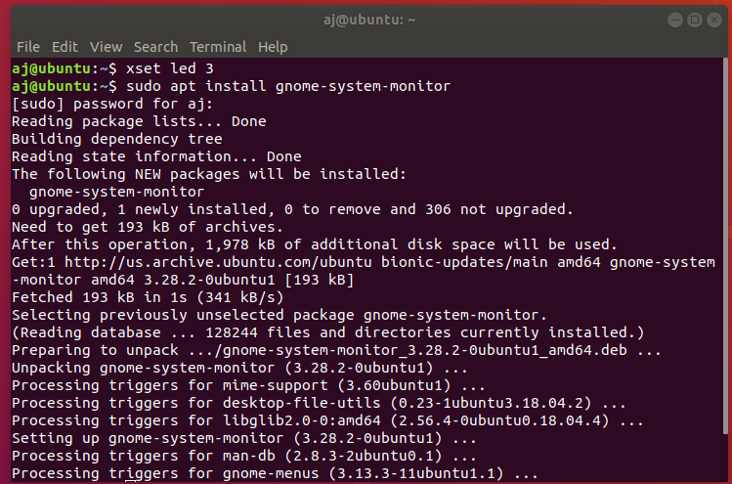

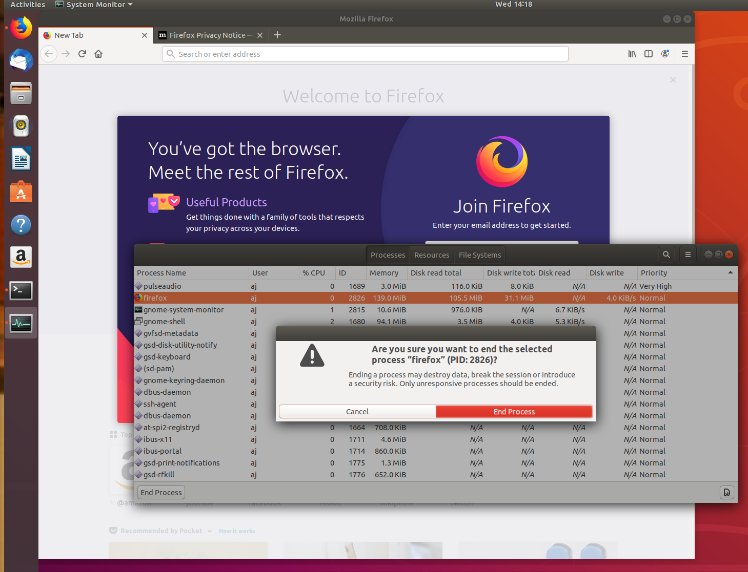
open gnome-system-montitor by typing into a terminal: gnome-system-montor. Open Firefox. Find it in the process list and kill it.

Test high priority:

Acquire Hardinfo program for benchmarking by running: sudo apt install hardinfo -y
After it install open it by typing hardinfo into the terminal. Scroll down to cpu cryptohash. Do this for both normal and high priority and post results:

Normal:

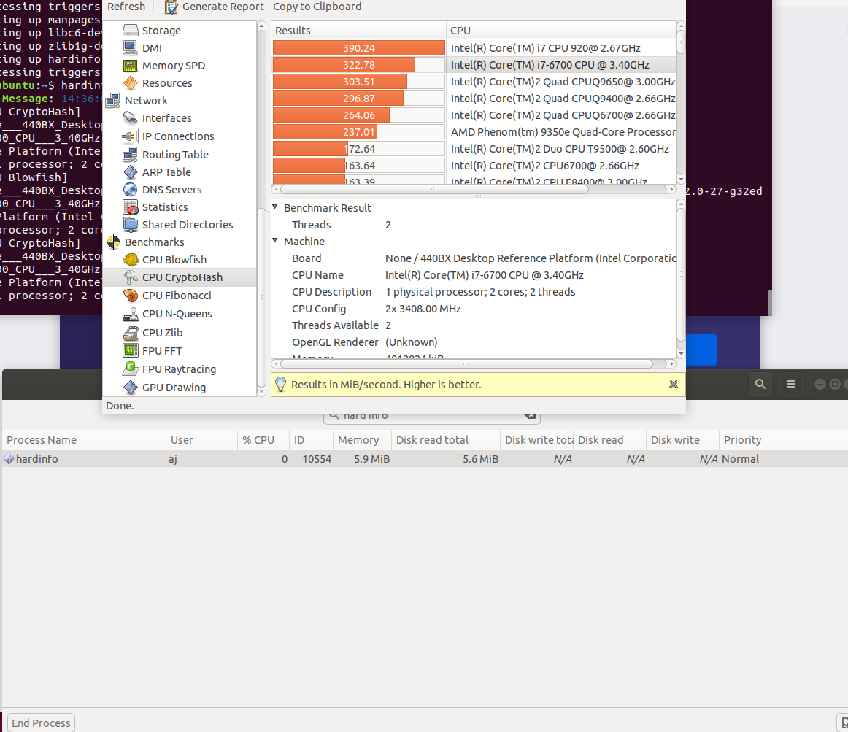
High priority:

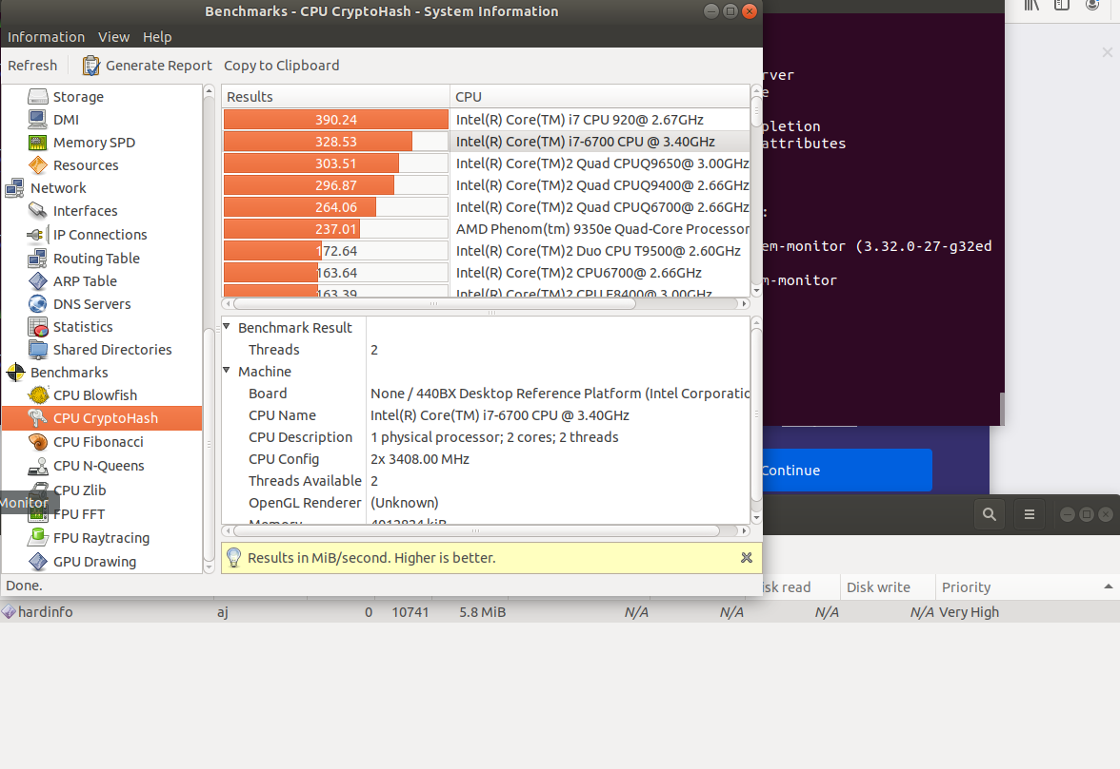

No noticeable difference. Some sections scored higher on each. I think it lacked an effect because the benchmark software should have an ability to utilize everything I have to give when it runs regardless of priority as well as not having many background processes that might be attempting to utilize my system resources.

