Alexander King
Unix Admin
PHP Lab
3.25.20

Install openssh-server with default options by runninng:
sudo apt-get install openssh-server -y
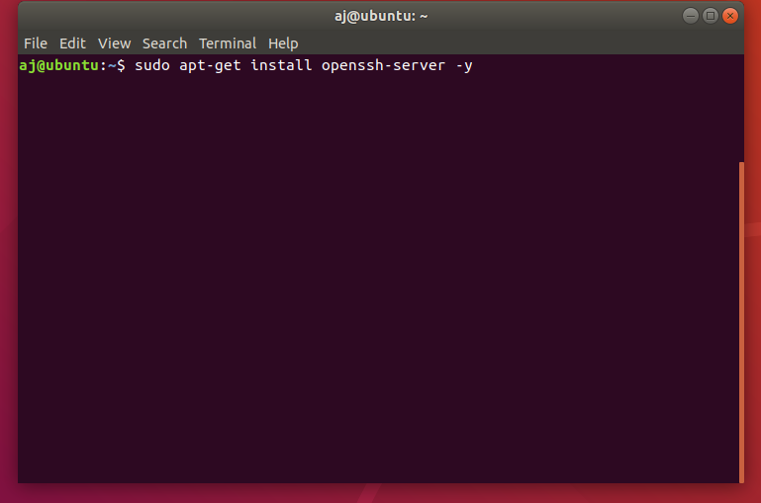

Check for your own ip address by running ifconfig:
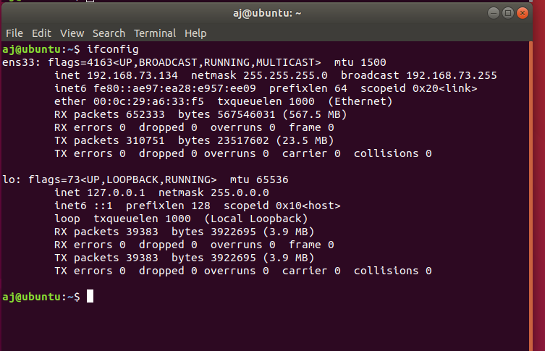

We are looking for the inet address of ens33. In my case 192.168.73.134. On the client windows machine open command prompt and try to ping it.

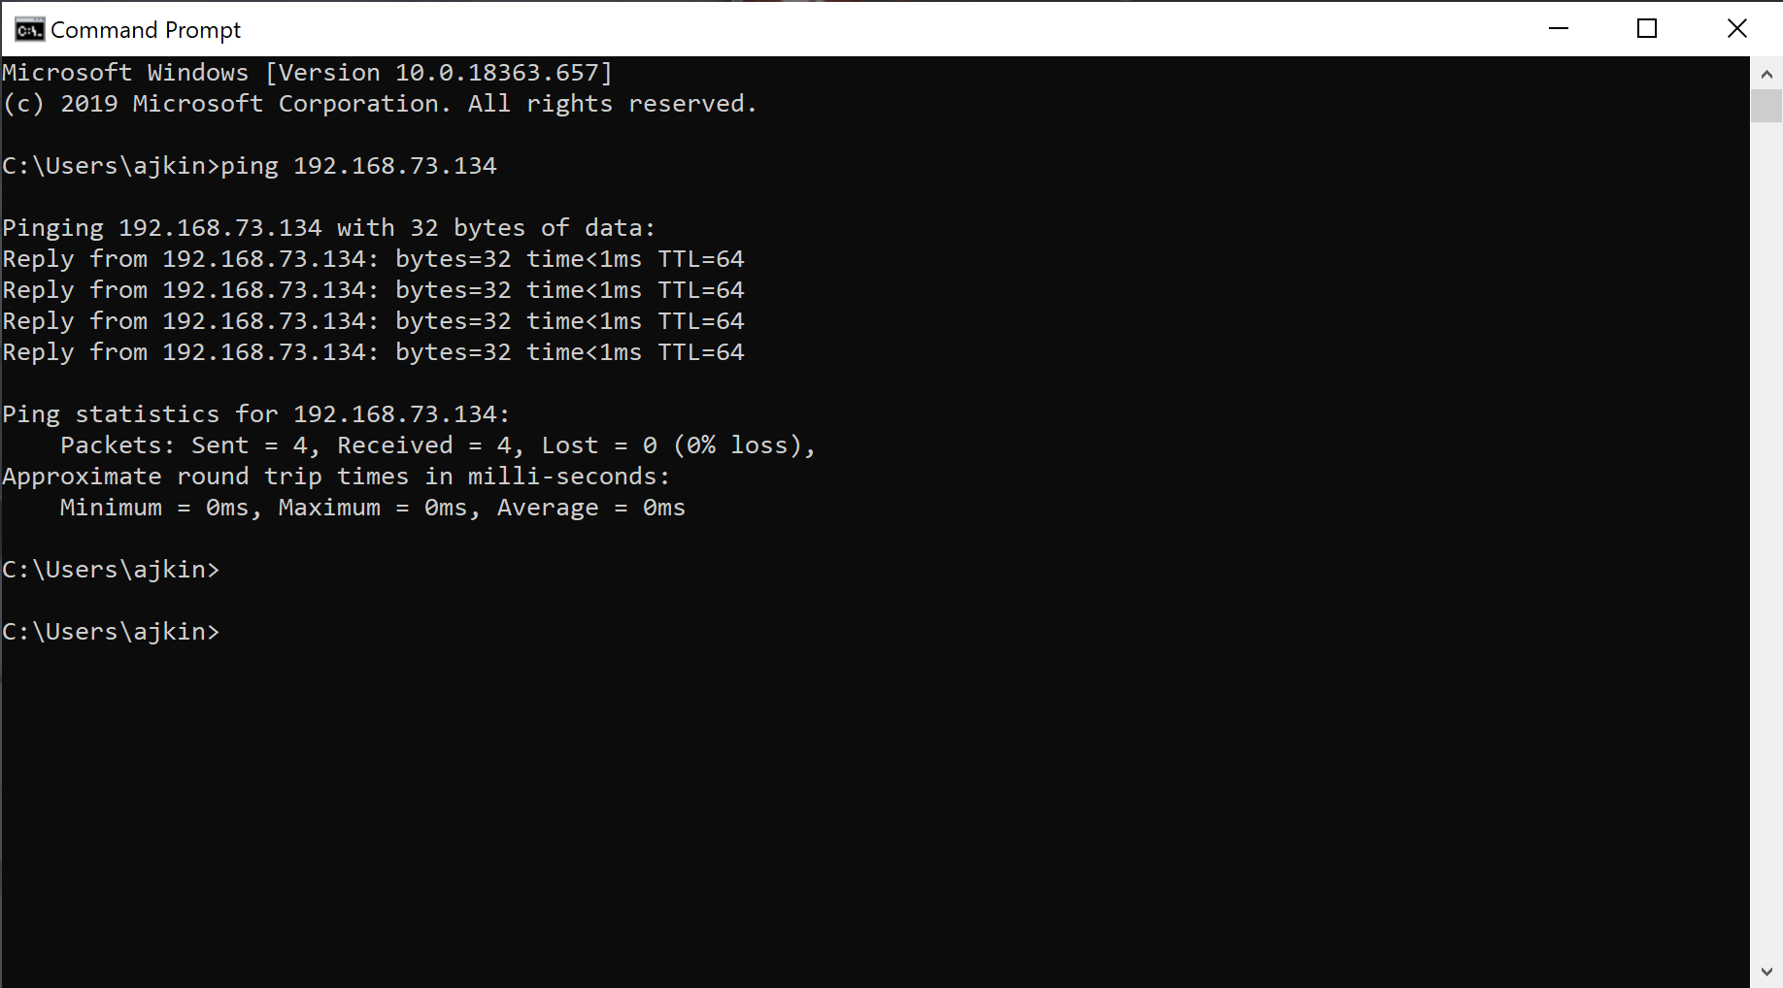
I already have putty installed on my client machine but you may not so: download it from here < https://putty.org/ >
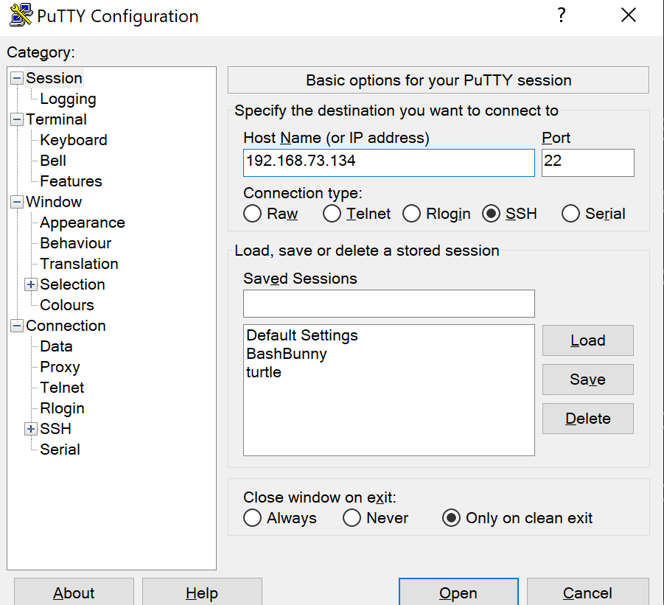
Once Putty is installed open it and put in the inet address we pinged.

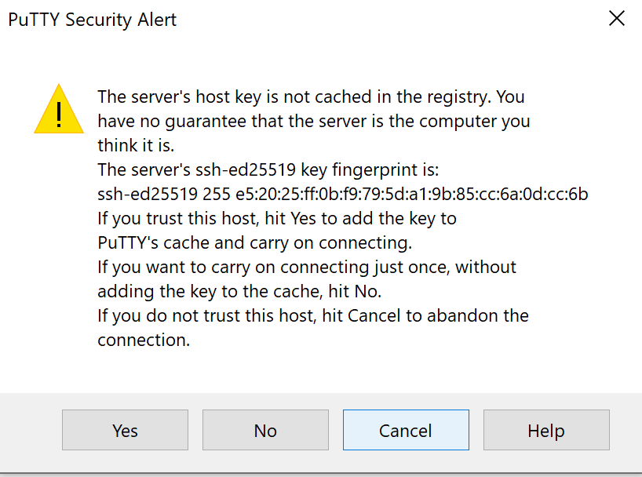
The first time you will connect it will give you a warning prompt. I suggest saying no for security reasons. Someone else could be assigned this local IP in future.

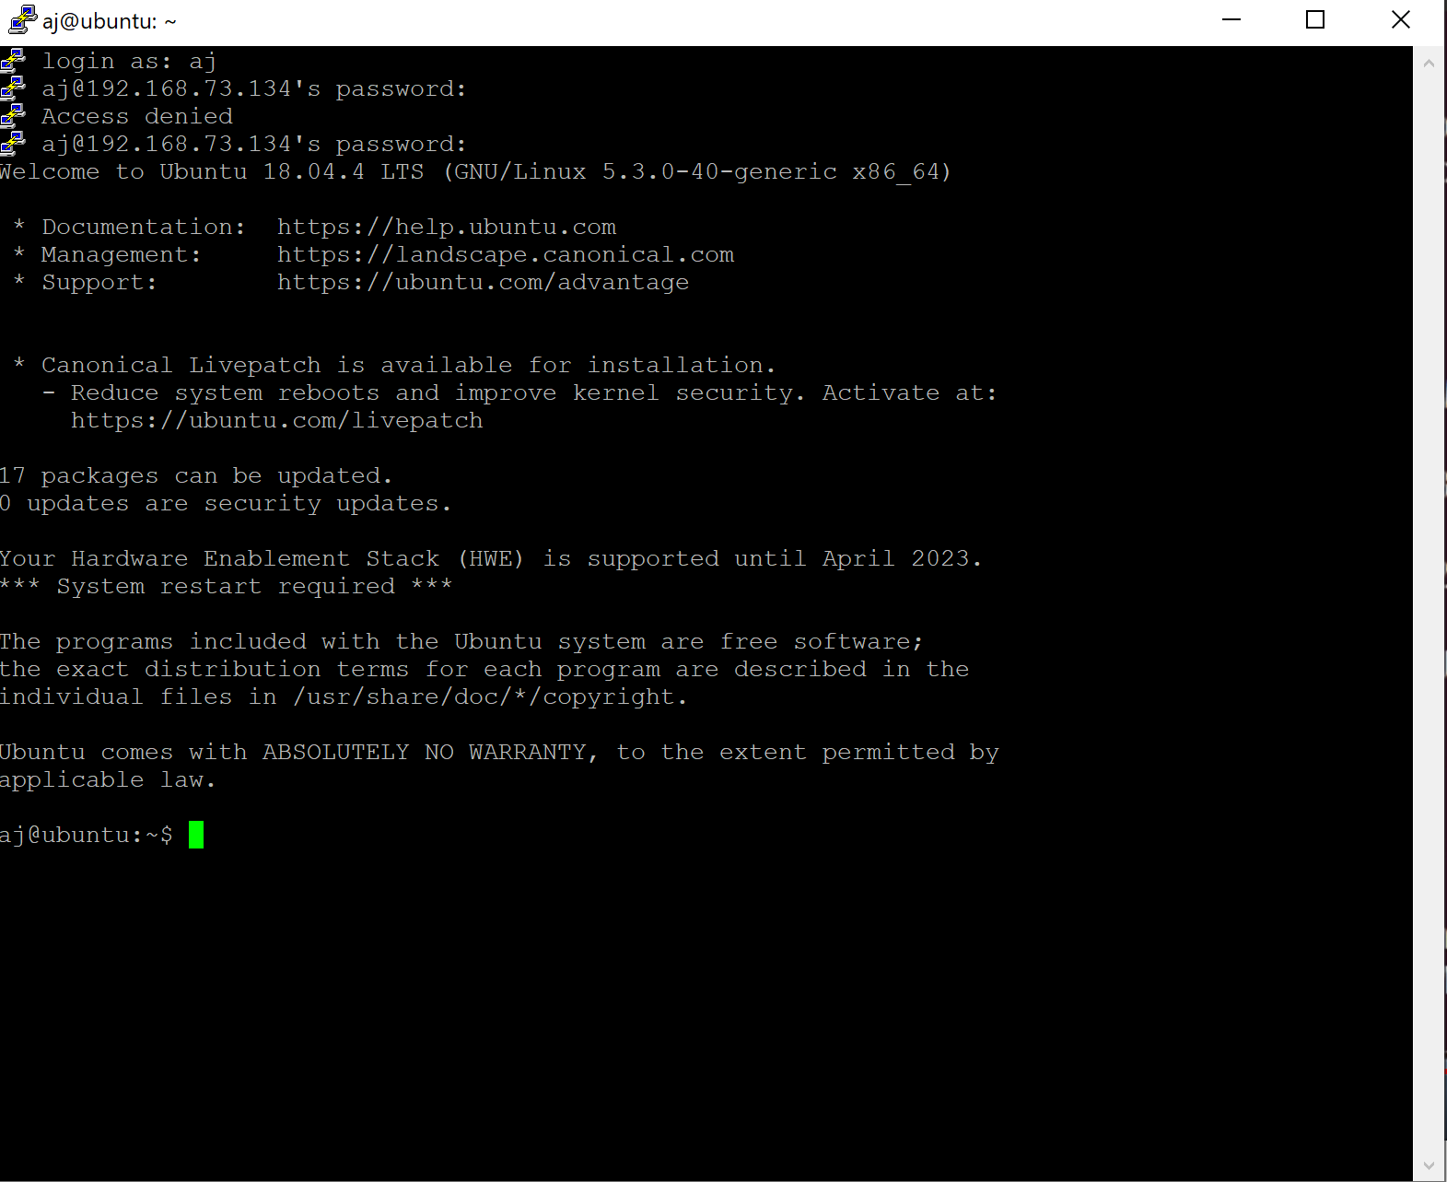
Log in:

Ensure the firewall is enabled on both client and server:
On the Ubuntu machine run sudo ufw status to see if the firewall is active. If it is not run sudo ufw enable.

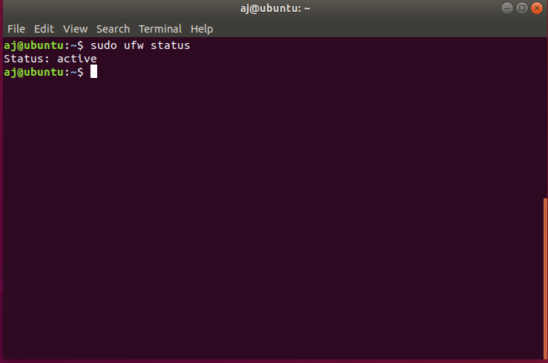

Ensure the port you intend to connect with is allowed by running: sudo ufw allow <port number>

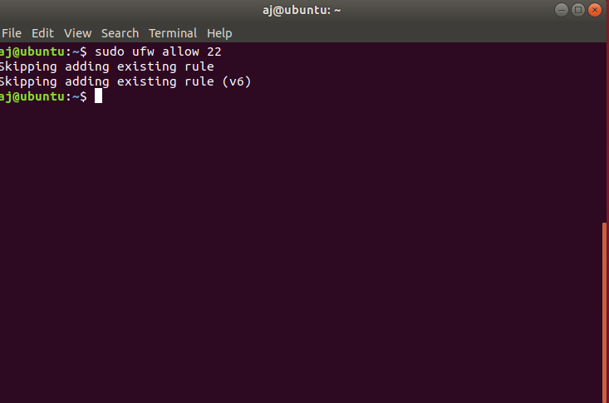

From the Windows machine hit the window button and type ‘firewall’ and open Firewall and Network Protection.

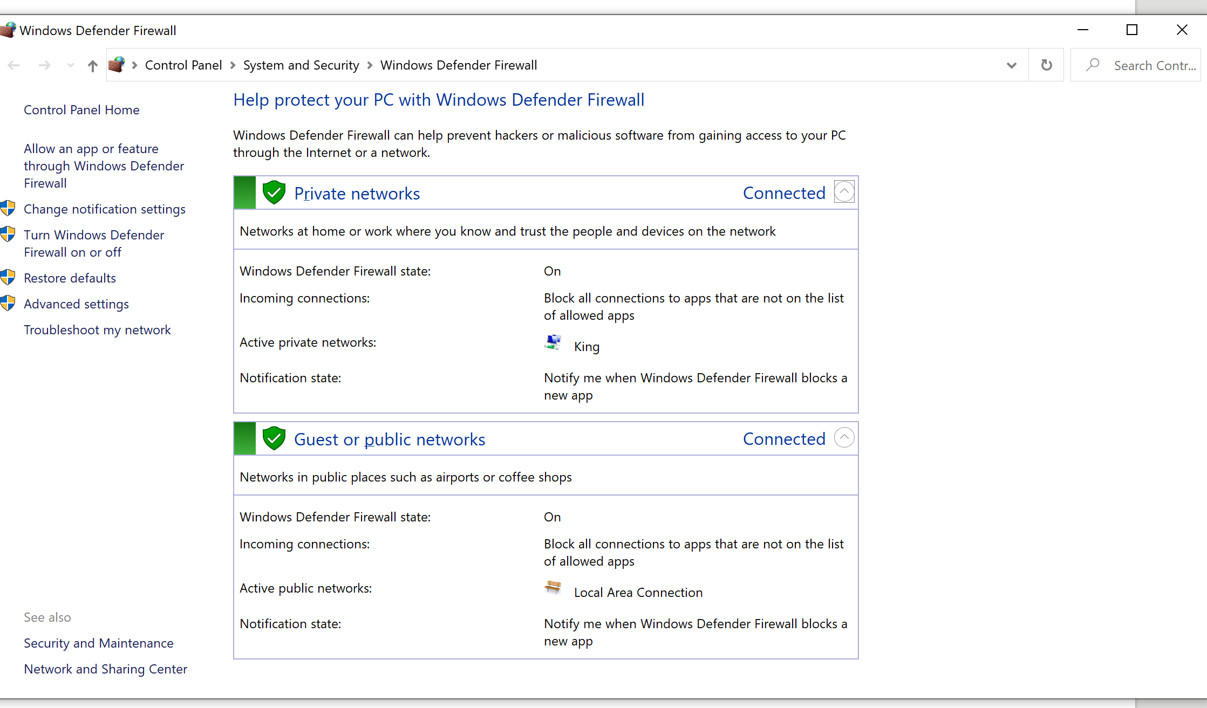

SOURCE: Source I used to ‘how to’ in setting up ssh server. < https://www.youtube.com/watch?v=ur-ctfgzGxs >

xRDP
Install xRDP with default options by running: sudo apt-get install xrdp -y
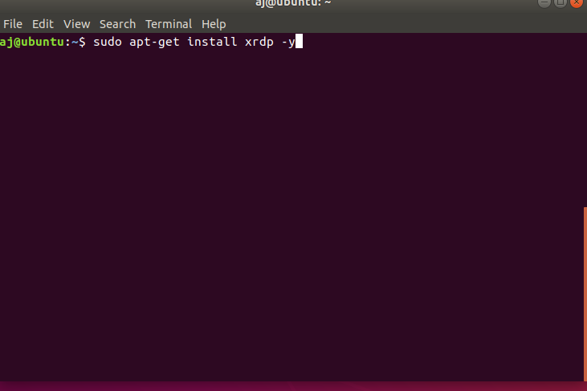

Enable xRDP by running: sudo systemctl enable xrdp

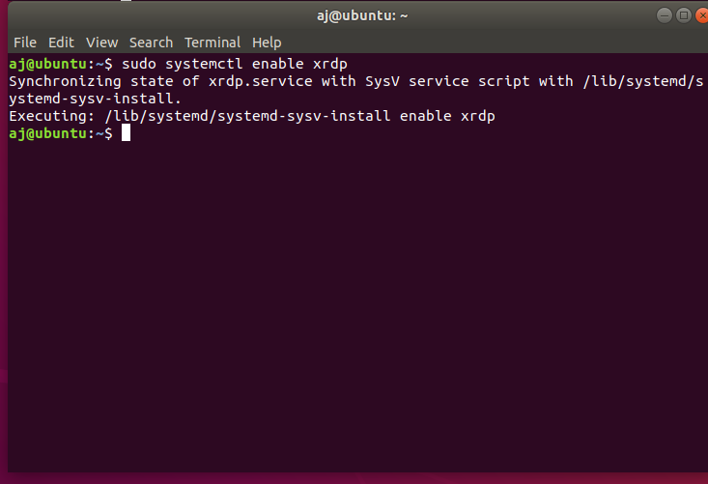

Start the xRDP service by running :sudo systemctl start xrdp
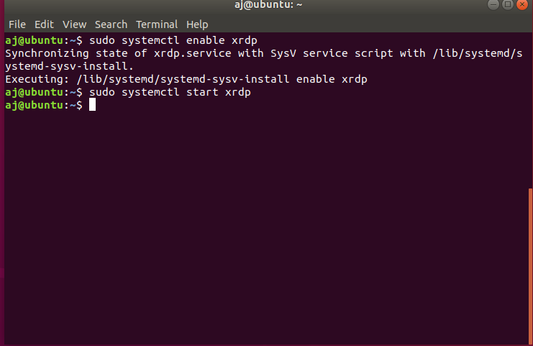

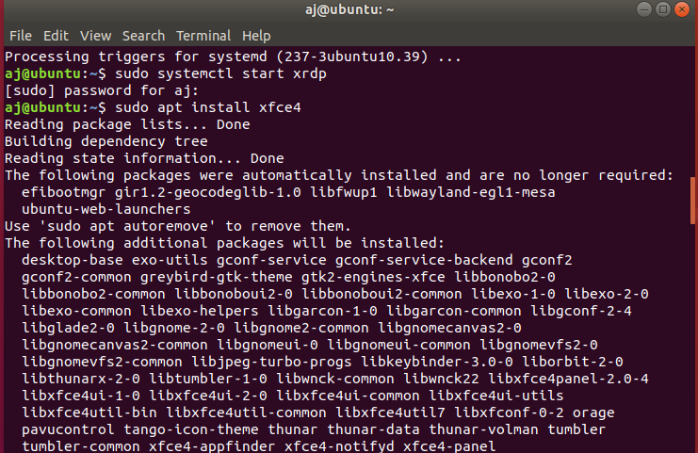

Add firewall rule to allow connection via tcp on port 3389 and renew firewall rules.
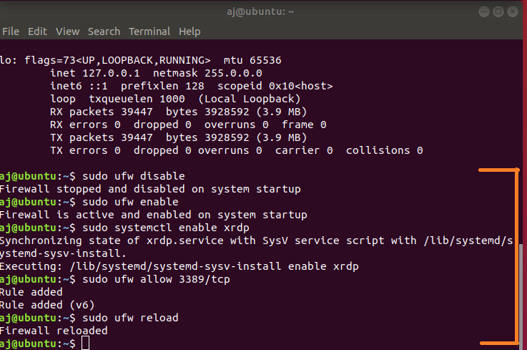

****ENSURE YOU’RE LOGGED OUT OF THE ACCOUNT YOU’RE GOING TO ATTEMPT TO LOG INTO******

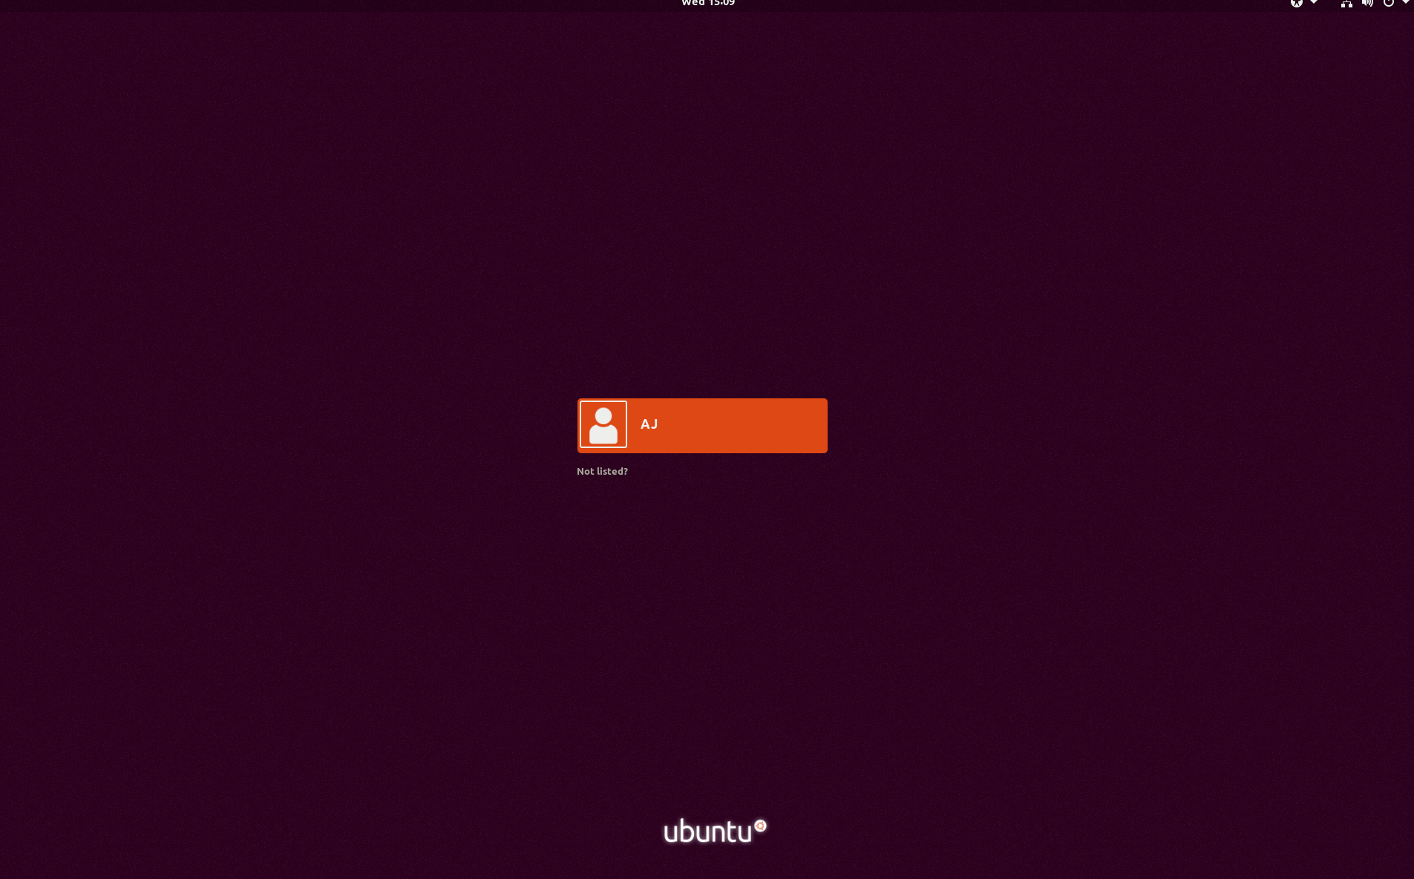

Open Windows Remote Connection an input your IP address of the machine you want to connect to.
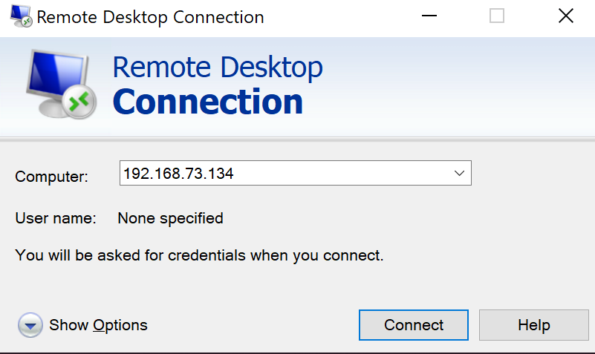

You will then be prompted for your credentials. So for me it is aj and my passsword.
Then if all goes well your desktop will display:
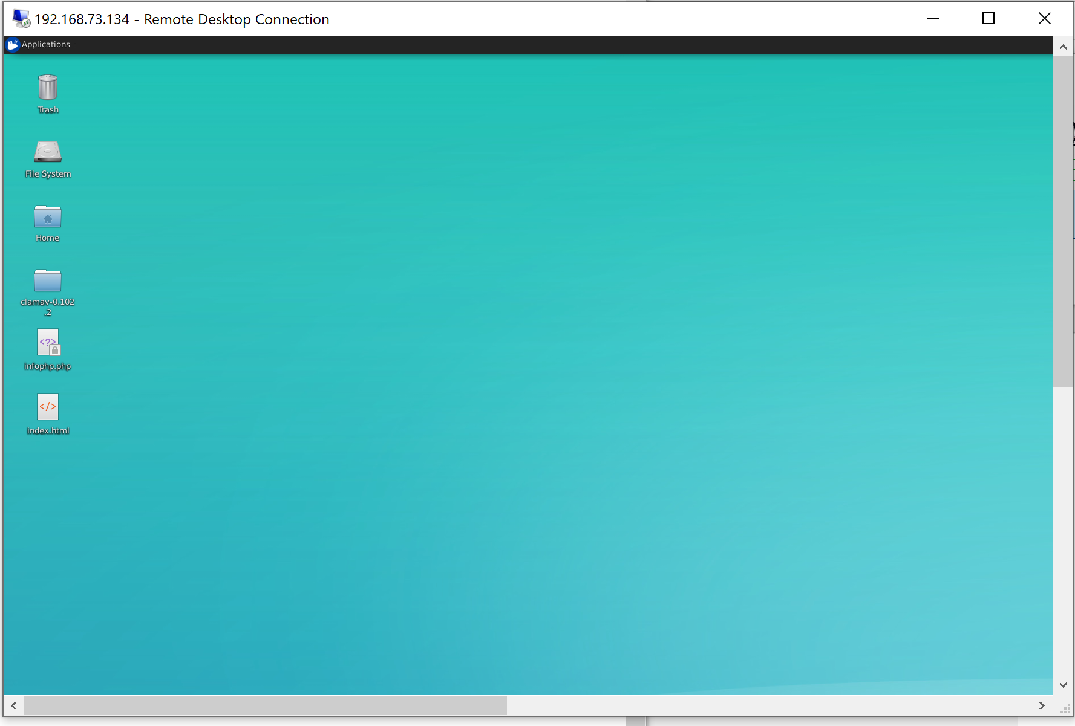

SOURCES:
https://www.youtube.com/watch?v=3G3GKUaDEE0 -
K JL - Ubuntu 19 04 | How to access Remote Desktop RDP using XRDP

VNC

Ensure we have the required packages by running: sudo apt update && apt install -y vino
This are default in Ubuntu I believe. I was already updated and had vino.

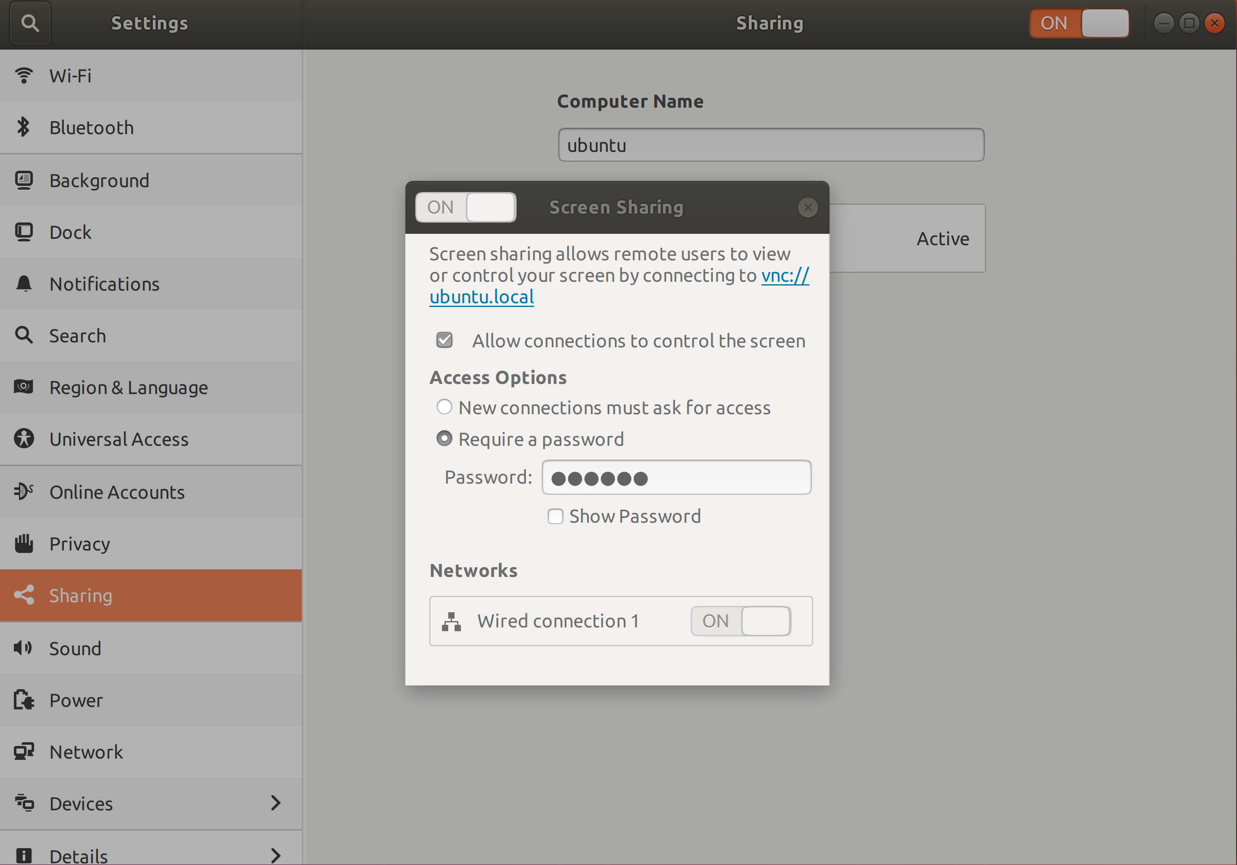
Press the windows button and type sharing. Open sharing . Ensure that sharing and screen sharing with a password is enabled.
Allow needed port. Sudo ufw allow 5900/tcp
Get dconf editor: sudo apt-get install dconf-editor
run dconf-editor
-----
incomplete. Wasn’t working decided to call it quits but include the work I did do on it.
----

