Alexander King
Unix Admin
Final Paper: Windows Server vs Ubuntu Server
4.20.20

Executive summary:
Businesses who require their own domains and server infrastructure often find themselves picking between two competing providers in the current market. Windows Server and Ubuntu Server. This report intends to compare compare the two with the end result being a recommendation of which way we should go. Each has their own strengths and weaknesses and I believe compelling arguments for both could be made.

Background

Our company needs a server solution that accommodates at least 30 users. We have narrowed our options down to 2 competitors both with their own advantages and shortcomings. We will explore speed, ease of use, features, reliability, sharing, and some other factors I feel are important to our mission such as security. Our two competitors are Windows Server and Ubuntu Server. Both can accommodate all of our needs but have many important differences that we will explore that will ultimately help us come to an informed decision about which would suit us best.

Comparison/Analysis

Windows Server
We will explore windows server first as I imagine more of us are more familiar with the name Windows than we are Ubuntu.

Windows Server is more beginner-friendly and presents and environment that will look and feel more familiar to the average user. The dashboard, shown below in figure 1, will look and feel significantly more familiar to the average user.
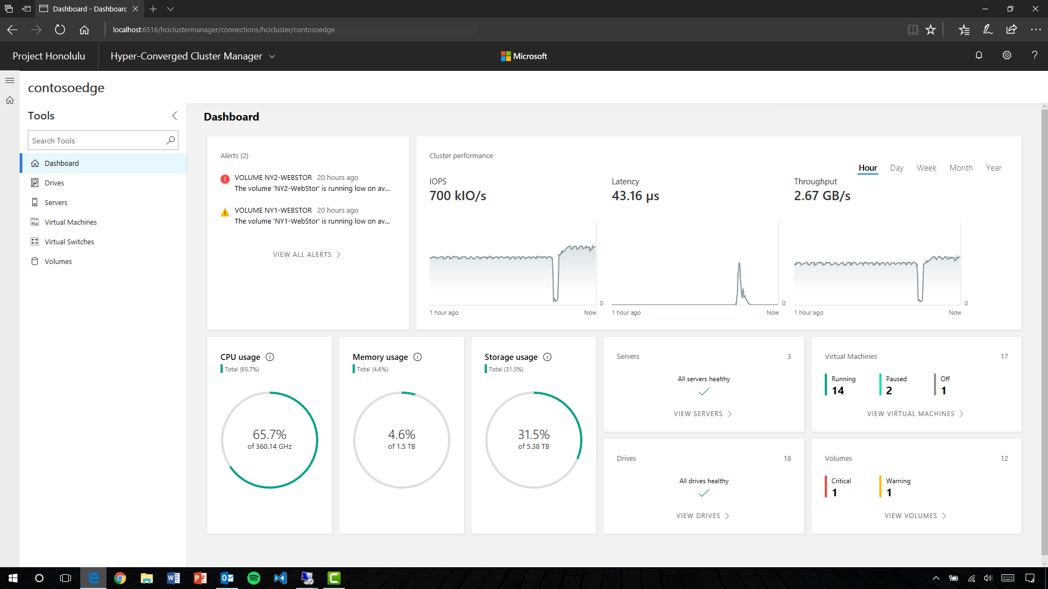Figure 1: Windows Server Dashboard < https://msdnshared.blob.core.windows.net/media/2017/09/Dashboard-Screenshot.png >

Updates: Windows Server updates/support are available relatively quickly. Updates are important because they keep our services running smoothly for all of our users. These updates can help us support the newest hardware configurations (new computers or equipment), plug up security vulnerabilities to stop unwanted hackers or exploits, and keep the program looking and feeling modern. The downsides are the possibility for frequent need of updates and potential for a bad update that causes issues. Updates can typically be scheduled to happen during hours that will not affect users during peak hours. Support for products tend to be long term. Currently Windows is releasing bi-annual feature updates and monthly quality updates (with important security updates mixed in). The windows 10 client is currently defined to be supported through October 14, 2025 at which time it can be expected to have to pay for a new update cycle. Although there are some unknowns about this as well because Microsoft has changed their release schedule with Windows 10 for the first time in their history of selling operating systems so this potentially could be different than it has been in the past. See release schedule here <https://support.microsoft.com/en-us/help/4076506>

Software support: Windows server supports many third-party apps users may want. The users could potentially use one of their favorite programs that is possibly not officially supported on Ubuntu or might take above average skills to get to work. The down side to this is that it opens up a greater surface of attack for outside hackers. The user could also download a virus that attacks Windows and causes us issues.

Active Directory: The users downloading things we don’t want them too is a good segue into Active Directory. Active Directory is where Windows Server really shines in my opinion. This is a built-in command and control center that lets IT decide the rules for our users. We can make them as strict or laissez-faire as we desire. We can do this by grouping of employees (IT, vs executive, vs support, vs any) or down to the individual employee (Karen from accounting vs Sarah the owner). So if we like we can attempt to limit what risks users can potentially be allowed to take without approval from IT. This is a balancing act as you don’t want users to be able to let hackers in when they click a link they shouldn’t have from their email but you also don’t want IT to have to approve opening every internal document for every employee. Access controls allow us to hide information from users who should not see it while providing access for those that do. EX: Some employees do not need to know who our suppliers are or information about how much we pay for supplies so we can block them from being able to see such things while allowing people that need access to have it. We can fully customize settings and what is accessible from individual programs, websites, etc.
Beware of creating too many active directory rules and maintaining it. Too many rules and changing employees who maintain them can potentially lead to labor-intensive servicing.

Performance: Windows operating environment will require more resources than its Ubuntu counterpart which means things will run slower on the exact same hardware compared to Ubuntu.

Maintenance: Maintaining a Windows Server will require a professional employee but may not have as large of a learning curve to become proficient as Ubuntu Server.

Cost is the major downside to the Microsoft products. They have expensive licenses and one encourages getting another. So if we buy Windows server for our 30 employees the license for it will cost Min $1000 before we sign up for any additional services like web hosting, email, or office. If we need higher tier services the $1000 could quickly become $6000 and these will need to be renewed periodically.

Ubuntu

Cost: Ubuntus greatest asset is that it is FREE of change. It costs nothing to acquire and use the Ubuntu Server and updates are also free. This money can be reallocated elsewhere within the company. This is a minimum $1000 value and potentially much more.

Updates: Security errors are relatively rare and when they occur are usually easily fixed but not all versions come with long term support options. Updates are less frequent and provided by a community of enthusiastic users. This is both positive and negative. Security updates may take longer to roll out and some features may lag behind in rolling out. But on the positive side they’re free and open source. This means we can have our professionals review and understand the code and we can adapt it to our needs specifically catered to us without licensing fees. Things we create will be our own and not reliant on paid-proprietary support.

Look and Feel: The look and feel of Linux will be foreign to a first time user. It will take some learning and getting used to that a Windows 10 environment might not. I personally think this distribution looks similar to a mac computer OS:
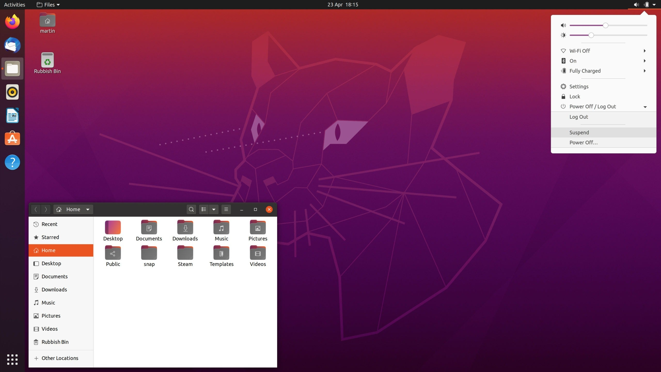Figure 2: Ubuntu Desktop < https://external-content.duckduckgo.com/iu/?u=https%3A%2F%2Fwww.ghacks.net%2Fwp-content%2Fuploads%2F2020%2F04%2Fubuntu-20.04-lts-scaled.jpg&f=1&nofb=1 >

Usability/Security: Many third party programs will not immediately work on Ubuntu as they were designed for Windows. So some programs might be harder to find or not exist. This appears to be changing though. More and more programs are being supported on Linux (Ubuntu) operating systems. For example we could still use QuickBooks or Spotify as these programs make versions for Linux. Many other Windows programs can be run with a program called Wine but these are not as simple to set up as most people familiar with Windows would find it to be on a Windows operating system. Since Linux does not run Windows programs our attack vector is also greatly lessened. It is significantly harder for users to click a link or download a thing that is going to break their computer. Ubuntu provides solutions for all of our file and printer sharing needs as well as permissions accessibility to control them.

User Freedoms: Admin users can often enjoy greater freedom offered by the system admins. This is partially due to being relatively to Windows operating systems a rare target for Cyber crimes and system admins being able to reasonably allow a greater degree of freedom to the user if desired. As well as the incompatibility of many malicious software mentioned above. Users will probably need to learn some basic command line commands at some points vs being able to be reliant on a graphical user interface for everything. If the end users understand their additional freedom they might take learning more seriously. For example a windows server set up might prohibit launching any unapproved executable files, like opening Spotify or its installer, while the Ubuntu option maybe given the ability to do so with lesser security concerns on their Linux machine. Giving the user some freedoms and goals to learn how to do things in a different way than what they’re used to can be an excellent motivation to learn some of the skills that will also apply directly to their daily work.

Reliability: Ubuntu is typically much more reliable than the Windows counterpart but requires higher skill server admin.

More Freebies: The additional potential costs in the Windows section revolve around their other complimenting services that are also free in Ubuntu. Instead of paying for Microsoft Office we have LibreOffice it looks and feels almost identical but costs nothing. If we’re considering using PHP, Perl, Python, Ruby, or MySQL we have free complimentary software where Microsoft wants us to pay even more to utilize their services.

Performance: Ubuntu uses less hardware resources to run which mean you can expect greater performance out of the exact same hardware when compared to running a Windows operating system.

Servicing: Unix operating systems tend to be easy to service but require someone with the background knowledge to do so. Integrated remote access tools allow the systems admin to access user devices if and when needed. Some support done by the server admin may need to be done through community forums instead of contacting support by phone or messenger.

Direct Comparison Table:

1-10 | Windows | Ubuntu
File Sharing | 7  Work Group, the Windows file sharing solution, is frequently buggy. It is easier to set up but inferior to Samba in my opinion. | 9  Samba offers a similar service with higher reliability but more complicated initial set up.
Printer Sharing | 9  Windows printer sharing is easy from an administration standpoint but users still frequently manage to cause themselves avoidable printing issues. I see these as user errors without a nicer simpler option. | 8  Ubuntu Server has a more complicated set up and then otherwise functions very similarly to its windows counterpart that most people are familiar with. Users will still manage to be unable to print or select the wrong one if given too many options. Samba can be utilized for this and is of course free.
Web Hosting | 8  Microsoft IIS  Proprietary so it costs more money. | 9  Apache, Nginx  Opensource it is free  Requires more training and learning but has comparable open source options. I really like Apache.
Database Access | 9  MSSQL, and Microsoft Access. Microsoft Access is sold with their Microsoft Office package separate from the Windows Server Package. | 10  MySQL, MariaDB  Excellent free opensource options that accomplish the same thing but may require additional training. MySQL and MariaDB are my personal go-to.
Price | 1  Expensive. Minimum $1000 likely much more when including associated services that are sold separately. | 10  FREE  It doesn’t get better than free.
Ease of Use | 9  Windows is what most users are familiar with thus they feel at home in the environment. | 3  Ubuntu and Linux in general always requires greater effort to learn regardless of the required task because it is unfamiliar to most new users.
TOTAL | 43/60 71% | 49/60 81%

Recommendation

I think for our companies needs the best suited in Ubuntu with the most significant difference factor being the cost. Ubuntu outperforms the Windows competition in the majority of the categories and tends to fall short only in familiarity and ease of set up. So partnered with the recommendation of utilizing the cost-saving Ubuntu also invest some of the savings to ensure the server admins are proficient. Minimal additional training on an unfamiliar Ubuntu operating system for normal users should be expected too.

Conclusion
The scores are not terribly far from each other and compelling arguments can be made for either. For our company however I think the savings on the licensing costs cab be applied towards ensuring we have excellent server administrators as well as more money to put towards the performance of our machines. Doing this so-long-as we maintain an excellent IT department we will be able to enjoy the best of both worlds.

