Alexander King
Unix Admin
Samba
4.13.20

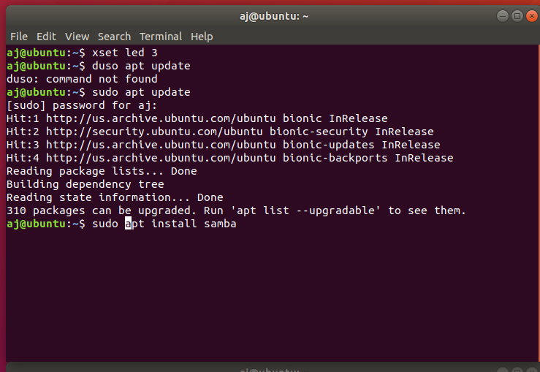
Ensure your system is updated first as always with a sudo apt update. Then install Samba with sudo apt install samba.

Open the conf file. Sudo nano /etc / samba /smb.conf
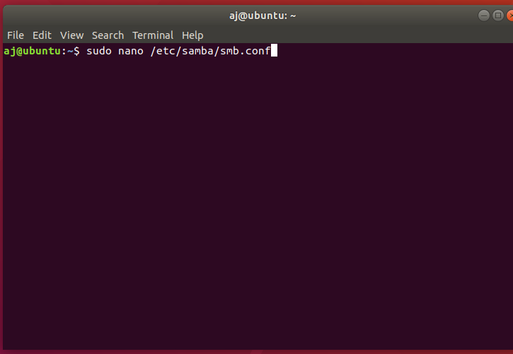

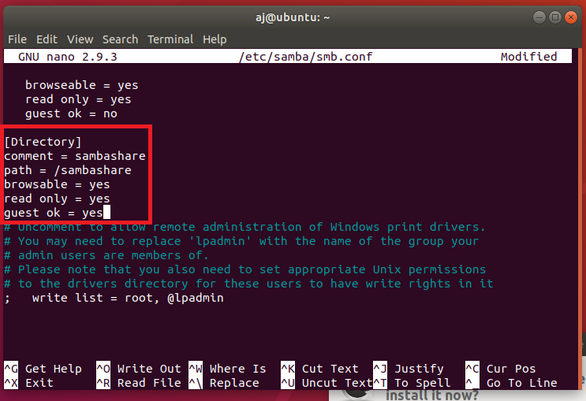
After opening the config file I made the following additions (inside the red box only):

Now lets make the directory we said we wanted to share in the previous step. Sudo mkdir /sambashare
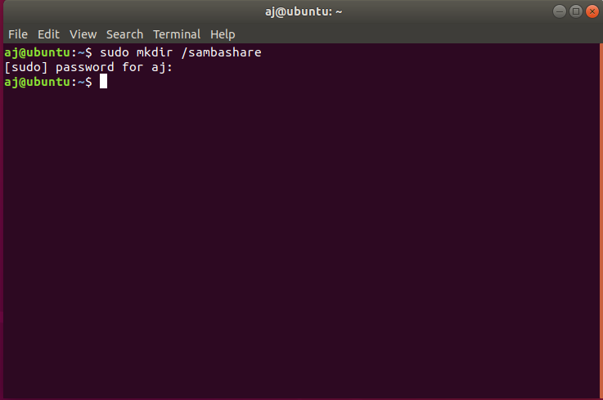

Add a user “user0”
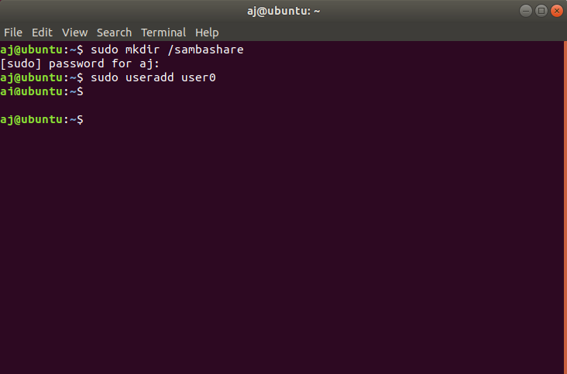

Assign user0 a password:
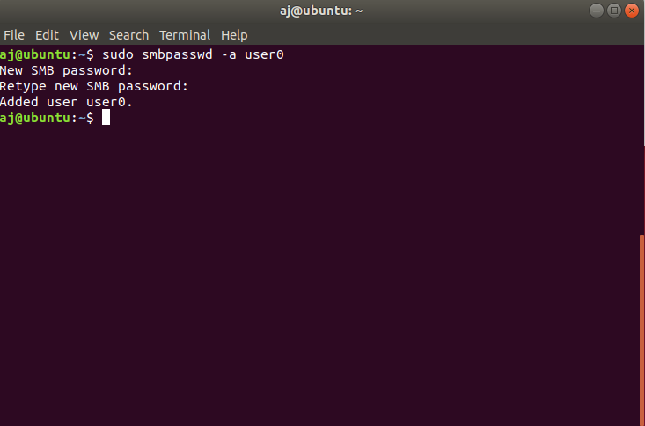

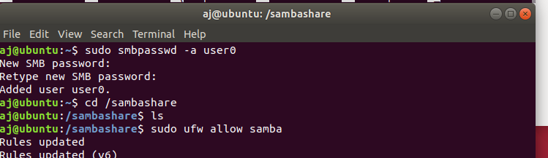
Add a firewall rule to allow traffic:

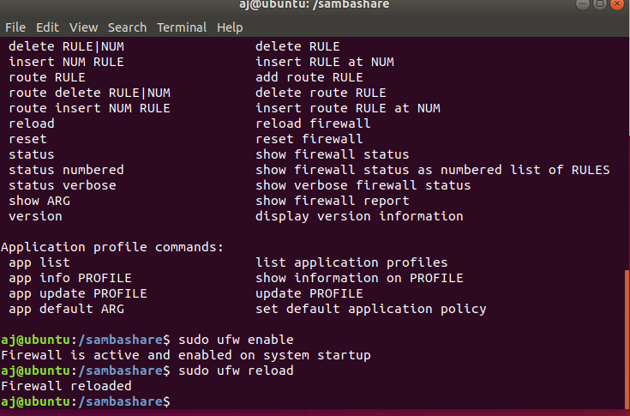
Ensure the firewall is on and reload to ensure rule changes are pushed. Sudo ufw enable and sudo ufw reload.

Restart the smbd service:
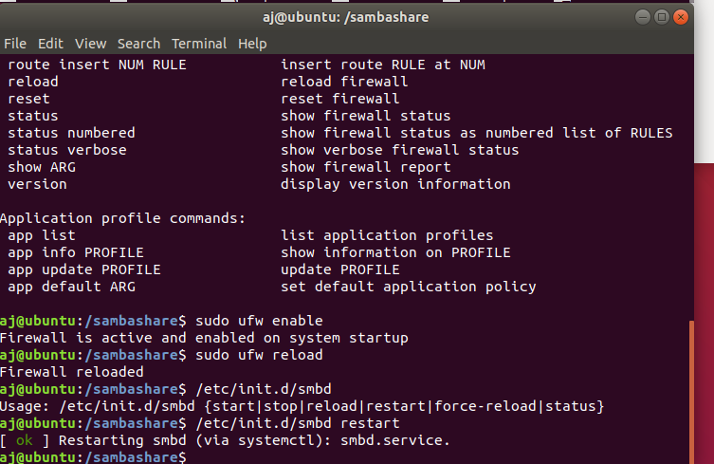

Create a test file by using sudo nano and ctrl-o to write it. When prompted save to /sambashare / test.txt.

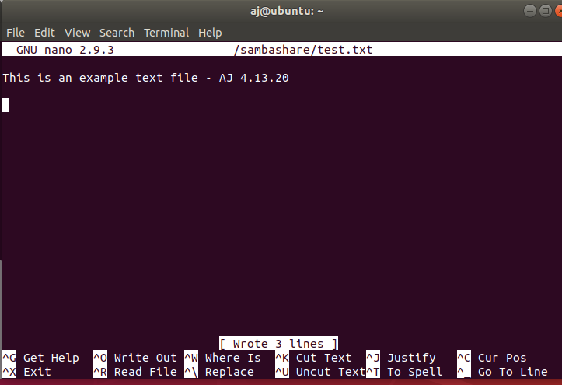

On the windows device go to network. In my network I see Ubuntu and when I double-click on it I am prompted for an username and password that I created in a previous step. User0 ***********. Log in with these credentials.

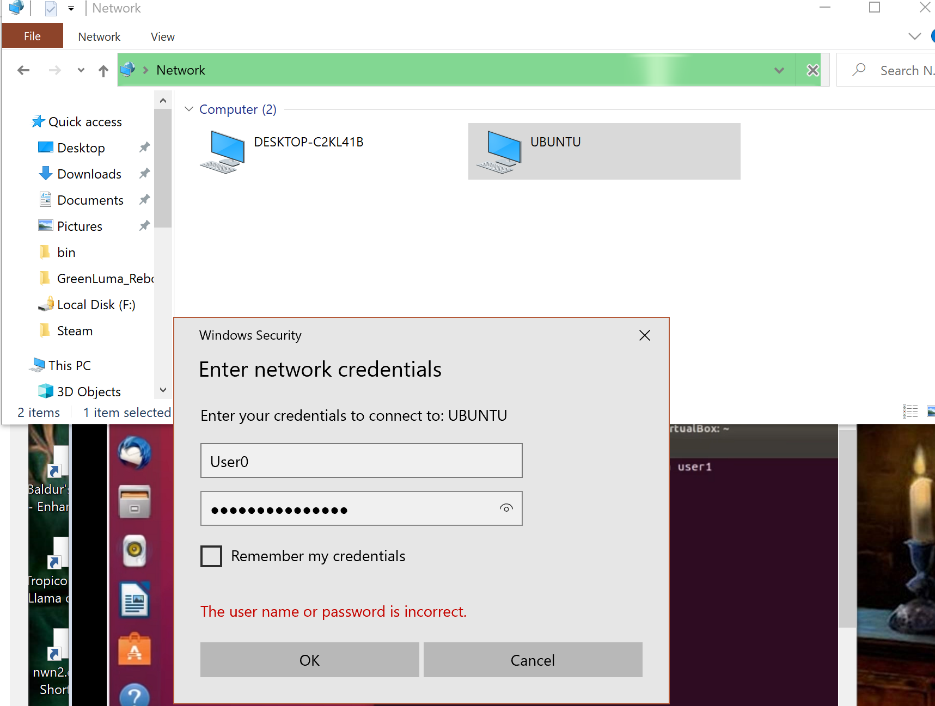

After logging in I see a folder named Directory. Inside of that folder is the test.txt file I made. See below:
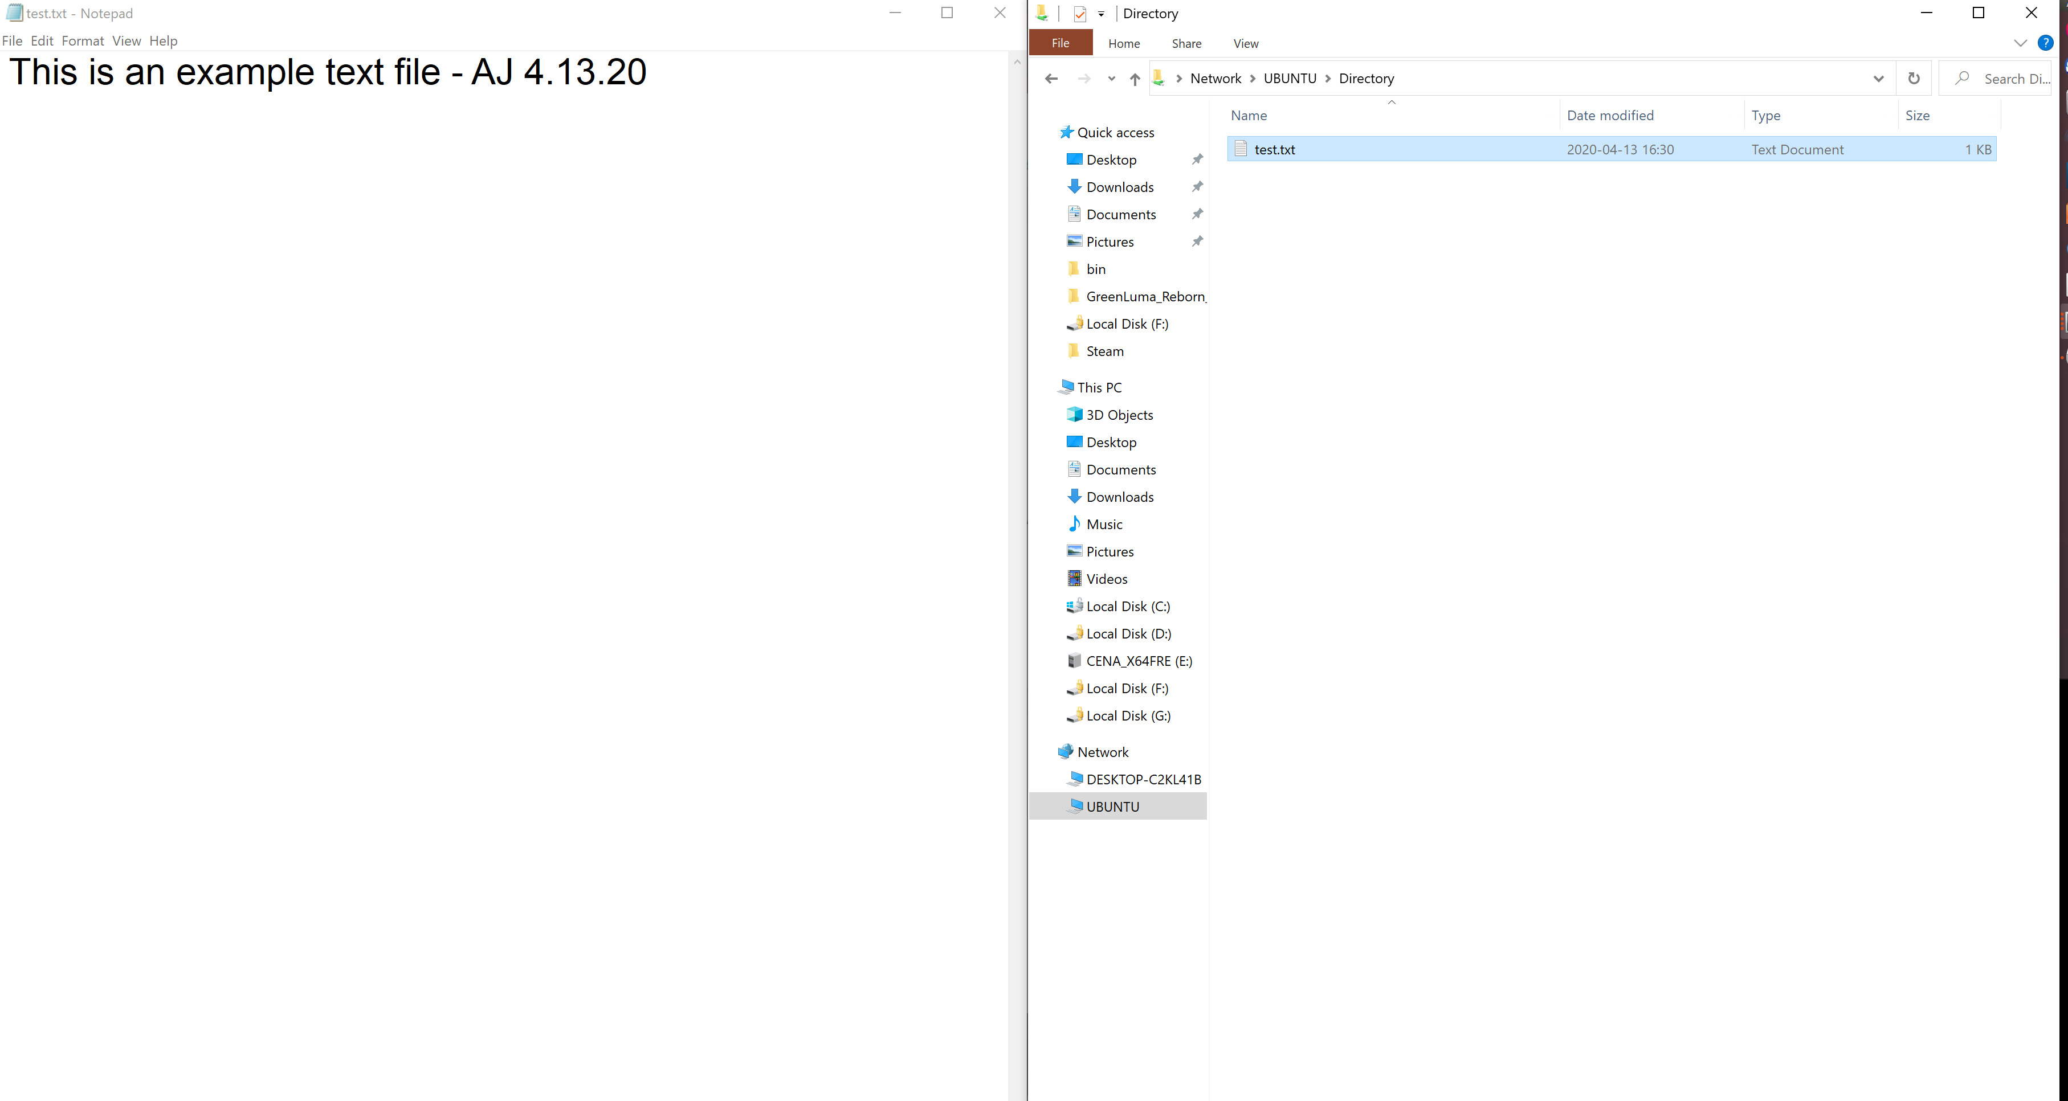
Attempt to make an edit from the windows machine (you should not be able to currently) and ctrl-s to save.

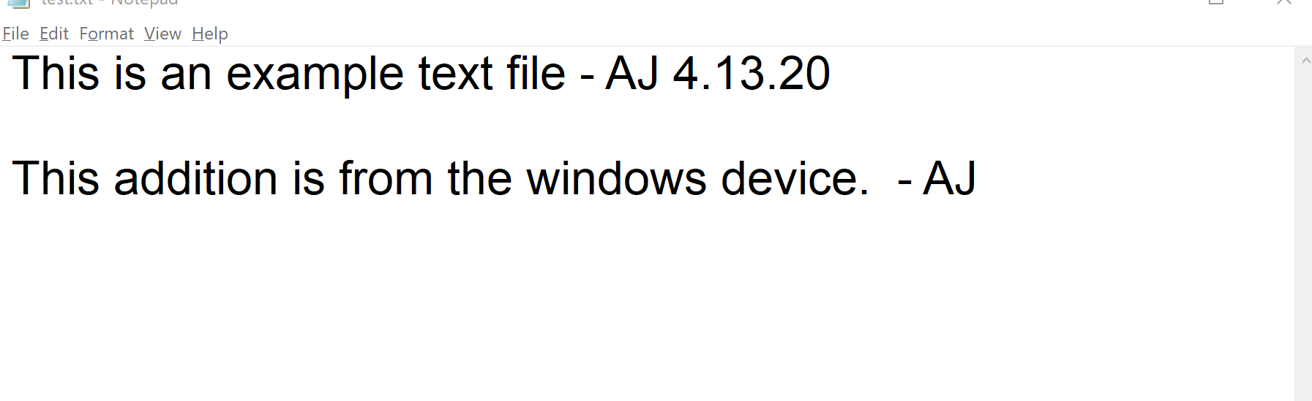
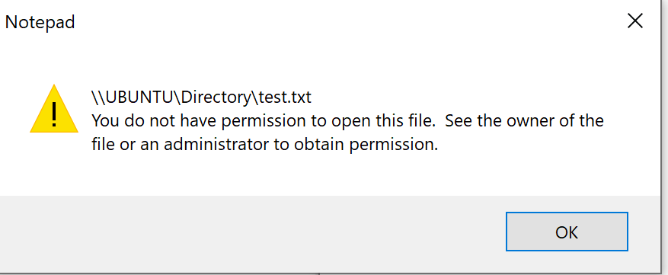

Now go back to the config file and allow read/write.

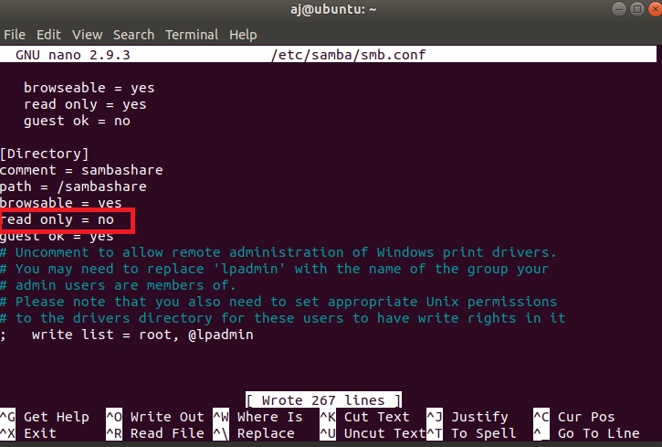

Now restart the smbd service and retry writing by saving a new .txt to test1.txt file from the windows machine.
aj@ubuntu:/sambashare$ /etc/init.d/smbd restart
[ ok ] Restarting smbd (via systemctl): smbd.service.
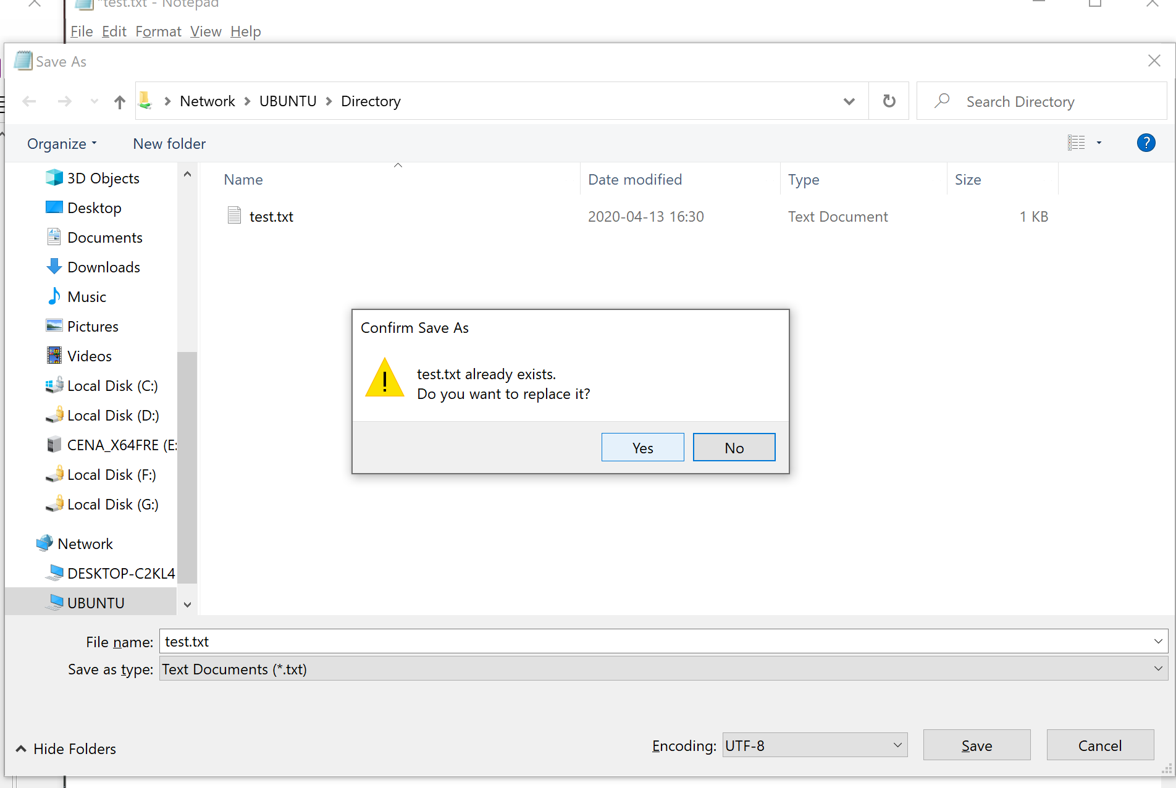

Now open the document in the Ubuntu machine to confirm changes were applied. Sudo nano /sambashare/test1.txt
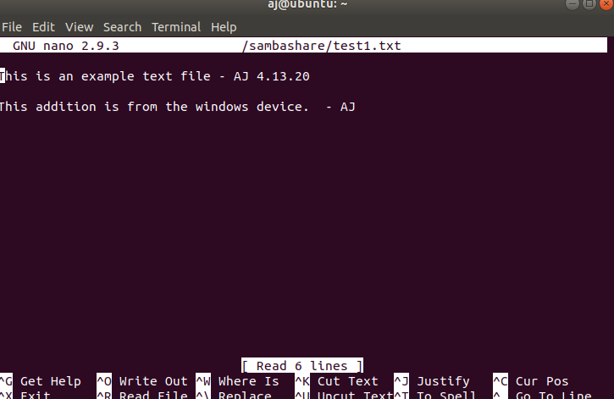

And we’re done! We have sucessfully created a file sharing solution between our unix and windows machines.

