Alexander King
Unix Admin
Unix Server Admin Monitoring Lab
4.20.20

As always start by updating and upgrading. Sudo apt get upadte sudo apt get upgrade.

Then we’re going to install tasksel with: sudo apt install tasksel. Afterwards we’re going to choose which packages to install by running sudo tasksel and selecting Ubuntu Cloud Image (instance) and LMAP server and click enter.
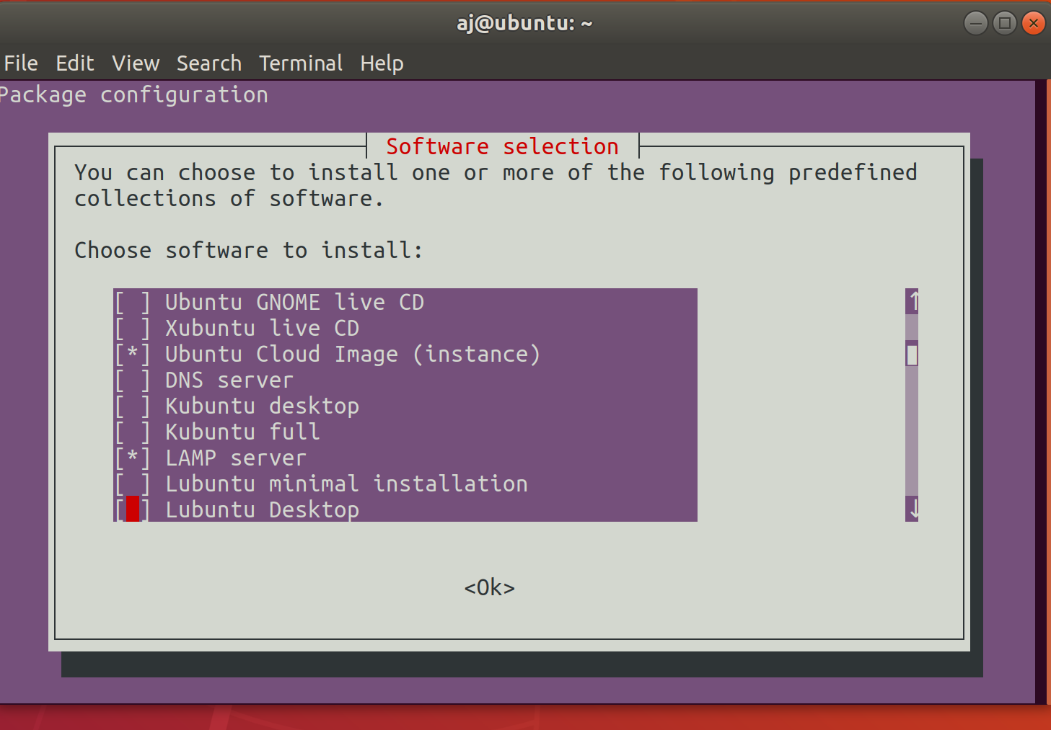
Then we’re going to set up MySQL by running: sudo mysql_secure_installation

y to log in with no password.
2 to log in with a strong password → input your “strong” password.
Enter to not remove anonmyous users (required homework step)
Allow root to connect from the network. This is for ease of use. It opens up an attack vector where someone might be able to guess at my “strong” password.

Remove testDB with option y.

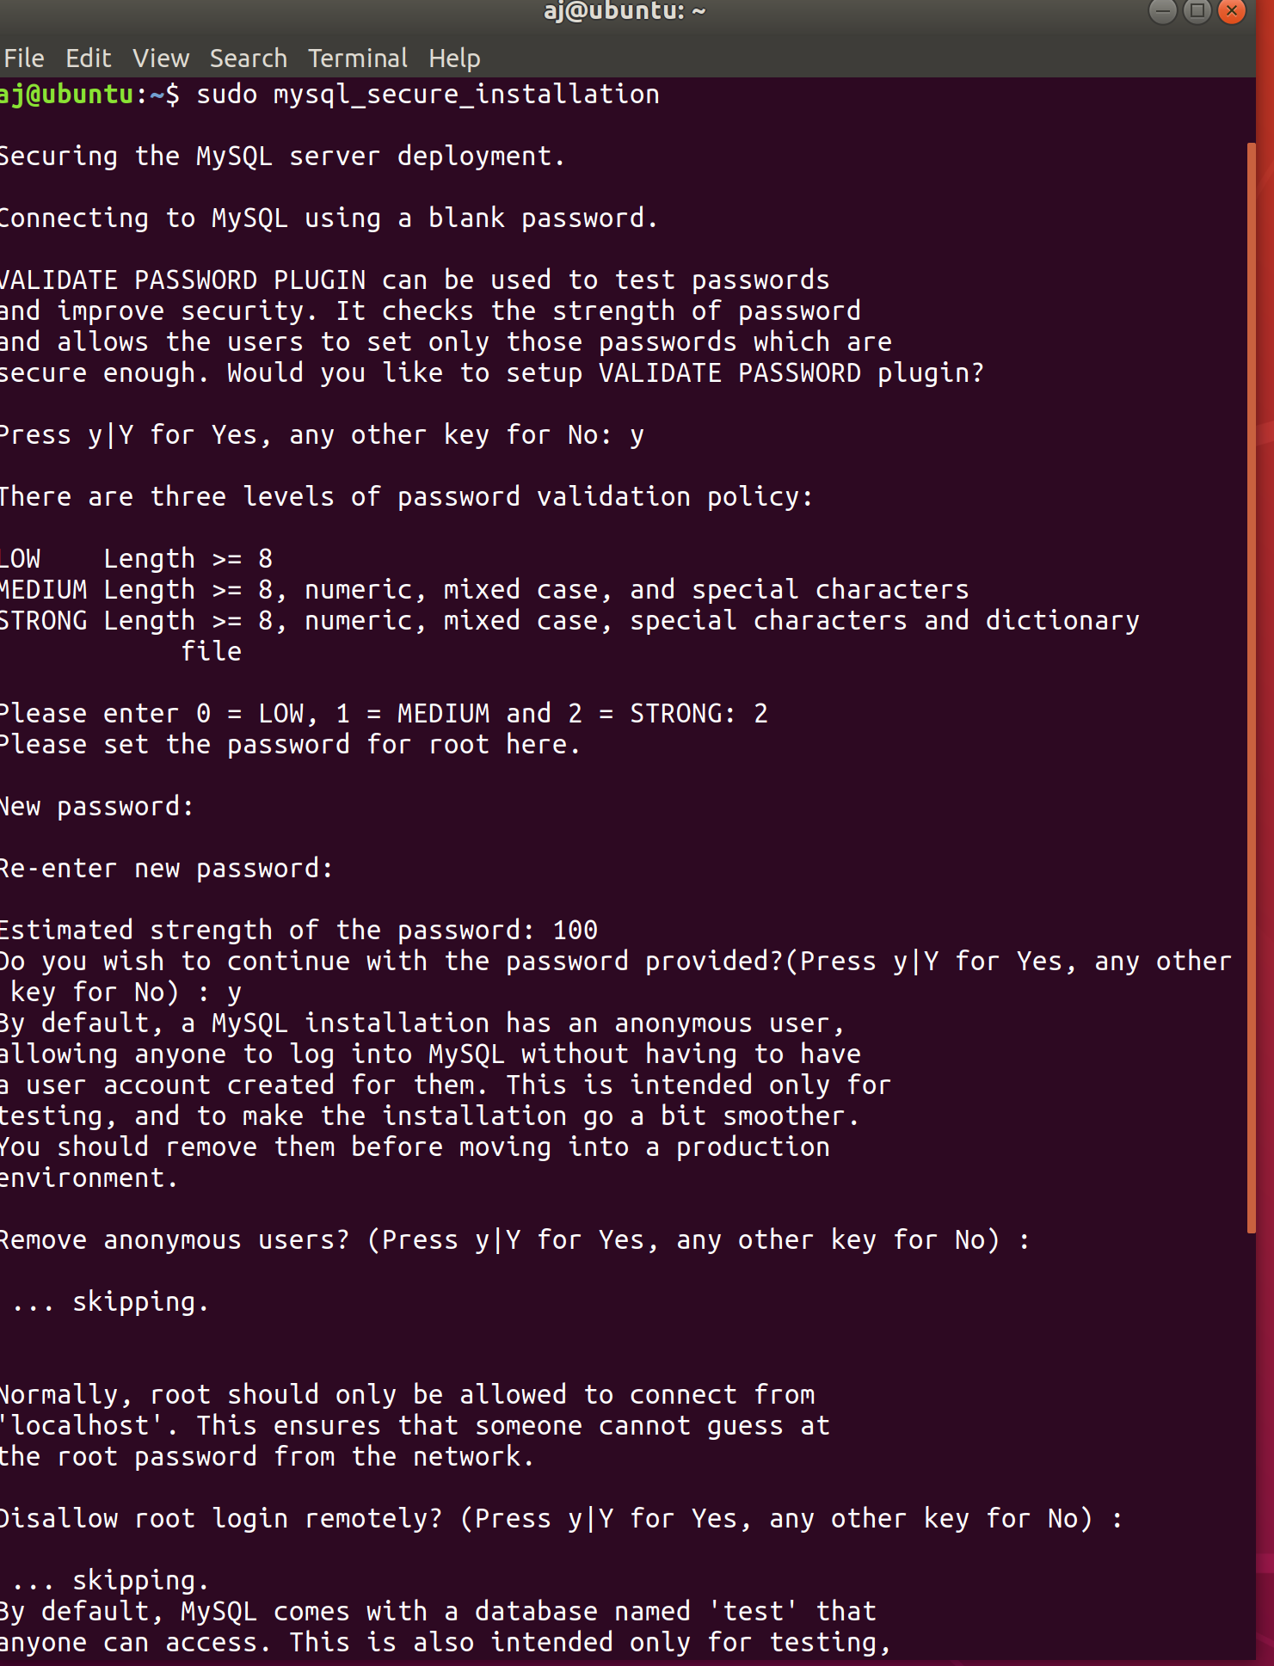
reload privileges with option y

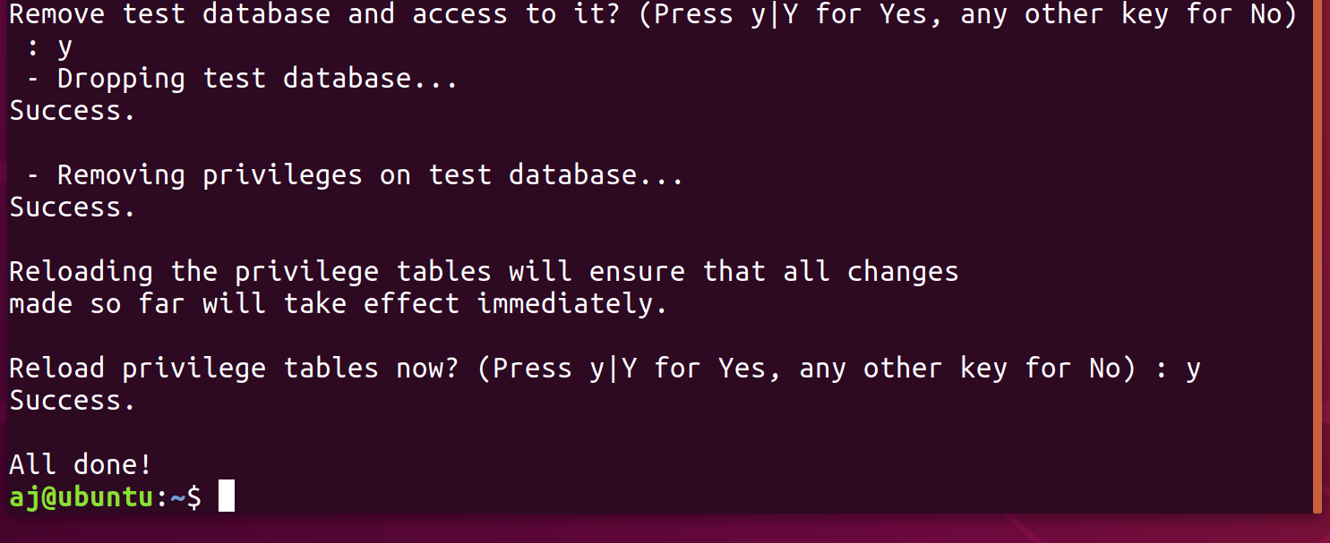
Open /etc/apt/sources..list by running: sudo nano /etc/apt/sources.list
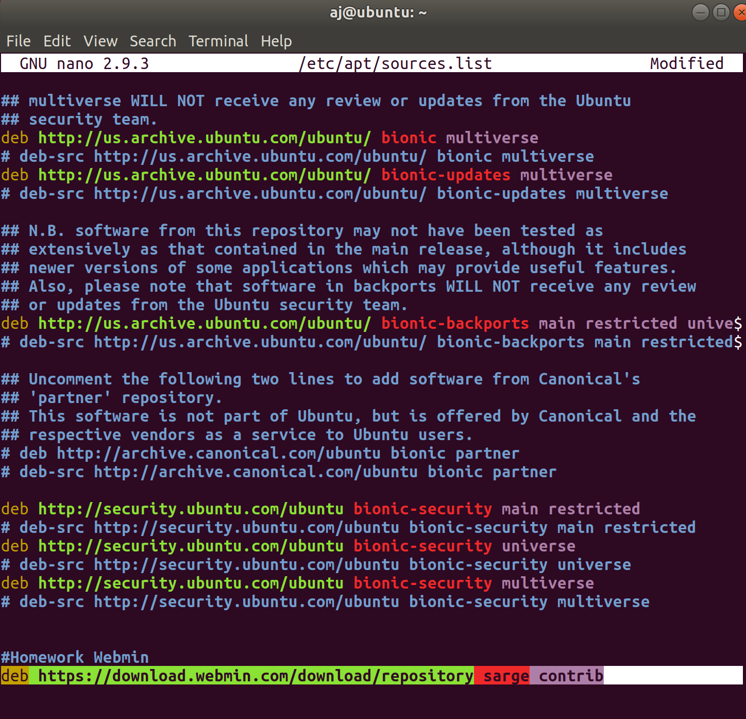
Add the following line: deb https://download.webmin.com/download/repository sarge contrib
Download the webadmin repository key:

cd into /tmp
wget http://www.webmin.com/jcameron-key.asc

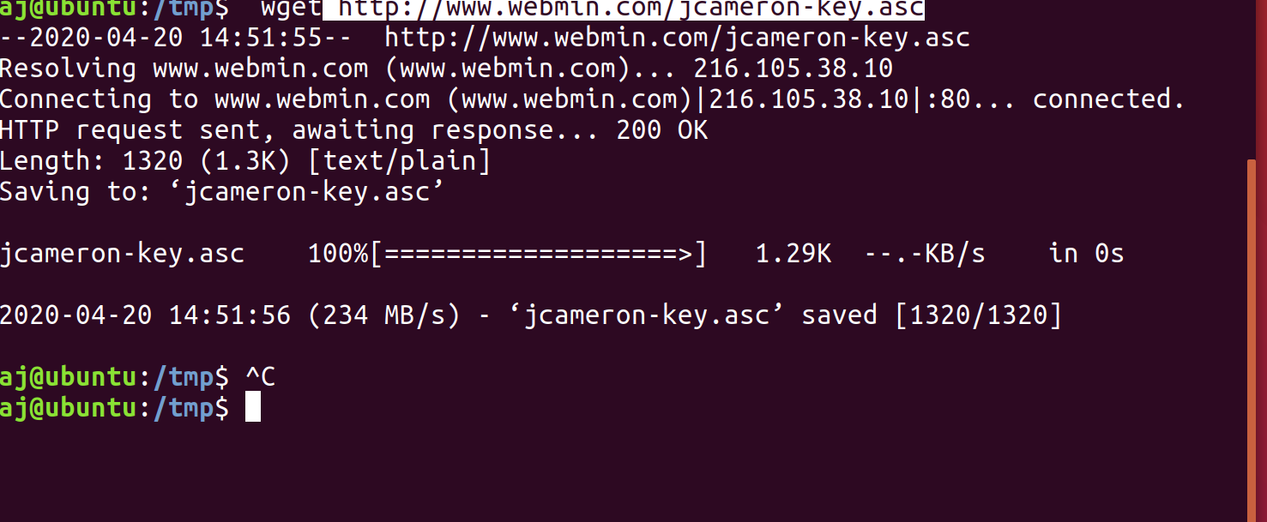

Install the repository key using: sudo apt-key add jcameron-key.asc
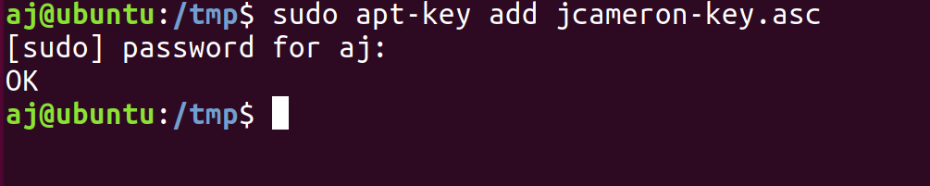

Update the package list: sudo apt update

install webmin admin panel: sudo apt install webmin
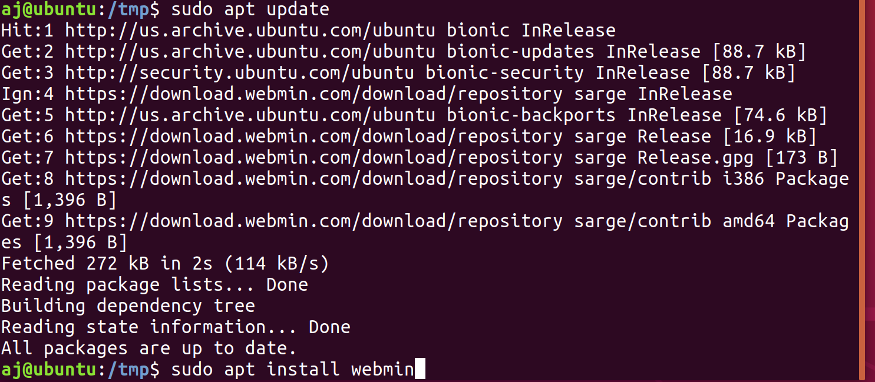
To access webmin:
yourserverip:10000
Ensure apache2 is running by running systemctl status apache2 (mine is running) in not start it with the start command.

Now check for my ip address by running ifconfig.

Open a browser and navigate to https://YourIPAddress:10000. In my instance https://192.168.73.136/1000
Log in with your credentials:
This is causing performance issues for me so im going to shut down and allocate the VM additional resources and then reboot.

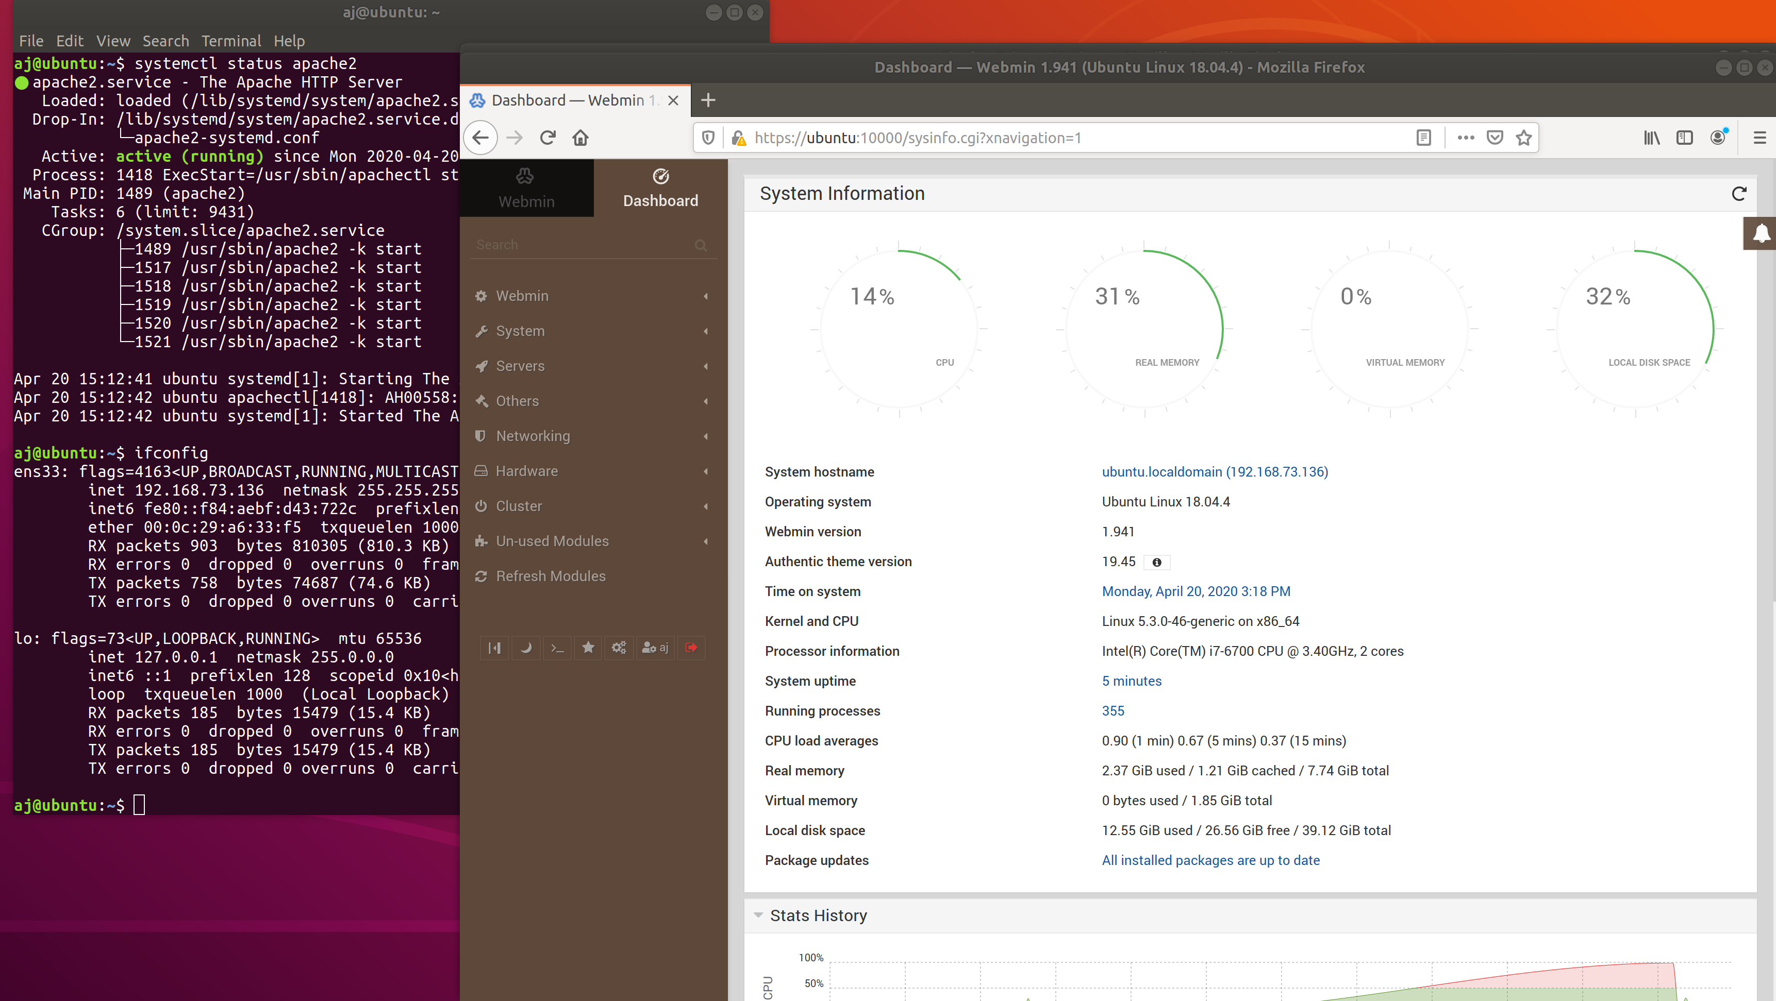
Performance is still questionable. Going to give it more cores. (wishful thinking RAM last time) The above picture indicates the issue lies with CPU. What is my peer on their trash laptop going to do? Haha

Processor optimized:
https://docs.vmware.com/en/VMware-Workstation-Pro/12.0/com.vmware.ws.using.doc/GUID-9745D560-9243-4262-A585-D709D52B1349.html
2 processor * 4 core is how it should be for my i7-6700.

I’ve tried optimizing the set up to isolate the potential issue(s). As soon as I launch webmin system performance dies. For example even the clock is several minutes off.

I reboot it works fine I launch Webmin from the browser and it dies again.
I assume this is due to lack of hardware ability and not having access to our computer lab even though my hardware isn’t terrible? So I cannot actually do the last step to set up the sms/email alerts etc.

So going forward I’m not going to actually set this up but I will explain how:
Get the module Ssystem and Server Status.

< https://doxfer.webmin.com/Webmin/System_and_Server_Status >
Here we can see how to add a new monitor under “Adding a new monitor” follow these steps and then proceed to “Setting up scheduled monitoring” utilizing email.

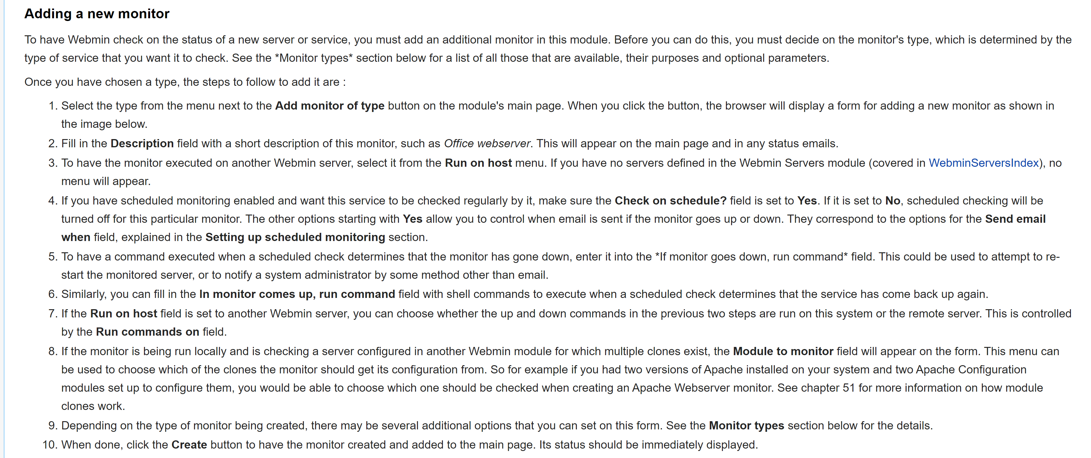
(copy pasta from above source on setting up a new monitor and scheduling monitoring)

