Bayesian Filter:

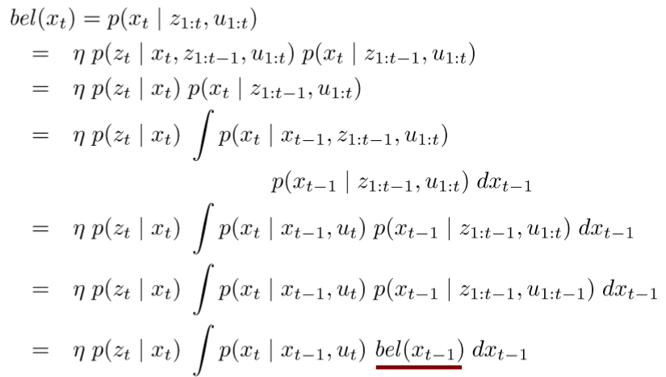

It can be divided into two parts: Prediction step and Correction step.

Prediction step is calculated via motion model.

Correction step is calculated via observation model.

## Typical Motion Models

* Odometry-based ( equipped with wheel encoders)

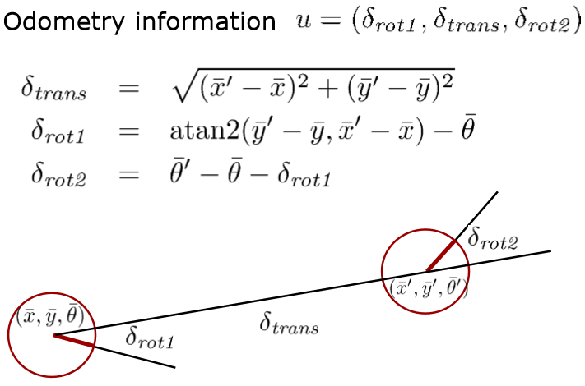

* Velocity-based ( no wheel encoders are available )

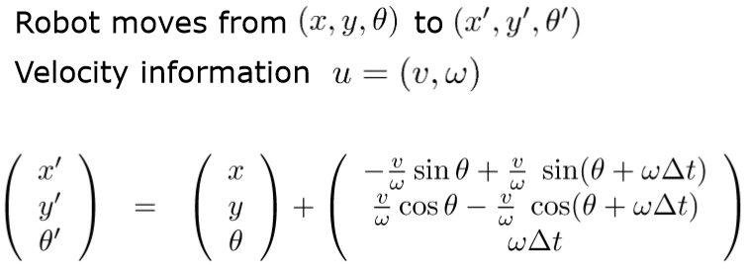

**Sensor Model**

Range-Bearing Sensors:

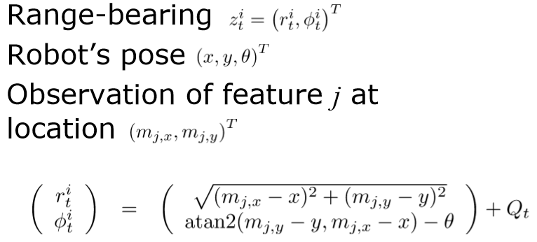

Kalman Filter Distribution:

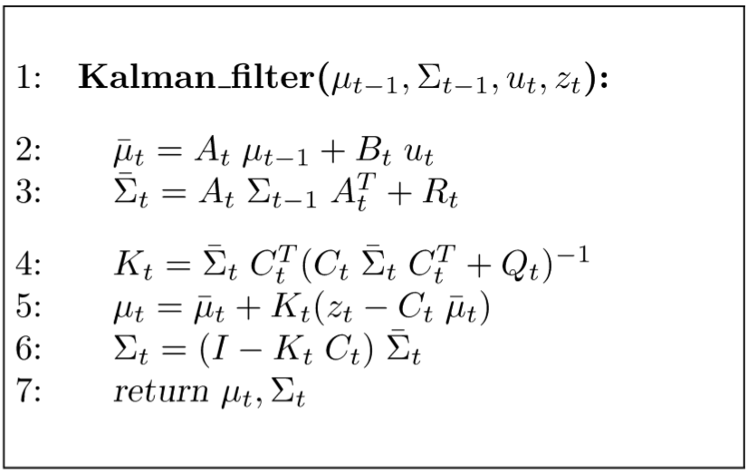

**Non-Gaussian Distributions**

