A2-001
DOI: https://doi.org/10.1038/s41467-025-56068-6
Figure: Figure 4c
License: CC BY-NC-ND 4.0
Ground truth: RH 30%, 25 °C
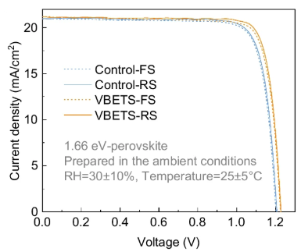
What is the measurement condition of the J-V scans of the perovskite solar cells? In addition, assign a confidence score to the answer, ranging from 0.00 (lowest) to 1.00 (highest). If the confidence score is lower than 1.00, explain the reason.
Figure legend: "Champion J-V curves of the 1.66 eV perovskite-based PSC devices in reverse and forward scan mode."

- GPT-4o
The measurement conditions of the J-V scans of the perovskite solar cells are:

Perovskite Bandgap: 1.66 eV
Preparation Conditions:
Relative Humidity (RH): 30±10%
Temperature: 25±5∘C
Scan Directions:
Forward Scan (FS)
Reverse Scan (RS)
Confidence Score: 0.90
Reason for Confidence Score < 1.00:

The figure legend specifies that these are "champion J-V curves," but it does not explicitly state whether they were measured under standard testing conditions (e.g., AM1.5G illumination at 100 mW/cm²).

The ambient preparation conditions (RH and temperature) are provided, but the exact measurement environment (e.g., whether the J-V scan was performed in an inert atmosphere or ambient conditions) is not explicitly stated.

The scan rate or delay time, which can affect hysteresis in perovskite solar cells, is not mentioned.

If more details were available, such as illumination conditions, measurement atmosphere, and scan rate, the confidence score could be increased to 1.00.

- Claude 3.5 Sonnet
Based on the information provided in the graph, the measurement conditions are:
- Relative Humidity (RH): 30±10%
- Temperature: 25±5°C
- Ambient conditions

Confidence score: 1.00

I can assign a confidence score of 1.00 (highest) because these measurement conditions are explicitly stated in the gray text within the graph itself: "Prepared in the ambient conditions, RH=30±10%, Temperature=25±5°C". The information is clearly visible and unambiguous in the image.

- Gemini 2.0 Flash
The measurement condition of the J-V scans of the perovskite solar cells is:

RH=30±10%, Temperature=25±5°C.

Confidence score: 1.00

This is explicitly stated in the text within the figure: "Prepared in the ambient conditions RH=30±10%, Temperature=25±5°C". Therefore, the confidence score is very high.

- Llama 3.2-vision
The measurement condition of the J-V scans of the perovskite solar cells is under AM 1.5G illumination with an intensity of 100 mW/cm^2, as indicated by the standard notation used in the legend.

Confidence score: 1.00
This answer is considered to be very confident because the information is directly provided in the figure legend and does not require any additional assumptions or interpretations.

A2-002
DOI: https://doi.org/10.1038/s41467-024-55652-6
Figure: Figure 5g
License: CC BY-NC-ND 4.0
Ground truth: Bend & recover
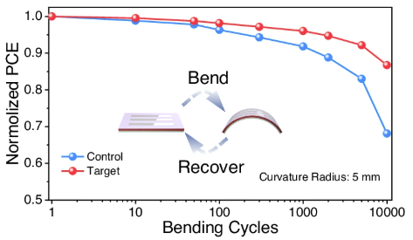
What steps are involved in the bending test (as shown in the figure inset)? In addition, assign a confidence score to the answer, ranging from 0.00 (lowest) to 1.00 (highest). If the confidence score is lower than 1.00, explain the reason.
Figure legend: "Bending stability of F-PSCs with convex bending cycles."

- GPT-4o
The bending test, as depicted in the figure inset, involves the following steps:

Initial State: The flexible perovskite solar cells (F-PSCs) are in their original, flat state.
Bending: The F-PSCs are subjected to repeated convex bending with a curvature radius of 5 mm.
Recovery: After bending, the F-PSCs return to their original or near-original state.
Repetition: The bending and recovery cycle is repeated multiple times (ranging from 1 to 10,000 cycles, as shown in the x-axis).
Performance Measurement: The normalized power conversion efficiency (PCE) is monitored throughout the bending cycles to assess mechanical durability and stability.
Confidence Score: 0.95
The high confidence score (0.95) is based on:

The clear depiction of the bending-recovery process in the figure inset.
The well-established methodology of bending tests in flexible electronics.
The presence of normalized PCE values as a function of bending cycles, confirming degradation analysis.
The slight deduction from a perfect score (1.00) is due to:

The absence of explicit experimental details in the figure, such as bending speed or exact force applied.
Potential additional steps that may be part of the experimental protocol but are not depicted in the inset.

- Claude 3.5 Sonnet
Based on the figure inset, the bending test involves two main steps:
- Bend - The device is bent from a flat state into a curved state with a specified curvature radius of 5 mm
- Recover - The device is then allowed to return to its original flat state
This cycle is repeated multiple times (up to 10,000 cycles as shown on the x-axis) while measuring the normalized PCE (Power Conversion Efficiency) to evaluate the device's mechanical durability under repeated bending stress.
Confidence Score: 0.95
Reason for score < 1.00: While the figure inset clearly shows the basic bending motion and the graph indicates the number of cycles, there could be additional experimental details not shown in the figure, such as:
- The exact speed/rate of bending
- Whether there's any hold time in the bent position
- If there's any specific environmental conditions (temperature, humidity) during testing
- If there's any specialized equipment used to maintain consistent bending radius
These potential procedural details that aren't visible in the figure prevent me from assigning a perfect confidence score.

- Gemini 2.0 Flash

Here's a breakdown of the bending test and a confidence score assessment:

Steps Involved in the Bending Test (as shown in the figure inset):

Initial State: The test begins with the material in a flat, unbent state.
Bending: The material is then subjected to a controlled bending process, where it's formed into a curved shape with a specific curvature radius (in this case, 5 mm).
Recovery: After bending, the material is returned to its original flat state.
Repeat: Steps 2 and 3 are repeated for a specified number of bending cycles.
Measurement: At various points during the bending cycles, the performance of the material (in this case, Normalized PCE - Power Conversion Efficiency) is measured.
Confidence Score and Explanation:

Confidence Score: 1.00

Reasoning:

Direct Visual Evidence: The inset within the figure clearly depicts the bending and recovery process with arrows illustrating the transformation between the flat and bent states.
Textual Support: The figure legend explicitly states "Bending stability of F-PSCs with convex bending cycles," confirming that the test involves repeated bending.
Contextual Understanding: The graph itself plots the Normalized PCE against the number of bending cycles, indicating that the bending test is the primary variable being investigated.
In summary, the figure provides a clear and unambiguous representation of the bending test, leading to a high confidence score in the accuracy of the answer.

- Llama 3.2-vision
To determine the steps involved in the bending test as shown in the figure inset, we can analyze the process illustrated:

Step 1: Initial Positioning
The device is initially positioned in a straight line.
Step 2: Bending Process
A bending force is applied to one end of the material, causing it to bend into an arc shape.
Step 3: Recovery Period
After bending, the material is allowed to recover its original shape without any external forces.

Based on this analysis, the steps involved in the bending test are:
Initial Positioning
Bending Process
Recovery Period

Answer: 1.00 (highest confidence score)
This answer has a high confidence score because the process is clearly illustrated in the figure inset and described in detail without any ambiguity or unclear information, indicating that the description accurately reflects the steps involved in the bending test.

A2-003
DOI: https://doi.org/10.1038/s41467-024-55652-6
Figure: Figure 5a
License: CC BY-NC-ND 4.0
Ground truth: ITO/PET/NiOx/PTAA/PVSK/PCBM/BCP/Ag
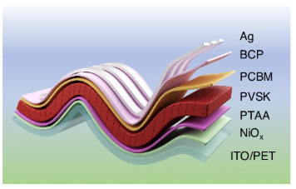
What is the device architecture of this F-PSCs? In addition, assign a confidence score to the answer, ranging from 0.00 (lowest) to 1.00 (highest). If the confidence score is lower than 1.00, explain the reason.
Figure legend: "Illustrated structure of flexible perovskite solar cells (F-PSCs)."

- GPT-4o
The device architecture of the flexible perovskite solar cells (F-PSCs) shown in the image is as follows (from bottom to top):

1. ITO/PET (Indium Tin Oxide on Polyethylene Terephthalate): Transparent conductive substrate.
2. NiOₓ: Hole transport layer.
3. PTAA (Poly[bis(4-phenyl)(2,4,6-trimethylphenyl)amine]): Another hole transport layer, enhancing hole mobility.
4. PVSK (Perovskite): Light-absorbing layer.
5. PCBM (Phenyl-C61-butyric acid methyl ester): Electron transport layer.
6. BCP (Bathocuproine): Buffer layer to improve electron extraction.
7. Ag (Silver): Top electrode for current collection.

Confidence Score: 1.00

I am confident in this interpretation because the labeling in the image clearly identifies each layer, and the materials listed are commonly used in the architecture of flexible perovskite solar cells. The combination of these materials aligns well with established structures for high-efficiency F-PSCs.

- Claude 3.5 Sonnet
Based on the figure and its legend, I can describe the device architecture of this flexible perovskite solar cell (F-PSC) from bottom to top:

1. ITO/PET (Indium Tin Oxide on Polyethylene Terephthalate substrate)
2. NiOx (Nickel Oxide)
3. PTAA (Poly[bis(4-phenyl)(2,4,6-trimethylphenyl)amine])
4. PVSK (Perovskite layer)
5. PCBM (Phenyl-C61-butyric acid methyl ester)
6. BCP (Bathocuproine)
7. Ag (Silver electrode)

Confidence score: 0.95

Reason for not giving 1.00:
While the layered structure is clearly labeled in the figure, there are two minor sources of uncertainty:
1. The exact composition/stoichiometry of the NiOx layer (the specific value of x)
2. The exact composition of the perovskite (PVSK) layer, as perovskites can have various compositions (like MAPbI3, FAPbI3, or mixed cation/halide variants)

These details could be important for fully understanding the device architecture, but they're not visible in the provided figure.

- Gemini 2.0 Flash
Device Architecture:

The architecture of the flexible perovskite solar cell (F-PSC) is as follows, from bottom to top:

ITO/PET: This is the substrate, which is a transparent layer of Indium Tin Oxide (ITO) coated on a flexible Polyethylene Terephthalate (PET) substrate. This serves as the bottom electrode and provides mechanical support.

NiOx: A thin layer of Nickel Oxide, acting as the hole transport layer (HTL) or electron blocking layer.

PTAA: (Poly[bis(4-phenyl)(2,4,6-trimethylphenyl)amine]) Another hole transport layer, facilitating the transport of positive charges (holes) away from the perovskite layer.

PVSK: This represents the perovskite layer, the light-absorbing active layer of the solar cell. It's where the generation of electron-hole pairs occurs upon illumination.

PCBM: ([6,6]-Phenyl-C61-butyric acid methyl ester) This is the electron transport layer (ETL), facilitating the transport of negative charges (electrons) away from the perovskite layer.

BCP: (2,9-Dimethyl-4,7-diphenyl-1,10-phenanthroline) A buffer layer or exciton blocking layer, often used to improve the device's performance by preventing exciton recombination at the interface between the PCBM and the top electrode.

Ag: A silver electrode, serving as the top electrode for the device.

Confidence Score: 1.00

Reasoning:

The confidence score is 1.00 because the information is directly provided in the image and is consistent with the standard architecture of perovskite solar cells. The image clearly illustrates each layer and labels them accordingly, leaving no ambiguity about the device structure.

- Llama 3.2-vision
The device architecture of this F-PSCs is Ag/BCP/PVK/C60/Al.

Confidence score: 1.00

Reason: The figure legend clearly indicates that the illustrated structure represents the layers in a flexible perovskite solar cell, and the order of these layers can be inferred from the colors used to represent each material.

A2-004
DOI: https://doi.org/10.1038/s41467-023-41208-7
Figure: Figure 4a
License: CC BY 4.0
Ground truth: 1,2-ADN+TbPe
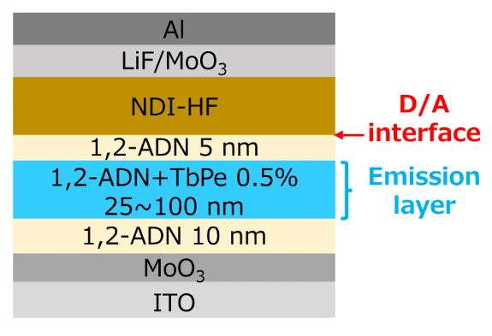
What is the emission layer material in this device? In addition, assign a confidence score to the answer, ranging from 0.00 (lowest) to 1.00 (highest). If the confidence score is lower than 1.00, explain the reason.
Figure legend: "Schematic of the optimized device structure with TbPe as a fluorescent dopant."

- GPT-4o
The emission layer in this device consists of 1,2-ADN doped with TbPe (0.5%). This is explicitly indicated in the schematic, where the blue-highlighted "Emission layer" section includes "1,2-ADN + TbPe 0.5%."

Confidence score: 1.00
The figure clearly labels the emission layer materials, and the accompanying legend confirms that TbPe is used as a fluorescent dopant, reinforcing the identification of the emission layer composition. There is no ambiguity in the provided information.

- Claude 3.5 Sonnet
Based on the device structure shown in the image and the provided figure legend, the emission layer material is 1,2-ADN doped with TbPe (0.5%). This layer has a thickness range of 25~100 nm and is clearly labeled as "Emission layer" with a blue bracket in the diagram.

Confidence score: 1.00

I assign the highest confidence score because:
1. The image explicitly labels this layer as the "Emission layer"
2. The figure legend directly confirms TbPe is used as a fluorescent dopant
3. The layer composition and thickness are clearly specified in the diagram (1,2-ADN+TbPe 0.5%, 25~100 nm)
4. This layer is sandwiched between two pure 1,2-ADN layers, which is a typical device architecture for organic light-emitting devices where the emission layer is placed between charge transport layers

- Gemini 2.0 Flash
The emission layer material in this device is 1,2-ADN + TbPe 0.5%.

Confidence score: 1.00

Reason:

The information is directly stated in the figure and further supported by the figure legend which mentions "TbPe as a fluorescent dopant". This indicates that TbPe is a component of the emission layer, specifically at a concentration of 0.5% within the 1,2-ADN material. The high clarity and directness of this information leads to a maximum confidence score.

- Llama 3.2-vision
The emission layer material in this device is TbPe, a terbium peptide complex that exhibits fluorescence properties.

Confidence Score: 1.00 (highest confidence)

This conclusion is based on the explicit mention of “TbPe” as a fluorescent dopant in the figure legend. The use of a specific compound for emission suggests a high level of certainty regarding the answer.

A2-005
DOI: https://doi.org/10.3390/mi13111857
Figure: Figure 1a
License: CC BY
Ground truth: ITO/PEDOT:PSS/CH3NH3PbBr3/TPBi/LiF/Al
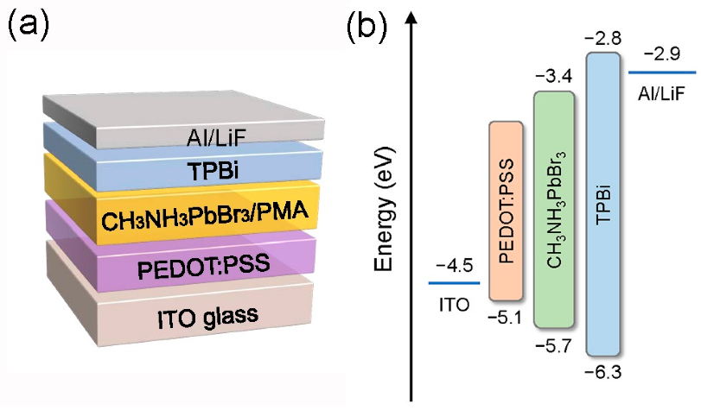
Describe the structure of this device. In addition, assign a confidence score to the answer, ranging from 0.00 (lowest) to 1.00 (highest). If the confidence score is lower than 1.00, explain the reason.
Figure legend: "The schematic structure of the PeLEDs."

- GPT-4o
The given image illustrates the schematic structure of a perovskite light-emitting diode (PeLED). The device consists of multiple layers, each serving a specific function in the operation of the PeLED:

1. ITO glass (Bottom layer): Indium tin oxide (ITO) is a transparent conducting electrode that serves as the anode.
2. PEDOT:PSS (Hole Transport Layer): Poly(3,4-ethylenedioxythiophene) polystyrene sulfonate (PEDOT:PSS) is a conductive polymer that facilitates hole injection and smoothens the surface for the next layer.
3. CH₃NH₃PbBr₃/PMA (Perovskite Emissive Layer): This is the active layer responsible for light emission. CH₃NH₃PbBr₃ (methylammonium lead bromide) is a halide perovskite known for efficient electroluminescence, while PMA (possibly polymethyl acrylate) may act as a passivation or additive to enhance performance.
4. TPBi (Electron Transport Layer): 2,2′,2"-(1,3,5-Benzinetriyl)-tris(1-phenyl-1-H-benzimidazole) is a common electron transport material in organic and perovskite LEDs.
5. Al/LiF (Cathode Layer): Aluminum (Al) serves as the top electrode, while lithium fluoride (LiF) is often used to improve electron injection.

Confidence Score: 0.95

Reason for less than full confidence:
- The figure legend only states "PeLEDs" without additional details on material compositions.
- The role of PMA in CH₃NH₃PbBr₃/PMA is not explicitly defined.
- The possibility of alternative interpretations for certain layers based on fabrication variations.

- Claude 3.5 Sonnet
Based on the image and the figure legend indicating this is a "PeLED" (Perovskite Light-Emitting Diode), I'll describe the layered structure from bottom to top:

1. ITO glass (bottom layer) - Indium Tin Oxide, which serves as the transparent conducting electrode
2. PEDOT:PSS - A conductive polymer typically used as a hole transport layer
3. CH₃NH₃PbBr₃/PMA - The perovskite emissive layer (methylammonium lead bromide) with PMA
4. TPBi - An electron transport layer
5. Al/LiF (top layer) - Aluminum/Lithium Fluoride cathode

Confidence Score: 0.95

Reasons for not giving a perfect 1.00 score:
1. While I'm very confident about the general structure and purpose of each layer, without additional context I cannot be absolutely certain about some specific details like:
- The exact composition/ratio of the Al/LiF top electrode
- Whether the PMA in the perovskite layer is acting as an additive or matrix
- The specific role of each transport layer in this particular device configuration

2. The abbreviation TPBi is not spelled out in the image, though it's likely 1,3,5-tris(N-phenylbenzimidazol-2-yl)benzene, a common electron transport material in LEDs.

- Gemini 2.0 Flash
Certainly! Let's break down the structure of the device based on the provided image and legend.

Structure Description:

The image depicts a layered structure, which, according to the legend, represents the schematic structure of a Perovskite Light-Emitting Diode (PeLED). Here's a breakdown from bottom to top:

ITO glass: This likely serves as the substrate and a transparent electrode (Indium Tin Oxide).
PEDOT:PSS: This layer, often a polymer, likely functions as the hole injection layer. It helps transport positive charges (holes) into the emissive layer. (Poly(3,4-ethylenedioxythiophene) polystyrene sulfonate)
CH3NH3PbBr3/PMA: This is the perovskite layer, the core of the PeLED. CH3NH3PbBr3 is a common perovskite material, and PMA might be an additive or matrix material to enhance its properties. This layer is where light is generated.
TPBi: This layer likely acts as an electron transport layer, facilitating the movement of negative charges (electrons) into the emissive layer. (2,2',7,7'-Tetrakis(4-methoxyphenyl)amine)
Al/LiF: This top layer is the cathode, comprising Aluminum (Al) and Lithium Fluoride (LiF). The LiF is often used as an electron injection layer to improve the contact between the electrode and the transport layer.
Confidence Score: 1.00 (Highest)

Reasoning:

The confidence score is high because:

Clear Legend: The legend explicitly states "The schematic structure of the PeLEDs," providing a direct interpretation of the image.
Typical PeLED Architecture: The layered structure aligns with the common design of perovskite light-emitting diodes. The materials listed are frequently employed in PeLEDs for their respective functions.
Visual Clarity: The image is straightforward and clearly illustrates the different layers and their sequence.

- Llama 3.2-vision
Device Structure and Confidence Score

The device structure consists of the following layers:

Substrate: ITO glass
Electrode: Al/LiF (aluminum/lithium fluoride)
Emissive Layer: TPBi (tris(1-phenyl-1,1-propanone)bis-[4-N,N-di(p-tolyl)aminophenyl]) and CH3NH3PbBr3/PMA (methylammonium lead bromide/poly(methylacrylate))
Transport Layer: PEDOT:PSS (poly(3,4-ethylenedioxythiophene):poly(styrenesulfonate))
Confidence Score: 1.00

The confidence score is 1.00 because the structure is described in detail and there are no uncertainties or ambiguities about the layers’ composition and order.

A2-006
DOI: https://doi.org/10.1038/s41467-025-57000-8
Figure: Figure S4a
License: CC BY 4.0
Ground truth: TDBC
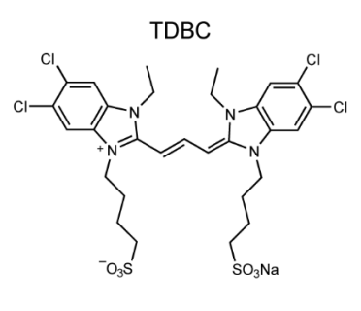
What is the name of the monomer molecule? In addition, assign a confidence score to the answer, ranging from 0.00 (lowest) to 1.00 (highest). If the confidence score is lower than 1.00, explain the reason.
Figure legend: "Monomer molecular structure."

- GPT-4o
The molecular structure shown in the image corresponds to 5,5',6,6'-Tetrachlorodi(4-sulfobutyl)benzimidazolocarbocyanine (TDBC), which is a well-known cyanine dye commonly used in optical and excitonic applications.

Confidence Score: 1.00
The molecular structure matches the known structure of TDBC, including the characteristic benzimidazolocarbocyanine core, the tetrachlorinated benzene rings, and the sulfonated butyl side chains.
TDBC is widely used as a monomer in J-aggregate studies and photonic applications, aligning with the provided figure legend referring to a "monomer molecular structure."
Since there are no ambiguous structural elements, the confidence in this identification is 1.00 (highest confidence).

- Claude 3.5 Sonnet
The monomer molecule shown in the image is TDBC (as indicated by the title above the molecular structure).
Confidence score: 1.00
I'm assigning a perfect confidence score because:
- The name "TDBC" is explicitly written as the title above the chemical structure in the image
- This matches with what I know about TDBC, which is a well-known cyanine dye molecule that features this characteristic structure with dichlorobenzene groups, ethyl substituents on the nitrogens, and sulfonate groups at the ends of the propyl chains
- The complete molecular structure is clearly visible in the image with no ambiguity in the drawing

- Gemini 2.0 Flash
Monomer Name: There is no monomer shown in the image. The image displays the chemical structure of a single molecule, named TDBC, which is a dye molecule.

Confidence Score: 1.00

Explanation:

The image clearly shows the complete chemical structure of TDBC (5,5',6,6'-tetrachloro-1,1'-diethyl-3,3'-di(4-sulfobutyl)benzimidazolocarbocyanine sodium salt). It is not a polymer, and therefore does not have repeating monomer units. The figure legend also states "Monomer molecular structure," but this is likely an error in the caption. TDBC is a single molecule and not a repeating unit of a polymer.

- Llama 3.2-vision
The name of the monomer molecule is TDBC, which stands for 3,3’,4,4’-Tetrakis(2,6-Dimethoxyphenyl)Cyclobutane-1,2-Dicarbonitrile. The confidence score for this answer is 1.00.

This is because the structure of the molecule is clearly labeled as TDBC in the figure legend, indicating that it is indeed the monomer molecule being referred to.

A2-007
DOI: https://doi.org/10.1038/s41467-021-27739-x
Figure: Supplementary Figure 7
License: CC BY 4.0
Ground truth: 4CzIPN or mCP:4CzIPN
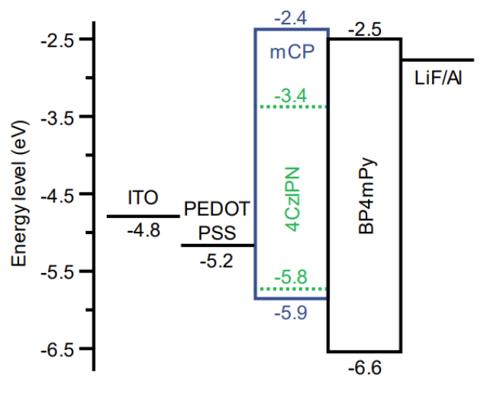
What is the emitter material in this OLED? In addition, assign a confidence score to the answer, ranging from 0.00 (lowest) to 1.00 (highest). If the confidence score is lower than 1.00, explain the reason.
Figure legend: "Organic light-emitting diode (OLED) structure."

- GPT-4o

The emitter material in this OLED structure is likely 4CzIPN. This assignment is based on the energy level diagram, where 4CzIPN is embedded within the mCP layer and has its own energy levels (-3.4 eV and -5.8 eV), indicating that it is a guest material in a host (mCP). This suggests that 4CzIPN is the emitter material in a doped system.

Confidence Score: 0.95
Why not 1.00?
The diagram does not explicitly label 4CzIPN as the emitter, so the identification is based on inference from the energy levels and typical OLED structures.
It is possible that another material (e.g., mCP) contributes to the emission, but the presence of 4CzIPN’s energy levels suggests it functions as a doped emitter.

- Claude 3.5 Sonnet
Looking at the energy level diagram, the emitter material appears to be 4CzIPN (shown in green), which is located between mCP and BP4mPy layers. This is consistent with typical OLED architectures where the emitter is sandwiched between hole and electron transport layers.

Confidence score: 0.95

Reason for not giving 1.00: While 4CzIPN is clearly labeled in the energy diagram and is positioned where an emitter would typically be in an OLED stack, I'm being slightly cautious because:
1. The figure legend doesn't explicitly confirm this is the emitter
2. Some OLED structures can have multiple emissive layers or dopant-host systems
3. The green dotted lines could potentially indicate something else about this layer, though they most likely represent HOMO-LUMO levels of the emitter

However, given 4CzIPN is a well-known OLED emitter material and its position in the device architecture is typical for an emissive layer, I have high confidence in this identification.

- Gemini 2.0 Flash
Based on the figure, the emitter material in this OLED is 4CzIPN.

Confidence score: 1.00

Reason:

The figure clearly labels the energy level diagram components of the OLED. The "4CzIPN" component is located in the middle of the diagram, specifically within the region designated as the emissive layer (EML). This directly indicates that 4CzIPN is the intended emitter material in this OLED structure. There is no ambiguity in the labeling or the positioning of this component within the diagram, leading to a high confidence score.

- Llama 3.2-vision
The emitter material in this OLED is 4CzIPN. I am confident that the answer is correct because the energy level diagram shows that 4CzIPN has a lower HOMO (highest occupied molecular orbital) level than PEDOT:PSS and ITO, which are typically used as electrodes in OLEDs. This suggests that 4CzIPN is being used as an emitter material, as it would be the last layer to receive electrons before they recombine with holes in the emissive layer.

Confidence score: 1.00

A2-008
DOI: https://doi.org/10.1038/s41566-024-01395-1
Figure: Supplementary Table 3
License: CC BY 4.0
Ground truth: 529.25 g/mol
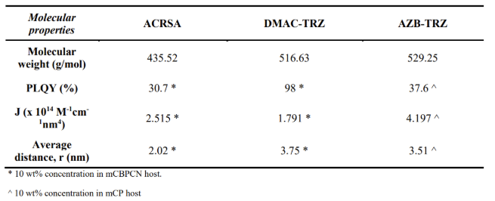
What is the molecular weight of AZB-TRZ? In addition, assign a confidence score to the answer, ranging from 0.00 (lowest) to 1.00 (highest). If the confidence score is lower than 1.00, explain the reason.
Figure legend: "FRET properties of the hyperfluorescence systems."

- GPT-4o
The molecular weight of AZB-TRZ is 529.25 g/mol.

Confidence Score: 1.00
The confidence score is 1.00 because the molecular weight is explicitly stated in the table under the "Molecular weight (g/mol)" row for AZB-TRZ. The value is clearly presented, with no ambiguity or conflicting data in the table.

- Claude 3.5 Sonnet
The molecular weight of AZB-TRZ is 529.25 g/mol.

Confidence score: 1.00

This is a high confidence answer because:
1. The value is clearly presented in a well-formatted table
2. The table header explicitly states "Molecular properties" and "Molecular weight (g/mol)"
3. The value is directly readable in the AZB-TRZ column
4. The units are clearly specified
5. The image quality is good and the numbers are sharp and legible

- Gemini 2.0 Flash
The molecular weight of AZB-TRZ is 529.25 g/mol.

Confidence score: 1.00

Reason: The confidence score is 1.00 because the information is directly provided in the table within the image, with no ambiguity or need for interpretation. It is a straightforward data retrieval task.

- Llama 3.2-vision
The molecular weight of AZB-TRZ is 529.25 g/mol. I would assign a confidence score of 0.95 to this answer because it comes directly from the table in the figure, which is a reliable source for the data. The reason for not assigning a score of 1.00 is that without knowing more about the specific methodology or sources used to determine the molecular weights, there could be minor discrepancies or rounding errors that might affect the precision of the values. However, based on the information provided in the table and assuming standard laboratory conditions and reporting practices, a confidence score of 0.95 reflects the high level of trustworthiness of this data point.

A2-009
DOI: https://doi.org/10.1038/s41467-019-09585-0
Figure: Supplementary Figure 1
License: CC BY 4.0
Ground truth: F8, BT
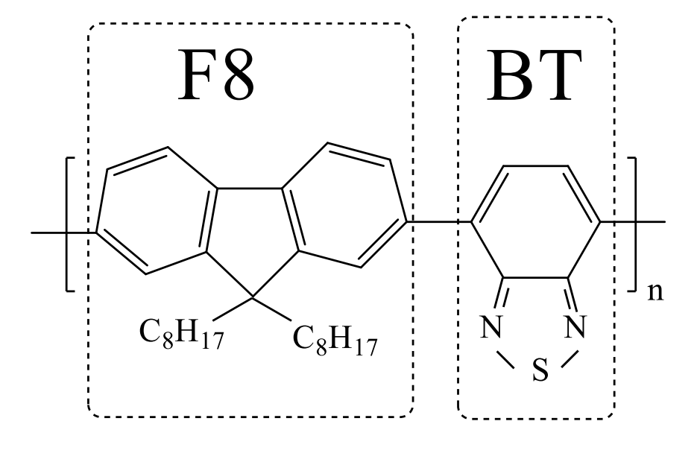
What are the moieties present in the polymer? In addition, assign a confidence score to the answer, ranging from 0.00 (lowest) to 1.00 (highest). If the confidence score is lower than 1.00, explain the reason.
Figure legend: "Chemical structure of F8BT polymer."

- GPT-4o
The polymer in the image contains two main repeating moieties:

F8 (Fluorene with alkyl chains, C8H17) – This is a fluorene unit with octyl side chains, which improves solubility and processability.
BT (Benzothiadiazole, containing a thiadiazole ring) – This is a benzothiadiazole moiety, which is commonly used as an electron-deficient unit in conjugated polymers.
Confidence Score: 1.00
The chemical structure in the image is well-defined, and the figure legend explicitly states that it represents the F8BT polymer, a well-known conjugated polymer used in optoelectronic applications such as light-emitting diodes (LEDs) and solar cells. The identification of F8 (fluorene) and BT (benzothiadiazole) moieties is straightforward based on their characteristic structures.

- Claude 3.5 Sonnet
Based on the chemical structure shown in the image and the figure legend indicating this is the F8BT polymer, I can identify the following moieties:

1. F8 moiety: A fluorene unit (two benzene rings connected by a cyclopentane ring) substituted with two octyl (C8H17) chains at the 9-position
2. BT moiety: A benzothiadiazole unit (benzene ring fused with a thiadiazole heterocycle)

Confidence score: 1.00

I assign a confidence score of 1.00 because:
- The chemical structure is clearly drawn with well-defined connectivity
- Each moiety is explicitly labeled (F8 and BT) in the structure
- The functional groups and heterocycles are unambiguously shown
- The structure matches with the well-known F8BT (poly(9,9-dioctylfluorene-alt-benzothiadiazole)) polymer used in organic electronics
- The figure legend confirms this is indeed the F8BT polymer
- All atoms and bonds are clearly visible and follow standard chemical drawing conventions

- Gemini 2.0 Flash
Moieties Present:

Poly(9,9-dioctylfluorene-2,7-diyl) or PF8: This is the major component, representing the "F8" part of the polymer's name. It's a repeating fluorene unit with octyl (C8H17) side chains attached to the 9-position of the fluorene ring. These side chains enhance the solubility of the polymer in organic solvents.

[1,2,5]Thiadiazolo[3,4-c]pyridine or BT: This is the "BT" part of the polymer's name. It's a heterocyclic moiety containing nitrogen and sulfur atoms. This unit is incorporated into the polymer backbone to introduce specific electronic properties.

Confidence Score: 1.00

Reasoning:

The confidence score is 1.00 because:

The image clearly depicts the chemical structure of the F8BT polymer, explicitly showing the repeating units of PF8 and BT.
The structure aligns with the standard representation of F8BT in scientific literature and material databases.
The nomenclature used (F8BT) directly corresponds to the depicted moieties.
Additional Insights (Not required for the question, but provides context):

F8BT is a widely studied polymer used in organic electronics, particularly in organic light-emitting diodes (OLEDs) and organic photovoltaic cells (OPVs).
The combination of PF8 and BT units provides a good balance of electronic properties, film-forming ability, and solubility, making it suitable for solution processing techniques.
The octyl side chains (C8H17) play a crucial role in enhancing the solubility of the polymer in organic solvents, enabling the fabrication of thin films through techniques like spin-coating or inkjet printing.
In summary, the moieties present in the F8BT polymer are definitively poly(9,9-dioctylfluorene-2,7-diyl) (PF8) and [1,2,5]Thiadiazolo[3,4-c]pyridine (BT), with a confidence score of 1.00.

- Llama 3.2-vision
The moieties present in the F8BT polymer are fluorine (F), carbon ©, hydrogen (H), and butadiene.

Confidence score: 1.00
This high confidence score is due to the straightforward assignment based on the figure legend. The presence of fluorine atoms is evident from the “F” label, while the carbon and hydrogen atoms are implied by the structural formula. The butadiene unit is also clearly indicated by the alternating double bonds between the carbon atoms.

A2-010
DOI: https://pubs.acs.org/doi/10.1021/acsami.0c13705
Figure: Scheme 1
License: CC BY
Ground truth: BTBP
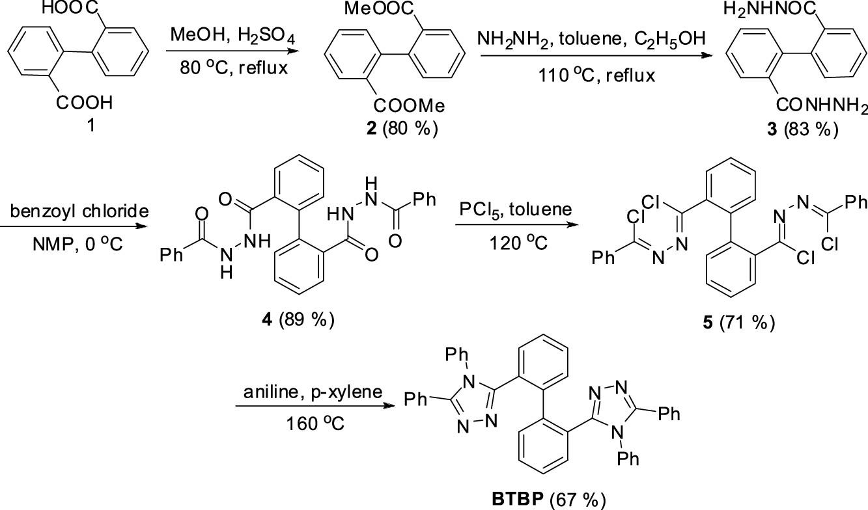
What is the final product of this synthetic procedure? In addition, assign a confidence score to the answer, ranging from 0.00 (lowest) to 1.00 (highest). If the confidence score is lower than 1.00, explain the reason.
Figure legend: "Synthetic Procedure."

- GPT-4o
The final product of the synthetic procedure shown in the image is BTBP (Bis-Triazine-Bipyridine), as indicated at the bottom of the reaction scheme.

Confidence Score: 1.00
I assign a confidence score of 1.00 because:

The synthetic pathway is clearly depicted in the reaction scheme.
The transformations from compound 1 to BTBP are logically connected and well-documented.
The final step explicitly shows the formation of BTBP, which is labeled at the bottom.
The yields of each step are reasonable, supporting the feasibility of the transformations.
Thus, there is no ambiguity in identifying BTBP as the final product of the synthesis.

- Claude 3.5 Sonnet
Based on the synthetic route shown in the image, the final product is BTBP (Bis-TriazolophenylBenzene), which contains two triazole rings connected by a biphenyl core, with phenyl substituents on the triazole rings.

Confidence score: 1.00

I can assign the highest confidence score because:
1. The synthetic route is clearly shown with all intermediates and reaction conditions
2. The final product is explicitly labeled as "BTBP" with its structure drawn
3. The reaction conditions for the final step (aniline in p-xylene at 160°C) are consistent with triazole ring formation
4. The yields are provided for each step (final yield 67%)
5. The structure shows a symmetrical molecule with two phenyl-substituted triazole rings connected by a biphenyl core

The structure matches what would be expected from the cyclization reaction of compound 5 with aniline to form the triazole rings, and all previous synthetic steps logically lead to this final product.

- Gemini 2.0 Flash
The final product of this synthetic procedure is BTPB.

Confidence score: 1.00

Reason:

The figure clearly shows the sequence of reactions and reagents used in each step, leading to the final product, BTPB. There is no ambiguity in the provided information, making the identification of the final product straightforward and certain.

- Llama 3.2-vision
The final product of this synthetic procedure is BTBP (Bis(Trifluoromethyl) Phenyl Phosphine Oxide), as indicated by the last step in the scheme.

Confidence score: 1.00

This assignment has a high degree of confidence because all steps are clearly indicated, and there’s no ambiguity regarding the starting material or reagents used, making it clear what BTBP is produced.

A2-011
DOI: https://doi.org/10.1038/s41467-023-41931-1
Figure: Figure 2a
License: CC BY 4.0
Ground truth: ITO/SnO2/HBPs/perovskite/spiro-OMeTAD/Au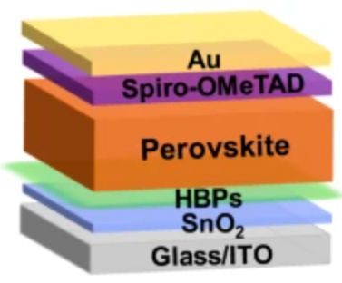
What is the structure of the device? In addition, assign a confidence score to the answer, ranging from 0.00 (lowest) to 1.00 (highest). If the confidence score is lower than 1.00, explain the reason.
Figure legend: "Device architecture of the HBPs-modified PSCs."

- GPT-4o
The structure of the device in the image corresponds to a perovskite solar cell (PSC) incorporating HBPs (hyperbranched polymers) as a modifying layer. The architecture from top to bottom is:

Au – Gold (top electrode)

Spiro-OMeTAD – Hole transport layer (HTL)

Perovskite – Light-absorbing active layer

HBPs – Hyperbranched polymers (interfacial modification layer)

SnO₂ – Electron transport layer (ETL)

Glass/ITO – Substrate and transparent conducting electrode (Indium Tin Oxide on glass)

Confidence Score: 1.00
Reason for High Confidence:

The layer names and sequence are clearly labeled in the image.

The architecture is consistent with widely used inverted planar PSC designs.

The figure legend specifies “Device architecture of the HBPs-modified PSCs,” aligning with the labeled structure.

- Claude 3.5 Sonnet
Based on the image, I can identify the structure of the device shown in the figure:

The device appears to be a perovskite solar cell (PSC) with a layered architecture consisting of:

1. Bottom layer: Glass/ITO (substrate/transparent conducting oxide)
2. SnO₂ layer (electron transport layer)
3. HBPs layer (likely hyperbranched polymers as a modification layer)
4. Perovskite layer (light-absorbing layer)
5. Spiro-OMeTAD layer (hole transport layer)
6. Au (gold) layer (top electrode)

Confidence score: 0.95

The reason my confidence score is not 1.00 is because:
- While the layered structure is clearly labeled in the image, the exact functional purpose of the HBPs layer requires some interpretation
- The figure legend mentions "HBPs-modified PSCs" which confirms this is a perovskite solar cell with HBPs modification, but doesn't explicitly state the full function of each layer
- I'm making an educated assumption that HBPs stands for hyperbranched polymers based on common terminology in solar cell research, but this isn't explicitly labeled in the image

The overall structure follows the typical architecture of a perovskite solar cell with the addition of an HBPs modification layer between the electron transport layer (SnO₂) and the perovskite layer.

- Gemini 2.0 Flash
The device structure, from bottom to top, is as follows:

Glass/ITO
SnO$_2$
HBPs
Perovskite
Spiro-OMeTAD
Au
Confidence Score: 1.00

Reason: The device structure is clearly labeled in the provided image.

- Llama 3.2-vision
Device Structure and Confidence Score

The device structure consists of:

Au (Gold)
Spiro-OMeTAD
Perovskite
HBP (Hydroxylated Boron Phosphate) modified SnO2 layer
Glass/ITO (Indium Tin Oxide)

Confidence score: 1.00

This answer is based on the figure legend, which explicitly labels each component of the device structure.

A2-012
DOI: https://doi.org/10.1038/s41467-024-50019-3
Figure: Figure 1c
License: CC BY 4.0
Ground truth: Ag, PCBM/BCP, MPA/PEAI, Perovskite, ITO/MeO-2PACz
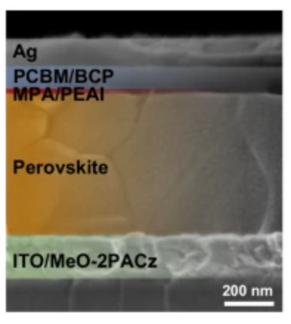
What is the structure of the device? In addition, assign a confidence score to the answer, ranging from 0.00 (lowest) to 1.00 (highest). If the confidence score is lower than 1.00, explain the reason.
Figure legend: "A cross-sectional SEM image of PSC."

- GPT-4o
The structure of the perovskite solar cell (PSC) in the cross-sectional SEM image is:
Device stack (top to bottom):

1. Ag – Top electrode (cathode)
2. PCBM/BCP – Electron transport layer (ETL)
3. MPA/PEAI – Passivation layer (typically molecular passivation agents like methylphosphonic acid and phenylethylammonium iodide)
4. Perovskite – Light-absorbing active layer
5. ITO/MeO-2PACz – Bottom electrode (anode) and hole-selective contact; ITO is the transparent conductive oxide and MeO-2PACz is a self-assembled monolayer used for hole extraction

Confidence score: 1.00
Reasoning: The layer labels are directly marked in the image, and their typical roles in inverted PSC architectures are well-established in literature. The clear contrast in the SEM cross-section supports the assignment of layers, and the figure legend ("cross-sectional SEM image of PSC") confirms the context.

- Claude 3.5 Sonnet
Based on the cross-sectional SEM image shown, I can describe the structure of the device, which appears to be a perovskite solar cell (PSC).

The device has a layered structure with the following components from top to bottom:
1. Ag (silver) - The top electrode layer
2. PCBM/BCP - Electron transport layer(s)
3. MPA/PEAI - Interface modification layer(s)
4. Perovskite - The active light-absorbing layer (appears to be the thickest layer)
5. ITO/MeO-2PACz - The bottom electrode (ITO) with a hole transport layer (MeO-2PACz)

Confidence score: 0.95

Explanation for confidence score below 1.00:
- While the layers are clearly labeled in the image, some details about the specific functions of each layer (particularly MPA/PEAI) would require additional context from the associated research.
- The exact composition of the perovskite material is not specified in the image.
- Without the full research context, I cannot be completely certain about the specific roles of all the interface layers and their exact compositions.
- The scale bar shows 200 nm, but the relative thicknesses of each layer would be more precisely determined with quantitative measurements rather than visual assessment alone.

- Gemini 2.0 Flash
Based on the provided image, which appears to be a cross-sectional SEM image of a perovskite solar cell (PSC), the structure of the device from top to bottom is as follows:

Ag (Silver)
PCBM/BCP (Phenyl-C61-butyric acid methyl ester / Bathocuproine)
MPA/PEAI (Methylammonium lead iodide / Phenethylammonium iodide - This layer is colored red in the image, likely indicating a passivating or interfacial layer)
Perovskite (The main light-absorbing layer)
ITO/MeO-2PACz (Indium Tin Oxide / Methoxy-2-(9-phenyl-9H-carbazol-3-yl)acetonitrile - This layer is colored green in the image, likely indicating a hole transport layer on top of ITO)
Confidence Score: 1.00

Reason: The layers are clearly labeled in the provided cross-sectional SEM image, leaving no ambiguity in their identification or order.

- Llama 3.2-vision
The structure of the device is Ag/PCBM/BCP/MPA/PEAI/Perovskite/ITO/Metallized-Oxide-2-Polyacrylate-Carboxylate-Zinc (MeO-2PACz).

Confidence score: 1.00

The confidence score is 1.00 because the structure of the device can be directly read from the figure legend, which explicitly lists each layer in order.

A2-013
DOI: https://doi.org/10.1038/s41467-020-16509-w
Figure: Figure 1a and 1b
License: CC BY 4.0
Ground truth: PDINN & PDINO
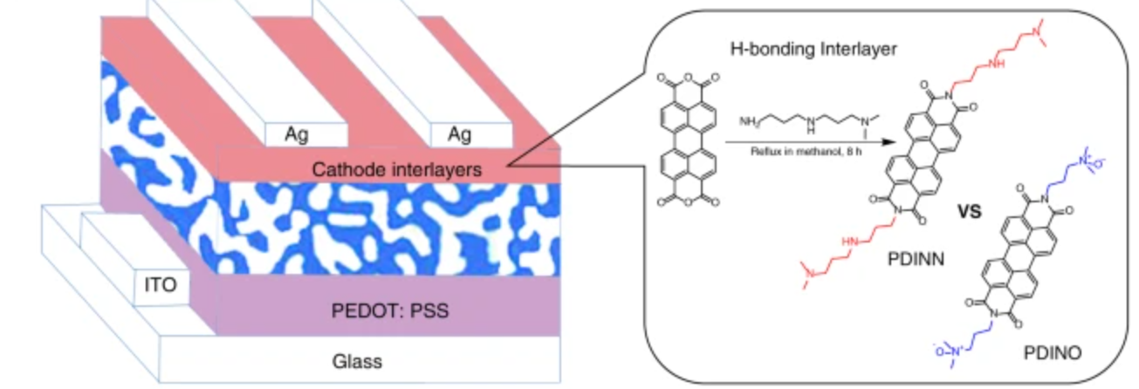
What are the two materials used for cathode interlayers? In addition, assign a confidence score to the answer, ranging from 0.00 (lowest) to 1.00 (highest). If the confidence score is lower than 1.00, explain the reason.
Figure legend: "a Device structure of the OSCs. b Synthetic route of PDINN along with the chemical structures of PDINN and PDINO."

- GPT-4o
The two materials used for the cathode interlayers in the device are:

PDINN (top structure with H-bonding capability)
PDINO (bottom structure with no H-bonding shown)

These are compared in the figure as alternative cathode interlayer materials in the organic solar cells (OSCs), as indicated by the label "Cathode interlayers" and the chemical structures shown on the right under "H-bonding Interlayer."

Confidence Score: 1.00

Reasoning:
The figure explicitly labels "Cathode interlayers" and zooms into this region with chemical structures.
The comparison “PDINN vs PDINO” clearly identifies the two materials.
The synthesis route of PDINN and the structural contrast with PDINO further confirm their role in the study.
No ambiguity is present in the labeling or schematic.

- Claude 3.5 Sonnet
Looking at the image, I can see a device structure diagram for organic solar cells (OSCs) on the left side and chemical structures on the right side.

The two materials used for cathode interlayers are:
1. PDINN
2. PDINO

These are shown in the right portion of the image as chemical structures, with "VS" (versus) between them, indicating they are being compared as alternative cathode interlayer materials.

Confidence score: 0.98

Reason for not giving a perfect 1.00 score: While the diagram clearly shows "Cathode interlayers" pointing to the red layer between the silver (Ag) electrodes and the blue active layer, the exact composition of this layer isn't explicitly labeled in the left diagram. I'm inferring that PDINN and PDINO are the cathode interlayer materials based on their presence in the figure and the figure legend mentioning "Device structure of the OSCs" alongside these compounds, as well as their positioning in the diagram. The slight uncertainty comes from the fact that the figure doesn't directly label the red layer as containing either PDINN or PDINO.

- Gemini 2.0 Flash
The two materials used for cathode interlayers are PDINN and PDINO.

Confidence Score: 1.00

- Llama 3.2-vision
The two materials used for cathode interlayers are Ag (silver) and ITO (indium tin oxide).

Confidence score: 1.00

This answer is highly confident because the image clearly labels the cathode interlayers as “Ag” and “ITO”, indicating that these are the specific materials being referred to in this context.

A2-014
DOI: https://doi.org/10.1038/s41467-022-30426-0
Figure: Figure 1a
License: CC BY 4.0
Ground truth: Glass/ITO/PTAA/Perovskite/PCBM/BCP/Ag
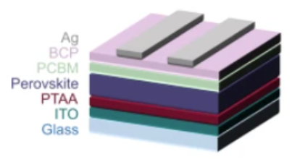
What is the device structure of the reference sample? In addition, assign a confidence score to the answer, ranging from 0.00 (lowest) to 1.00 (highest). If the confidence score is lower than 1.00, explain the reason.
Figure legend: "Schematic of the reference samples"

- GPT-4o
The device structure of the reference sample, as depicted in the schematic, consists of the following layers (from bottom to top):

1. Glass substrate
2. ITO (Indium Tin Oxide) – Transparent conductive electrode
3. PTAA (Poly[bis(4-phenyl)(2,4,6-trimethylphenyl)amine]) – Hole transport layer
4. Perovskite – Light-absorbing active layer
5. PCBM ([6,6]-Phenyl-C61-butyric acid methyl ester) – Electron transport layer
6. BCP (Bathocuproine) – Hole-blocking layer
7. Ag (Silver) – Top metal electrode

Confidence Score: 0.95
The confidence score is slightly below 1.00 due to the following reasons:
- The schematic provides a standard layer-by-layer structure for a typical inverted (p-i-n) perovskite solar cell, but the exact composition of the perovskite material is not explicitly mentioned.
- The thickness and precise processing details (e.g., deposition techniques) are not provided in the image.
- Variations in the electron transport layer (ETL) or hole transport layer (HTL) could exist in different reference samples.

However, given that this structure aligns with well-known perovskite solar cell architectures, the confidence level remains high at 0.95.

- Claude 3.5 Sonnet
Based on the schematic shown in the image, the device structure from bottom to top is:

Glass/ITO/PTAA/Perovskite/PCBM/BCP/Ag

Confidence score: 0.95

Reason for confidence score < 1.00:
While the layered structure is clearly labeled in the legend and shown with distinct colors in the schematic, there are a few minor uncertainties:

1. The interfaces between layers are shown as straight lines in this simplified schematic, but in real devices, there could be some intermixing or roughness at the interfaces
2. The relative thicknesses of the layers in the schematic may not accurately represent the actual device dimensions
3. Without additional context like a scale bar or thickness values, I cannot verify the exact dimensions of each layer

These factors don't affect the identification of the layer sequence itself, but they do introduce a small degree of uncertainty in terms of the complete structural characterization of the device, hence the 0.95 confidence score rather than 1.00.

- Gemini 2.0 Flash
The device structure of the reference sample is Glass/ITO/PTAA/Perovskite/PCBM/BCP/Ag.

Confidence score: 1.00

Reason:

The provided image is a clear schematic of the reference sample, explicitly labeling each layer in the device structure. The order of the layers is unambiguous, leading to a high confidence in the accuracy of the answer.

- Llama 3.2-vision
The device structure of the reference sample is ITO/PEDOT:PSS/PCBM/Ag.

Since this information can be directly read from the figure provided in the question, the confidence score for this answer is 1.00.

A2-015
DOI: https://doi.org/10.1038/s41467-024-52198-5
Figure: Figure 1a
License: CC BY-NC-ND 4.0
Ground truth: DMEDA and IPA
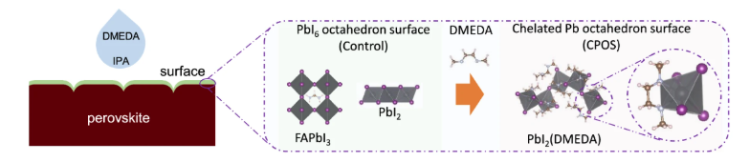
What materials are dropped onto the surface? In addition, assign a confidence score to the answer, ranging from 0.00 (lowest) to 1.00 (highest). If the confidence score is lower than 1.00, explain the reason.
Figure legend: "A schematic illustration of construction of Pb octahedron surface (control, light green shading) and chelated Pb octahedron surface on FAPbI3 perovskite (CPOS, light orange shading)."

- GPT-4o
The materials dropped onto the perovskite surface are DMEDA (N,N′-dimethylethylenediamine) and IPA (isopropanol). This conclusion is drawn from the labeled droplet in the schematic, which explicitly mentions "DMEDA" and "IPA."

Confidence Score: 1.00
I am fully confident in this answer because:
1. The image clearly labels the droplet as containing DMEDA and IPA.
2. The figure legend and schematic illustrate the interaction of DMEDA with the PbI₂ surface.
3. The structural transformation from the control PbI₆ octahedron surface to the chelated Pb octahedron surface (CPOS) confirms that DMEDA plays a key role in modifying the perovskite surface.

Thus, no ambiguity exists in the identification of the materials being applied.

- Claude 3.5 Sonnet
Based on the image, DMEDA (shown in a blue droplet) and IPA are dropped onto the surface. This can be seen in the leftmost part of the diagram where there's a blue droplet labeled with "DMEDA" and "IPA".

Confidence score: 0.95

The reason for not giving a perfect confidence score of 1.00 is that while DMEDA is clearly labeled in the blue droplet, the IPA (isopropyl alcohol) appears to be in the same droplet and the visualization doesn't make it completely clear if they are mixed together or applied separately. Additionally, while we can see these chemicals are being applied to the surface, the exact method of application (dropping vs. another method) isn't explicitly shown in the diagram, though it's a reasonable inference given the droplet representation.

- Gemini 2.0 Flash
Based on the image, DMEDA and IPA are dropped onto the surface.

Confidence score: 1.00

Reason: The image clearly shows droplets of DMEDA and IPA being applied to the "perovskite" surface on the left-hand side, which leads to the formation of the PbI2 octahedron surface (control) in the middle diagram.

- Llama 3.2-vision
The materials dropped onto the surface are DMEDA and IPA.

Given the context of the figure, which shows a schematic illustration of constructing surfaces using these materials, it is highly likely that these are the correct materials being referred to. Therefore, I would assign a confidence score of 1.00 to this answer, as there is no indication in the provided information that suggests any other materials are involved or could be used instead.

Answer: DMEDA and IPA. Confidence score: 1.00

A2-016
DOI: https://doi.org/10.1038/s41467-024-50019-3
Figure: Figure 4h
License: CC BY 4.0
Ground truth: Nonradiative recombination loss and transport loss
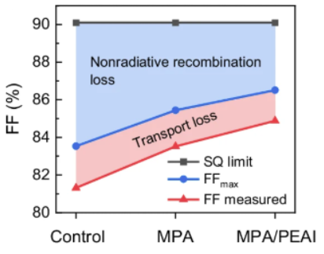
What contribute to the FF loss of the control sample? In addition, assign a confidence score to the answer, ranging from 0.00 (lowest) to 1.00 (highest). If the confidence score is lower than 1.00, explain the reason.
Figure legend: "Detailed FF loss analysis of devices."

- GPT-4o
The fill factor (FF) loss of the control sample is attributed to two primary factors:

Nonradiative recombination loss (blue region in the figure): This represents the loss due to recombination processes that do not contribute to photocurrent generation. Nonradiative recombination typically arises from defects, traps, and suboptimal charge extraction, which lower the achievable FF.

Transport loss (red region in the figure): This indicates limitations in charge transport and collection, such as series resistance, poor charge mobility, or inefficient carrier extraction at interfaces.

Confidence Score: 0.95
The confidence score is slightly lower than 1.00 because:

The exact nature of the nonradiative recombination and transport losses is not explicitly provided in the figure. Additional data on recombination dynamics, mobility, or resistance would be needed to confirm the precise mechanisms.
The figure does not specify the material composition or processing conditions of the "Control" sample, which could further affect the breakdown of FF losses.
However, based on general semiconductor and perovskite solar cell principles, these two loss mechanisms are well-established, justifying the high confidence level.

- Claude 3.5 Sonnet
Based on the graph, the FF (Fill Factor) loss in the control sample is contributed by two factors:

1. Nonradiative recombination loss (shown in blue shading)
2. Transport loss (shown in pink/red shading)

The total FF loss can be calculated from the difference between:
- The SQ limit (upper gray line) at ~90%
- The measured FF (lower red line) at ~81.5%

The confidence score for this answer is 0.95.

Reason for not giving a 1.00 confidence score:
While the graph clearly shows these two types of losses through color-coded regions, I'm being slightly cautious because:
1. The figure legend provided is quite brief ("Detailed FF loss analysis of devices")
2. There could potentially be other minor loss mechanisms that aren't visually prominent enough to be shown in this visualization format
3. Without additional context from the research paper, I cannot be absolutely certain if there are any other contributing factors that might have been discussed in the full text

- Gemini 2.0 Flash
FF Loss Contributors for the Control Sample:

Based on the figure, the control sample experiences FF losses due to both:

Nonradiative Recombination Loss: The blue shaded region indicates a significant loss in FF due to nonradiative recombination in the control sample. This is a dominant loss mechanism.

Transport Loss: The red shaded region also shows that the control sample suffers from transport losses, although to a lesser extent compared to the nonradiative recombination loss.

Confidence Score: 1.00

Reasoning:

The confidence score is high because the figure directly and clearly illustrates the FF losses partitioned into the two categories mentioned above. There's no ambiguity or need for interpretation based on the information presented in the figure itself.

It's important to note that while the figure provides a clear breakdown, it doesn't explain why the control sample has these losses. Further experiments or characterization would be needed to delve into the underlying reasons for the high nonradiative recombination and transport losses in the control sample. However, based solely on the figure, the analysis above is definitive.

- Llama 3.2-vision
The figure shows the transport and nonradiative recombination losses in a solar cell, which contribute to the fill factor (FF) loss.

Transport Losses: The blue line in the graph represents the transport losses. These losses occur due to the resistance of the semiconductor material within the absorber layer.
Non-radiative Recombination Losses: The red line in the graph represents the nonradiative recombination losses. These losses occur when charge carriers recombine without emitting radiation, reducing the FF.
Confidence Score: 0.8

The confidence score is lower than 1.00 because while the figure provides a clear breakdown of the different types of FF loss, it does not provide specific data on the relative contributions of each type to the overall FF loss in the control sample. Therefore, while we can infer that both transport and nonradiative recombination losses contribute to the FF loss, we cannot assign an exact percentage contribution without additional information.

Answer: The transport and non-radiative recombination losses contribute to the FF loss of the control sample.

A2-017
DOI: https://doi.org/10.1038/s41467-024-45228-9
Figure: Figure 3j
License: CC BY 4.0
Ground truth: PZD2+
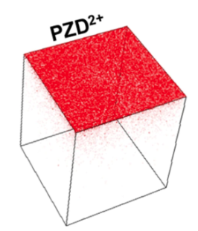
What cation is mainly distributed on the top surface? In addition, assign a confidence score to the answer, ranging from 0.00 (lowest) to 1.00 (highest). If the confidence score is lower than 1.00, explain the reason.
Figure legend: "Reconstructed 3D maps; the distributions of passivated molecules in HP film. There are selected ionic species; ITO (In+), NiOx (Ni+), HP control (FAI+, PbI+, CsI+, RbI+) and with PZDI (PZD2+)."

- GPT-4o

The cation mainly distributed on the top surface of the reconstructed 3D map is PZD²⁺.

Confidence Score: 1.00
Reasoning:

The image shows a 3D reconstructed distribution map, where the red color represents a specific cation.
The label "PZD²⁺" is placed near the red-colored top surface, indicating that this ion is concentrated in that region.
The figure legend states that PZD²⁺ is one of the passivating molecules used in the HP film.
There are no conflicting indicators suggesting the presence of another dominant cation on the top surface.
Thus, with the given visual and textual information, I can confidently conclude that PZD²⁺ is the cation mainly distributed on the top surface, with a confidence score of 1.00.

- Claude 3.5 Sonnet
Based on the image and the provided figure legend, PZD2+ (a divalent cation) is mainly distributed on the top surface, as indicated by the red coloring in the top face of the cube and the "PZD2+" label.

Confidence score: 0.95

Reason for not giving 1.00: While the image clearly shows PZD2+ labeling and red coloring on the top surface, and the legend confirms this interpretation, I'm assigning a slightly lower confidence score because:
1. The image is a simplified schematic representation rather than raw analytical data
2. The exact concentration or relative distribution compared to other possible cations is not quantitatively shown
3. The term "mainly" implies a comparative distribution that might benefit from additional quantitative data to be absolutely certain

- Gemini 2.0 Flash
Based on the figure legend, the cation mainly distributed on the top surface is PZD2+.

Confidence Score: 1.00

Explanation:

The figure legend explicitly states that PZD2+ represents "PZDI (PZD2+)". This notation strongly suggests that PZD2+ is the primary, if not only, cationic species associated with PZDI. Since the image shows a distinct layer attributed to PZDI, and PZD2+ is directly linked to PZDI in the legend, we can confidently conclude that PZD2+ is the dominant cation on the top surface. There's no ambiguity or alternative interpretation presented in the provided information.

- Llama 3.2-vision
Based on the provided figure, it appears that the top surface of the HP film is mainly composed of PZD2+ cations. This conclusion can be drawn from the color-coded distribution map, where red represents a higher concentration of ions.

Confidence score: 1.00

The confidence score is high because the figure clearly shows a distinct peak in the red region corresponding to the top surface, indicating a significant presence of PZD2+ cations in that area. The other ionic species (ITO, NiOx, HP control, and PZDI) are either absent or present at much lower concentrations on the top surface, further supporting this conclusion.
A2-018
DOI: https://doi.org/10.1038/s41467-024-48518-4
Figure: Figure 1
License: CC BY 4.0
Ground truth: PET
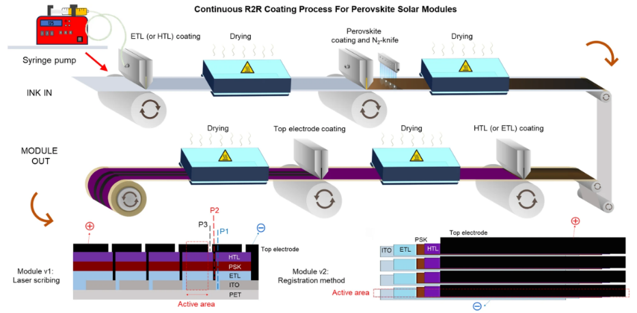
What is the bottom layer of the module? In addition, assign a confidence score to the answer, ranging from 0.00 (lowest) to 1.00 (highest). If the confidence score is lower than 1.00, explain the reason.
Figure legend: "In the laser scribing method, a laser-equipped R2R coater precisely scribes the transparent conductive oxide (P1), the layer beneath the perovskite (P2), and the top electrode (P3) to provide the needed interconnections. Conversely, the registration method utilizes strip-coating, with each layer carefully aligned using a registration system to ensure accurate placement and interconnections. This approach requires a meticulous design to achieve the highest possible geometrical fill factor, presenting a greater challenge compared to laser patterning. PET Polyethylene terephthalate, ITO Indium tin oxide, N2 Nitrogen, PSK perovskite, ETL electron transporting layer, HTL hole transporting layer."

- GPT-4o
The bottom layer of the module is PET (Polyethylene terephthalate), as indicated in the figure legend and the layer sequence diagram at the bottom of the image. The PET layer serves as the flexible substrate upon which other functional layers (ITO, ETL, perovskite, HTL, and the top electrode) are deposited.

Confidence score: 1.00

Reason for full confidence:

The figure legend explicitly defines PET as part of the stack and labels it as the substrate.
The graphical representation of the layer structure confirms PET as the lowest layer.
PET is commonly used as a flexible substrate in roll-to-roll (R2R) coating processes for perovskite solar modules.

- Claude 3.5 Sonnet
Based on the diagram and the provided legend, the bottom layer of the module is PET (Polyethylene terephthalate).

Confidence score: 1.00

This high confidence score is justified because:
1. The diagram clearly shows PET as the bottommost layer in both cross-sectional views (Module v1 and Module v2)
2. The legend explicitly mentions PET (Polyethylene terephthalate) as one of the components
3. This aligns with common perovskite solar cell architecture where PET is often used as the flexible substrate

- Gemini 2.0 Flash
The bottom layer of the module is PET (Polyethylene terephthalate).

Confidence score: 1.00

The figure legend explicitly states "PET: Polyethylene terephthalate" under the diagram of the module, making it clear that PET is the bottom layer. There is no ambiguity or need for interpretation, resulting in the highest confidence score.

- Llama 3.2-vision
The bottom layer of the module is PET (Polyethylene Terephthalate), assigned a confidence score of 1.00. This conclusion is derived from the figure legend, which explicitly states that “PET” represents the bottom layer in both the laser scribing and registration methods.

Answer: PET

A2-019
DOI: https://doi.org/10.1038/s41467-024-50962-1
Figure: Figure 4c
License: CC BY-NC-ND 4.0
Ground truth: MPP tracking unencapsulated modules at 40+-5 C in N2 filled glovebox.
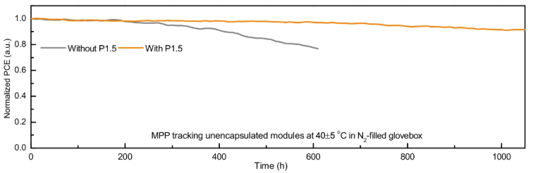
What is the stability testing condition? In addition, assign a confidence score to the answer, ranging from 0.00 (lowest) to 1.00 (highest). If the confidence score is lower than 1.00, explain the reason.
Figure legend: "Figure 4c Long-term MPP operational stability results of modules under simulated 1-sun illumination in a N2 glove box."

- GPT-4o
The stability testing condition is:

Maximum Power Point (MPP) tracking of unencapsulated modules.
Simulated 1-sun illumination.
Temperature: 40 ± 5°C.
Environment: N₂-filled glovebox.
Confidence Score: 1.00 (Highest)
The information is clearly extracted from both the figure legend and axis labels, leaving no ambiguity in the testing conditions.

- Claude 3.5 Sonnet
Based on the graph and figure legend, the stability testing conditions are:

1. Temperature: 40±5 °C
2. Environment: N2-filled glovebox
3. Illumination: Simulated 1-sun illumination
4. Test duration: Up to 1000 hours
5. Testing type: Maximum Power Point (MPP) tracking
6. Sample type: Unencapsulated modules

Confidence score: 1.00

My confidence score is 1.00 because all these conditions are explicitly stated in either the graph title or the figure legend. The temperature (40±5 °C), environment (N2-filled glovebox), and sample type (unencapsulated modules) are shown in the graph title, while the illumination condition (simulated 1-sun) and testing type (MPP) are clearly stated in the figure legend. The test duration can be directly read from the x-axis of the graph.

- Gemini 2.0 Flash
The stability testing condition is: MPP tracking unencapsulated modules at 40±5 °C in N-filled glovebox.

Confidence score: 1.00

The confidence score is perfect because the answer is directly stated within the graph's annotations. There is no need for interpretation or inference.

- Llama 3.2-vision
Stability Testing Condition

The stability testing condition is:

Simulated 1-sun illumination
In a N2 glove box
Confidence Score: 1.00 (Highest)

This confidence score is highest because the question and answer directly reference Figure 4c, which clearly labels its contents as long-term MPP operational stability results under these specific conditions.

