#include <iostream>

#include <vector>

#include <queue>

#include <stack>

#include <omp.h>

#include <chrono>

#include <cstdlib>

using namespace std;

using namespace std::chrono;

class Graph {

public:

int V;

vector<vector<int>> adj;

Graph(int V) {

this->V = V;

adj.resize(V);

}

void addEdge(int u, int v) {

adj[u].push_back(v);

adj[v].push_back(u);

}

void generateRandomGraph(int edges);

void sequentialBFS(int start);

void parallelBFS(int start);

void sequentialDFS(int start);

void parallelDFS(int start);

};

void Graph::generateRandomGraph(int edges) {

srand(time(0));

for (int i = 0; i < edges; i++) {

int u = rand() % V;

int v = rand() % V;

if (u != v) {

addEdge(u, v);

}

}

}

void Graph::sequentialBFS(int start) {

vector<bool> visited(V, false);

queue<int> q;

visited[start] = true;

q.push(start);

while (!q.empty()) {

int node = q.front();

q.pop();

for (int neighbor : adj[node]) {

if (!visited[neighbor]) {

visited[neighbor] = true;

q.push(neighbor);

}

}

}

}

void Graph::parallelBFS(int start) {

vector<bool> visited(V, false);

queue<int> q;

visited[start] = true;

q.push(start);

while (!q.empty()) {

int size = q.size();

vector<int> levelNodes;

#pragma omp parallel for shared(visited, q)

for (int i = 0; i < size; i++) {

int node;

#pragma omp critical

{

if (!q.empty()) {

node = q.front();

q.pop();

}

}

for (int neighbor : adj[node]) {

if (!visited[neighbor]) {

visited[neighbor] = true;

#pragma omp critical

levelNodes.push_back(neighbor);

}

}

}

for (int node : levelNodes) {

q.push(node);

}

}

}

void Graph::sequentialDFS(int start) {

vector<bool> visited(V, false);

stack<int> s;

s.push(start);

while (!s.empty()) {

int node = s.top();

s.pop();

if (!visited[node]) {

visited[node] = true;

for (int neighbor : adj[node]) {

if (!visited[neighbor]) {

s.push(neighbor);

}

}

}

}

}

void Graph::parallelDFS(int start) {

vector<bool> visited(V, false);

stack<int> s;

s.push(start);

#pragma omp parallel

{

while (!s.empty()) {

int node;

#pragma omp critical

{

if (!s.empty()) {

node = s.top();

s.pop();

}

}

if (!visited[node]) {

visited[node] = true;

#pragma omp parallel for

for (int i = 0; i < adj[node].size(); i++) {

int neighbor = adj[node][i];

if (!visited[neighbor]) {

#pragma omp critical

s.push(neighbor);

}

}

}

}

}

}

int main() {

int V, E;

cout << "Enter the number of vertices: ";

cin >> V;

cout << "Enter the number of edges: ";

cin >> E;

if (E > (V * (V - 1)) / 2) {

cout << "Too many edges for the given number of vertices. Adjusting to maximum possible edges.\n";

E = (V * (V - 1)) / 2;

}

Graph g(V);

g.generateRandomGraph(E);

auto start = high_resolution_clock::now();

g.sequentialBFS(0);

auto stop = high_resolution_clock::now();

auto seqBFS_time = duration_cast<microseconds>(stop - start);

start = high_resolution_clock::now();

g.parallelBFS(0);

stop = high_resolution_clock::now();

auto parBFS_time = duration_cast<microseconds>(stop - start);

start = high_resolution_clock::now();

g.sequentialDFS(0);

stop = high_resolution_clock::now();

auto seqDFS_time = duration_cast<microseconds>(stop - start);

start = high_resolution_clock::now();

g.parallelDFS(0);

stop = high_resolution_clock::now();

auto parDFS_time = duration_cast<microseconds>(stop - start);

cout << "Sequential BFS Time: " << seqBFS_time.count() << " microseconds" << endl;

cout << "Parallel BFS Time: " << parBFS_time.count() << " microseconds" << endl;

cout << "Speedup for BFS: " << (double)seqBFS_time.count() / parBFS_time.count() << endl;

cout << "Sequential DFS Time: " << seqDFS_time.count() << " microseconds" << endl;

cout << "Parallel DFS Time: " << parDFS_time.count() << " microseconds" << endl;

cout << "Speedup for DFS: " << (double)seqDFS_time.count() / parDFS_time.count() << endl;

return 0;

}

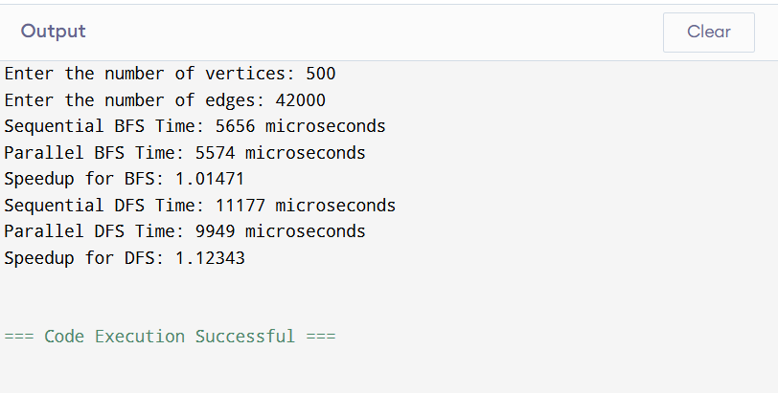

#include <iostream>

#include <chrono>

#include <omp.h>

#include <vector>

using namespace std;

using namespace std::chrono;

class Sorting {

private:

    vector<int> arr;

    int n;

    void merge(vector<int>& arr, int start, int mid, int end) {

        vector<int> left(arr.begin() + start, arr.begin() + mid + 1);

        vector<int> right(arr.begin() + mid + 1, arr.begin() + end + 1);

        int i = 0, j = 0, k = start;

        while (i < left.size() && j < right.size()) {

            if (left[i] <= right[j]) {

                arr[k++] = left[i++];

            } else {

                arr[k++] = right[j++];

            }

        }

        while (i < left.size()) arr[k++] = left[i++];

        while (j < right.size()) arr[k++] = right[j++];

    }

public:

    Sorting(vector<int> inputArr) : arr(inputArr), n(inputArr.size()) {}

    void bubbleSort() {

        for (int i = 0; i < n - 1; i++) {

            for (int j = 0; j < n - i - 1; j++) {

                if (arr[j] > arr[j + 1]) {

                    swap(arr[j], arr[j + 1]);

                }

            }

        }

    }

    void mergeSort(int start, int end) {

        if (start < end) {

            int mid = start + (end - start) / 2;

            mergeSort(start, mid);

            mergeSort(mid + 1, end);

            merge(arr, start, mid, end);

        }

    }

    void parallelBubbleSort() {

        bool sorted = false;

        while (!sorted) {

            sorted = true;

            #pragma omp parallel for shared(arr, sorted)

            for (int i = 0; i < n - 1; i += 2) {

                if (arr[i] > arr[i + 1]) {

                    swap(arr[i], arr[i + 1]);

                    sorted = false;

                }

            }

            #pragma omp parallel for shared(arr, sorted)

            for (int i = 1; i < n - 1; i += 2) {

                if (arr[i] > arr[i + 1]) {

                    swap(arr[i], arr[i + 1]);

                    sorted = false;

                }

            }

        }

    }

    void parallelMergeSort(int start, int end) {

        if (start < end) {

            int mid = start + (end - start) / 2;

            #pragma omp parallel sections

            {

                #pragma omp section

                parallelMergeSort(start, mid);

                #pragma omp section

                parallelMergeSort(mid + 1, end);

            }

            merge(arr, start, mid, end);

        }

    }

    void displayArray() {

        for (int i : arr) {

            cout << i << " ";

        }

        cout << endl;

    }

    vector<int> getArray() {

        return arr;

    }

};

int main() {

    cout << "Enter number of elements: ";

    int n;

    cin >> n;

    vector<int> inputArr(n);

    for (int i = 0; i < n; i++) {

        inputArr[i] = rand() % 100;

        cout << inputArr[i] << " ";

    }

    cout << "\n\n";

    Sorting sorter(inputArr);

    vector<int> originalArr = sorter.getArray();

    cout << "Sequential Execution:\n\n";

    cout << "Bubble Sort: ";

    auto start = high_resolution_clock::now();

    sorter.bubbleSort();

    auto end = high_resolution_clock::now();

    sorter.displayArray();

    double seq_bubble_time = duration<double, milli>(end - start).count();

    cout << "TIME TAKEN: " << seq_bubble_time << " ms\n";

    sorter = Sorting(originalArr);

    cout << "\nMerge Sort: ";

    start = high_resolution_clock::now();

    sorter.mergeSort(0, n - 1);

    end = high_resolution_clock::now();

    sorter.displayArray();

    double seq_merge_time = duration<double, milli>(end - start).count();

    cout << "TIME TAKEN: " << seq_merge_time << " ms\n";

    cout << "\nParallel Execution:\n\n";

    sorter = Sorting(originalArr);

    cout << "Parallel Bubble Sort: ";

    start = high_resolution_clock::now();

    sorter.parallelBubbleSort();

    end = high_resolution_clock::now();

    sorter.displayArray();

    double par_bubble_time = duration<double, milli>(end - start).count();

    cout << "TIME TAKEN: " << par_bubble_time << " ms\n";

    cout << "Speedup Factor (Bubble Sort): " << seq_bubble_time / par_bubble_time << "\n";

    sorter = Sorting(originalArr);

    cout << "\nParallel Merge Sort: ";

    start = high_resolution_clock::now();

    sorter.parallelMergeSort(0, n - 1);

    end = high_resolution_clock::now();

    sorter.displayArray();

    double par_merge_time = duration<double, milli>(end - start).count();

    cout << "TIME TAKEN: " << par_merge_time << " ms\n";

    cout << "Speedup Factor (Merge Sort): " << seq_merge_time / par_merge_time << "\n";

    return 0;

}

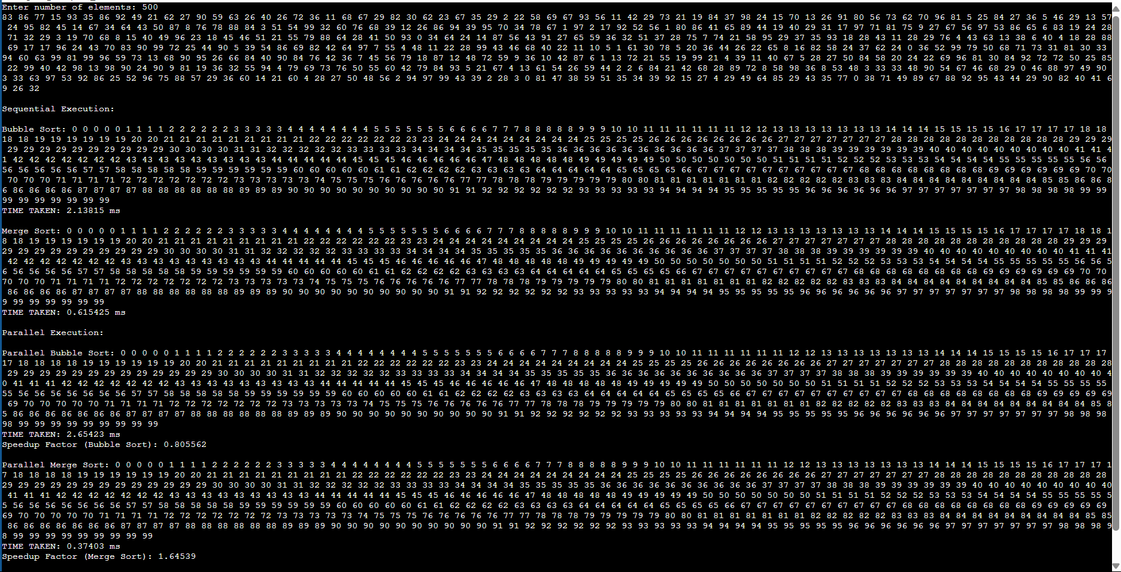

#include <iostream>

#include <vector>

#include <cstdlib>

#include <ctime>

#include <chrono>

#include <omp.h>

using namespace std;

class ParallelMinMax {

private:

    vector<int> arr;

    int size;

    int min_seq, max_seq, min_par, max_par;

    long long sum_seq, sum_par;

    double avg_seq, avg_par;

    double time_min_seq, time_max_seq, time_sum_seq, time_avg_seq;

    double time_min_par, time_max_par, time_sum_par, time_avg_par;

public:

    ParallelMinMax(int size) : size(size), min_seq(0), max_seq(0), min_par(0), max_par(0), sum_seq(0), sum_par(0), avg_seq(0), avg_par(0),

        time_min_seq(0), time_max_seq(0), time_sum_seq(0), time_avg_seq(0), time_min_par(0), time_max_par(0), time_sum_par(0), time_avg_par(0) {

        arr.resize(size);

    }

    void generateRandomArray() {

        srand(time(0));

        for (int i = 0; i < size; i++) {

            arr[i] = rand() % 100 + 1;

        }

    }

    void computeMinSequential() {

        auto start = chrono::high_resolution_clock::now();

        min_seq = arr[0];

        for (int i = 1; i < size; i++) {

            if (arr[i] < min_seq) min_seq = arr[i];

        }

        auto end = chrono::high_resolution_clock::now();

        time_min_seq = chrono::duration<double>(end - start).count();

    }

    void computeMaxSequential() {

        auto start = chrono::high_resolution_clock::now();

        max_seq = arr[0];

        for (int i = 1; i < size; i++) {

            if (arr[i] > max_seq) max_seq = arr[i];

        }

        auto end = chrono::high_resolution_clock::now();

        time_max_seq = chrono::duration<double>(end - start).count();

    }

    void computeSumSequential() {

        auto start = chrono::high_resolution_clock::now();

        sum_seq = 0;

        for (int i = 0; i < size; i++) {

            sum_seq += arr[i];

        }

        auto end = chrono::high_resolution_clock::now();

        time_sum_seq = chrono::duration<double>(end - start).count();

    }

    void computeAvgSequential() {

        auto start = chrono::high_resolution_clock::now();

        avg_seq = static_cast<double>(sum_seq) / size;

        auto end = chrono::high_resolution_clock::now();

        time_avg_seq = chrono::duration<double>(end - start).count();

    }

    void computeMinParallel() {

        auto start = chrono::high_resolution_clock::now();

        min_par = arr[0];

        #pragma omp parallel for reduction(min:min_par)

        for (int i = 1; i < size; i++) {

            if (arr[i] < min_par) min_par = arr[i];

        }

        auto end = chrono::high_resolution_clock::now();

        time_min_par = chrono::duration<double>(end - start).count();

    }

    void computeMaxParallel() {

        auto start = chrono::high_resolution_clock::now();

        max_par = arr[0];

        #pragma omp parallel for reduction(max:max_par)

        for (int i = 1; i < size; i++) {

            if (arr[i] > max_par) max_par = arr[i];

        }

        auto end = chrono::high_resolution_clock::now();

        time_max_par = chrono::duration<double>(end - start).count();

    }

    void computeSumParallel() {

        auto start = chrono::high_resolution_clock::now();

        sum_par = 0;

        #pragma omp parallel for reduction(+:sum_par)

        for (int i = 0; i < size; i++) {

            sum_par += arr[i];

        }

        auto end = chrono::high_resolution_clock::now();

        time_sum_par = chrono::duration<double>(end - start).count();

    }

    void computeAvgParallel() {

        auto start = chrono::high_resolution_clock::now();

        avg_par = static_cast<double>(sum_par) / size;

        auto end = chrono::high_resolution_clock::now();

        time_avg_par = chrono::duration<double>(end - start).count();

    }

    void sequentialComputation() {

        computeMinSequential();

        computeMaxSequential();

        computeSumSequential();

        computeAvgSequential();

    }

    void parallelComputation() {

        computeMinParallel();

        computeMaxParallel();

        computeSumParallel();

        computeAvgParallel();

    }

    void displayResults() {

        cout << "---- Sequential Computation ----\n";

        cout << "Min: " << min_seq << " | Time: " << time_min_seq << " sec\n";

        cout << "Max: " << max_seq << " | Time: " << time_max_seq << " sec\n";

        cout << "Sum: " << sum_seq << " | Time: " << time_sum_seq << " sec\n";

        cout << "Average: " << avg_seq << " | Time: " << time_avg_seq << " sec\n\n";

        cout << "---- Parallel Computation ----\n";

        cout << "Min: " << min_par << " | Time: " << time_min_par << " sec\n";

        cout << "Max: " << max_par << " | Time: " << time_max_par << " sec\n";

        cout << "Sum: " << sum_par << " | Time: " << time_sum_par << " sec\n";

        cout << "Average: " << avg_par << " | Time: " << time_avg_par << " sec\n\n";

        cout << "---- Speedup Factors ----\n";

        cout << "Speedup (Min): " << (time_min_seq / time_min_par) << "x\n";

        cout << "Speedup (Max): " << (time_max_seq / time_max_par) << "x\n";

        cout << "Speedup (Sum): " << (time_sum_seq / time_sum_par) << "x\n";

        cout << "Speedup (Average): " << (time_avg_seq / time_avg_par) << "x\n";

    }

};

int main() {

    int size;

    cout << "Enter array size: ";

    cin >> size;

    if (size <= 0) {

        cout << "Invalid size!" << endl;

        return 1;

    }

    ParallelMinMax pm(size);

    pm.generateRandomArray();

    pm.sequentialComputation();

    pm.parallelComputation();

    pm.displayResults();

    return 0;

}

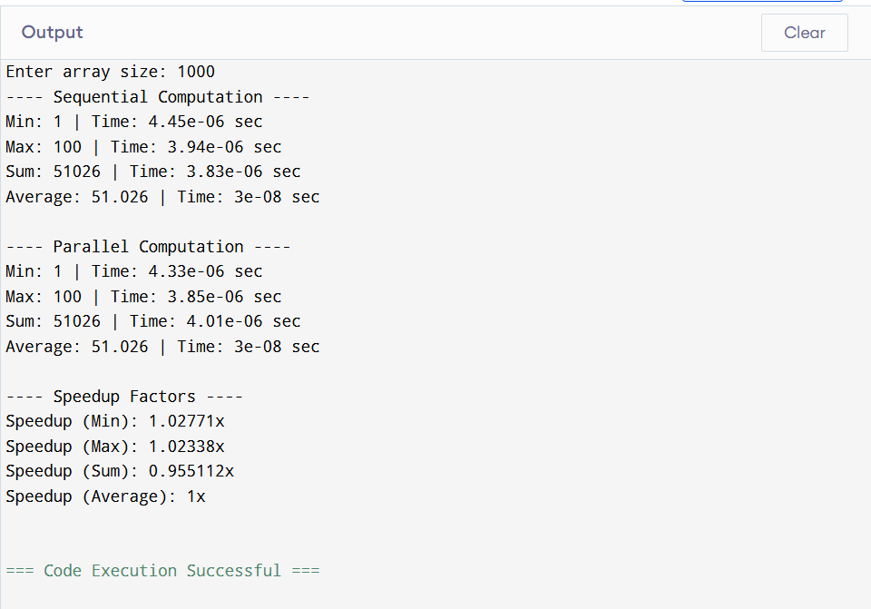

#include <cuda.h>

#include <stdio.h>

#include <stdlib.h>

#include <math.h>

#include <time.h>

#include <iostream>

#include "cuda_runtime.h"

using namespace std;

#define N 1000

__global__ void vectorAdd(int *d_a, int *d_b, int *d_c, int n) {

int i = threadIdx.x + blockIdx.x * blockDim.x;

if (i < n) {

     d_c[i] = d_a[i] + d_b[i];

}

}

__global__ void matrixMultiplyKernel(float *a, float *b, float *c) {

int row = blockIdx.y * blockDim.y + threadIdx.y;

int col = blockIdx.x * blockDim.x + threadIdx.x;

if (row < N && col < N) {

     float sum = 0;

     for (int i = 0; i < N; i++) {

         sum += a[row * N + i] * b[i * N + col];

     }

     c[row * N + col] = sum;

}

}

class VectorAddition {

public:

void performVectorAddition() {

     int *a, *b, *c, *d;

     int *d_a, *d_b, *d_c;

     size_t size = N * sizeof(int);

     a = (int *)malloc(size);

     b = (int *)malloc(size);

     c = (int *)malloc(size);

     d = (int *)malloc(size);

     srand(time(NULL));

     for (int i = 0; i < N; i++) {

         a[i] = rand() % 100;

         b[i] = rand() % 100;

     }

     clock_t start_cpu = clock();

     for (int i = 0; i < N; i++) {

         c[i] = a[i] + b[i];

     }

     clock_t end_cpu = clock();

     double cpu_time = (double)(end_cpu - start_cpu) / CLOCKS_PER_SEC;

     cudaMalloc((void **)&d_a, size);

     cudaMalloc((void **)&d_b, size);

     cudaMalloc((void **)&d_c, size);

     cudaMemcpy(d_a, a, size, cudaMemcpyHostToDevice);

     cudaMemcpy(d_b, b, size, cudaMemcpyHostToDevice);

     int threadsPerBlock = 256;

     int blocksPerGrid = (N + threadsPerBlock - 1) / threadsPerBlock;

     cudaEvent_t start, stop;

     cudaEventCreate(&start);

     cudaEventCreate(&stop);

     cudaEventRecord(start);

     vectorAdd<<<blocksPerGrid, threadsPerBlock>>>(d_a, d_b, d_c, N);

     cudaEventRecord(stop);

     cudaMemcpy(d, d_c, size, cudaMemcpyDeviceToHost);

     cudaEventSynchronize(stop);

     float gpu_time = 0;

     cudaEventElapsedTime(&gpu_time, start, stop);

     bool match = true;

     for (int i = 0; i < N; i++) {

         if (c[i] != d[i]) {

             match = false;

             break;

         }

     }

     printf("CPU Time: %.6f s\n", cpu_time);

     printf("GPU Time: %.6f ms\n", gpu_time);

     printf("Speedup Factor: %.2f\n", (cpu_time) *10000/ gpu_time);

     printf("Arrays Match: %s\n", match ? "Yes" : "No");

     free(a); free(b); free(c); free(d);

     cudaFree(d_a); cudaFree(d_b); cudaFree(d_c);

     cudaEventDestroy(start);

     cudaEventDestroy(stop);

}

};

class MatrixMultiplier {

private:

float *hostA, *hostB, *hostC, *hostD;

float *devA, *devB, *devC;

int size;

float cpuTime, gpuTime;

public:

MatrixMultiplier() {

     size = N * N * sizeof(float);

     hostA = (float *)malloc(size);

     hostB = (float *)malloc(size);

     hostC = (float *)malloc(size);

     hostD = (float *)malloc(size);

     cudaMalloc((void **)&devA, size);

     cudaMalloc((void **)&devB, size);

     cudaMalloc((void **)&devC, size);

     cpuTime = gpuTime = 0.0;

}

     ~MatrixMultiplier() {

     free(hostA);

     free(hostB);

     free(hostC);

     free(hostD);

     cudaFree(devA);

     cudaFree(devB);

     cudaFree(devC);

}

     void initializeMatrices() {

     for (int i = 0; i < N * N; i++) {

         hostA[i] = rand() % 100;

         hostB[i] = rand() % 100;

     }

}

void gpuMatrixMultiplication() {

     cudaMemcpy(devA, hostA, size, cudaMemcpyHostToDevice);

     cudaMemcpy(devB, hostB, size, cudaMemcpyHostToDevice);

     dim3 dimBlock(16, 16);

     dim3 dimGrid((N + 15) / 16, (N + 15) / 16);

     clock_t tic = clock();

     matrixMultiplyKernel<<<dimGrid, dimBlock>>>(devA, devB, devC);

     cudaDeviceSynchronize();

     clock_t toc = clock();

     gpuTime = ((float)(toc - tic)) / CLOCKS_PER_SEC;

     cudaMemcpy(hostC, devC, size, cudaMemcpyDeviceToHost);

}

     void cpuMatrixMultiplication() {

     clock_t tic = clock();

     for (int i = 0; i < N; i++) {

         for (int j = 0; j < N; j++) {

             float sum = 0;

             for (int k = 0; k < N; k++) {

                 sum += hostA[i * N + k] * hostB[k * N + j];

             }

             hostD[i * N + j] = sum;

         }

     }

             clock_t toc = clock();

     cpuTime = ((float)(toc - tic)) / CLOCKS_PER_SEC;

}

bool verifyEquality() {

     float tolerance = 1e-5;

     for (int i = 0; i < N * N; i++) {

         if (fabs(hostC[i] - hostD[i]) > tolerance) {

             printf("Mismatch at index %d: GPU = %f, CPU = %f\n", i, hostC[i], hostD[i]);

             return false;

             }

     }

     return true;

}

void printResults() {

     printf("CPU Time: %f seconds\n", cpuTime);

     printf("GPU Time: %f seconds\n", gpuTime);

     if (gpuTime > 0) {

         printf("Speed-Up Factor: %.2f x\n", (cpuTime) / gpuTime);

     } else {

         printf("Speed-Up Factor: N/A (GPU time too small)\n");

     }

}

};

int main() {

int choice;

VectorAddition vectorAdder;

MatrixMultiplier matrixMultiplier;

matrixMultiplier.initializeMatrices();

matrixMultiplier.cpuMatrixMultiplication();

matrixMultiplier.gpuMatrixMultiplication();

bool success = matrixMultiplier.verifyEquality();

do {

     cout << "\nMenu:" << endl;

     cout << "1. Vector Addition" << endl;

     cout << "2. Matirx Multiplication" << endl;

     cout << "3. Exit" << endl;

     cout << "Enter your choice: ";

     cin >> choice;

     switch (choice) {

         case 1:

             vectorAdder.performVectorAddition();

             break;

         case 2:

             matrixMultiplier.printResults();

             printf("Verification: %s\n", success ? "true" : "false");

             break;

         case 3:

             cout << "Exiting..." << endl;

             break;

         default:

             cout << "Invalid choice!" << endl;

     }

} while (choice != 3);

return 0;

}

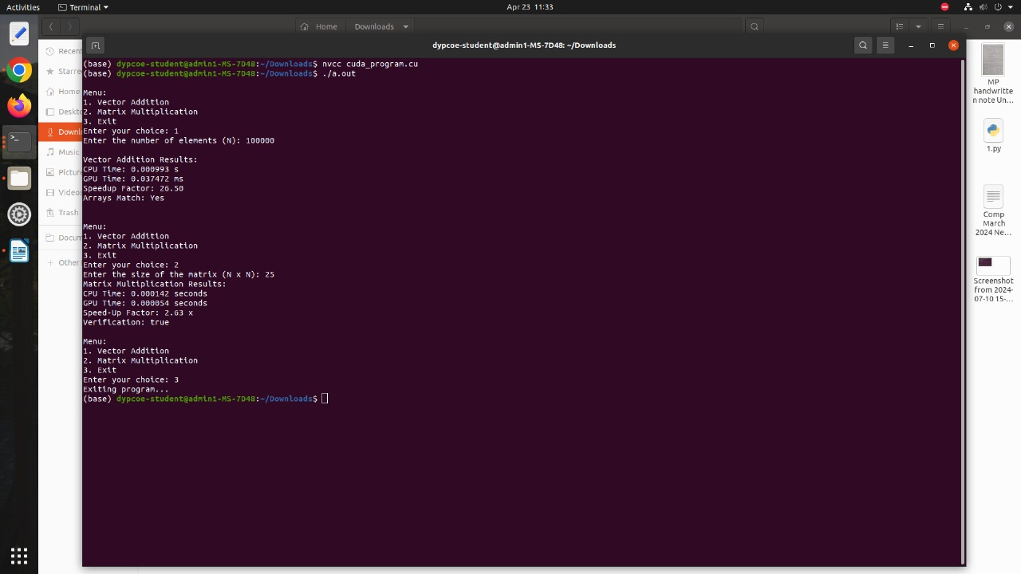

#include <iostream>

#include <vector>

#include <cmath>

#include <chrono>

#include <cuda.h>

#define N 1000  // number of data points

// CUDA Kernel for parallel sum calculation

__global__ void computeSums(const float* x, const float* y, float* sumX, float* sumY, float* sumXY, float* sumX2, int n) {

int i = blockIdx.x * blockDim.x + threadIdx.x;

if (i < n) {

     atomicAdd(sumX, x[i]);

     atomicAdd(sumY, y[i]);

     atomicAdd(sumXY, x[i] * y[i]);

     atomicAdd(sumX2, x[i] * x[i]);

}

}

// CPU implementation of linear regression

void linearRegressionCPU(const float* x, const float* y, int n, float& b0, float& b1) {

float sumX = 0, sumY = 0, sumXY = 0, sumX2 = 0;

for (int i = 0; i < n; i++) {

     sumX += x[i];

     sumY += y[i];

     sumXY += x[i] * y[i];

     sumX2 += x[i] * x[i];

}

b1 = (n * sumXY - sumX * sumY) / (n * sumX2 - sumX * sumX);

b0 = (sumY - b1 * sumX) / n;

}

int main() {

// Host data

std::vector<float> h_x(N), h_y(N);

float b0_cpu, b1_cpu;

float b0_gpu, b1_gpu;

// Generate synthetic data: y = 2.5 + 1.2x

for (int i = 0; i < N; ++i) {

     h_x[i] = i;

     h_y[i] = 2.5f + 1.2f * i;

}

// === CPU Linear Regression ===

auto start_cpu = std::chrono::high_resolution_clock::now();

linearRegressionCPU(h_x.data(), h_y.data(), N, b0_cpu, b1_cpu);

auto end_cpu = std::chrono::high_resolution_clock::now();

float cpu_time = std::chrono::duration<float, std::milli>(end_cpu - start_cpu).count();

// === GPU Linear Regression ===

float *d_x, *d_y, *d_sumX, *d_sumY, *d_sumXY, *d_sumX2;

cudaMalloc(&d_x, N * sizeof(float));

cudaMalloc(&d_y, N * sizeof(float));

cudaMalloc(&d_sumX, sizeof(float));

cudaMalloc(&d_sumY, sizeof(float));

cudaMalloc(&d_sumXY, sizeof(float));

cudaMalloc(&d_sumX2, sizeof(float));

// Initialize device memory for sums

cudaMemset(d_sumX, 0, sizeof(float));

cudaMemset(d_sumY, 0, sizeof(float));

cudaMemset(d_sumXY, 0, sizeof(float));

cudaMemset(d_sumX2, 0, sizeof(float));

cudaMemcpy(d_x, h_x.data(), N * sizeof(float), cudaMemcpyHostToDevice);

cudaMemcpy(d_y, h_y.data(), N * sizeof(float), cudaMemcpyHostToDevice);

int threadsPerBlock = 256;

int blocksPerGrid = (N + threadsPerBlock - 1) / threadsPerBlock;

cudaEvent_t start_gpu, stop_gpu;

cudaEventCreate(&start_gpu);

cudaEventCreate(&stop_gpu);

cudaEventRecord(start_gpu);

computeSums<<<blocksPerGrid, threadsPerBlock>>>(d_x, d_y, d_sumX, d_sumY, d_sumXY, d_sumX2, N);

cudaEventRecord(stop_gpu);

cudaEventSynchronize(stop_gpu);

float gpu_time = 0;

cudaEventElapsedTime(&gpu_time, start_gpu, stop_gpu);

float sumX, sumY, sumXY, sumX2;

cudaMemcpy(&sumX, d_sumX, sizeof(float), cudaMemcpyDeviceToHost);

cudaMemcpy(&sumY, d_sumY, sizeof(float), cudaMemcpyDeviceToHost);

cudaMemcpy(&sumXY, d_sumXY, sizeof(float), cudaMemcpyDeviceToHost);

cudaMemcpy(&sumX2, d_sumX2, sizeof(float), cudaMemcpyDeviceToHost);

b1_gpu = (N * sumXY - sumX * sumY) / (N * sumX2 - sumX * sumX);

b0_gpu = (sumY - b1_gpu * sumX) / N;

bool verified = fabs(b0_cpu - b0_gpu) < 1e-2 && fabs(b1_cpu - b1_gpu) < 1e-2;

std::cout << "=== Linear Regression using CUDA ===\n";

std::cout << "CPU Time: " << cpu_time << " ms\n";

std::cout << "GPU Time: " << gpu_time << " ms\n";

std::cout << "Speedup Factor: " << cpu_time / gpu_time << "x\n";

std::cout << "Verification: " << (verified ? "PASSED ✅" : "FAILED ❌") << "\n";

std::cout << "Equation (CPU): y = " << b0_cpu << " + " << b1_cpu << " * x\n";

std::cout << "Equation (GPU): y = " << b0_gpu << " + " << b1_gpu << " * x\n";

cudaFree(d_x);

cudaFree(d_y);

cudaFree(d_sumX);

cudaFree(d_sumY);

cudaFree(d_sumXY);

cudaFree(d_sumX2);

cudaEventDestroy(start_gpu);

cudaEventDestroy(stop_gpu);

return 0;

}

