Kanhaiya Lal — Mock Interview CV

Ward No. 6 – Sadulpur, Churu, Rajasthan 331023 – India

I +91 8619224297 • # klaggarwal1610@gmail.com • [ð www.linkedin.com/in/kanhaiya-aggarwal](http://www.linkedin.com/in/kanhaiya-aggarwal) § <https://github.com/Kanhaiya1610>

# Objective



To secure a challenging internship as a Software Engineer or Machine Learning Engineer in a dynamic and innovative organization where I can leverage my skills in Python, Java, AI/ML, and web development to contribute to impactful projects, gain practical experience, and grow as a professional while contributing to the company's success.

Education

Lovely Professional University Jalandhar, Punjab

*Bachelor of Technology in Computer Science and Engineering, CGPA: 7.23* 2026

Relevant Coursework: Data Structures and Algorithms, Operating Systems, Database Management Systems, Artificial Intelligence, Computer Networks, Software Engineering

Central Board of Secondary Education Churu, Rajasthan

*Senior Secondary* 2021

Key Subjects: Physics, Chemistry, Mathematics

Central Board of Secondary Education Churu, Rajasthan

*Higher Secondary* 2019

Achievements: State and district Level Football player who led team with good leadership skills.

# Technical Skills

Programming Languages: Python, Java, C++, JavaScript, C

Technologies\Frameworks: Spring Boot, Shell Scripting, React JS, Git, GitHub, MongoDB, JSP,

Streamlit, Firebase, TradingView API, NLTK, Flask, JPA, Lombok

Systems: Linux (KALI, TAILS, PARROT), Windows

Skills: Data Structures and Algorithms, Problem-Solving, Responsive Web Design, Scripting in Python, OS, Networking

AI & ML: Machine Learning, Natural Language Projects

**Project Title:** RESTful Calculator API

**Description:** Developed a robust RESTful Calculator API using Java and Spring Boot, featuring full CRUD functionality for basic arithmetic operations, comprehensive error handling, and deployed on a local server for seamless integration with other applications.

**Demo/Code Link:**<https://github.com/Kanhaiya1610>

**Project Title:** Finance Ai Assistant

**Description:** Developed a comprehensive AI-powered financial management application using Python, Streamlit, and Firebase, integrating real-time stock market data via Trading View API to provide intelligent budget tracking, expense analysis, and personalized financial insights, enhancing user experience and informed decision-making.

**Technologies Used:** Python (Flask), Streamlit, Firebase, Trading View API, NLTK, Plotly

**Impact/Achievements**: It highlights that the app gives users more control and understanding of their finances.

It directly states the app helps users manage their money effectively.

It shows the app helps users make better choices about their finances. **Demo/Code Link**: <https://github.com/Kanhaiya1610>

**Project Title:** Space Weather Alert System

**Description:** Developed a reactive RESTful API using Java, Spring Boot, and WebFlux to provide real-time space weather alerts, integrating data from external sources like NASA and ensuring data persistence with JPA and an H2 database.

**Technologies Used:** Java, Spring Boot, JPA, WebFlux, H2 Database, Lombok, REST API

**Impact/Achievements:** Successfully integrated external space weather data sources to provide timely and accurate alerts, improving situational awareness and enabling proactive responses to potential space weather hazards. **Demo/Code Link**: <https://github.com/Kanhaiya1610>

# Certifications



**Full Stack Data Science Developer Course from scratch**, awarded by Udemy, ude.my/UC-dda2f2db-c1ee-4e7a-83ce-478f58975b90

**Workshop on Containers and AI/ML on AWS Cloud by AWS,** awarded by Cognizance IIT Roorkee, <https://hyperstack.id/credential/155dd044-0e6c-42d0-abc6-ec0e0a1f3104>**Complete Machine Learning & Data Science Program**, awarded by GeeksforGeeks, [*https://media.geeksforgeeks.org/courses/certificates/9d6e337822df251c3e2aab610cfbc2a9.pdf*](https://media.geeksforgeeks.org/courses/certificates/9d6e337822df251c3e2aab610cfbc2a9.pdf) **Oracle Cloud Infrastructure 2023 AI Certified Foundations Associate,** awarded by Oracle, [*https://www.linkedin.com/posts/kanhaiya-aggarwal_oracle-oci-ai-foundations-associate-certificate-activity-*](https://www.linkedin.com/posts/kanhaiya-aggarwal_oracle-oci-ai-foundations-associate-certificate-activity-7210637933463187456-ssHH?utm_source=social_share_send&utm_medium=member_desktop_web&rcm=ACoAACEbvTQBf0IRnn3aFKJvWgPv-aVC8PH32Sk)

[*7210637933463187456-*](https://www.linkedin.com/posts/kanhaiya-aggarwal_oracle-oci-ai-foundations-associate-certificate-activity-7210637933463187456-ssHH?utm_source=social_share_send&utm_medium=member_desktop_web&rcm=ACoAACEbvTQBf0IRnn3aFKJvWgPv-aVC8PH32Sk)

[*ssHH?utm_source=social_share_send&utm_medium=member_desktop_web&rcm=ACoAACEbvTQBf0IRnn3aFKJv WgPv-aVC8PH32Sk*](https://www.linkedin.com/posts/kanhaiya-aggarwal_oracle-oci-ai-foundations-associate-certificate-activity-7210637933463187456-ssHH?utm_source=social_share_send&utm_medium=member_desktop_web&rcm=ACoAACEbvTQBf0IRnn3aFKJvWgPv-aVC8PH32Sk)

# Languages



**Japanese –** Elementary Proficiency

**English –** Working Proficiency

**Hindi –** Working Proficiency

# AI Recommendations for Improvement



Recommendation 1: **Enhance Core Machine Learning & AI Skills**

* + Work on projects implementing **Deep Learning** using frameworks like TensorFlow or PyTorch.

Recommendation 2: **Focus on Competitive Programming & DSA**

* **Why:** Strong problem-solving skills are critical for placements in top companies like Nvidia.

Recommendation 3: **Strengthen Database and Backend Development**

* Earn the **MongoDB Java Developer Path Badge** (Free) to solidify NoSQL knowledge.
* Enhance RESTful APIs with complex queries, indexing, and database optimization. Build a project that handles real-time data (e.g., stock market dashboard or live weather feed).

# Self-Assigned Tasks (Till 10*th* week of this semester)



Task 1: MongoDB Developer’s Toolkit: CRUD Operations Course by GeeksforGeeks.

Task 2: Complete Machine Learning & Data Science Program by GeeksforGeeks.

Task 3: Project: Space Weather Web App using JSP and New features like Geomagnetic Storms etc.

# Targets Allocated (Till 10*th* week of this semester)

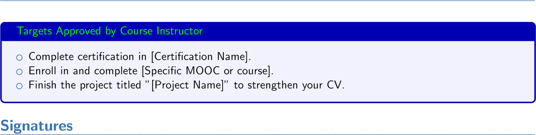

*Student’s Full Name Instructor’s Full Name*