Kanhaiya Lal — Mock Interview CV
Ward No. 6 – Sadulpur, Churu, Rajasthan 331023 – India
I +91 8619224297 • # klaggarwal1610@gmail.com • ð www.linkedin.com/in/kanhaiya-aggarwal § https://github.com/Kanhaiya1610

Objective
To secure a challenging internship as a Software Engineer or Machine Learning Engineer in a dynamic and innovative organization where I can leverage my skills in Python, Java, AI/ML, and web development to contribute to impactful projects, gain practical experience, and grow as a professional while contributing to the company's success.

Education

Lovely Professional University Jalandhar, Punjab
Bachelor of Technology in Computer Science and Engineering, CGPA: 7.23 2026
Relevant Coursework: Data Structures and Algorithms, Operating Systems, Database Management Systems, Artificial Intelligence, Computer Networks, Software Engineering
Central Board of Secondary Education Churu, Rajasthan
Senior Secondary 2021
Key Subjects: Physics, Chemistry, Mathematics
Central Board of Secondary Education Churu, Rajasthan
Higher Secondary 2019
Achievements: State and district Level Football player who led team with good leadership skills.

Technical Skills

Programming Languages: Python, Java, C++, JavaScript, C
Technologies\Frameworks: Spring Boot, Shell Scripting, React JS, Git, GitHub, MongoDB, JSP,
Streamlit, Firebase, TradingView API, NLTK, Flask, JPA, Lombok
Systems: Linux (KALI, TAILS, PARROT), Windows
Skills: Data Structures and Algorithms, Problem-Solving, Responsive Web Design, Scripting in Python, OS, Networking
AI & ML: Machine Learning, Natural Language Projects

Project Title: RESTful Calculator API
Description: Developed a robust RESTful Calculator API using Java and Spring Boot, featuring full CRUD functionality for basic arithmetic operations, comprehensive error handling, and deployed on a local server for seamless integration with other applications.
Demo/Code Link: https://github.com/Kanhaiya1610

Project Title: Finance Ai Assistant
Description: Developed a comprehensive AI-powered financial management application using Python, Streamlit, and Firebase, integrating real-time stock market data via Trading View API to provide intelligent budget tracking, expense analysis, and personalized financial insights, enhancing user experience and informed decision-making.
Technologies Used: Python (Flask), Streamlit, Firebase, Trading View API, NLTK, Plotly
Impact/Achievements: It highlights that the app gives users more control and understanding of their finances.
It directly states the app helps users manage their money effectively.
It shows the app helps users make better choices about their finances. Demo/Code Link: https://github.com/Kanhaiya1610
Project Title: Space Weather Alert System
Description: Developed a reactive RESTful API using Java, Spring Boot, and WebFlux to provide real-time space weather alerts, integrating data from external sources like NASA and ensuring data persistence with JPA and an H2 database.
Technologies Used: Java, Spring Boot, JPA, WebFlux, H2 Database, Lombok, REST API
Impact/Achievements: Successfully integrated external space weather data sources to provide timely and accurate alerts, improving situational awareness and enabling proactive responses to potential space weather hazards. Demo/Code Link: https://github.com/Kanhaiya1610

Certifications
Full Stack Data Science Developer Course from scratch, awarded by Udemy, ude.my/UC-dda2f2db-c1ee-4e7a-83ce-478f58975b90
Workshop on Containers and AI/ML on AWS Cloud by AWS, awarded by Cognizance IIT Roorkee, https://hyperstack.id/credential/155dd044-0e6c-42d0-abc6-ec0e0a1f3104 Complete Machine Learning & Data Science Program, awarded by GeeksforGeeks, https://media.geeksforgeeks.org/courses/certificates/9d6e337822df251c3e2aab610cfbc2a9.pdf Oracle Cloud Infrastructure 2023 AI Certified Foundations Associate, awarded by Oracle, https://www.linkedin.com/posts/kanhaiya-aggarwal_oracle-oci-ai-foundations-associate-certificate-activity-
7210637933463187456-
ssHH?utm_source=social_share_send&utm_medium=member_desktop_web&rcm=ACoAACEbvTQBf0IRnn3aFKJv WgPv-aVC8PH32Sk

Languages
Japanese – Elementary Proficiency
English – Working Proficiency
Hindi – Working Proficiency

AI Recommendations for Improvement
Recommendation 1: Enhance Core Machine Learning & AI Skills
  - Work on projects implementing Deep Learning using frameworks like TensorFlow or PyTorch.
Recommendation 2: Focus on Competitive Programming & DSA
- Why: Strong problem-solving skills are critical for placements in top companies like Nvidia.
Recommendation 3: Strengthen Database and Backend Development
- Earn the MongoDB Java Developer Path Badge (Free) to solidify NoSQL knowledge.
- Enhance RESTful APIs with complex queries, indexing, and database optimization. Build a project that handles real-time data (e.g., stock market dashboard or live weather feed).

Self-Assigned Tasks (Till 10th week of this semester)
Task 1: MongoDB Developer’s Toolkit: CRUD Operations Course by GeeksforGeeks.
Task 2: Complete Machine Learning & Data Science Program by GeeksforGeeks.
Task 3: Project: Space Weather Web App using JSP and New features like Geomagnetic Storms etc.

Targets Allocated (Till 10th week of this semester)
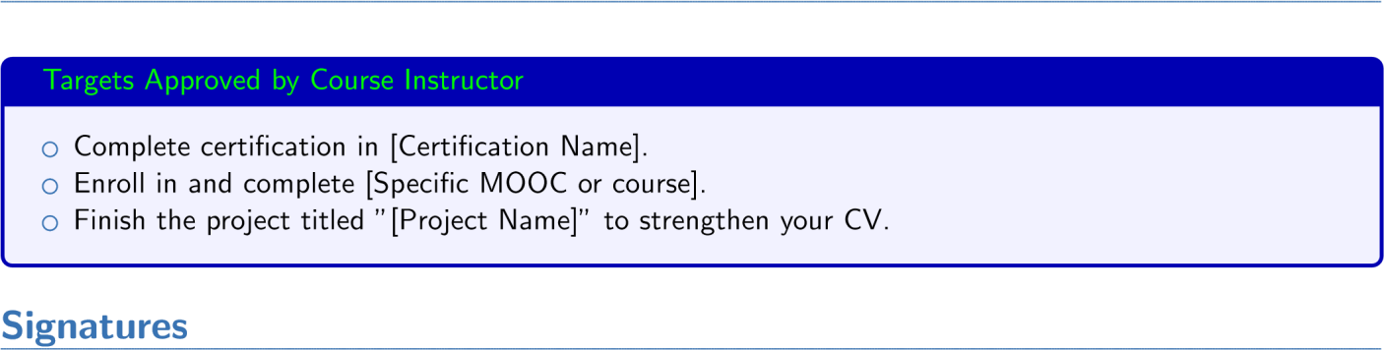

Student’s Full Name Instructor’s Full Name

