**University Institute of Engineering and Technology, Panjab University Hoshiarpur**



**Mid Term Industrial Training**

________________________________

**CREATORS**

**Name: Kanhaiya Kumar**

**IT - (SG19820)**

**TABLE OF CONTENTS:**

1) Introduction

2) Purpose

3) Target Audience

4) Scope

5) Project Objectives

5.1) Goals

5.2) Tasks

5.2.1) Proper Environment Setup

5.2.2) Frame Work Building

5.2.3) Designing

5.2.4) Coding

5.2.5) Testing

5.2.6) Bug Fixing

5.2.7) Final Documentation

5.3) Resources

5.4) Budget

6) Milestone

7) Abbrevations

8) Project Client

9) Project Manager

10) Project Group

11) Steering Group

12) Requirements

13) Requirement Summary

14) Project Specifications

15) Pages

16) Project Experience

1. **INTRODUCTION:-**

The Web Music Player is a music platform designed to play music from across the web by utilizing a simple chrome browser. The intent is to designate a machine to present a simple frontend web page of music playe website and play music for other devices to control through a Web Interface.

1. **PURPOSE:-**

They are portable digital music players that play music as audio files, such as MP3. In addition, most of these devices allow to store video, pictures, and to receive radio and TV programs (podcasting). Earphones and external speakers are the typical output devices delivering sound to the listener.

1. **SCOPE:-**

The music player allows a user to play various media file formats. It can be used to play audio as well as video files. The music player is a software project supporting all known media files and has the ability to play them with ease.

**4. GOALS:-**

The primary purpose of the music streaming application is to play music available in the databases of the service, compose custom playlists and suggest similar songs. The main elements of music streaming apps are: Discovery.

**5. RESOURCES:-**

They are portable digital music players that play music as audio files, such as MP3. In addition, most of these devices allow to store video, pictures, and to receive radio and TV programs (podcasting). Earphones and external speakers are the typical output devices delivering sound to the listener.

**6. MILESTONE:-**

|  |  |
| --- | --- |
| Description | Fixed date |
| Kick off | Project start date – 05 july 2022 |
| Design | Design and layout must be completed till 25 july 2022 |
| Basic structure | Basic structure of the website must be completed till 25 july 2022 |
| Functionalities | All the functionalities must be completed till 25july 2022 |
| Testing | Testing should be done till 30july 2022 |
| Bug fixing | Till 30july 2022 |
| Finishing | Design finishing should be done till 30july 2022 |

7. STEERING GROUP:-

|  |  |
| --- | --- |
| Kanhaiya Kumar | HEAD |

13. REQUIREMENT:-

|  |  |
| --- | --- |
| API | No |
| Environment setup  (1)VS - code & (2)bracket | Yes |
| Bootstrap framework | Yes |
| JQuery plugin | No |
| Basic  (1)HTML(2)CSS(3)JS | Yes |
| Photoshop | Yes |
| Illustrator | Yes |
| Internet | Yes |
| TeamViewer | Yes |
| NPM | No |
| Preloaded | No |
| Nodejs | No |
| GitHub | Yes |
| Server | No |

**14. Project experience:-**

(i) Positive and excellent experience during doing this project.

(ii) Time management and get to know how to tackle problem.

(iii) Group coordination improvement.

(iv) Improved mistakes.

(v) Learned about these technologies more while working on them in the project.

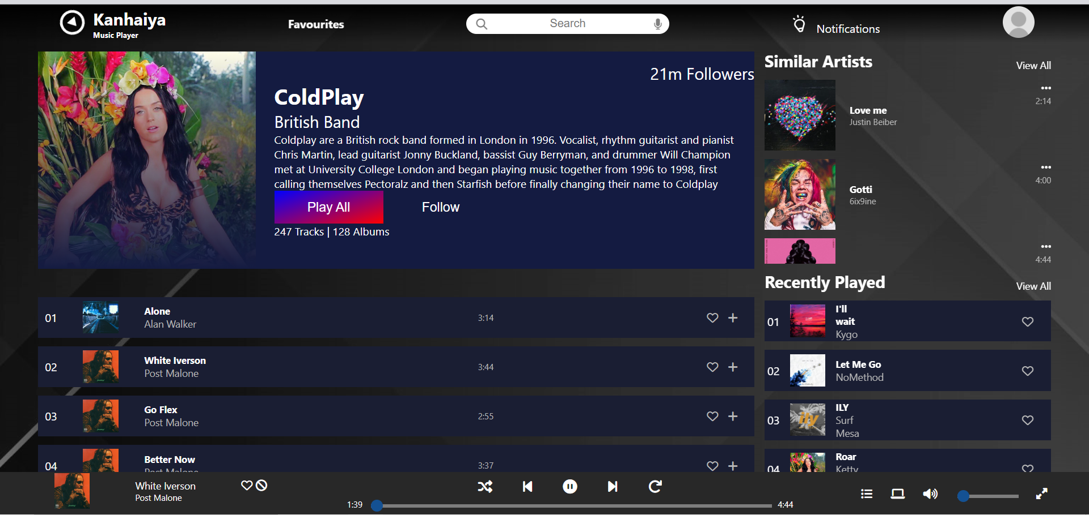

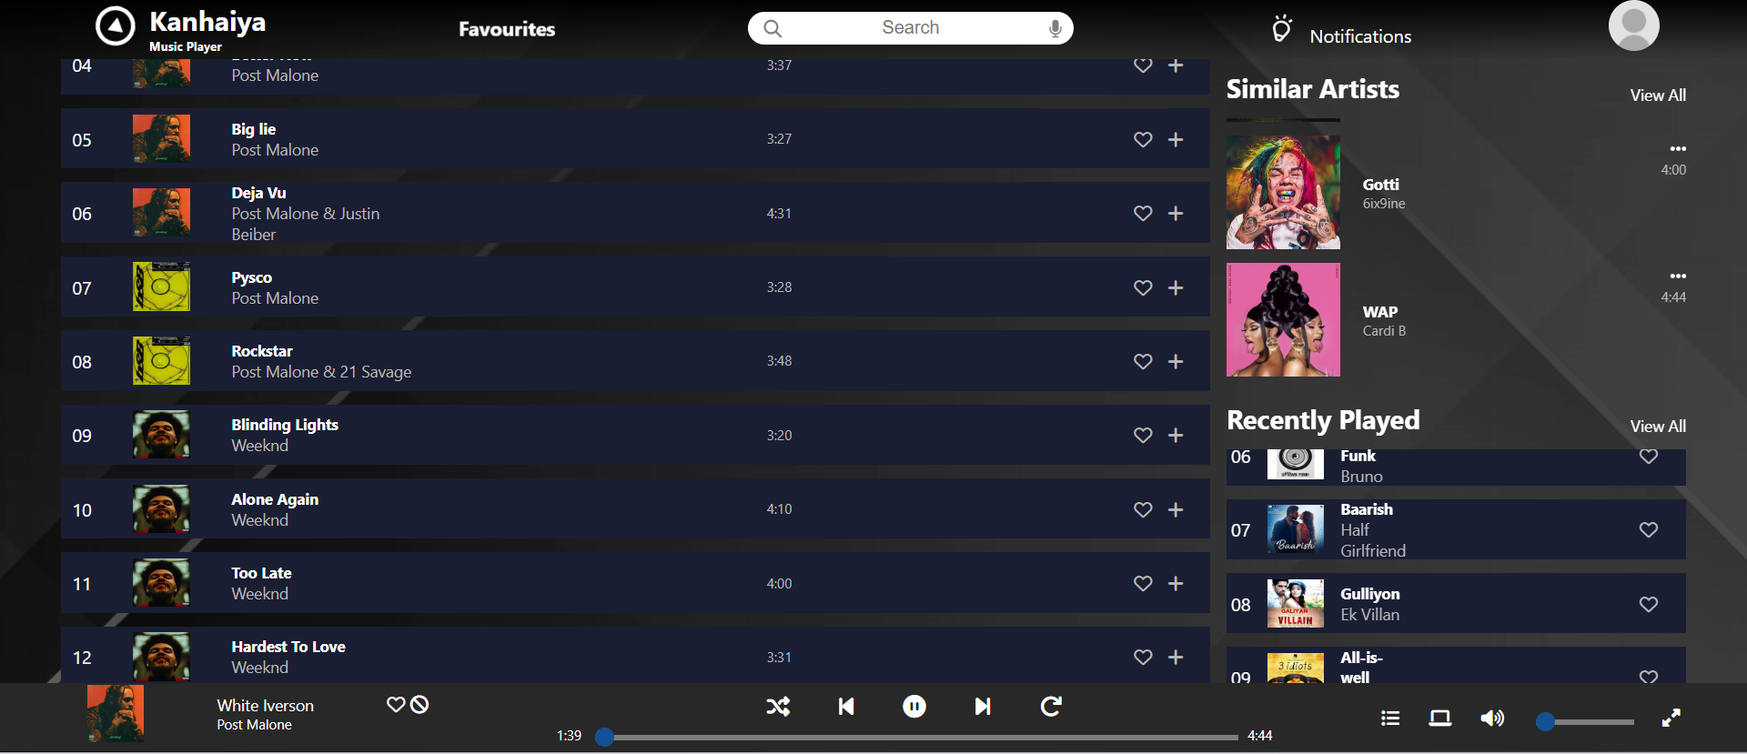

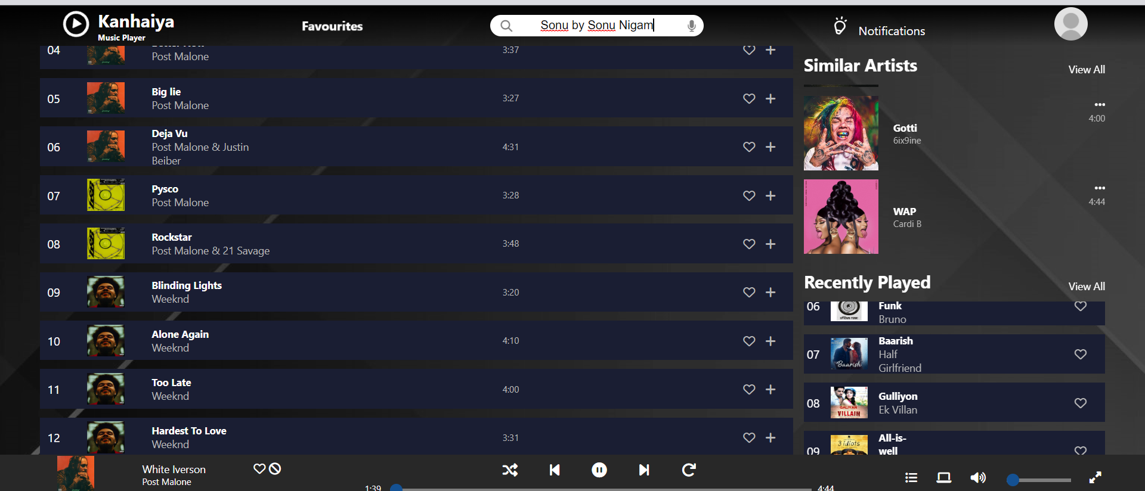

Sample code:

