SYCS

Name: Kanhaiya SUB: HAD II SYCS:369

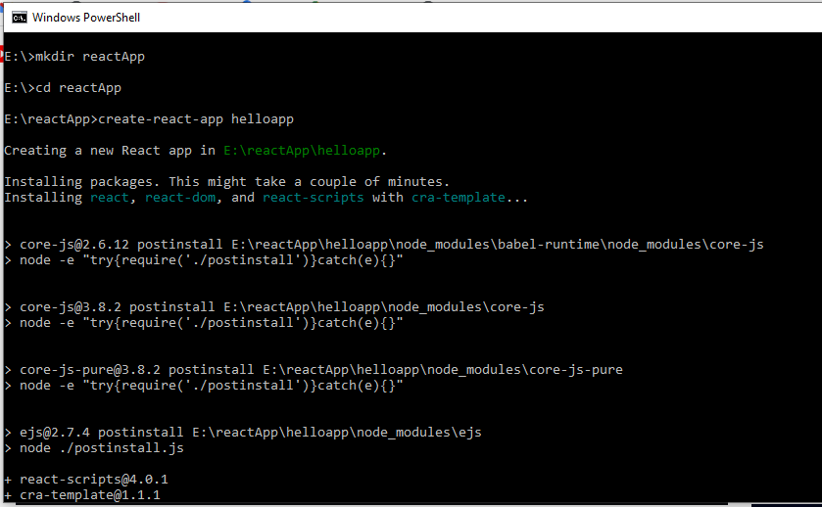

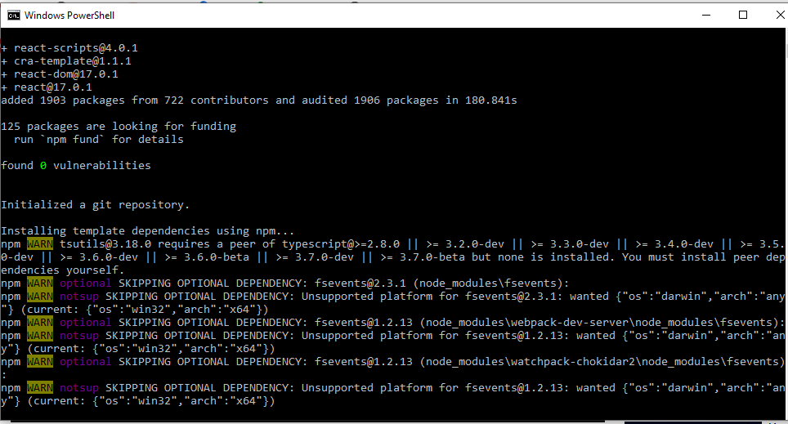

SYCS

Name: Kanhaiya SUB: HAD II SYCS:369

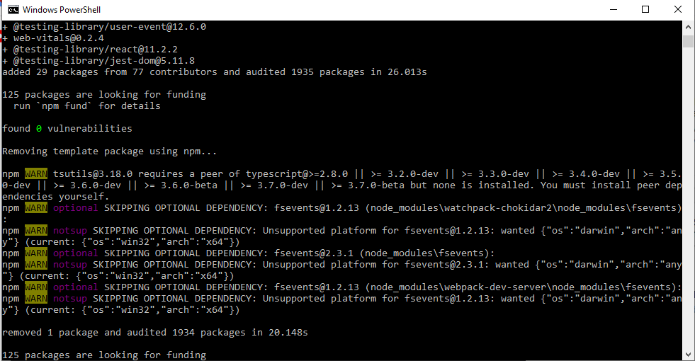

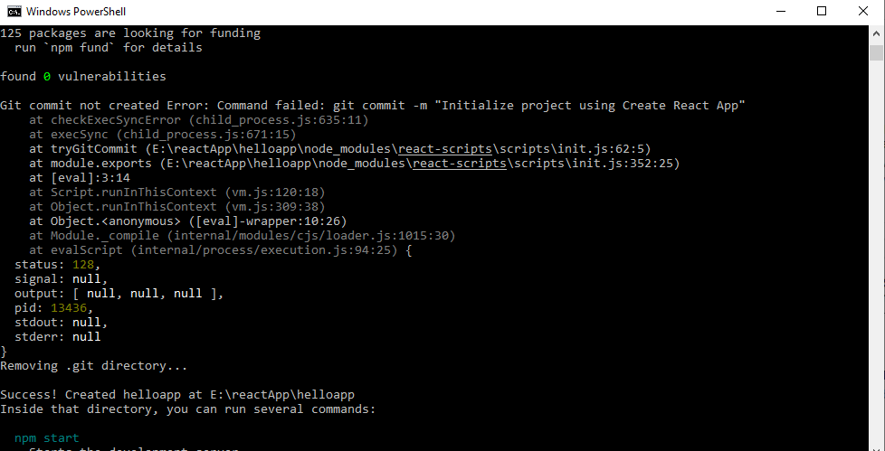

SYCS

Name: Kanhaiya SUB: HAD II SYCS:369





SYCS

Name: Kanhaiya SUB: HAD II SYCS:369

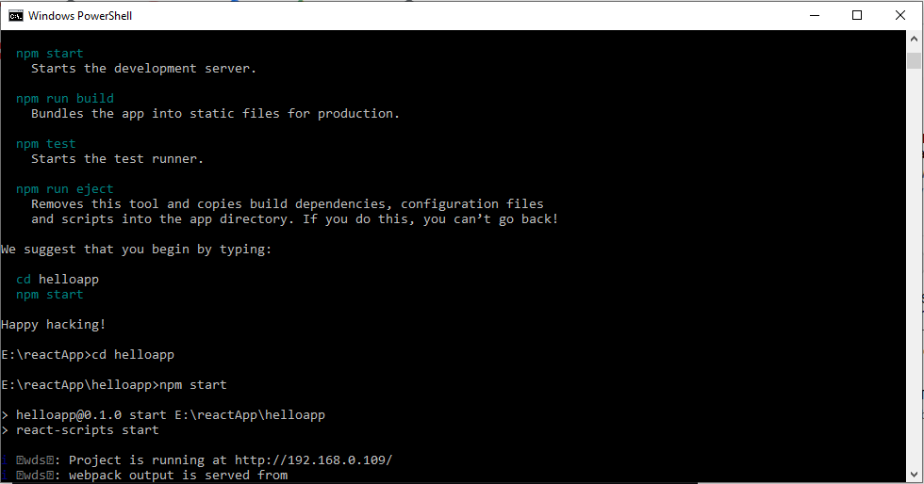

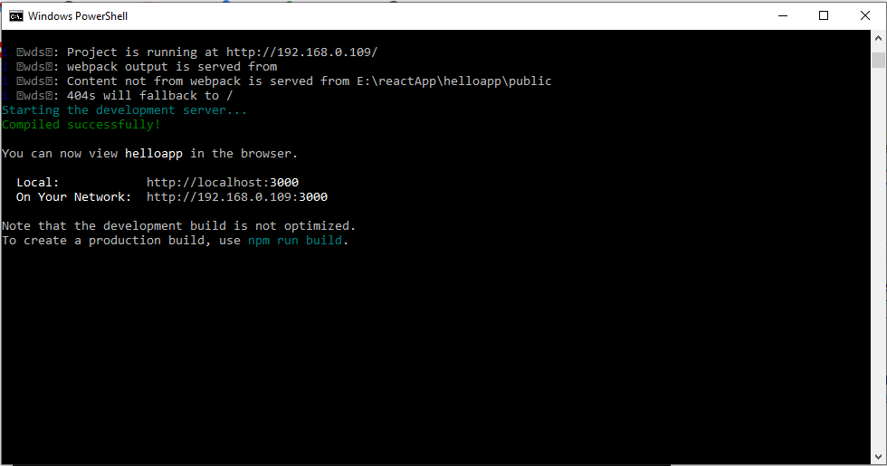

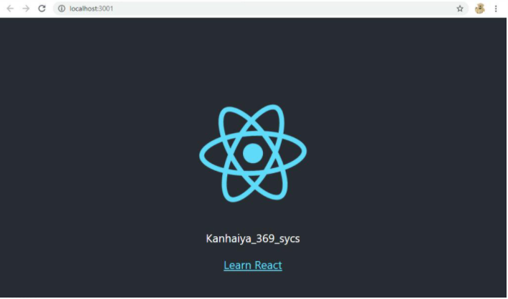

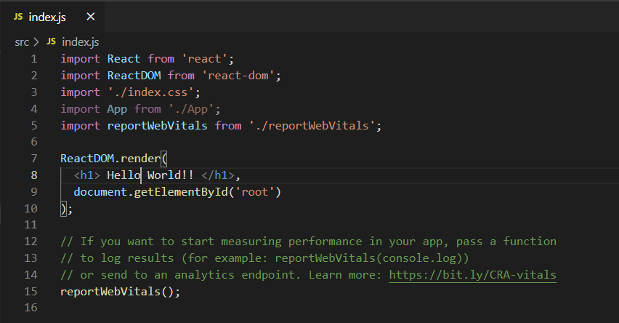

SYCS

Name: Kanhaiya SUB: HAD II SYCS:369

