PRN – 25070521157 NAME- Kanhaiya Tyagi
4.1.1] Set Operations
ALGORITHM
Step 1: Start
Step 2: Input Set A
Step 3: Convert the input values into Set A
Step 4: Input Set B
Step 5: Convert the input values into Set B
Step 6: Find the Union of Set A and Set B
Union = A | B
Step 7: Find the Intersection of Set A and Set B
Intersection = A & B
Step 8: Find the Difference of Set A and Set B
Difference = A − B
Step 9: Print Union, Intersection, and Difference
Step 10: Stop
FLOWCHART

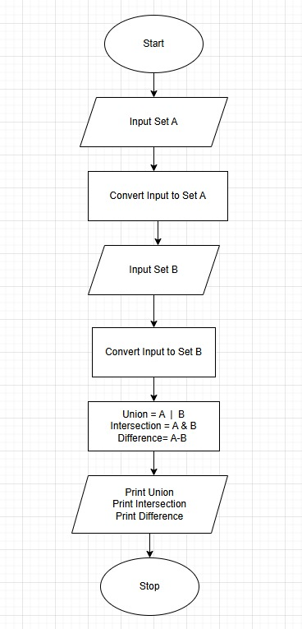

PYTHON CODE
set_a = set(map(int, input("Set A: ").split()))
set_b = set(map(int, input("Set B: ").split()))

print("Union:", set_a | set_b)
print("Intersection:", set_a & set_b)
print("Difference:", set_a - set_b)

EXCECUTION
