EE8203: Network Design Document
Campus Network Automation Project
Module Code | EE8203: Design and Management of Data Networks
Group Members | EG/2021/4465 - De Silva K.G.B.P  EG/2021/4520 - Gangadara M.G.K
Date | July 24, 2026

1. Topology Overview
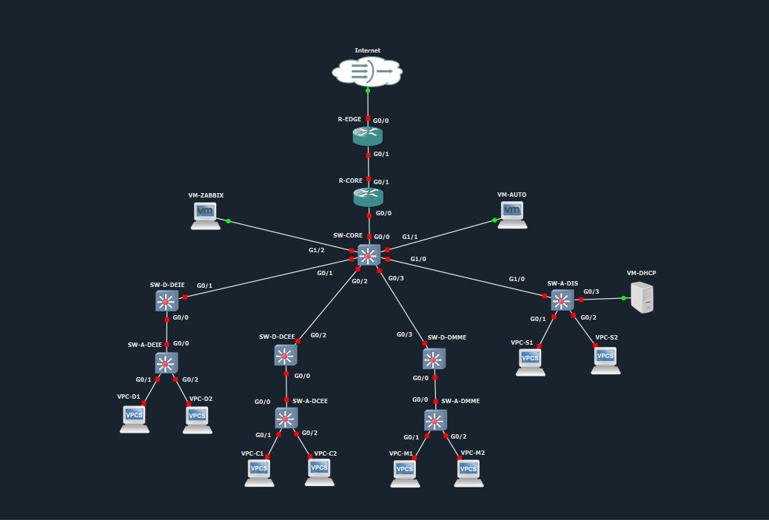
The network utilizes a hierarchical three-layer architecture designed for the campus premises. The routing boundary is pushed down to the distribution layer for the DEIE, DCEE, and DMME departments. This means their respective default gateways (SVIs) reside directly on their designated Layer 3 distribution switches (SW-D-DEIE, SW-D-DCEE, SW-D-DMME).
The Department of Inter Disciplinary Studies (DIS) does not utilize a distribution switch. Its access switch (SW-A-DIS) trunks directly to the Core Switch (SW-CORE), meaning the Layer 3 gateway for the server farm resides at the core.

2. IP Addressing and VLAN Scheme

2.1 Loopback Interfaces
Loopback interfaces provide stable OSPF router-IDs and clean management/monitoring targets for Zabbix.
Device | Loopback0 Address | Purpose
R-EDGE | 10.255.255.1/32 | OSPF Router-ID / MGMT
R-CORE | 10.255.255.2/32 | OSPF Router-ID / MGMT
SW-CORE | 10.255.255.3/32 | OSPF Router-ID / MGMT
SW-D-DEIE | 10.255.255.11/32 | OSPF Router-ID / MGMT
SW-D-DCEE | 10.255.255.12/32 | OSPF Router-ID / MGMT
SW-D-DMME | 10.255.255.13/32 | OSPF Router-ID / MGMT

2.2 WAN and Routed Core Links (OSPF Area 0)
All point-to-point transit links utilize /30 subnets to conserve IP space and isolate broadcast domains.
Link | Subnet | Side A | Side B
Internet ↔ R-EDGE | 192.0.2.0/30 | Internet = .1 | R-EDGE (outside) = .2
R-EDGE ↔ R-CORE | 10.255.0.0/30 | R-EDGE = .1 | R-CORE = .2
R-CORE ↔ SW-CORE | 10.255.0.4/30 | R-CORE = .5 | SW-CORE (routed port) = .6
SW-CORE ↔ SW-D-  DEIE | 10.255.1.0/30 | SW-CORE = .1 | SW-D-DEIE (routed port) = .2
SW-CORE ↔ SW-D-DCEE | 10.255.1.4/30 | SW-CORE = .5 | SW-D-DCEE (routed port) = .6
SW-CORE ↔ SW-D-DMME | 10.255.1.8/30 | SW-CORE = .9 | SW-D-DMME (routed port) = .10

2.3 Data VLANs and Gateways
VLAN | Name | Subnet | Gateway | Gateway Host Device
10 | VLAN_DEIE | 10.10.10.0/24 | 10.10.10.1 | SW-D-DEIE
20 | VLAN_DCEE | 10.10.20.0/24 | 10.10.20.1 | SW-D-DCEE
30 | VLAN_DMME | 10.10.30.0/24 | 10.10.30.1 | SW-D-DMME
40 | VLAN_DIS | 10.10.40.0/24 | 10.10.40.1 | SW-CORE
99 | MGMT | 10.99.99.0/24 | 10.99.99.1 | SW-CORE
100 | NATIVE | N/A | N/A | Unused (mitigates VLAN hopping)

2.4 End-Hosts, VMs and Management IPs
Management IPs reside on VLAN 99. The core routing devices (R-EDGE, R-CORE, SW-CORE) do not require VLAN 99 IP assignments as they are managed via their advertised Loopback addresses.
Hostname / Device Type | IP Address | VLAN Assignment
SW-D-DEIE (MGMT) | 10.99.99.11 | 99
SW-D-DCEE (MGMT) | 10.99.99.12 | 99
SW-D-DMME (MGMT) | 10.99.99.13 | 99
SW-A-DEIE (MGMT) | 10.99.99.21 | 99
SW-A-DCEE (MGMT) | 10.99.99.22 | 99
SW-A-DMME (MGMT) | 10.99.99.23 | 99
SW-A-DIS (MGMT) | 10.99.99.24 | 99
VM-AUTO | 10.99.99.50/24 | 99 (Bridged)
VM-ZABBIX | 10.99.99.60/24 | 99 (Bridged)
VM-SERVICES (DHCP/DNS) | 10.10.40.10/24 | 40
DEIE-PC1 / PC2 | 10.10.10.101 / .102 | 10
DCEE-PC1 / PC2 | 10.10.20.101 / .102 | 20
DMME-PC1 / PC2 | 10.10.30.101 / .102 | 30
DIS-PC1 / PC2 | 10.10.40.101 / .102 | 40

3. Routing and Security Policies

3.1 OSPF and NAT
- Dynamic Routing: OSPF (Process ID 1) operates entirely in single Area 0. Router-IDs are explicitly set via loopback interfaces rather than relying on automated interface selection.
- Passive Interfaces: Data VLANs and Management VLAN SVIs are configured as passive-interface to prevent OSPF hello packet transmission to end-hosts, while transit uplinks remain active.
- Default Route: R-EDGE originates the default route into the OSPF domain via the default-information originate command.
- NAT Overload (PAT): Configured exclusively on R-EDGE. Only the DEIE (10.10.10.0/24) and DCEE (10.10.20.0/24) subnets are permitted internet egress via the outside interface.

3.2 Access Control Lists (ACLs)
Because the default gateways reside on the distribution switches, ACL policy enforcement occurs natively at the distribution layer (the closest enforcement point to the source).
- ACL_DEIE_IN: Applied inbound on SW-D-DEIE (Vlan10); permits all traffic to DIS.
- ACL_DCEE_IN: Applied inbound on SW-D-DCEE (Vlan20); permits HTTP/HTTPS to DIS only, denies traffic to DEIE.
- ACL_DMME_IN: Applied inbound on SW-D-DMME (Vlan30); implicitly denies traffic to DIS and explicitly denies DMME to DCEE.
- ACL_DIS_IN: Applied inbound on SW-CORE (Vlan40); catches and logs default-deny traffic sourced from DIS.

4. Device Selection Justification

4.1 Edge and Core Routers (R-EDGE, R-CORE)
- Selection: Cisco IOSv Router Image (Qty: 2)
- OSI Layer Role: Layer 3 (Network). Responsible for WAN routing, dynamic OSPF backbone calculations, and NAT/PAT enforcement.
- Justification: The IOSv image handles complex routing protocols with high stability. Deploying virtualized IOSv images is exceptionally cost-effective for a lab environment while preserving absolute scalability, allowing administrators to seamlessly integrate features like IPsec VPNs or BGP in the future without hardware procurement.

4.2 Switching Fabric (SW-CORE, SW-D-*, SW-A-*)
- Selection: Cisco IOSvL2 Switch Image (Qty: 8 total)
- OSI Layer Role: Layer 2 (Data Link) access/trunking and Layer 3 (Network) distribution routing.
- Justification: Utilizing a distributed Layer 3 model allows the Core switch to delegate SVI processing to the distribution tier (SW-D-*). Using the IOSvL2 image universally ensures feature parity across all switching tiers. This standardization minimizes software licensing and deployment costs, while allowing scalable port density for access edges and high-speed trunking for uplinks.

5. Automation Tool Selection Justification

5.1 Netmiko (Python) for Routers and SNMP
- Role: Configuration of R-CORE, R-EDGE, and the global SNMP push.
- Justification: Router configurations require imperative, sequenced CLI commands (such as strict OSPF and NAT ordering) with tight control over error handling. Netmiko provides excellent precision for these tasks. Because the scale is limited to two routers and a one-shot SNMP push across 10 devices, deploying a full management framework for this phase would be computationally inefficient.
- Limitations & Idempotency: Netmiko lacks a built-in state model; therefore, idempotency must be manually programmed by utilizing declarative IOS syntax that acts as a no-op upon resending.

5.2 Ansible (cisco.ios) for Switches
- Role: Configuration of all distribution and access switches (SW-D-*, SW-A-*).
- Justification: Switch configuration in this topology involves highly repetitive, declarative structures across 7 devices (VLAN databases, trunking protocols, STP, and access ports). Ansible excels at this scale. Utilizing Ansible roles, group_vars, and host_vars provides a highly modular and scalable framework.
- Limitations & Idempotency: While connection plugins can be slower per-host than native SSH scripts, Ansible provides native idempotency via modules like ios_vlans. Administrators can execute --check mode to compute diffs and guarantee zero unintended changes are pushed to production.

