Cloud Question:

Created the user with permisions

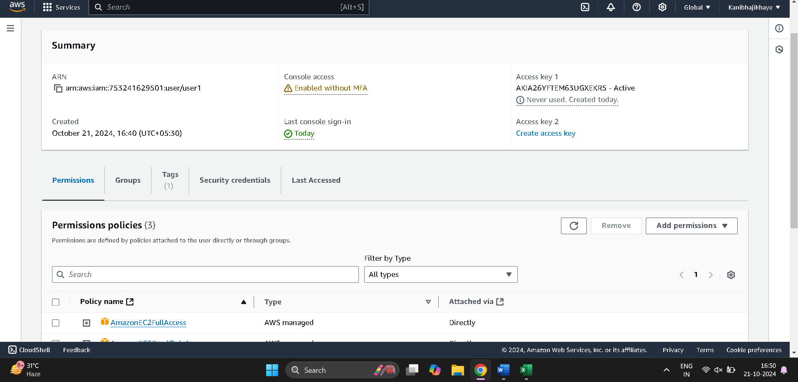

Succesfully loged in to user1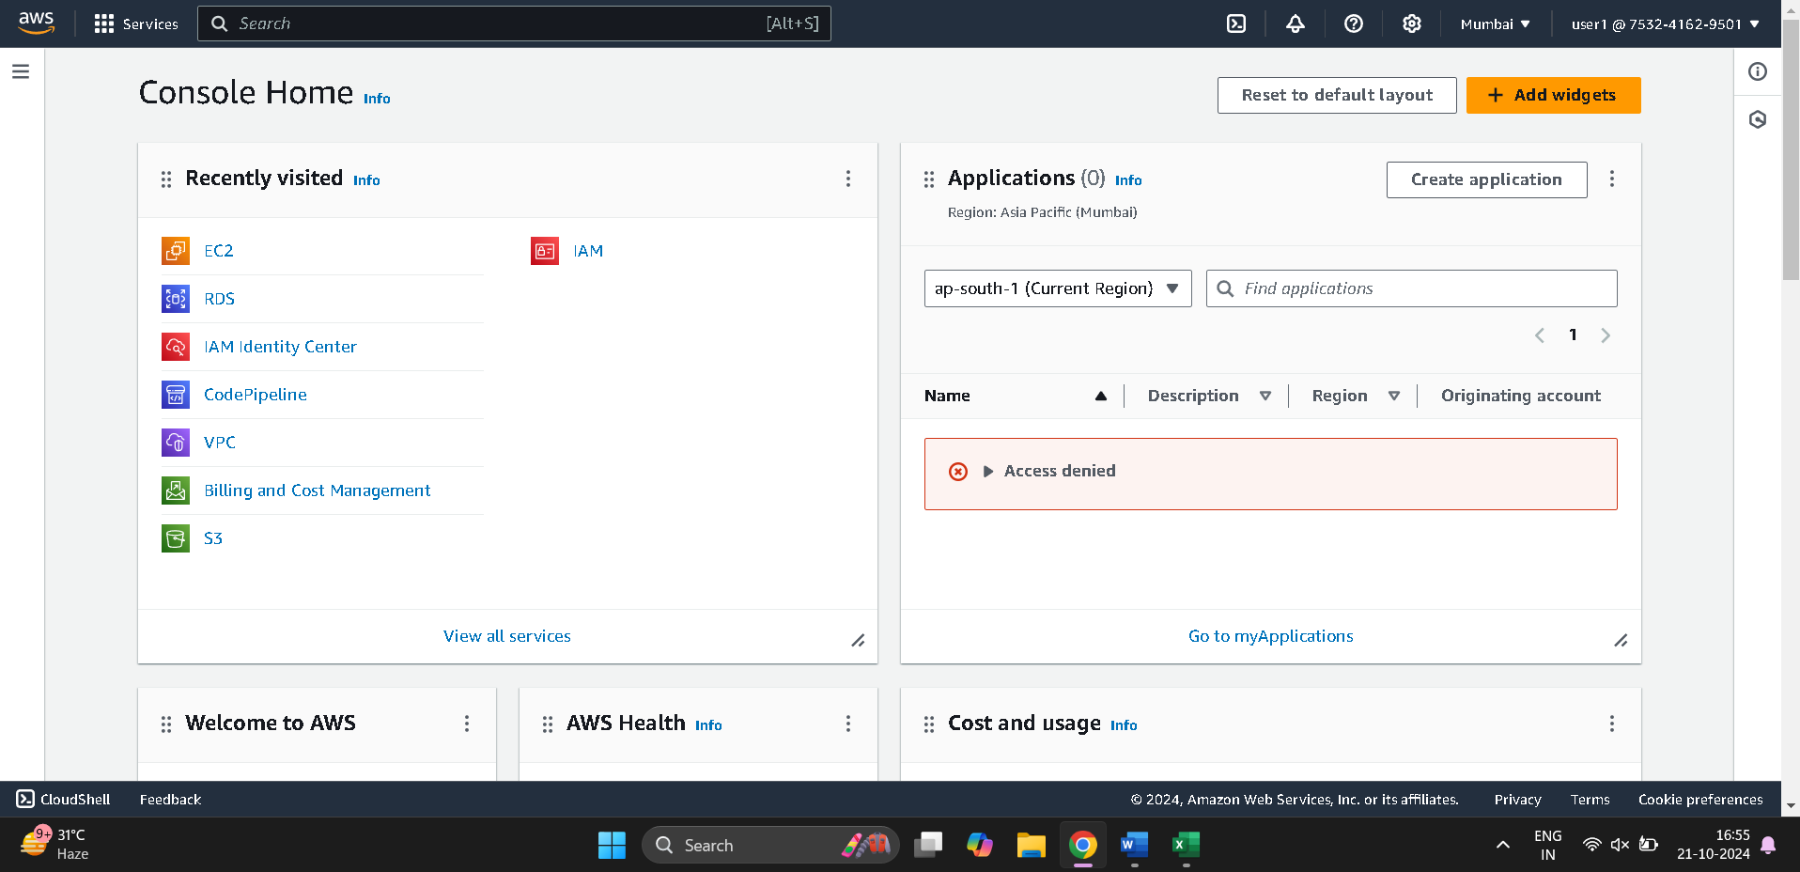

Sucessfully created instance inside user1

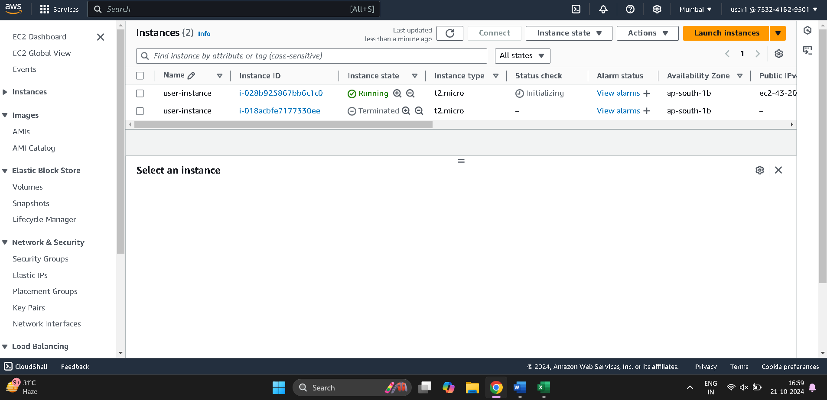

Create the bucket to hold the html file

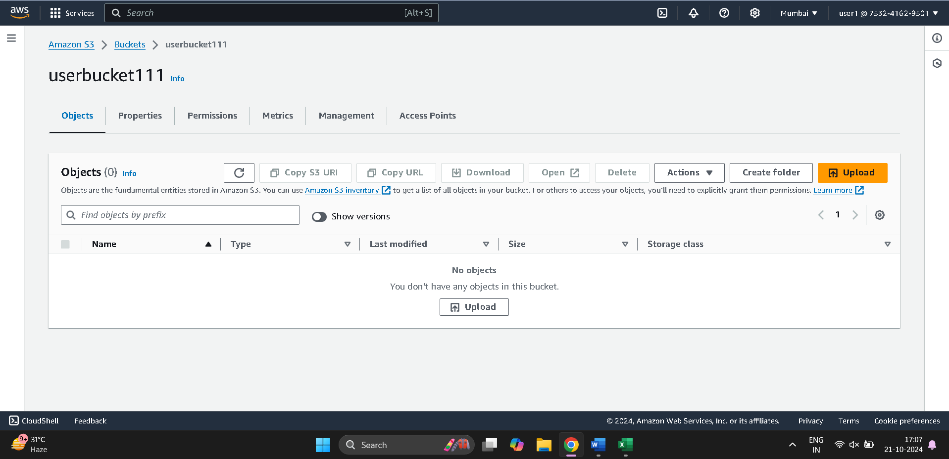

Connected to the instance and created the html file 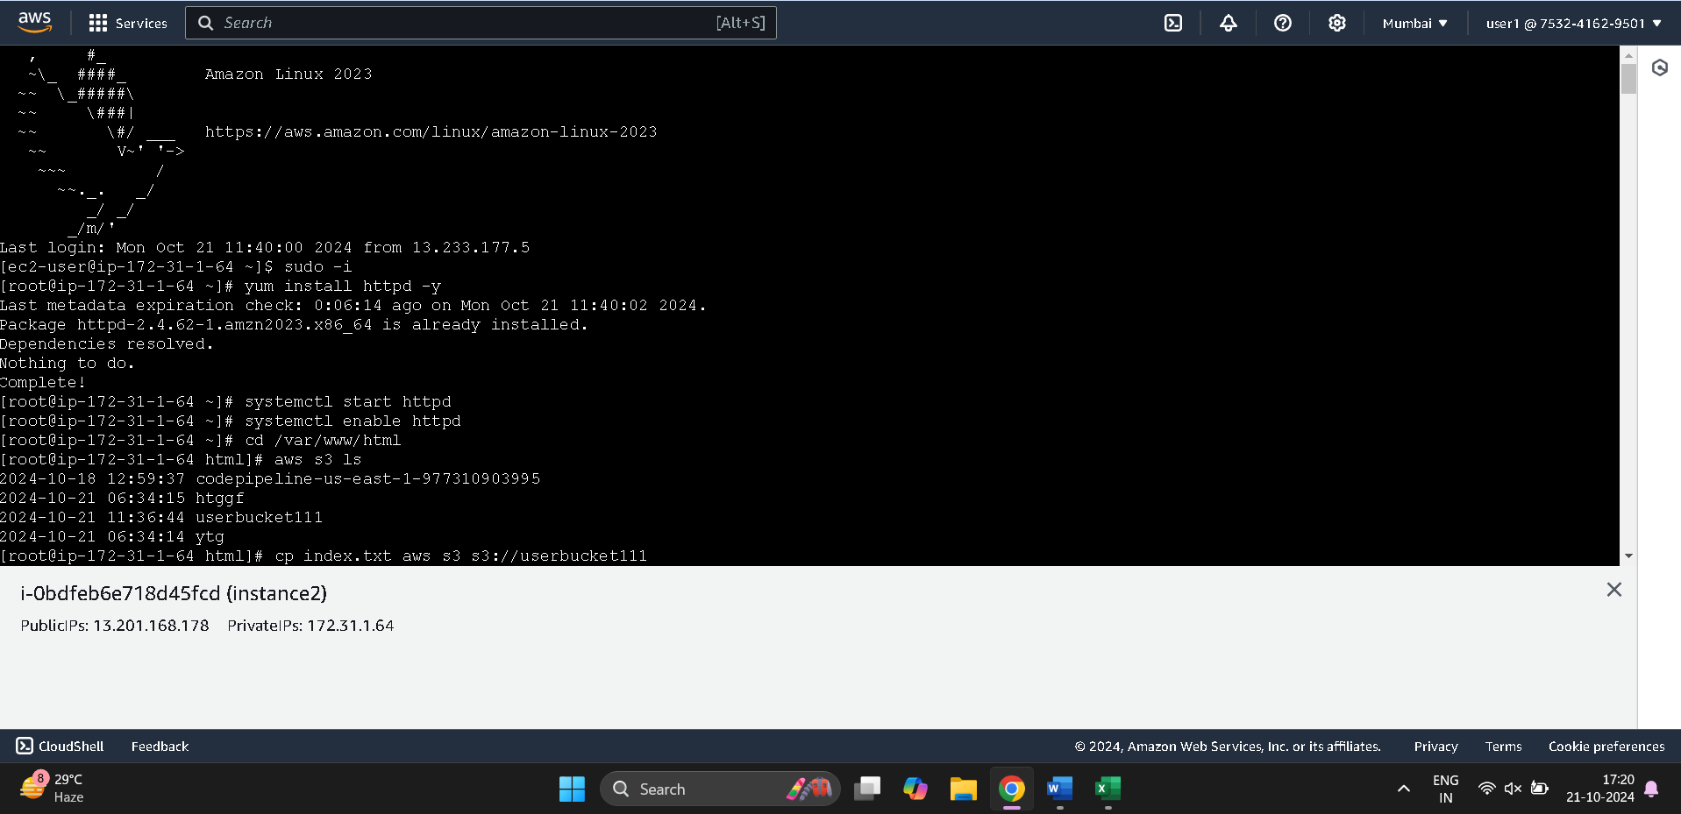

Html file uploaded to the s3 bucket

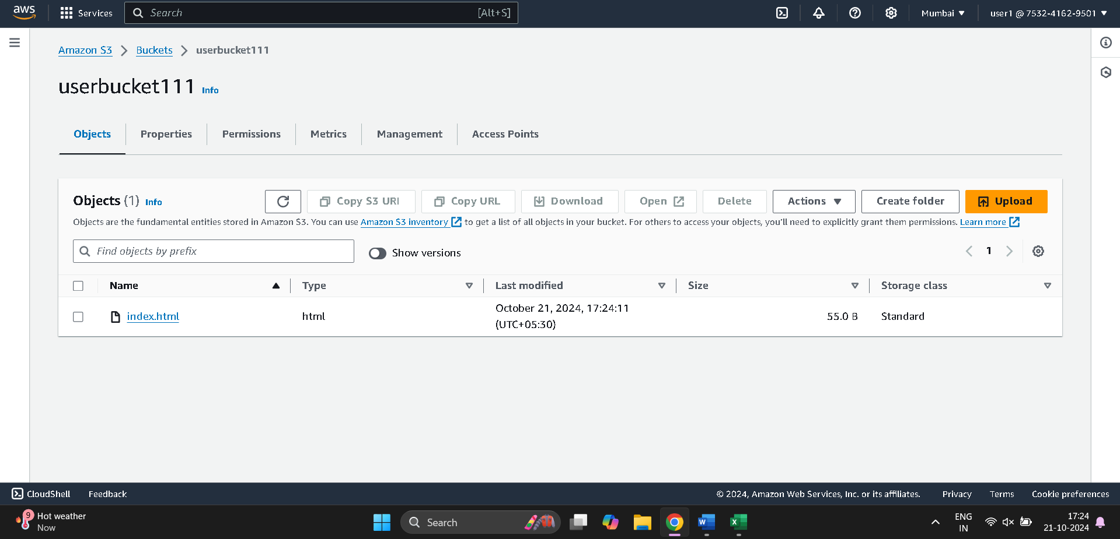

Made the html file public

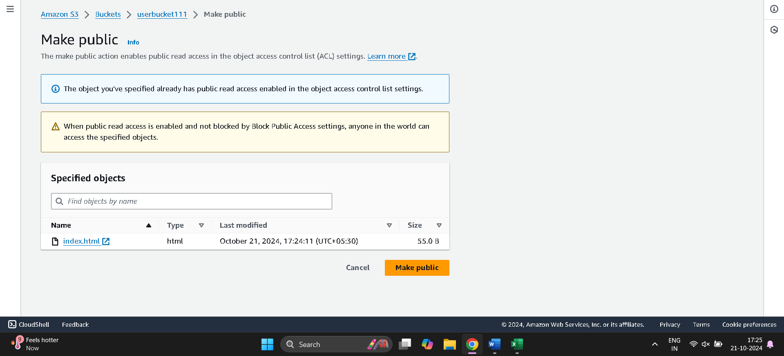

Hosted the html file

Html file is publicly accessed through object URL in web browser

https://userbucket111.s3.ap-south-1.amazonaws.com/index.html

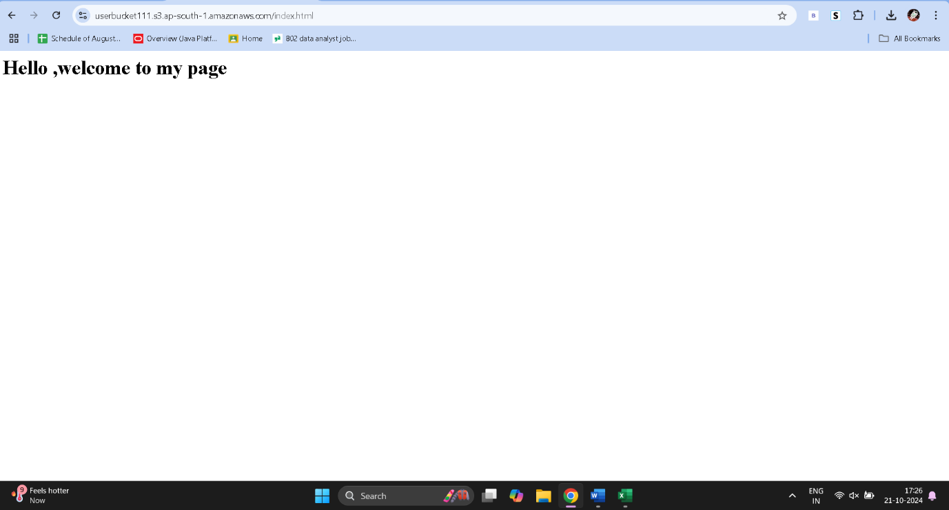

Linux Question :

Que 2:

Created a dir /rename the dir using mv command:

Mkdir Kanishk

Mv Kanishk root

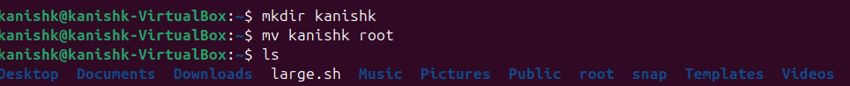

Move existing dir to a new location :

Mv root Pictures

Cd Pictures && ls # the change the dir and list the content



Created and deleted the dir using rmdir:

Mkdir Kanishk

Ls

Rmdir kanishk

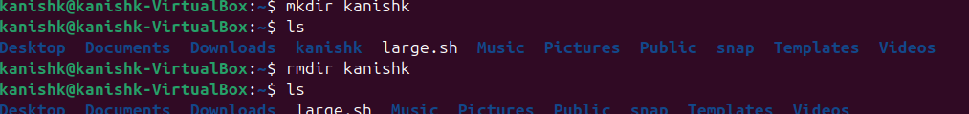

Created a file and name it file1.txt and created the hardlink

Touch file1.txt



Que 1 :

Average of 4 num:

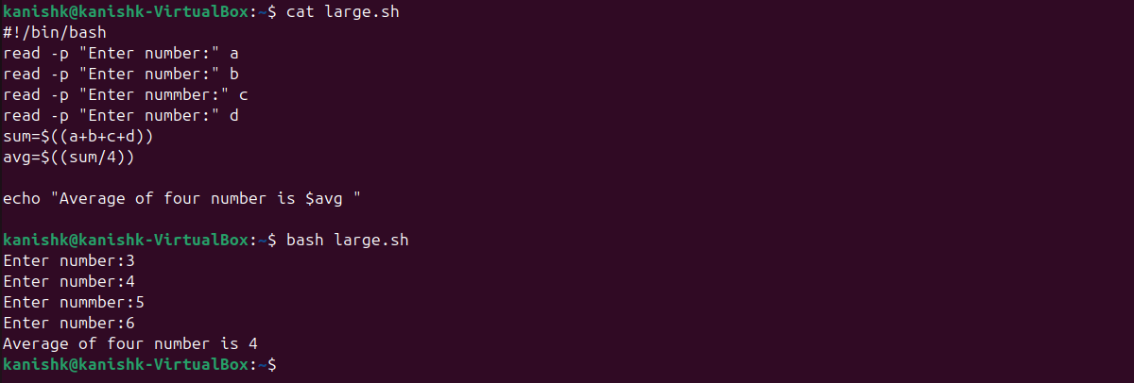

Calculate the product of four num :

