

[#PROJECTOVERVIEW](https://www.linkedin.com/feed/hashtag/?keywords=projectoverview&highlightedUpdateUrns=urn%3Ali%3Aactivity%3A7215760831014195202)  
The aim of this Project is to:  
A. Establish robust data integration processes to compile and validate diverse datasets related to carbon emission industries in 1854-2019, ensuring data consistency and accuracy.  
B. Perform descriptive data analysis to summarize key statistics related to parent entities and types.  
C. Split the production value and total emission by commodity.  
D. To show the difference between high granularity emission data and medium granularity data.  
E. By using tree type visual spilt the data of total emission by parent type.

[#InsightsExplored](https://www.linkedin.com/feed/hashtag/?keywords=insightsexplored&highlightedUpdateUrns=urn%3Ali%3Aactivity%3A7215760831014195202)

\***Emission in 2019:** OIL AND NGL-29% NATURAL GAS-21.67% CEMENT-3.66% TOTAL COAL-44%.

* **The database categorizes entities into three types**: investor-owned companies, state-owned companies, and nation-states.

\***Commodity Statistics:** Coal types are having highest percentage in CO2 emission.

\***Sum of total emission in tree method:** separated the data by Parent types using low, medium, high granularity data.

\***Sum of production value by commodity:** arranged the production value data by commodity using stacked area chart.

**The database categorizes entities into three types**: investor-owned companies, state-owned companies, and nation-states. Historically, investor-owned companies account for 31% of all emissions tracked by the database (440 GtCO2e), with **Chevron**, **ExxonMobil**, and **BP** the three largest contributors respectively. State-owned companies are linked to 33% of the database total (465 GtCO2e), with **Saudi Aramco**, **Gazprom**, and the **National Iranian Oil Company** being the largest contributors. Nation-states account for the remaining 36% (516 GtCO2e), with **China's coal production** and the **Former Soviet Union** the largest contributors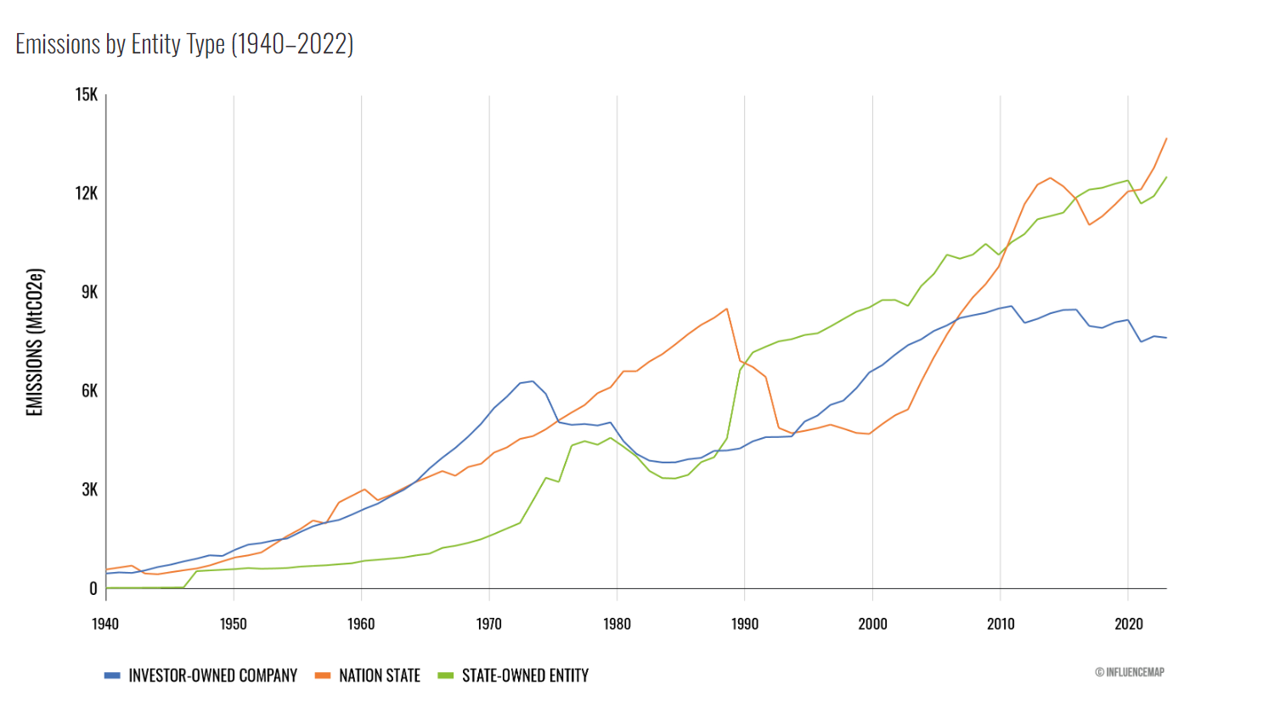

*Crime Types: Theft is the highest crime, followed closely by burglary and assault.  
*Incident by Location: Most incidents occur in urban areas, with downtown and suburban areas showing relatively similar counts. Rural areas have the fewest crime incidents.  
*Gender Statistics: Males are involved in a significant majority of incidents, representing 69% of the total.  
*Age Group Data: Majority of incidents involve individuals in the 26-38 and 39-59 age groups.  
*Drug Incidents: Cocaine and Marijuana-related incidents are the highest , with their counts being close.